Relax Report

Adopted users are users who have logged onto the system on at least three different occasions in a seven-day period. Therefore, I grouped user engagement by weeks, and then identified a person who logged int at least 3 times in week as adopted. Adopted Users only account for 12% of users; thus, the majority of users did not adopt the platform. Additionally, 25% of users opted into the mailing list while 15% opted into the marketing.

Since our primarily interested in determining which factors predict future adoption, I did not split our data into train and test set. I did this only because we don't want to predict whether or not a person adopts but which factors increase the likelihood of adoption.

Since we are interested in explain ability, we will use logistic regression, so we need to create dummy variables for the creation source. Furthermore, since only 12% of the data are adopted users, and we are interested in adopted users, we need to over sample from the adopted user class. Additionally, to understand which factors impacted user adoption, it is important we discover all adopted users; recall is the ratio of predicted adopted users to the total number of actual adopted users. Therefore, we will use recall as our metric.

From the graph, it is apparent that both guest invite and google authentication creation sources have the same impact on adopted users; however, from the table, guest invite has a slightly larger impact. Guest invites increases the probability that a user is adopted by .248% while a user who uses Google Authentication is a .245 % more likely to adopted the system. Interestingly, a person who creates and account for personal project is .66.7% less likely to become an adopted user.

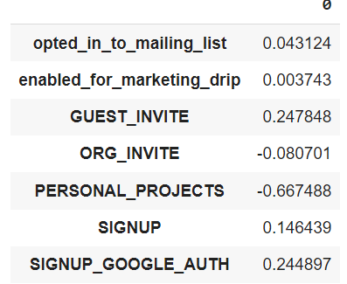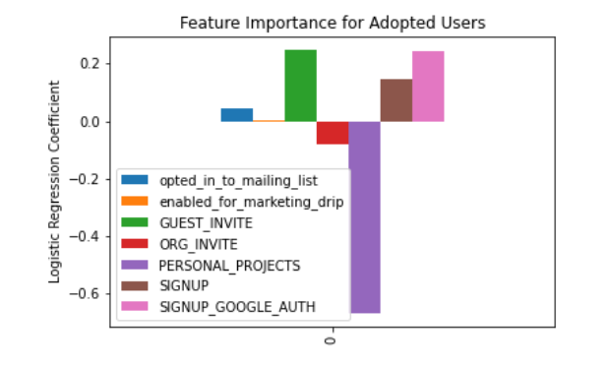Thus, these results suggest, Relax should encourage more people to send guest invites, and they should conduct more research on personal project use to determine why there is such a large negative impact. For further research, organization id’s should be included in the analysis because certain organization may be more likely to adopted the program. There are 417 different organization id's, so I wasn’t able to use the organization id in the model; however, if we knew what industries the organization ids belong to, we may be able to group the ids into a more useful format for analysis.