**Problem Definition:**

The challenge is to create a chatbot in Python that offers solution for the various queries related to radiological equipments their usage and application for exceptional customer service, answering user queries on a website or application. The objective is to deliver high-quality support to users, ensuring a positive user experience and customer satisfaction of radiological equipments

**1. Introduction**

**What is radiology?**

Radiology is a medical specialty that uses medical imaging techniques, such as X-rays, CT scans, MRI scans, and ultrasound, to diagnose and treat diseases and injuries. Radiologists are medical doctors who interpret these images to help other healthcare professionals make accurate diagnoses and treatment decisions. Radiology plays a crucial role in modern medicine by providing detailed insights into the internal structures of the body.

**Types of radiological equipments:**

Radiological equipment encompasses a diverse array of imaging tools crucial to the practice of modern medicine. X-ray machines are ubiquitous, enabling the visualization of bones and soft tissues. Computed Tomography (CT) scanners offer detailed cross-sectional images useful in diagnosing injuries and internal conditions. Magnetic Resonance Imaging (MRI) machines provide high-resolution images of soft tissues and organs. Ultrasound machines use sound waves for real-time imaging, especially in obstetrics and cardiology. Positron Emission Tomography (PET) and Single-Photon Emission Computed Tomography (SPECT) scanners delve into functional processes, often applied in cancer diagnosis. Mammography machines focus on breast health, while fluoroscopy machines offer real-time X-ray guidance for procedures. Interventional radiology equipment aids minimally invasive interventions, and Digital Radiography (DR) and Picture Archiving and Communication Systems (PACS) modernize image capture and management, enhancing diagnostic capabilities. These tools collectively empower healthcare professionals to diagnose, treat, and monitor a wide spectrum of medical conditions.

**Applications of radiological equipments:**

Radiological equipment encompasses a diverse array of imaging tools crucial to the practice of modern medicine. X-ray machines are ubiquitous, enabling the visualization of bones and soft tissues. Computed Tomography (CT) scanners offer detailed cross-sectional images useful in diagnosing injuries and internal conditions. Magnetic Resonance Imaging (MRI) machines provide high-resolution images of soft tissues and organs. Ultrasound machines use sound waves for real-time imaging, especially in obstetrics and cardiology. Positron Emission Tomography (PET) and Single-Photon Emission Computed Tomography (SPECT) scanners delve into functional processes, often applied in cancer diagnosis. Mammography machines focus on breast health, while fluoroscopy machines offer real-time X-ray guidance for procedures. Interventional radiology equipment aids minimally invasive interventions, and Digital Radiography (DR) and Picture Archiving and Communication Systems (PACS) modernize image capture and management, enhancing diagnostic capabilities. These tools collectively empower healthcare professionals to diagnose, treat, and monitor a wide spectrum of medical conditions.

To streamline this process and provide real-time assistance, we introduce a Chatbot for radiological medical Equipment, powered by Python. This innovative solution harnesses the capabilities of artificial intelligence and natural language processing to serve as a knowledgeable virtual assistant for healthcare professionals, technicians, and anyone involved in the healthcare equipment ecosystem.

Importance of Customer Service Chatbots:

24/7 Accessibility: radiological Medical equipment may need attention at any time. A Python-powered chatbot ensures that healthcare professionals can access information and troubleshooting guidance round the clock, reducing downtime and ensuring continuous patient care.

Efficient Troubleshooting: Quick and accurate troubleshooting through the chatbot can save precious time in critical situations. It can help identify the applications and potentially preventing equipment failures that could jeopardize patient health.

RADIOLOGICAL EQUIPMENTS

RADIATION ONCOLOGY

INTERVENTIONAL RADIOLOGY

DIAGNOSTIC RADIOLOGY

a way to diagnose and treat cancer and other conditions without major surgery

a medical speciality that uses high-energy radiation to damage the DNA of cancer cells and prevent them from dividing and growing

a group of various modalities of medical imaging by using X-rays

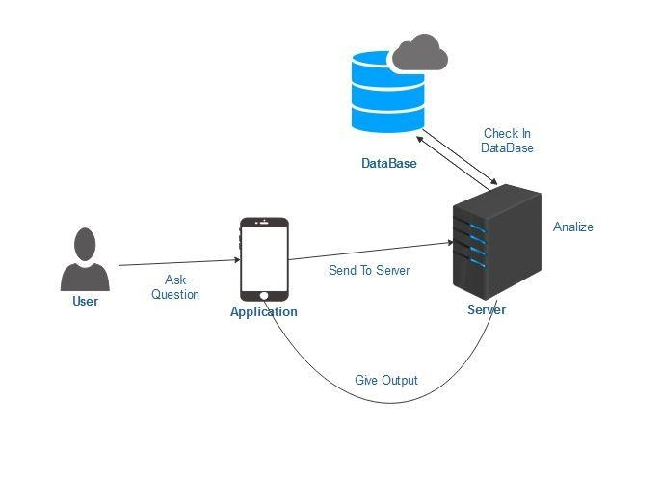

**2. Project Setup**

Choose a Framework or Library: The choice of the framework for building a chatbot in Python for medical equipment management can depend on the specific requirements and familiarity with programming and NLP (Natural Language Processing) tools. However we are using Rasa for building chatbot.

Rasa is a popular open-source framework for building conversational AI applications, including chatbots. Here’s why it can be a good choice for building a chatbot for medical equipment:

1.NLU and Dialogue Management: Rasa provides a powerful NLU (Natural Language Understanding) component for understanding user input and dialogue management for handling conversations. It uses machine learning to extract intents and entities from user messages.

2.Open Source: Rasa is open-source, which means it’s free to use and has a supportive community. We can leverage pre-built components and extensions created by the community to accelerate our chatbot development.

Data Collection and Preprocessing: Gather a dataset of user queries and responses. Clean and preprocess this data to train our chatbot effectively.

Training the Chatbot: Utilize machine learning techniques and NLP models (e.g., GPT-3 or BERT) to train our chatbot on the collected data. Fine-tuning is essential to enhance accuracy.

**3. Chatbot Design**

Design Conversational Flow:

Integration with website or Application:

Frontend Integration:

•For a Website:

•Embed the chatbot interface within your website. This can be done using HTML, CSS, and JavaScript.

•Set up event listeners to capture user interactions and send them to the chatbot API endpoints.

•Display chatbot responses within a chat interface in our website.

For applications:

•Integrate the chatbot into app’s user interface. This might involve creating a chat window or integrating it into an existing user interface.

•Use the app’s programming language (e.g., Python, JavaScript, etc.) to make API calls to the chatbot backend.

•Display chatbot responses within the app’s interface.

Natural Language Understanding:Implement NLP techniques for accurate understanding and interpretation of user queries, including entity recognition, sentiment analysis, and intent detection.

**4. Bot Functionality**

Responses and Personalization: Craft responses that are helpful and engaging. Personalize responses when appropriate, using user data (with their consent) to enhance the customer experience.

Testing and Debugging: Thoroughly test the chatbot to identify and resolve any issues. This includes testing with different user scenarios and edge cases.

Feedback Loop:Implement a feedback mechanism for users to provide feedback on the chatbot's performance. Use this feedback to continually improve the bot's responses.

**5. Security and Privacy**

Handling User Data Securely: Ensure that user data is handled securely, following best practices in data encryption and access control.

Compliance with Privacy Regulations: Ensure that the chatbot complies with privacy regulations such as GDPR, respecting user consent and data rights.

**6. Maintenance and Improvement**

Monitoring and Maintenance:Continuously monitor the chatbot's performance and make necessary updates. Keep the bot's knowledge base up to date.

User Training: Provide training to the chatbot through reinforcement learning to improve its responses over time, if necessary.

Scaling: Be prepared to scale the chatbot infrastructure to handle increased user interactions as the website or application grows.

**7. Documentation and Communication**

User and Developer Documentation:Create comprehensive user and developer documentation to explain how the chatbot works and how users can interact with it effectively.

Analytics and Reporting:Implement analytics to track user interactions and gather insights into user behavior and satisfaction. Use this data for continuous improvement.

**DESIGN THINKING:**

**FUNCTIONALITY**

**SCOPE OF CHATBOT:**

* Chatbots can provide instant assistance to customers, which can help reduce wait times and improve customer satisfaction.
* In the future, chatbots may become even more sophisticated and be able to handle more complex customer service interactions.

**COMMON QUESTIONS:**

* The Chatbots are used to answer the common questions that are pre defined and the way of responding the answers are also well defined previously with a data type. The questions that are defined with-a codeword.

**PROPER GUIDANCE:**

Proper guidance is essential when developing a chatbot for radiological medical equipment using Python. Such chatbots play a crucial role in healthcare, aiding users in selecting, operating, and maintaining medical devices effectively. To create a reliable and user-friendly solution, developers should begin by understanding the specific needs of healthcare professionals and patients. They must employ secure data handling practices to ensure patient privacy and comply with relevant regulations, such as HIPAA. Furthermore, implementing natural language processing (NLP) techniques can enhance the chatbot’s ability to understand and respond to user queries accurately. Regular testing, updates, and collaboration with medical experts are integral to refining the chatbot’s performance and ensuring it remains a valuable tool in the healthcare industry.

**USER INTERFACE**

**DETERMINE WHETHER THE CHATBOT WILL BE INTEGRATED:**

* Chatbot integration entails linking the chatbot to other platforms. Deploying the chatbot with numerous platforms and applications is a lengthy procedure. To engage with visitors, you can connect the chatbot with many platforms like websites, apps, WhatsApp, Viber, Telegram, WordPress, Magenta, Messenger, and others

**DESIGN A USER FRIENDLY INTERFACE:**

* To design a user friendly interface for a chatbot to know audience the way they are more easily to interact
* To analyze the purpose for the chatbot to be created.Depending on this the interface of the chatbot are designed.
* If the chatbot are created for personal or business purpose the chatbot is to be created the interface is where the chatbot has been performed then the Chatbot interface is made up with a personal id and password in thew interface.

**NATURAL LANGUAGE PROCESSING**

* Natural language processing is a field of study in artificial intelligence (AI) and computer science that focuses on the interactions between humans and computers using natural language. It involves the development of algorithms and techniques to enable machines to understand, interpret, and generate human language, allowing computers to interact with humans in a way that is more intuitive and efficient.
* Conversational AI chatbots are computer programs that simulate conversation with human users in natural language.
* These chatbots use conversational AI techniques to understand and respond to user inputs, providing instant support and personalized recommendations. They are being used in a variety of industries, from customer service to healthcare, to provide instant support and reduce operational costs. Conversational AI chatbots are becoming more sophisticated and are expected to play a significant role in the future of communication and customer service.

**RESPONSES**

* The simplest thing to do when writing responses to command and inquiry utterances in a conversational UI is to get straight to the point: respond with facts. That’ll remove a lot of the ambiguity and simplify the dialogue.
* When you want to give the bot more personality and make the conversation feel more natural, include an acknowledgement response before fulfilling the request.
* For each query their will be separate pattern and responses will be given based on the user query the certain pattern will be called and the response will be given as the output for the user

**INTEGRATION**

* The Chatbot will be integrated with a website that we were created at the time for submission.
* The Website that are integrated with the python program to create a Chatbot using Python Program
* Inserting the chatbot on your site couldn't be easier. Beneath the chatbot builder, there's a short-code that can use to insert the chatbot into a page or post on the WordPress site. We simply copy that code and paste it where we want the chatbot to appear on the page/post.
* An integral is a function, of which a given function is the derivative. Integration is basically used to find the areas of the two-dimensional region and computing volumes of three-dimensional objects

**For applications:**

1. API Integration: Develop the chatbot as a standalone application with a RESTful API. This allows other applications to communicate with the chatbot by sending HTTP requests and receiving responses in a structured format (usually JSON).

2. Web Applications: Embed the chatbot into web applications using HTML, JavaScript, and CSS. You can create a chat interface on the website where users can interact with the chatbot seamlessly.

3. Mobile Apps: For mobile applications, we can integrate the chatbot by creating a chat interface within the app. Python-based chatbot logic can be hosted on a server, and the mobile app communicates with it through APIs.

4. Messaging Platforms: Integrate the chatbot with popular messaging platforms like Facebook Messenger, WhatsApp, or Slack. Many of these platforms provide APIs and SDKs for chatbot integration.

5.Voice Assistants: we can extend the chatbot’s functionality to voice assistants like Amazon Alexa or Google Assistant using their respective development kits. This allows users to interact with the chatbot through voice commands

**The Process of Chatbot Integration With the Website:**

* Define the Uses.
* Choose the Chatbot.
* Personalize and Finalize the Actions.
* Configure Sentiment Analysis.
* Develop Fallback Response.
* Add the Frequently Asked Questions.
* Test the Chatbot.
* Now Ready for Use.

**TESTING AND IMPROVEMENT**

* Conversational interfaces it connect with customers at scale and 24/7. However, when they fail to deliver a great customer experience, they also do it at scale. Therefore, testing should be the key aspect of any chatbot development process. It helps evaluate the bot's performance in terms of accuracy, speed, and usefulness. It can also give hints on improving the bot's language and personality or which features to add or remove to streamline the flow.
* Additionally, chatbot testing let’s identify unforeseen issues. Underdeveloped scenarios, frequent fallback messages, or poorly displayed visuals spoil the user experience and negatively affect the chatbot adoption. [73% of consumers](https://venturebeat.com/ai/the-good-the-bad-and-the-ugly-of-chatbots/) declare that if they had a bad user experience with a virtual assistant, they wouldn't use it again. Pre-launch testing can help to polish the chatbot and build user trust in the chatbot customer service.

**What is data wrangling in python?**

Data wrangling in Python is a fundamental and indispensable process in data science and analysis. It involves the art of cleaning, transforming, and structuring raw, often messy data into a format that is suitable for analysis. Python, with its rich ecosystem of libraries like pandas, NumPy, and regular expressions, provides data professionals with a versatile toolkit for these tasks. Data wrangling typically entails dealing with missing values, correcting data types, merging data from different sources, and aggregating information. Whether it's handling CSV files, JSON data, or data from databases, Python's data wrangling capabilities make it possible to shape and refine data for more meaningful and reliable insights, setting the stage for subsequent analysis and visualization. It's an essential step in the data workflow that ensures the data's quality and usability for informed decision-making and deeper understanding**.**

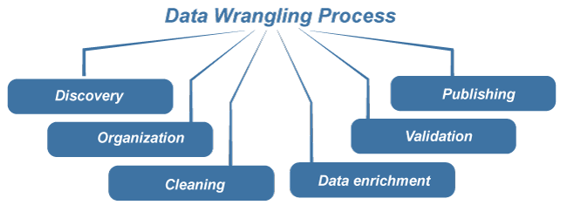

**Process involved in our Innovation:**

In this document we guys will discuss about the process involved in the innovation for our problem statement in detail.

Creating an chatbot using python related on radiological medical equipments

**1. Data Collection:**

Collecting data for a chatbot focused on radiological medical equipment using Python involves several key steps. First, define the scope of the chatbot's knowledge by specifying the topics and areas it should cover, such as X-ray machines, MRI scanners, CT scans, radiation safety, maintenance, and troubleshooting. Next, identify and gather data from reputable sources, including textbooks, research papers, manufacturer documentation, medical websites, and industry forums. Python can be used to automate the data collection process, such as web scraping to extract information from websites or parsing documents to extract relevant data. It's essential to ensure that the collected data is accurate, up-to-date, and well-organized for the chatbot's use. Additionally, we need to preprocess and clean the data to ensure its quality. Once we have a substantial dataset, we can proceed with chatbot development, using natural language processing (NLP) libraries in Python to train our chatbot on the acquired knowledge.

**2.Data Preprocessing:**

This process involves cleaning, organizing, and transforming the collected data to make it suitable for training and use by the chatbot.

Initially, data cleaning involves removing any irrelevant or duplicated information, correcting inaccuracies, and handling missing values. Given the importance of accuracy in medical information, this step is particularly crucial.Python libraries like Pandas can be instrumental in these tasks.

Next, data organization entails structuring the information in a format that the chatbot can understand and utilize effectively. This may involve creating a database or data structures to store the information efficiently. For example, data about different types of medical equipment, their specifications, maintenance procedures, and safety guidelines should be categorized logically.

Data transformation is also a part of preprocessing. It includes text normalization, such as converting text to lowercase, removing punctuation, and stemming or lemmatization to reduce words to their base forms. These techniques help the chatbot understand user queries better and retrieve relevant information.

Additionally, data preprocessing in the context of medical chatbots may involve ensuring compliance with privacy and security regulations, like HIPAA, to protect sensitive patient information. This may require anonymizing or redacting certain data.

Python offers a wide range of libraries and tools for data preprocessing, including Pandas, NLTK, spaCy, and scikit-learn. Once the data is preprocessed, it can be used to train and fine-tune the chatbot's natural language processing models, enabling it to provide accurate and useful information to users in the field of radiological medical equipment.

Basic algorithm:

1. **Import Libraries:** Import the necessary Python libraries, such as NLTK, spaCy, or TextBlob, for text processing.

**Python code:**

import nltk

from nltk.corpus import stopwords

import re

1. **Text Cleaning:** Clean the text to remove noise and irrelevant information. Remove special characters, numbers, and punctuation. Convert text to lowercase to ensure uniformity.

**Python code:**

def clean_text(text):

text = text.lower()

text = re.sub(r'[^a-z\s]', '', text)

return text

1. **Tokenization:** Tokenization is the process of splitting text into individual words or tokens.

**Python code:**

def tokenize_text(text):

tokens = nltk.word_tokenize(text)

return tokens

1. **Stopword Removal:** Remove common stopwords that do not add much meaning to the text.

**Python code:**

def remove_stopwords(tokens):

stop_words = set(stopwords.words('english'))

filtered_tokens = [token for token in tokens if token not in stop_words]

return filtered_tokens

1. **Lemmatization or Stemming:** Reduce words to their base or root form for better text analysis.

**Using NLTK for stemming:**

**Python code:**

from nltk.stem import PorterStemmer

def stem_tokens(tokens):

stemmer = PorterStemmer()

stemmed_tokens = [stemmer.stem(token) for token in tokens]

return stemmed_tokens

**Using spaCy for lemmatization:**

**Python code:**

import spacy

def lemmatize_tokens(tokens):

nlp = spacy.load('en_core_web_sm')

doc = nlp(' '.join(tokens))

lemmatized_tokens = [token.lemma_ for token in doc]

return lemmatized_tokens

1. **Text Normalization:** Normalize text by handling synonyms, abbreviations, or slang words to improve user understanding.
2. **Concatenate Tokens:** Join the processed tokens back into a single string for further analysis.

**Python code:**

def tokens_to_text(tokens):

return ' '.join(tokens)

1. **Data Cleaning and Preprocessing for the Chatbot Input and Responses:** Apply the same preprocessing steps to both user input and the chatbot's responses.
2. **Save Preprocessed Data:** Save the preprocessed data to be used for training and inference by your chatbot.

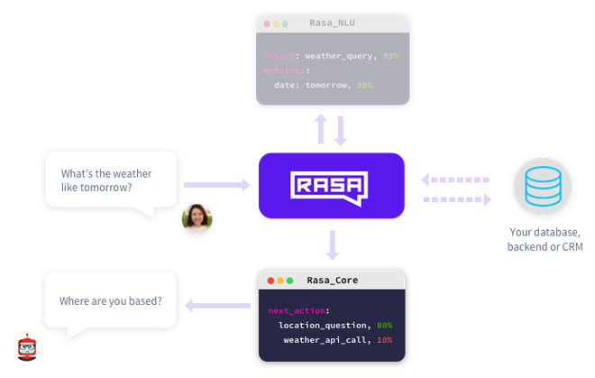

**3.FeatureEngineering:**

It involves crafting and refining data features to enable the chatbot to better understand user queries and provide more accurate and context-aware responses within the field of radiology. In this context, feature engineering may encompass tasks such as converting text-based radiological data, including manuals and research papers, into structured numerical representations using Python libraries like NLTK or spaCy. Named Entity Recognition (NER) can be employed to identify and extract essential entities, such as equipment names, model numbers, or medical terminology, from the text. Additionally, domain-specific features like equipment specifications, maintenance protocols, and safety guidelines can be created to provide the chatbot with a comprehensive knowledge base. By carefully engineering these features, the chatbot can offer more relevant and informative assistance to users seeking information on radiological medical equipment.

**4. Splitting the Data:**

It involves dividing the available dataset into distinct subsets for training, validation, and testing. Typically, the data is split into a training set, which the chatbot uses to learn from, a validation set, used for fine-tuning and hyperparameter tuning, and a testing set, used to assess the model's performance. Python's Scikit-learn library provides useful tools for data splitting, ensuring that the chatbot's training process is robust and that its responses generalize well to unseen user queries. This division also helps in evaluating the chatbot's performance and making necessary adjustments to improve its accuracy and reliability in providing information about radiological medical equipment.

**5. Choosing a Model:**

The choice of model greatly influences the chatbot's ability to understand user queries and provide accurate responses. In the field of natural language processing (NLP), a variety of models can be considered, ranging from traditional machine learning algorithms like decision trees and random forests to deep learning models like recurrent neural networks (RNNs) or transformer-based architectures such as BERT or GPT-3. The selection depends on factors like the complexity of the task, the size of the dataset, and the available computational resources. It's essential to strike a balance between model performance and efficiency, ensuring that the chatbot can deliver timely and accurate information about radiological medical equipment while maintaining responsiveness in real-time interactions. Regular evaluation and fine-tuning of the chosen model are also critical to continually enhance the chatbot's capabilities. Python provides a rich ecosystem of libraries, including TensorFlow and PyTorch, making it convenient to implement and experiment with various NLP models.

**6. Model Training:**

During this stage, the selected machine learning or deep learning model is exposed to the preprocessed data, enabling it to learn and understand the patterns and relationships within the dataset. The Python libraries like TensorFlow, PyTorch, or Scikit-learn are instrumental in training these models. The training process involves optimizing the model's internal parameters through iterative iterations, minimizing the prediction errors, and enhancing its ability to respond to user queries accurately. Additionally, techniques such as transfer learning, which leverages pre-trained language models, can significantly expedite and improve the training process. Continuous evaluation against a validation dataset is essential to monitor the model's performance, and fine-tuning may be necessary to ensure that the chatbot delivers reliable and up-to-date information about radiological medical equipment. Effective model training is a fundamental step in the chatbot development process, contributing to its proficiency in providing valuable insights and assistance to users in the radiological field.

**7.Model Evaluation:**

This process involves assessing the performance and effectiveness of the trained model to ensure that it meets the desired objectives and delivers accurate responses to user queries. Python offers a variety of evaluation metrics and techniques tailored to natural language processing (NLP) tasks, including precision, recall, F1-score, and accuracy. However, in the context of a chatbot, additional criteria such as user satisfaction and chatbot responsiveness are equally important. Real-world testing with a diverse set of user queries and scenarios is essential to identify any shortcomings or areas for improvement. Model evaluation not only validates the chatbot's capabilities but also guides further refinements, fine-tuning, and updates to enhance its knowledge and performance in providing information on radiological medical equipment, ensuring a valuable user experience.

**8.Testing:**

It involves subjecting the chatbot to various scenarios and user interactions to evaluate its performance and ensure that it functions as intended. Python provides tools and libraries for conducting comprehensive testing, including unit testing, integration testing, and user acceptance testing. During testing, the chatbot's responses to different types of user queries, including common inquiries and edge cases, are scrutinized for accuracy and appropriateness. Any bugs, errors, or unexpected behaviors are identified and addressed, and the chatbot is refined accordingly. Rigorous testing helps validate the chatbot's knowledge base, ensures it adheres to safety and ethical guidelines, and confirms its readiness to provide reliable information on radiological medical equipment in real-world scenarios.

**9.Deployment:**

It involves making the chatbot accessible to users, typically through a website, mobile app, or other communication channels. Python offers various frameworks and tools for deploying chatbots, including Flask, Django, or cloud-based platforms like AWS Lambda or Google Cloud Functions. During deployment, it's crucial to ensure the chatbot's scalability, security, and reliability to handle real-world user interactions. Integration with databases, APIs, and external systems may also be necessary to keep the chatbot's knowledge base up-to-date. Continuous monitoring and maintenance are vital to address any emerging issues or user feedback, as well as to refine and expand the chatbot's capabilities over time. Successful deployment ensures that the chatbot can effectively assist users in the radiological field, providing valuable information and guidance on medical equipment-related queries.

**10.Monitoring and Maintenance:**

Monitoring and maintenance are ongoing processes that play a critical role in the success of a chatbot specializing in radiological medical equipment, developed using Python. After deployment, continuous monitoring ensures that the chatbot performs optimally and remains up-to-date. Python libraries and tools like logging and analytics platforms can be employed to track user interactions, identify common queries, and detect any issues or errors. User feedback is invaluable in this phase, helping to pinpoint areas for improvement and expansion of the chatbot's knowledge base. Regular maintenance includes updating the chatbot with the latest information on medical equipment, addressing bugs or glitches, and fine-tuning its responses based on real-world usage. Moreover, as the field of radiology evolves, the chatbot's responses and knowledge need to stay current and aligned with emerging technologies and practices. By actively monitoring and maintaining the chatbot, its effectiveness and reliability in providing information about radiological medical equipment are assured, ensuring a valuable and continuously improving user experience.

**11. Feedback Loop:**

It establishes a continuous channel for user feedback, enabling the chatbot to improve and evolve over time. Python can be used to implement mechanisms for collecting and analyzing user input, such as sentiment analysis or keyword extraction, to gauge user satisfaction and identify areas where the chatbot may fall short. By incorporating user feedback, the chatbot can learn from its interactions and adapt to user needs, whether it's by refining its responses, expanding its knowledge base, or addressing specific pain points. This iterative process ensures that the chatbot remains responsive, accurate, and valuable to users seeking information on radiological medical equipment, ultimately enhancing the user experience and the bot's overall effectiveness in serving its purpose

**12.Scalability:**

As the chatbot's user base grows, it needs to efficiently handle increased traffic and user interactions without compromising performance. Python provides several options for achieving scalability, such as deploying the chatbot on cloud-based platforms like AWS or Google Cloud, utilizing containerization technologies like Docker, or implementing load balancing strategies. Additionally, Python frameworks like Flask or Django can be used to design the chatbot in a modular and scalable manner, making it easier to add new features or accommodate higher user volumes. Ensuring that the chatbot can seamlessly scale up to meet increased demand is essential for providing uninterrupted and reliable assistance to users in the radiological field, even as its user base expands over time.

**13. Regulatory Compliance:**

The healthcare and radiology sectors are heavily regulated, with stringent standards and laws in place to safeguard patient information and ensure the accuracy and safety of medical advice. Python developers working on such chatbots must adhere to regulations such as HIPAA (Health Insurance Portability and Accountability Act) to protect patient data confidentiality. Ensuring the chatbot provides reliable and medically sound information is crucial to meet quality and safety standards. It's essential to continuously monitor and update the chatbot to reflect the latest medical guidelines and equipment standards to stay compliant with regulatory changes. Regulatory compliance not only helps maintain trust among users but also mitigates legal and ethical risks associated with healthcare-related chatbots.

**14. User Interface:**

The user interface (UI) of a chatbot focused on radiological medical equipment, developed using Python, is a critical element in ensuring a user-friendly and effective interaction. Python offers various libraries and frameworks for designing intuitive and visually appealing interfaces, whether it's a web-based interface, a mobile app, or a standalone application. In the context of radiological medical equipment, the UI should be designed to facilitate easy navigation, enabling users to ask questions, access information, and receive responses in a clear and concise manner. Additionally, it should offer features like voice recognition, search functionalities, and multimedia integration for enhanced user engagement. The UI should also be responsive and adaptable to different devices, making it accessible to a wide range of users, from healthcare professionals to patients seeking information on radiological equipment. A well-designed UI not only enhances the chatbot's usability but also contributes to a positive user experience, ensuring that users can readily access valuable insights and assistance in the field of radiology.

Top of Form

Our innovation on this project is to creating an chatbot using python related with radiological medical equipment, to improve the usage of artificial intelligence in medical purposes and also to have a better communication with these bots and we may need to revisit and refine these steps as we gather more data and gain insights into specific application domain.

**Dataset:**

In this document we guys are here to discuss the loading and preprocessing of the dataset to make an effective chatbot.

**Source of Data:**

We made our own dataset for this chatbot . Thus we can customise the chatbot by customising the dataset.

**Data Processing:**

In this process we have made a pdf of words and then we turn them into a token so that it can be converted into vectors . thus it is the key point involved in this process .

**Python Program for data initialization and processing:**

!nvidia-smi

!pip install -Uqqq pip --progress-bar off

!pip install torch==2.0.1 --progress-bar off

!pip install transformers==4.31.0 --progress-bar off

!pip install langchain==0.0.266 --progress-bar off

!pip install chromadb==0.4.5 --progress-bar off

!pip install pypdf==3.15.0 --progress-bar off

!pip install xformers==0.0.20 --progress-bar off

!pip install sentence_transformers==2.2.2 --progress-bar off

!pip install InstructorEmbedding==1.0.1 --progress-bar off

!pip install pdf2image==1.16.3 --progress-bar off

!wget -q https://github.com/PanQiWei/AutoGPTQ/releases/download/v0.4.1/auto_gptq-0.4.1+cu118-cp310-cp310-linux_x86_64.whl

!pip install -qqq auto_gptq-0.4.1+cu118-cp310-cp310-linux_x86_64.whl --progress-bar off

!sudo apt-get install poppler-utils

!mkdir pdfs

from pdf2image import convert_from_path

from transformers import AutoTokenizer, TextStreamer, pipeline

!gdown 1v-Rn1FVU1pLTAQEgm0N9oB6cExMoebZr -O pdfs/tesla-earnings-report.pdf

!gdown 1Xc890jrQvCExAkryVWAttsv1DBLdVefN -O pdfs/nvidia-earnings-report.pdf

!gdown 1Epz-SQ3idPpoz75GlTzzomag8gplzLv8 -O pdfs/meta-earnings-report.pdf

meta_images = convert_from_path("/content/pdfs/dataf7b.pdf", dpi=88)

meta_images[0]

!rm -rf "db"

loader = PyPDFDirectoryLoader("pdfs")

docs = loader.load()

len(docs)

embeddings = HuggingFaceInstructEmbeddings(

model_name="hkunlp/instructor-large", model_kwargs={"device": DEVICE}

)

text_splitter = RecursiveCharacterTextSplitter(chunk_size=1024, chunk_overlap=64)

texts = text_splitter.split_documents(docs)

len(texts)

%%time

db = Chroma.from_documents(texts, embeddings, persist_directory="db")

**Development Part2**

In this part you will continue building your project. Continue building the chatbot by integrating it into a web app using Flask.

**Step 1:**

**Create a Flask Project**

1. Create a new directory for your Flask project.

2. Inside this directory, create a virtual environment:

**Python code:**

python -m venv venv

source venv/bin/activate # On Windows, use 'venv\Scripts\activate'

3. Install Flask:

**Python code:**

pip install Flask

**Step 2:**

**Create a Basic Flask Web App**

1. Create a file named app.py in your project directory.

2. In app.py, import Flask and create a basic Flask app:

**Python code:**

from flask import Flask, render_template, request

app = Flask(__name)

@app.route('/')

def home():

return render_template('index.html')

if __name__ == '__main__':

app.run(debug=True)

**Step 3:**

**Create HTML Templates**

1. Create a folder named templates in your project directory.

2. Inside the templates folder, create an HTML file named index.html:

**HTML code:**

<!DOCTYPE html>

<html>

<head>

<title>Chatbot</title>

</head>

<body>

<h1>Chatbot</h1>

<div id="chat-box"></div>

<input type="text" id="user-input" placeholder="Type your message">

<button id="send-button">Send</button>

<script src="static/chatbot.js"></script>

</body>

</html>

**Step 4:**

**Create JavaScript for Chatbot**

1. Create a folder named static in your project directory.

2. Inside the static folder, create a JavaScript file named chatbot.js. This file will handle user input and responses from the chatbot.

**JavaScript code**

// chatbot.js

const chatBox = document.getElementById('chat-box');

const userInput = document.getElementById('user-input');

const sendButton = document.getElementById('send-button');

sendButton.addEventListener('click', () => {

const userMessage = userInput.value;

chatBox.innerHTML += `<p>User: ${userMessage}</p>`;

// Send user message to the server for processing

fetch('/chat', {

method: 'POST',

body: JSON.stringify({ userMessage }),

headers: {

'Content-Type': 'application/json',

},

})

.then(response => response.json())

.then(data => {

const chatbotMessage = data.chatbotMessage;

chatBox.innerHTML += `<p>Chatbot: ${chatbotMessage}</p>`;

});

userInput.value = '';

});

**Step 5:**

**Implement Chatbot Logic in Flask**

1. In app.py, add a new route to handle user messages and return chatbot responses.

**Python code:**

import json

# Import your chatbot implementation here

@app.route('/chat', methods=['POST'])

def chat():

data = json.loads(request.data)

user_message = data['userMessage']

# Implement your chatbot logic here

chatbot_response = get_chatbot_response(user_message)

return json.dumps({'chatbotMessage': chatbot_response})

2. Implement the get_chatbot_response function using your existing chatbot logic. This function should take a user message as input and return the chatbot's response.

**Step 6:**

**Run Your Flask App**

1.Run your Flask app using the following command:

**Python Code:**

**python app.py**

2**.** Access your chatbot web app by opening a web browser and navigating to http://localhost:5000.

Our chatbot is now integrated into a Flask web app. Users can interact with it through the web interface. Make sure you adapt the chatbot logic and responses to suit your specific use case and chatbot implementation. You can also enhance the web interface to make it more interactive and visually appealing

**Architectural Diagram in Chatbot:**

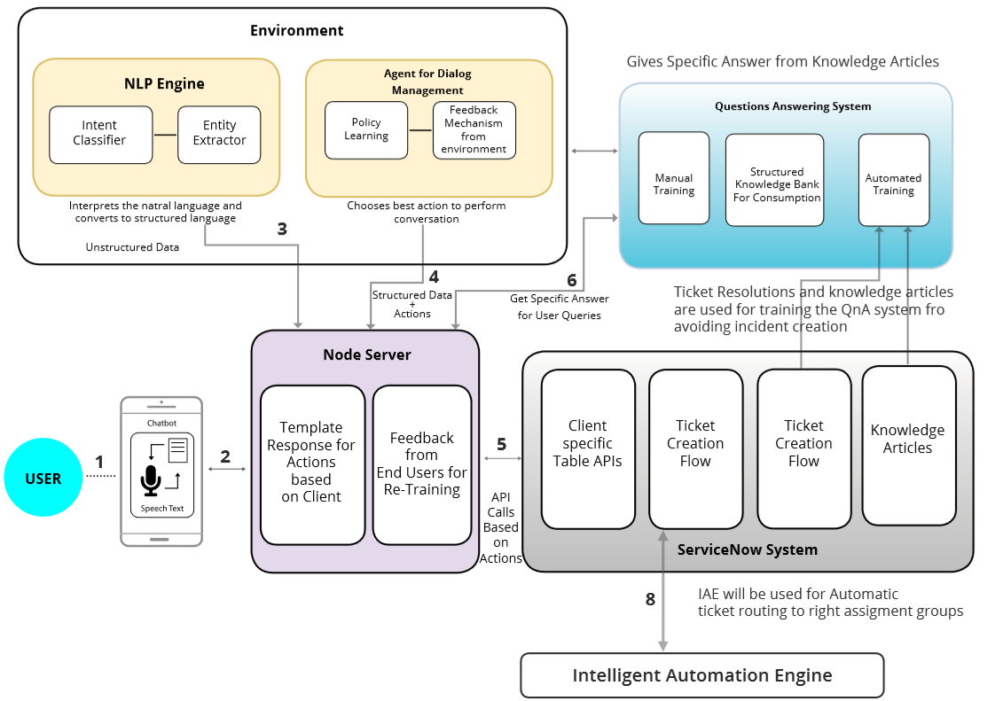

**Fig 1.1 Architectural design in chatbot**