**Exercise 1: Control Structures**

Scenario 1: The bank wants to apply a discount to loan interest rates for customers above 60 years old.

o Question: Write a PL/SQL block that loops through all customers, checks their age, and if they are above 60, apply a 1% discount to their current loan interest rates.

Scenario 2: A customer can be promoted to VIP status based on their balance.

o Question: Write a PL/SQL block that iterates through all customers and sets a flag IsVIP to TRUE for those with a balance over $10,000.

Scenario 3: The bank wants to send reminders to customers whose loans are due within the next 30 days.

o Question: Write a PL/SQL block that fetches all loans due in the next 30 days and prints a reminder message for each customer.

Lets take table which can help us with 3 scenarios:

CREATE TABLE BANK_CUSTOMERS (

CUST_ID NUMBER,

NAME VARCHAR2(100),

AGE NUMBER,

BALANCE NUMBER,

ISVIP VARCHAR2(5),

LOAN_INTEREST NUMBER,

LOAN_DUE_DATE DATE

);

INSERT INTO BANK_CUSTOMERS VALUES (1, 'John', 65, 15000, 'FALSE', 10, SYSDATE + 10);

INSERT INTO BANK_CUSTOMERS VALUES (2, 'Alice', 45, 8000, 'FALSE', 12, SYSDATE + 40);

INSERT INTO BANK_CUSTOMERS VALUES (3, 'Ravi', 70, 20000, 'FALSE', 9, SYSDATE + 5);

INSERT INTO BANK_CUSTOMERS VALUES (4, 'Priya', 30, 12000, 'FALSE', 11, SYSDATE + 20);

COMMIT;

**SCENARIO 1:**

BEGIN

FOR cust_rec IN (SELECT * FROM BANK_CUSTOMERS) LOOP

IF cust_rec.AGE > 60 THEN

UPDATE BANK_CUSTOMERS

SET LOAN_INTEREST = LOAN_INTEREST - 1

WHERE CUST_ID = cust_rec.CUST_ID;

DBMS_OUTPUT.PUT_LINE('Discount given to ' || cust_rec.NAME);

END IF;

END LOOP;

COMMIT;

END;

**Output:**

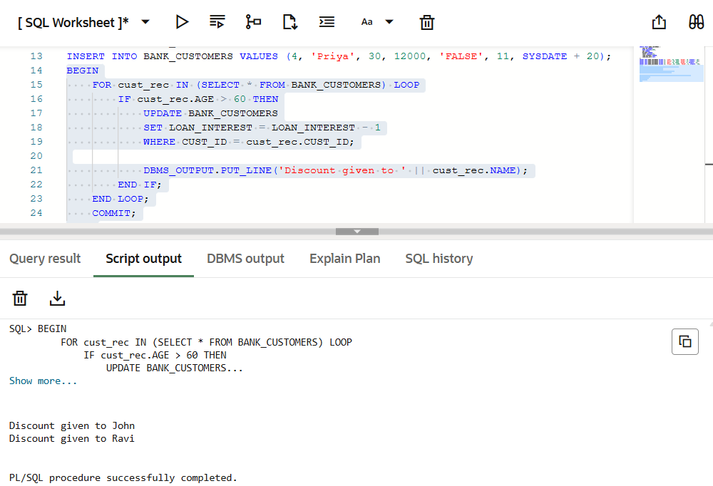

**SCENARIO 2:**

BEGIN

FOR cust_rec IN (SELECT * FROM BANK_CUSTOMERS) LOOP

IF cust_rec.BALANCE > 10000 THEN

UPDATE BANK_CUSTOMERS

SET ISVIP = 'TRUE'

WHERE CUST_ID = cust_rec.CUST_ID;

DBMS_OUTPUT.PUT_LINE(cust_rec.NAME || ' is marked as VIP.');

END IF;

END LOOP;

COMMIT;

END;

**Output:**

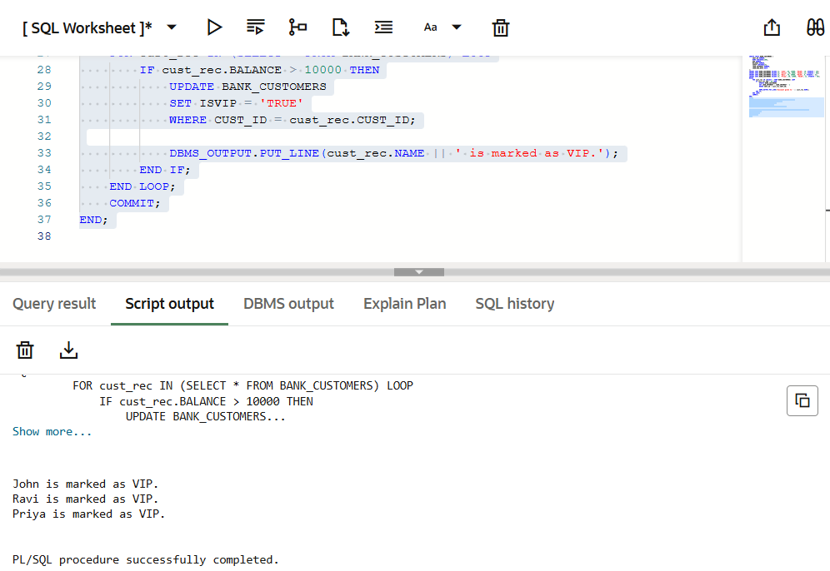

**SCENARIO 3:**

BEGIN

FOR cust_rec IN (

SELECT * FROM BANK_CUSTOMERS

WHERE LOAN_DUE_DATE <= SYSDATE + 30

) LOOP

DBMS_OUTPUT.PUT_LINE('Reminder: Loan for ' || cust_rec.NAME ||

' is due on ' || TO_CHAR(cust_rec.LOAN_DUE_DATE, 'DD-MON-YYYY'));

END LOOP;

END;

**Output:**

