**Create a Spring Web Project using Maven**   
  
Follow steps below to create a project: 

1. Go to <https://start.spring.io/>
2. Change Group as “com.cognizant”
3. Change Artifact Id as “spring-learn”
4. Select Spring Boot DevTools and Spring Web
5. Create and download the project as zip
6. Extract the zip in root folder to Eclipse Workspace
7. Build the project using ‘mvn clean package -Dhttp.proxyHost=proxy.cognizant.com -Dhttp.proxyPort=6050 -Dhttps.proxyHost=proxy.cognizant.com -Dhttps.proxyPort=6050 -Dhttp.proxyUser=123456’ command in command line
8. Import the project in Eclipse "File > Import > Maven > Existing Maven Projects > Click Browse and select extracted folder > Finish"
9. Include logs to verify if main() method of SpringLearnApplication.
10. Run the SpringLearnApplication class.

SME to walk through the following aspects related to the project created:

1. src/main/java - Folder with application code
2. src/main/resources - Folder for application configuration
3. src/test/java - Folder with code for testing the application
4. SpringLearnApplication.java - Walkthrough the main() method.
5. Purpose of @SpringBootApplication annotation
6. pom.xml
   1. Walkthrough all the configuration defined in XML file
   2. Open 'Dependency Hierarchy' and show the dependency tree.

**Solution:**

**Project setup:**

Visited <https://start.spring.io/> and filled the form

Downloaded the zip file and extracted it   
imported the file in eclipse

**Add a log in main() method:**

Now go to SpringLearnApplication.java file and update the code  
  
package com.cognizant.spring_learn;

import org.springframework.boot.SpringApplication;

import org.springframework.boot.autoconfigure.SpringBootApplication;

@SpringBootApplication

public class SpringLearnApplication {

public static void main(String[] args) {

SpringApplication.run(SpringLearnApplication.class, args);

System.out.println("SpringLearnApplication main() method running...");

}

}  
  
**then run the code:**

**Output:**

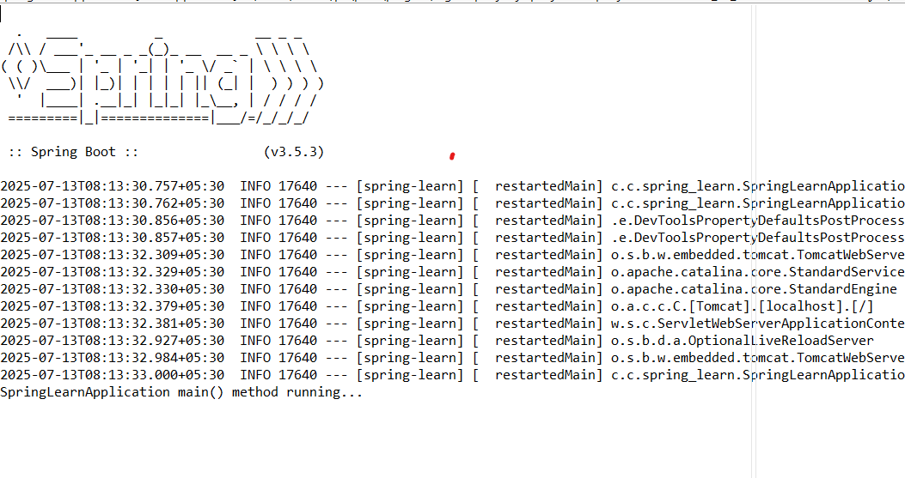

**Walkthrough:**

**1. src/main/java**

* Contains the main application code.
* Our package is com.cognizant.spring_learn.
* Inside this, we have the SpringLearnApplication.java file.
* Later, we can add controllers and services here.

**2. src/main/resources**

* Contains configuration files.
* Important file: application.properties (used for setting port, DB config, etc.)
* Spring Boot auto-loads this file during startup.

**3. src/test/java**

* This folder is used for writing test code using JUnit.
* For this assignment, it’s not used, but useful for future testing.

**4. SpringLearnApplication.java**

* This is the main class for the Spring Boot application.
* It contains the main() method.
* The line SpringApplication.run(...) starts the application.
* We added a System.out.println(...) to verify it's running.

**5. @SpringBootApplication Annotation**

This annotation combines 3 things:

* @Configuration – This class contains configuration info
* @EnableAutoConfiguration – Automatically configures Spring based on dependencies
* @ComponentScan – Scans the package for components like controllers, services

This is required to run any Spring Boot application.

Pom.xml:

<?xml version="1.0" encoding="UTF-8"?>

<project xmlns="http://maven.apache.org/POM/4.0.0" xmlns:xsi="http://www.w3.org/2001/XMLSchema-instance"

xsi:schemaLocation="http://maven.apache.org/POM/4.0.0 https://maven.apache.org/xsd/maven-4.0.0.xsd">

<modelVersion>4.0.0</modelVersion>

<parent>

<groupId>org.springframework.boot</groupId>

<artifactId>spring-boot-starter-parent</artifactId>

<version>3.5.3</version>

<relativePath/> <!-- lookup parent from repository -->

</parent>

<groupId>com.cognizant</groupId>

<artifactId>spring-learn</artifactId>

<version>0.0.1-SNAPSHOT</version>

<name>spring-learn</name>

<description>Demo project for Spring Boot</description>

<url/>

<licenses>

<license/>

</licenses>

<developers>

<developer/>

</developers>

<scm>

<connection/>

<developerConnection/>

<tag/>

<url/>

</scm>

<properties>

<java.version>17</java.version>

</properties>

<dependencies>

<dependency>

<groupId>org.springframework.boot</groupId>

<artifactId>spring-boot-starter-web</artifactId>

</dependency>

<dependency>

<groupId>org.springframework.boot</groupId>

<artifactId>spring-boot-devtools</artifactId>

<scope>runtime</scope>

<optional>true</optional>

</dependency>

<dependency>

<groupId>org.springframework.boot</groupId>

<artifactId>spring-boot-starter-test</artifactId>

<scope>test</scope>

</dependency>

</dependencies>

<build>

<plugins>

<plugin>

<groupId>org.springframework.boot</groupId>

<artifactId>spring-boot-maven-plugin</artifactId>

</plugin>

</plugins>

</build>

</project>

**Dependency Hierarchy:**

[INFO] com.cognizant:spring-learn:jar:0.0.1-SNAPSHOT

[INFO] +- org.springframework.boot:spring-boot-starter-web:jar:3.5.3:compile

[INFO] | +- org.springframework.boot:spring-boot-starter:jar:3.5.3:compile

[INFO] | | +- org.springframework.boot:spring-boot-starter-logging:jar:3.5.3:compile

[INFO] | | | +- ch.qos.logback:logback-classic:jar:1.5.18:compile

[INFO] | | | | \- ch.qos.logback:logback-core:jar:1.5.18:compile

[INFO] | | | +- org.apache.logging.log4j:log4j-to-slf4j:jar:2.24.3:compile

[INFO] | | | | \- org.apache.logging.log4j:log4j-api:jar:2.24.3:compile

[INFO] | | | \- org.slf4j:jul-to-slf4j:jar:2.0.17:compile

[INFO] | | +- jakarta.annotation:jakarta.annotation-api:jar:2.1.1:compile

[INFO] | | \- org.yaml:snakeyaml:jar:2.4:compile

[INFO] | +- org.springframework.boot:spring-boot-starter-json:jar:3.5.3:compile

[INFO] | | +- com.fasterxml.jackson.core:jackson-databind:jar:2.19.1:compile

[INFO] | | | +- com.fasterxml.jackson.core:jackson-annotations:jar:2.19.1:compile

[INFO] | | | \- com.fasterxml.jackson.core:jackson-core:jar:2.19.1:compile

[INFO] | | +- com.fasterxml.jackson.datatype:jackson-datatype-jdk8:jar:2.19.1:compile

[INFO] | | +- com.fasterxml.jackson.datatype:jackson-datatype-jsr310:jar:2.19.1:compile

[INFO] | | \- com.fasterxml.jackson.module:jackson-module-parameter-names:jar:2.19.1:compile

[INFO] | +- org.springframework.boot:spring-boot-starter-tomcat:jar:3.5.3:compile

[INFO] | | +- org.apache.tomcat.embed:tomcat-embed-core:jar:10.1.42:compile

[INFO] | | +- org.apache.tomcat.embed:tomcat-embed-el:jar:10.1.42:compile

[INFO] | | \- org.apache.tomcat.embed:tomcat-embed-websocket:jar:10.1.42:compile

[INFO] | +- org.springframework:spring-web:jar:6.2.8:compile

[INFO] | | +- org.springframework:spring-beans:jar:6.2.8:compile

[INFO] | | \- io.micrometer:micrometer-observation:jar:1.15.1:compile

[INFO] | | \- io.micrometer:micrometer-commons:jar:1.15.1:compile

[INFO] | \- org.springframework:spring-webmvc:jar:6.2.8:compile

[INFO] | +- org.springframework:spring-aop:jar:6.2.8:compile

[INFO] | +- org.springframework:spring-context:jar:6.2.8:compile

[INFO] | \- org.springframework:spring-expression:jar:6.2.8:compile

[INFO] +- org.springframework.boot:spring-boot-devtools:jar:3.5.3:runtime (optional)

[INFO] | +- org.springframework.boot:spring-boot:jar:3.5.3:compile

[INFO] | \- org.springframework.boot:spring-boot-autoconfigure:jar:3.5.3:compile

[INFO] \- org.springframework.boot:spring-boot-starter-test:jar:3.5.3:test

[INFO] +- org.springframework.boot:spring-boot-test:jar:3.5.3:test

[INFO] +- org.springframework.boot:spring-boot-test-autoconfigure:jar:3.5.3:test

[INFO] +- com.jayway.jsonpath:json-path:jar:2.9.0:test

[INFO] | \- org.slf4j:slf4j-api:jar:2.0.17:compile

[INFO] +- jakarta.xml.bind:jakarta.xml.bind-api:jar:4.0.2:test

[INFO] | \- jakarta.activation:jakarta.activation-api:jar:2.1.3:test

[INFO] +- net.minidev:json-smart:jar:2.5.2:test

[INFO] | \- net.minidev:accessors-smart:jar:2.5.2:test

[INFO] | \- org.ow2.asm:asm:jar:9.7.1:test

[INFO] +- org.assertj:assertj-core:jar:3.27.3:test

[INFO] | \- net.bytebuddy:byte-buddy:jar:1.17.6:test

[INFO] +- org.awaitility:awaitility:jar:4.2.2:test

[INFO] +- org.hamcrest:hamcrest:jar:3.0:test

[INFO] +- org.junit.jupiter:junit-jupiter:jar:5.12.2:test

[INFO] | +- org.junit.jupiter:junit-jupiter-api:jar:5.12.2:test

[INFO] | | +- org.opentest4j:opentest4j:jar:1.3.0:test

[INFO] | | +- org.junit.platform:junit-platform-commons:jar:1.12.2:test

[INFO] | | \- org.apiguardian:apiguardian-api:jar:1.1.2:test

[INFO] | +- org.junit.jupiter:junit-jupiter-params:jar:5.12.2:test

[INFO] | \- org.junit.jupiter:junit-jupiter-engine:jar:5.12.2:test

[INFO] | \- org.junit.platform:junit-platform-engine:jar:1.12.2:test

[INFO] +- org.mockito:mockito-core:jar:5.17.0:test

[INFO] | +- net.bytebuddy:byte-buddy-agent:jar:1.17.6:test

[INFO] | \- org.objenesis:objenesis:jar:3.3:test

[INFO] +- org.mockito:mockito-junit-jupiter:jar:5.17.0:test

[INFO] +- org.skyscreamer:jsonassert:jar:1.5.3:test

[INFO] | \- com.vaadin.external.google:android-json:jar:0.0.20131108.vaadin1:test

[INFO] +- org.springframework:spring-core:jar:6.2.8:compile

[INFO] | \- org.springframework:spring-jcl:jar:6.2.8:compile

[INFO] +- org.springframework:spring-test:jar:6.2.8:test

[INFO] \- org.xmlunit:xmlunit-core:jar:2.10.2:test