**Spring Core – Load Country from Spring Configuration XML**   
  
An airlines website is going to support booking on four countries. There will be a drop down on the home page of this website to select the respective country. It is also important to store the two-character ISO code of each country. 

|  |  |
| --- | --- |
| **Code** | **Name** |
| US | United States |
| DE | Germany |
| IN | India |
| JP | Japan |

Above data has to be stored in spring configuration file. Write a program to read this configuration file and display the details.  
  
Steps to implement

* Pick any one of your choice country to configure in Spring XML configuration named country.xml.
* Create a bean tag in spring configuration for country and set the property and values

    <bean id="country" class="com.cognizant.springlearn.Country">

        <property name="code" value="IN" />

        <property name="name" value="India" />

    </bean>

* Create Country class with following aspects:
  + Instance variables for code and name
  + Implement empty parameter constructor with inclusion of debug log within the constructor with log message as “Inside Country Constructor.”
  + Generate getters and setters with inclusion of debug with relevant message within each setter and getter method.
  + Generate toString() method
* Create a method displayCountry() in SpringLearnApplication.java, which will read the country bean from spring configuration file and display the country details. ClassPathXmlApplicationContext, ApplicationContext and context.getBean(“beanId”, Country.class). Refer sample code for displayCountry() method below.

ApplicationContext context = new ClassPathXmlApplicationContext("country.xml");

Country country = (Country) context.getBean("country", Country.class);

LOGGER.debug("Country : {}", country.toString());

* Invoke displayCountry() method in main() method of SpringLearnApplication.java.
* Execute main() method and check the logs to find out which constructors and methods were invoked.

SME to provide more detailing about the following aspects:

* bean tag, id attribute, class attribute, property tag, name attribute, value attribute
* ApplicationContext, ClassPathXmlApplicationContext
* What exactly happens when context.getBean() is invoked

**Solution:**

I picked India (IN) as the country for this exercise. The details are defined in country.xml and loaded using ApplicationContext.

**Country.xml:**

<?xml version="1.0" encoding="UTF-8"?>

<beans xmlns="http://www.springframework.org/schema/beans"

xmlns:xsi="http://www.w3.org/2001/XMLSchema-instance"

xsi:schemaLocation="http://www.springframework.org/schema/beans

https://www.springframework.org/schema/beans/spring-beans.xsd">

<bean id="country" class="com.cognizant.spring_learn.Country">

<property name="code" value="IN" />

<property name="name" value="India" />

</bean>

</beans>

**Country.java:**

package com.cognizant.spring_learn;

import org.slf4j.Logger;

import org.slf4j.LoggerFactory;

public class Country {

private static final Logger LOGGER = LoggerFactory.getLogger(Country.class);

private String code;

private String name;

public Country() {

LOGGER.debug("Inside Country Constructor.");

}

public String getCode() {

LOGGER.debug("Inside getCode()");

return code;

}

public void setCode(String code) {

LOGGER.debug("Inside setCode()");

this.code = code;

}

public String getName() {

LOGGER.debug("Inside getName()");

return name;

}

public void setName(String name) {

LOGGER.debug("Inside setName()");

this.name = name;

}

@Override

public String toString() {

return "Country [code=" + code + ", name=" + name + "]";

}

}  
  
**SpringLearnApplication.java: Adding log**

package com.cognizant.spring_learn;

import org.slf4j.Logger;

import org.slf4j.LoggerFactory;

import org.springframework.context.ApplicationContext;

import org.springframework.context.support.ClassPathXmlApplicationContext;

public class SpringLearnApplication {

private static final Logger LOGGER = LoggerFactory.getLogger(SpringLearnApplication.class);

public static void main(String[] args) {

LOGGER.debug("SpringLearnApplication main() method running...");

displayCountry();

}

public static void displayCountry() {

ApplicationContext context = new ClassPathXmlApplicationContext("country.xml");

Country country = context.getBean("country", Country.class);

LOGGER.debug("Country : {}", country.toString());

}

}

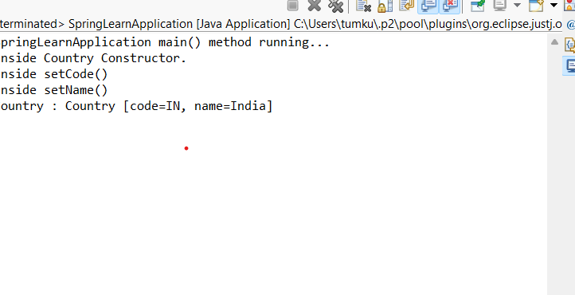**Output:**

**Walkthrough:**

**bean tag**

Defines the bean object in the XML file.

**2. id attribute**

The name used to refer to the bean (country in this case).

**3. class attribute**

The fully qualified Java class name (com.cognizant.spring_learn.Country).

**4. property tag**

Used to set values to fields inside the bean using setter methods.

**5. name attribute (in property tag)**

Matches the field name or setter method (setCode, setName).

**6. value attribute**

Provides the actual value (like IN, India).

**7. ApplicationContext**

Spring container used to load and manage beans.

**8. ClassPathXmlApplicationContext**

Loads the XML configuration file from the classpath (resources folder).

**9. context.getBean()**

Returns the bean object. It calls the constructor, setters, and logs are printed.