**REST - Country Web Service**   
  
Write a REST service that returns India country details in the earlier created spring learn application.  
  
**URL**: /country  
**Controller**: com.cognizant.spring-learn.controller.CountryController  
**Method Annotation**: @RequestMapping  
**Method Name**: getCountryIndia()  
**Method Implementation**: Load India bean from spring xml configuration and return  
**Sample Request**: http://localhost:8083/country  
**Sample Response**:

{

  "code": "IN",

  "name": "India"

}

SME to explain the following aspects:

* What happens in the controller method?
* How the bean is converted into JSON reponse?
* In network tab of developer tools show the HTTP header details received
* In postman click on "Headers" tab to view the HTTP header details received

**Solution:**

**Create a country controller:**

package com.cognizant.spring_learn.controller;

import org.slf4j.Logger;

import org.slf4j.LoggerFactory;

import org.springframework.context.ApplicationContext;

import org.springframework.context.support.ClassPathXmlApplicationContext;

import org.springframework.web.bind.annotation.RequestMapping;

import org.springframework.web.bind.annotation.RestController;

import com.cognizant.spring_learn.model.Country;

@RestController

public class CountryController {

private static final Logger LOGGER = LoggerFactory.getLogger(CountryController.class);

@RequestMapping("/country")

public Country getCountryIndia() {

LOGGER.info("START getCountryIndia()");

ApplicationContext context = new ClassPathXmlApplicationContext("country.xml");

Country country = (Country) context.getBean("in");

LOGGER.info("END getCountryIndia()");

return country;

}

}

**country.xml file:**

<?xml version="1.0" encoding="UTF-8"?>

<beans xmlns="http://www.springframework.org/schema/beans"

xmlns:xsi="http://www.w3.org/2001/XMLSchema-instance"

xsi:schemaLocation="

http://www.springframework.org/schema/beans

http://www.springframework.org/schema/beans/spring-beans.xsd">

<bean id="in" class="com.cognizant.spring_learn.model.Country">

<property name="code" value="IN"/>

<property name="name" value="India"/>

</bean>

</beans>  
  
**when I run the localhost in the web browser the output is:**

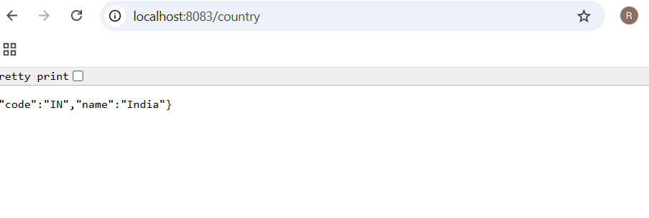

What happens in the controller method?

* The method getCountryIndia() is called when you access /country URL.
* It loads the in bean from country.xml.
* It returns the Country object as a response.

How the bean is converted into JSON response?

* Spring Boot uses a tool called Jackson (automatically included).
* It converts the Java object (Country) into JSON format.

In browser: Network tab of Developer Tools

* Open Chrome Developer Tools (F12), go to Network tab.
* Click on the /country request.
* Under Headers, you’ll see:
  + Request URL
  + Request Method: GET
  + Status Code: 200 OK
  + Content-Type: application/json

In Postman: Headers tab

* In the Postman response, click on Headers tab.
* You will see:
  + Content-Type: application/json
  + Date
  + Content-Length
  + Connection: keep-alive