**Objectives**

* Explain various ways of conditional rendering
* Explain how to render multiple components
* Define list component
* Explain about keys in React applications
* Explain how to extract components with keys
* Explain React Map, map() function

In this hands-on lab, you will learn how to:

* Implement conditional rendering in React applications

**Prerequisites**

The following is required to complete this hands-on lab:

* Node.js
* NPM
* Visual Studio Code

**Notes**

Estimated time to complete this lab: **60 minutes.**

Create a React App named “bloggerapp” in with 3 components.

1. Book Details
2. Blog Details
3. Course Details

Implement this with as many ways possible of Conditional Rendering.

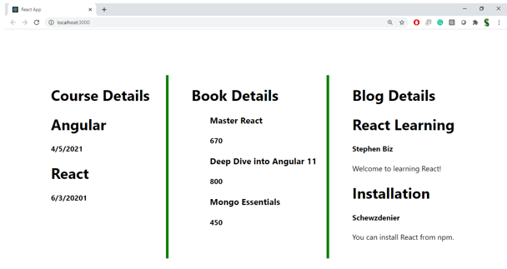

**Hint:**

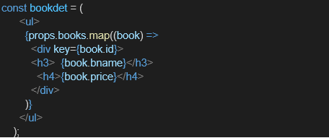

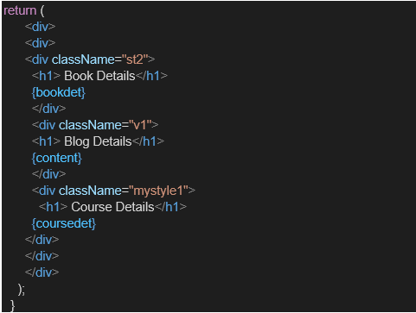

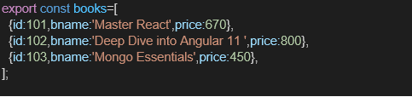

**Solution:  
My BlogDetails.js code is :**

import React from 'react';

function BlogDetails(props) {

  const content = props.blogs.map((blog) => (

    <div key={blog.id}>

      <h2>{blog.title}</h2>

      <h4>{blog.author}</h4>

      <p>{blog.content}</p>

    </div>

  ))

  return (

    <div className="v1">

      <h1>Blog Details</h1>

      {content}

    </div>

  );

}

export default BlogDetails;

**my CourseDetails.js code:**

import React from 'react';

function CourseDetails(props) {

  const coursedet = props.courses.map((course) => (

    <div key={course.id}>

      <h2>{course.name}</h2>

      <p>{course.date}</p>

    </div>

  ));

  return (

    <div className="mystyle1">

      <h1>Course Details</h1>

      {coursedet}

    </div>

  );

}

export default CourseDetails;

**My BookDetails.js code:**

import React from 'react';

function BookDetails(props) {

  const bookdet = (

    <ul>

      {props.books.map((book) => (

        <div key={book.id}>

          <h3>{book.bname}</h3>

          <h4>{book.price}</h4>

        </div>

      ))}

    </ul>

  );

  return (

    <div className="st2">

      <h1>Book Details</h1>

      {bookdet}

    </div>

  );

}

export default BookDetails;

**My App.js code:**

import React from 'react';

import './App.css';

import BookDetails from './BookDetails';

import BlogDetails from './BlogDetails';

import CourseDetails from './CourseDetails';

import { books, blogs, courses } from './data';

function App() {

  return (

    <div className="container">

      <CourseDetails courses={courses} />

      <BookDetails books={books} />

      <BlogDetails blogs={blogs} />

    </div>

  );

}

export default App;

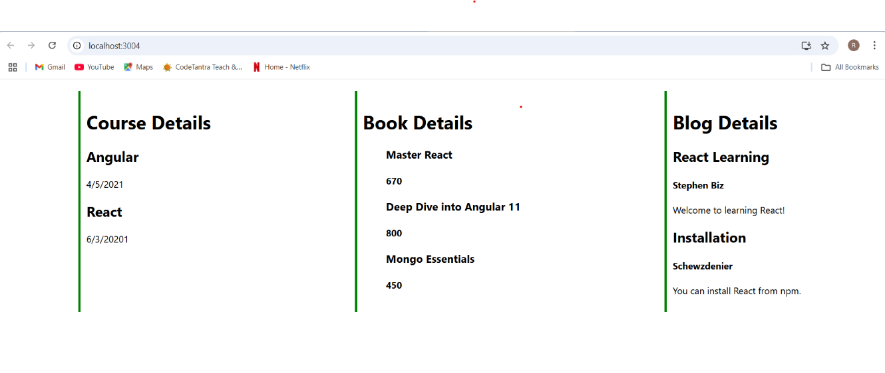**output:**