Install Docker

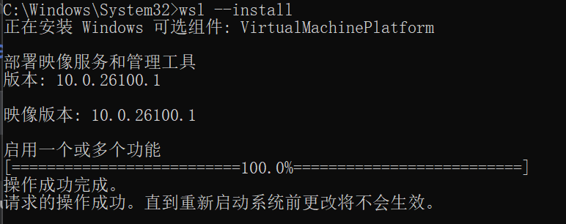

Create the folder for Gitea

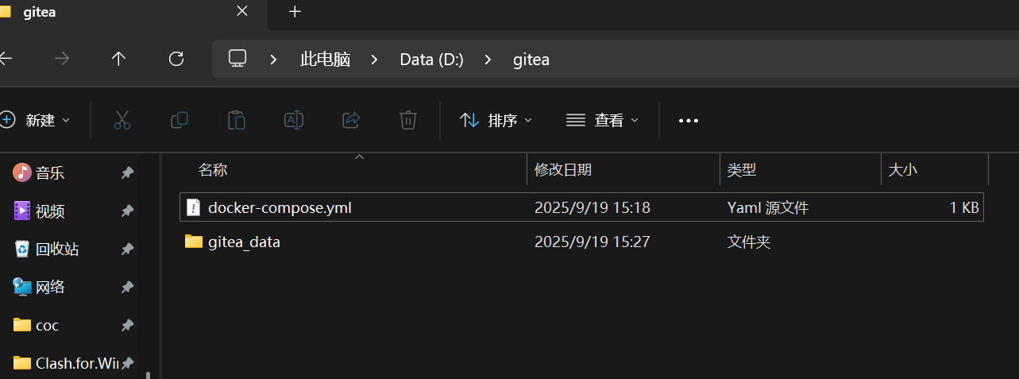

Configure the yml file

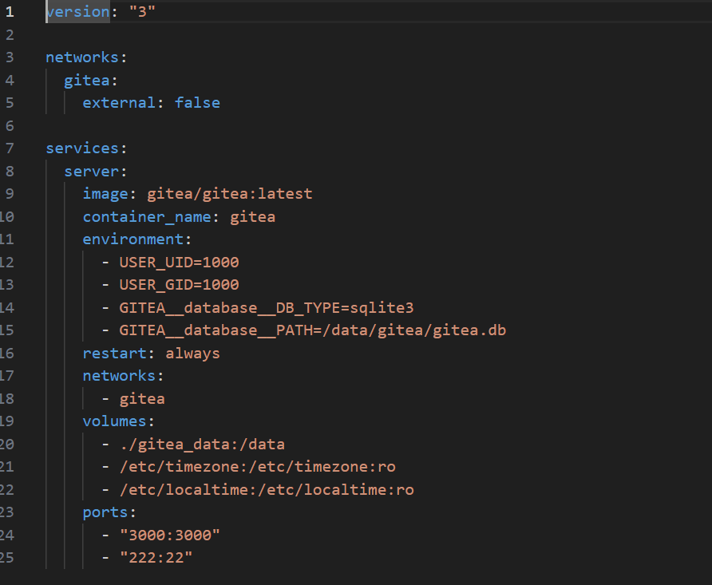

Running gitea

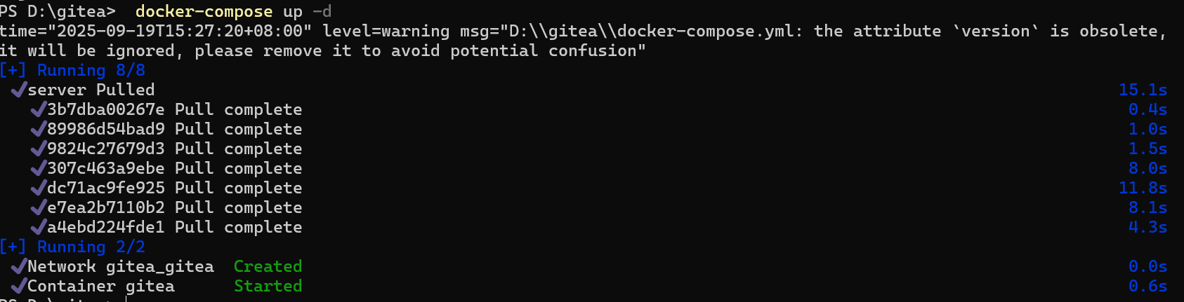

Carry out initial configuration

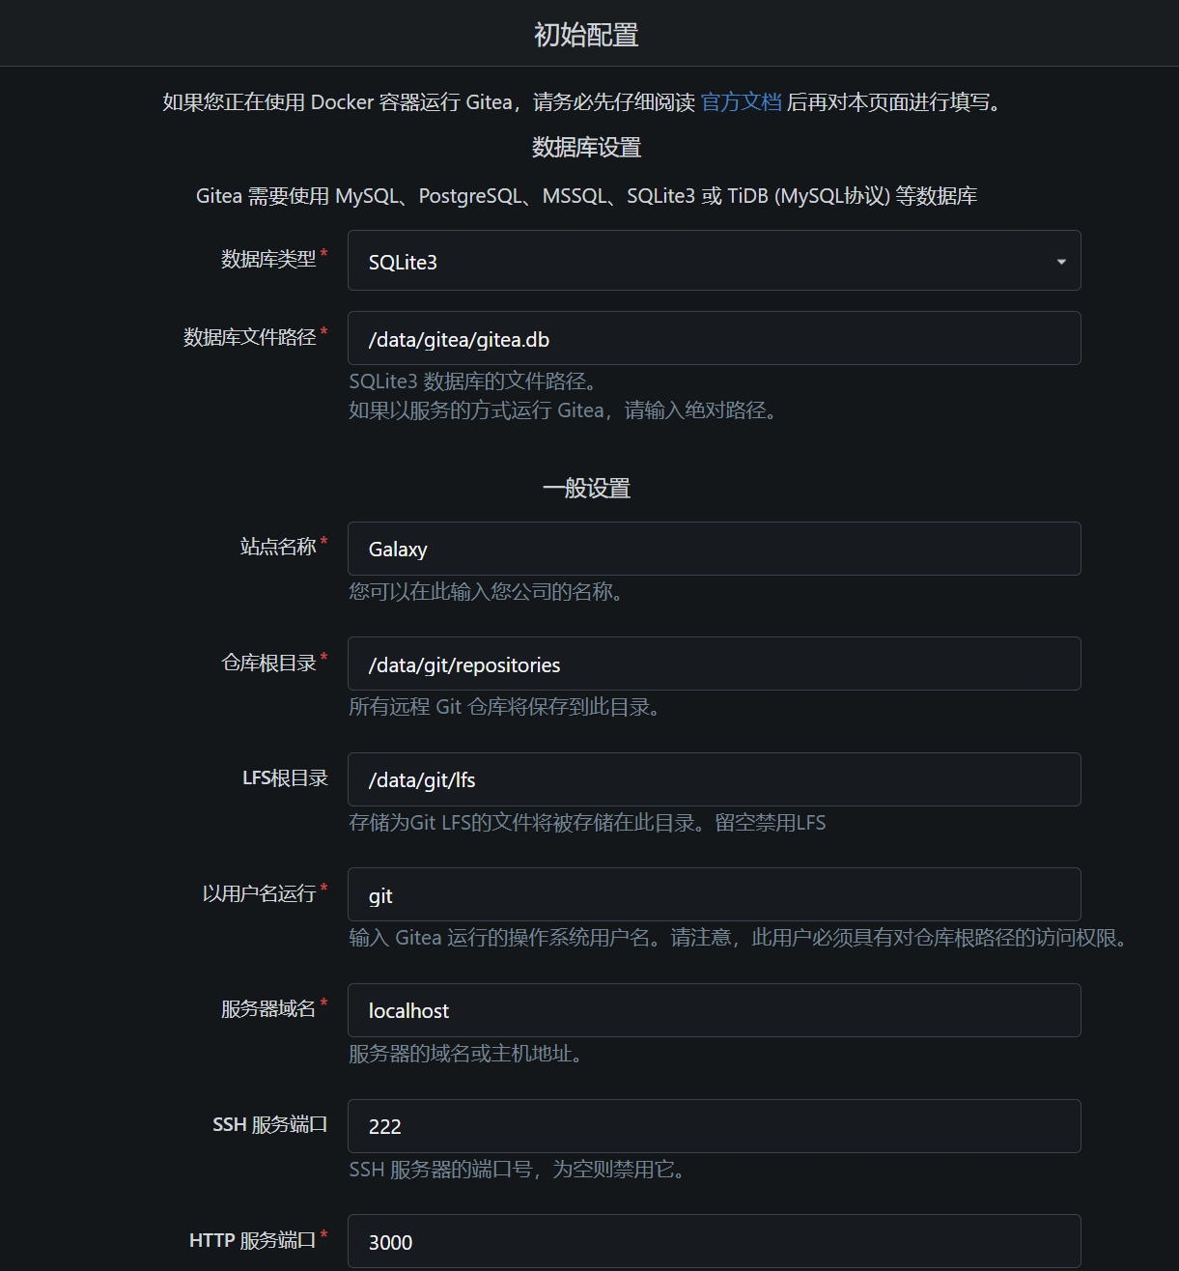

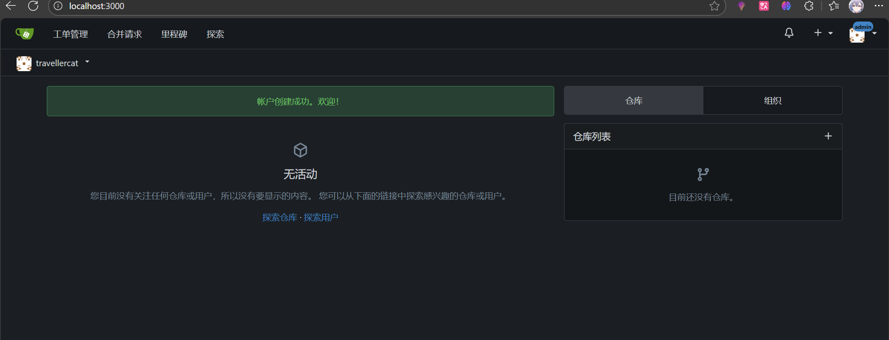

1. Does it support LFS? prove it.

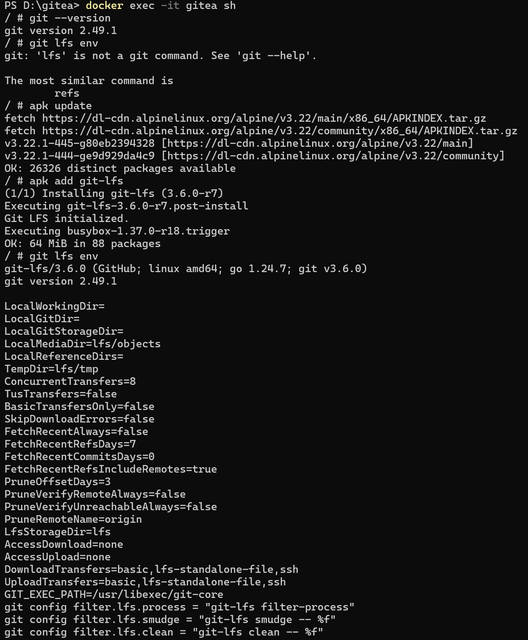

1. Create a repo with a large file (1G+)

Configure Git LFS Locally

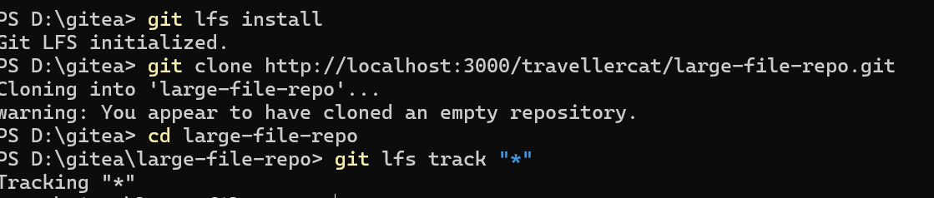

Generate and add large files



Submit and push large files:

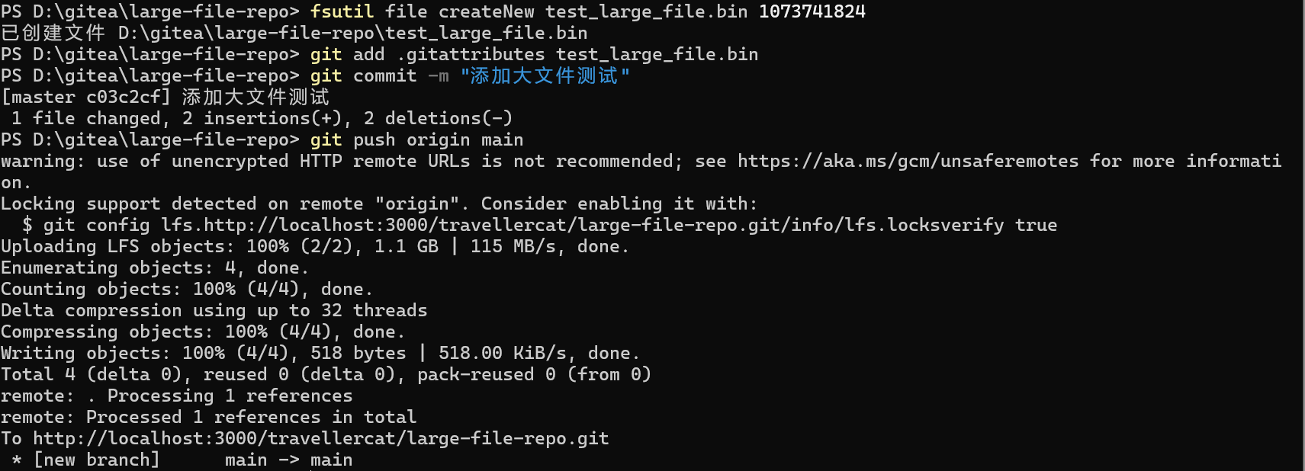

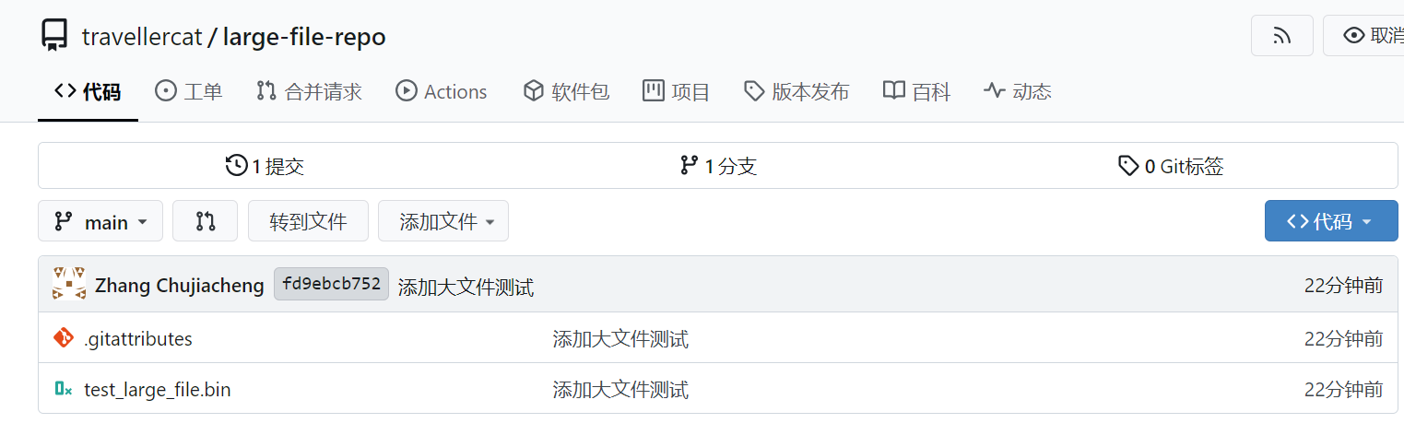

http://localhost:3000/travellercat/gitea-docker-module

