ICT PROJECT REPORT
BAHRIA UNIVERSITY ISLAMABAD

Project Title:
BurgerByte Fast Food - Cafeteria Order Management System
Subject Name:
Computer Programming
Submitted To:
_________Sir Asad Ullah___________
Group Members:
Amna Tariq 01-134261-022
Kanzul Eman 01-134261-046
Class:
BS CS (1-B)
Semester:
Spring 2026

Contents
Introduction .......................................................................................... 2
Objectives ............................................................................................. 2
Technologies Used ................................................................................. 3
System Design ....................................................................................... 3
Features of the Program ......................................................................... 4
Program Structure .................................................................................. 4
Project Screenshots ............................................................................... 5
Limitations ............................................................................................. 10
Future Improvements ............................................................................. 10
Conclusion ............................................................................................. 11

Objectives
- To create a cafeteria ordering system using C++.
- To practice arrays, loops, functions, conditionals, and structs.
- To organize menu items, categories, customer orders, and billing details.
- To calculate subtotal, discount, loyalty points, and final payable amount.
- To make the code more structured and easier to understand.

Introduction
Burger Byte Fast Food is a simple cafeteria order management system developed as a first semester C++ console project. The project is based on a realistic cafeteria scenario where customers can view a menu, select food items, apply discounts, and receive a final bill.
The main purpose of this project is to apply basic programming concepts in a useful system. Instead of writing separate small programs, the project combines arrays, loops, functions, conditions, and structs into one complete working program.
The theme of the project is kept simple and food-related so that it is easy to understand and present. The system is designed for learning purposes, but the idea can be improved in future semesters by adding file handling, object-oriented programming, and a graphical user interface.

Technologies Used
The project was developed using basic C++ programming concepts. The focus was on writing clear logic and dividing the program into smaller parts through functions and structs.
Technology / Concept | Purpose in the Project
C++ | Main language used to develop the console-based system.
Arrays | Used to store menu items, prices, and order data.
Functions | Used to separate tasks such as displaying menu, taking orders, and printing receipts.
Structs | Used to group related data such as menu item, customer, order, and day summary.
Loops | Used for repeated menu display, multiple orders, and customer processing.
Conditions | Used for discounts, input validation, and decision making.

The code is divided into functions so that each part of the program has a clear responsibility. Structs are used to keep data organized and readable.
Features of the Program
- Menu display with different food categories.
- Food item selection and combo deal support.
- Student discount calculation.
- Loyalty points earning and redeeming.
- Automatic subtotal and final bill calculation.
- Receipt generation for the customer.
- Daily customer and revenue summary.
- Input validation to avoid invalid choices.

Program Structure
The program is structured using functions and structs. This makes the code cleaner and easier to explain during presentation.
Function / Struct | Role
displayBanner() | Shows the welcome screen of BurgerByte.
displayMenu() | Displays menu categories and available items.
verifyStudentID() | Checks whether the student discount can be applied.
takeOrder() | Takes customer orders and stores selected items.
printReceipt() | Prints itemized bill and final amount.
printDaySummary() | Displays total customers and revenue.
MenuItem | Stores name and price of each menu item.
Customer | Stores customer details, subtotal, points, and orders.
DaySummary | Stores daily sales and customer summary.

Figure 1
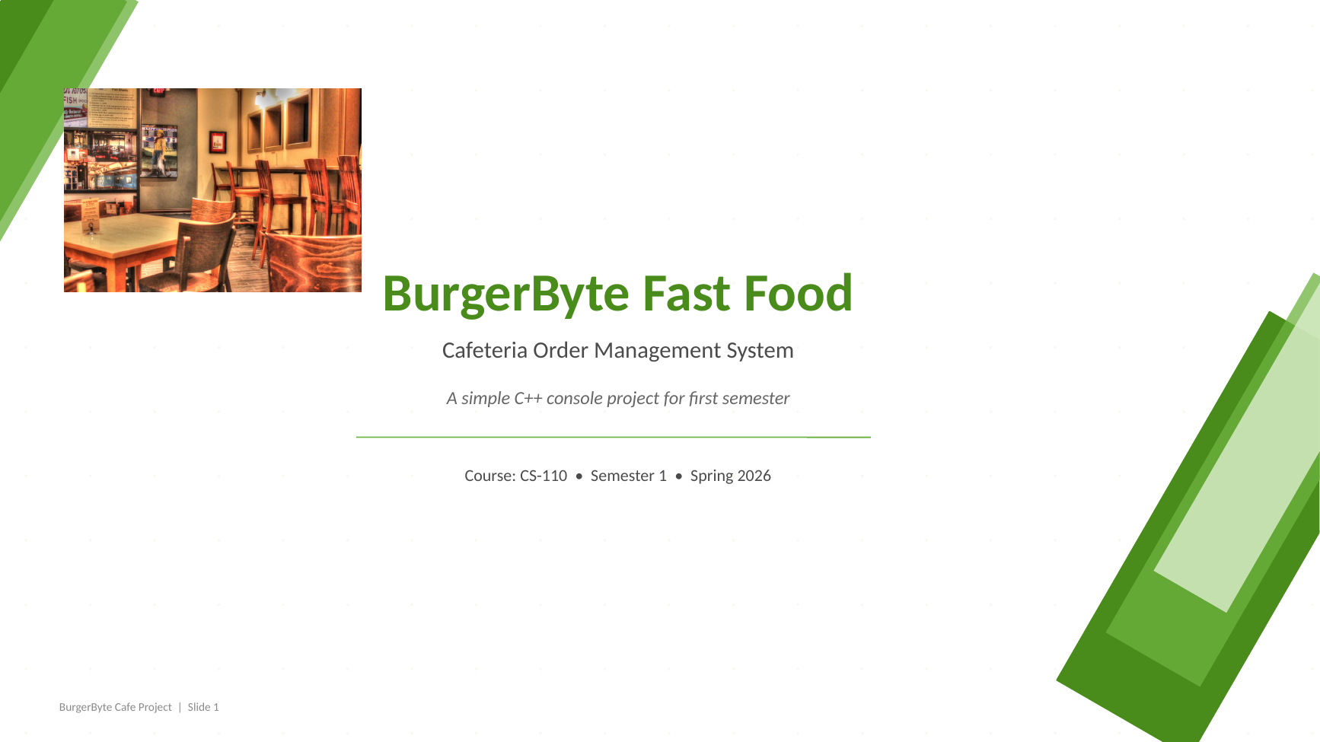
Figure 1: Title and Project Theme
This screen shows the overall theme of the BurgerByte project. A light green and white design is used to match the cafeteria idea while keeping the presentation simple and clean.

Figure 2
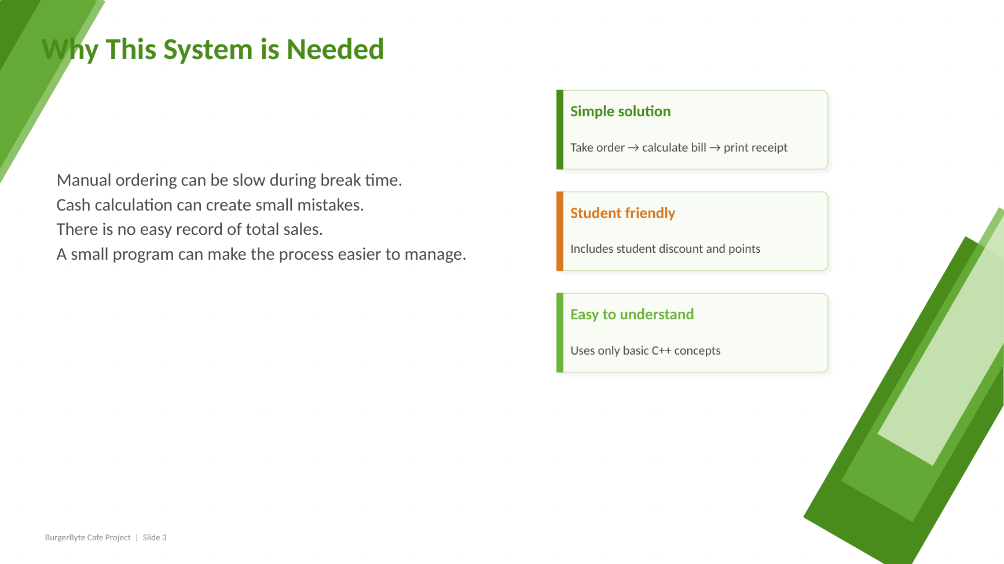
Figure 2: Need of the System
This slide explains why a cafeteria ordering system is useful. It shows that manual ordering can cause long queues, billing mistakes, and difficulty in managing orders.

Figure 3
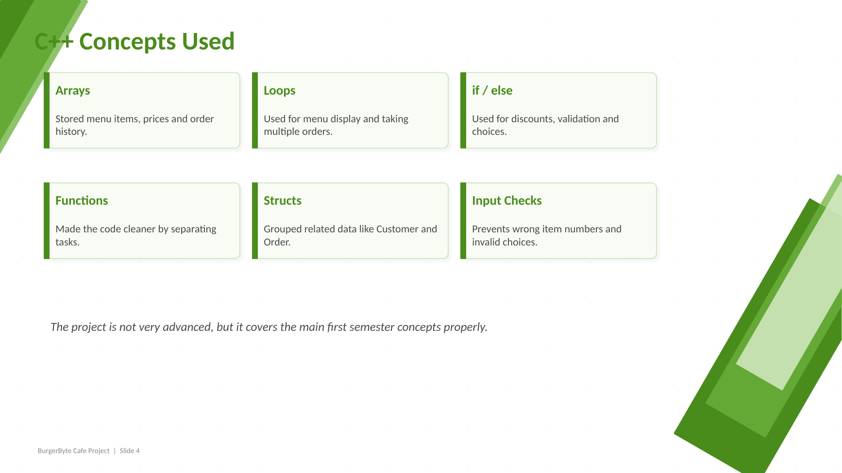
Figure 3: C++ Concepts Used
This slide presents the programming concepts used in the project, including arrays, loops, functions, if/else conditions, structs, and input validation.

Figure 4
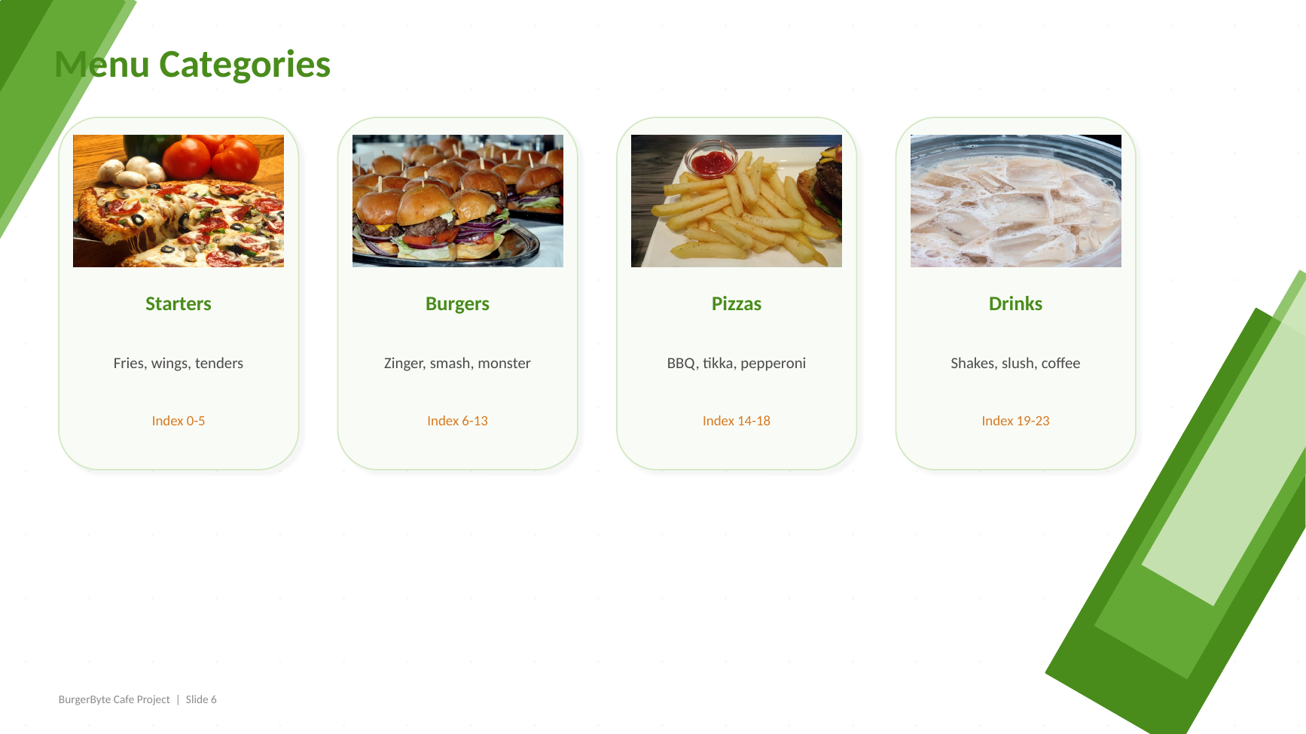
Figure 4: Menu Categories
This slide shows how the menu is divided into categories such as starters, burgers, pizzas, and drinks. The categories make the ordering process easier to understand.

Figure 5
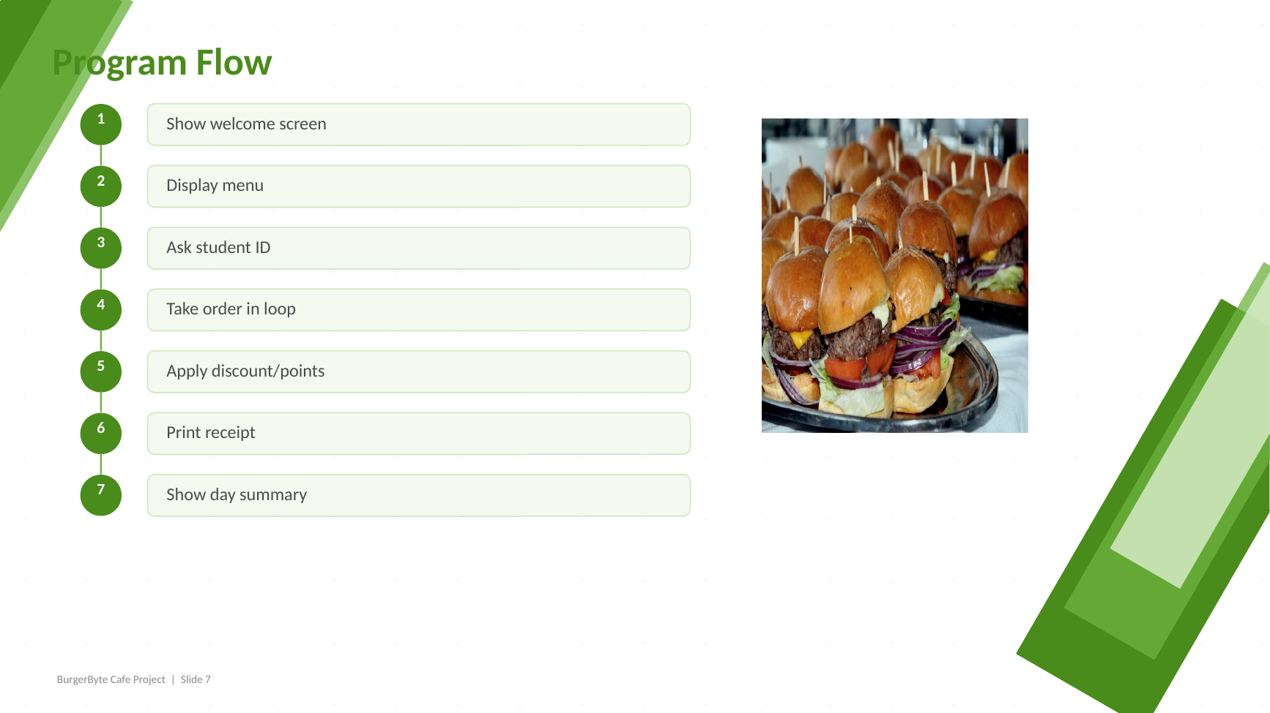
Figure 5: Program Flow
This slide explains the working flow of the program from welcome screen to menu display, order taking, discount handling, receipt printing, and final day summary.

Figure 6
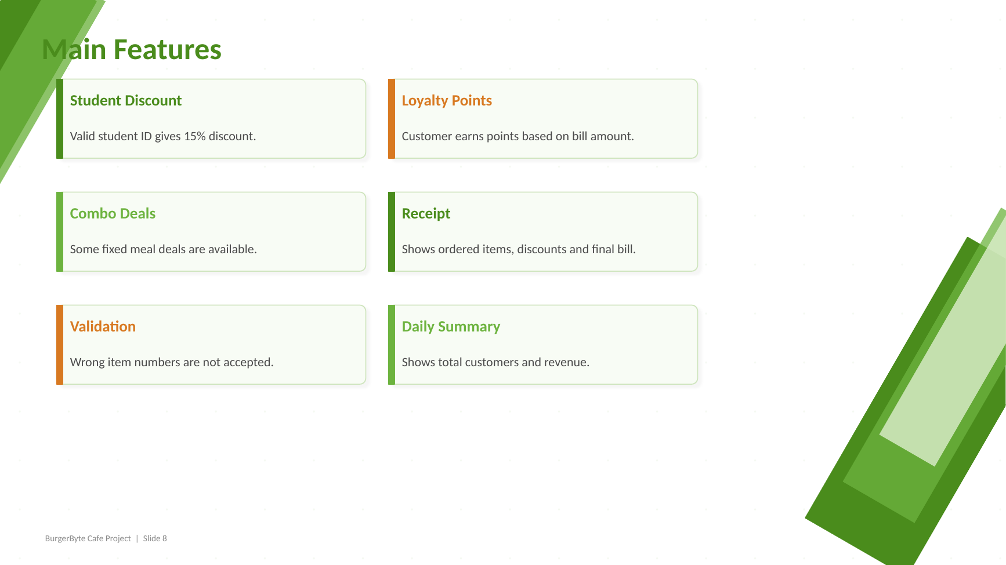
Figure 6: Main Features
This slide highlights the main features of the program such as student discount, loyalty points, combo deals, input validation, receipt generation, and daily summary.

Figure 7
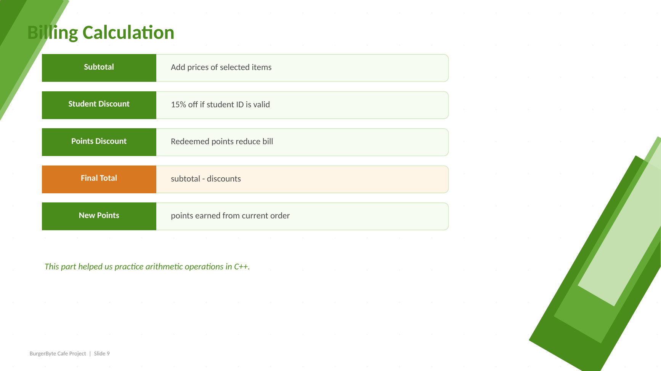
Figure 7: Billing Calculation
This slide explains how the billing system works. It includes subtotal calculation, student discount, point redemption, final total, and new points earned.

Limitations
- The project is console-based and does not have a graphical user interface.
- The data is not saved permanently after the program ends.
- There is no login system for admin or customers.
- The project is suitable for learning but not ready for real cafeteria deployment.
Future Improvements
- Add file handling to save orders and daily sales records.
- Use object-oriented programming in the next version.
- Create a graphical interface for better user experience.
- Add database support for menu, customers, and orders.
- Add admin panel for updating prices and menu items.
Conclusion
BurgerByte Fast Food was successfully developed as a simple cafeteria order management system using C++. The project helped us apply programming concepts in a practical way instead of only studying them separately.
Through this project, we learned how to organize a program using functions, arrays, conditions, loops, and structs. The project also improved our understanding of billing logic, input handling, and structured code design.
Overall, BurgerByte is a useful first semester project because it is simple enough to understand, but complete enough to show real programming logic and project presentation skills.

