MAT1856/APM466 Assignment 1

Your Name, Student #: Junbiao Liu 996619976

February, 2020

# Fundamental Questions - 25 points

## 1.

### (a)

Technically the government cannot print money, only the central bank can. The government controls the liquidity by issuing bonds. If it issues more bonds, the money is in high demand, and interest rate has the pressure to go up. The central bank is one of the market participants in the government bond auction. When it prints money, and buys the government bonds, money goes into circulation and increase the money supply, and thus provide relief to the interest upward pressure. Of course, the central is not limited to just buying the government bonds, but government is the major component of its balance sheet. During the financial crisis, the central government in the US buys a lot of assets in the private sectors too.

The adjustment of the interest rate has rippling effects over all other financial instruments. The government bonds interest rates serve as a risk-free rate benchmark for other financial products. If the central bank does not participate in the market auction, and instead straight up gives away money to the government to spend, it gives up the most effective way to regulate interest rate.

### (b)

The yield curve could flatten if people expect money demands in the future decreases. This is a sign of recession. When business activities slow down, and people don’t need money to spend, the interest rate goes down. The interest rate in technical term, is called forward rate, because it is an implied interest rate in the future.

### (c)

Quantitative easing is the central bank buying up a lot of assets, and releasing liquidity into the market. The interest rate, thus, is reduced, and costs of business borrowing, etc. is also reduced. This has multiple benefits. First, it encourages borrowing and investment. Secondly, it allows firms to borrow during this difficult and hopefully they can make it through this difficult time.

## 2.

I try to spread out the availability of data so interpolation is more accurate. I lay out all the available bonds below sorted by dates, and labeled the ones I choose by orange.

Originally, I wanted to pick the 8/1/2021 bond as the first bond. However, for some days in our observation period, this bond has an outstanding coupon payment before maturity that does not have proper discount rate and there’s no data to interpolate. Thus, we want the first bond to have only one cash flow, which happens on maturity day.

For the same reason, we cannot choose any bond that pays coupon between January and the maturity day of the first bond. For example, if I pick the 6/1/2021 bond, I need to exclude a lot of bonds that pay coupons between January and June.

Thus, first bond has to have short maturity.

The chosen bonds are below:

|  |  |  |  |
| --- | --- | --- | --- |
| index | Maturity date | coupon | ISIN |
| 1 | 3/1/2021 | 0.75 | CA135087F254 |
| 2 | 9/1/2021 | 0.75 | CA135087F585 |
| 3 | 3/1/2022 | 0.5 | CA135087G328 |
| 4 | 11/1/2022 | 0.25 | CA135087L369 |
| 5 | 6/1/2023 | 1.5 | CA135087A610 |
| 6 | 3/1/2024 | 2.25 | CA135087J546 |
| 7 | 9/1/2024 | 1.5 | CA135087J967 |
| 8 | 3/1/2025 | 1.25 | CA135087K528 |
| 9 | 9/1/2025 | 0.5 | CA135087K940 |
| 10 | 3/1/2026 | 0.25 | CA135087L518 |

If there are multiple bonds that mature on the same day, I choose the one that have similar coupon rate as others. This is because the coupon rate may affect bond price, because investors may or may not have a preference higher coupon payment.

## 3.

Principal component analysis is just to package features into orthogonal features, aka principal components. And we usually order them by how much each principal component can explain the variance. This allows us to distinguish two objects by just comparing their weights on the principal components. For example, the yield may have many shapes. We can describe its shape by its weights of the principal components. I don’t know terminologies for yield curve shapes. But one analogy is that you could describe a human face by his nose, eyes, ears, etc. And here nose, eyes, ears are the principal components of a human face.

# Empirical Questions - 75 points

## 4.

### (a)

Treatment of accrued interest is linear. The amount is proportion to the ratio between time past the last coupon payment and time between the coupon payment. For example, 26 days has passed, and coupon payments are made at interval of 100 days. Then accrued interest is of notional coupon payment.

Day counts is based on calendar days, not business days.

The price quoted in market is clean price. The value of the bond is dirty price. Thus, to do any calculation of yields, I will have to first compute the dirty price. In the following calculations, all references of bond prices will be dirty price unless specified.

Steps to calculate ytm:

1. create a cash flow schedule of the bond.

2. calculate the dirty price

3. Extract YTM from the pricing formula where P is bond price, CF is cash flow, and r is the YTM. Note that I use continuous compounding.

Method on step 1:

Assume that cash flow of a bond happens on maturity date and every six months before maturity.

Method on step 3:

I will use Newton’s method.

Let , try to find such that

There’s conflicting information about which days to collect data. Without jeopardizing the purpose of this problem set, I will collect data for the last 10 business days as of today (2021/2/4), shown below.



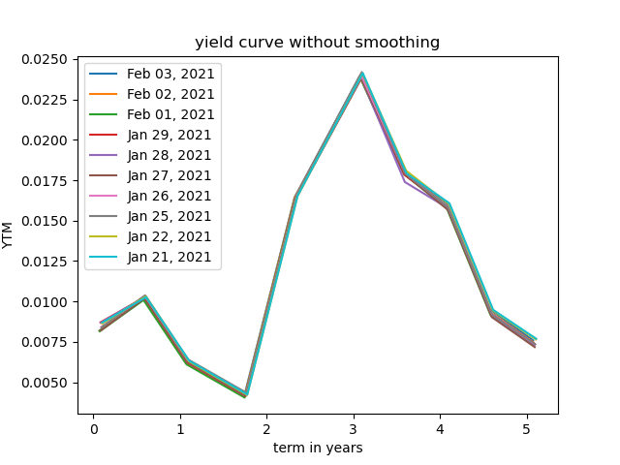

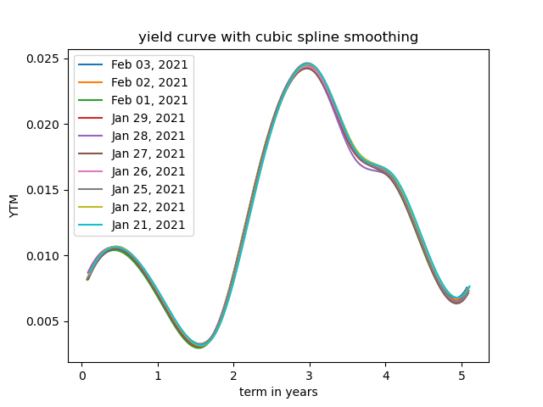

### (b)

Steps:

1. create an of spot rates. It has two columns, terms and spot rate. It will only contain 10 rows as we have 10 bonds with different maturity terms.

2. Take a bond of the next shortest duration, and construct its cash flows pattern. Our goal is to calculate the new spot rate

2.1 For each cash flow, if the timing of cashflow is covered in the inventory, linearly interpolate the discount rate.

2.2 If cash flow is outside of the coverage of the inventory, its discount rate will be the average of the last rate in the inventory and the new rate. For example, if is the last term in inventory, and is the term of the bond, and the bond may have cash flows that happens at , where , then

Discounted Value of Cash flow t is

3. calculate the new spot rate , and add it to the inventory

Details for step 3: apply root finding algorithm to where the only unknown is

4. repeat 1-3 until we have 10 spot rates

5. Apply smoothing technique and interpolate 1-year, 2-year…5-year spot rate.

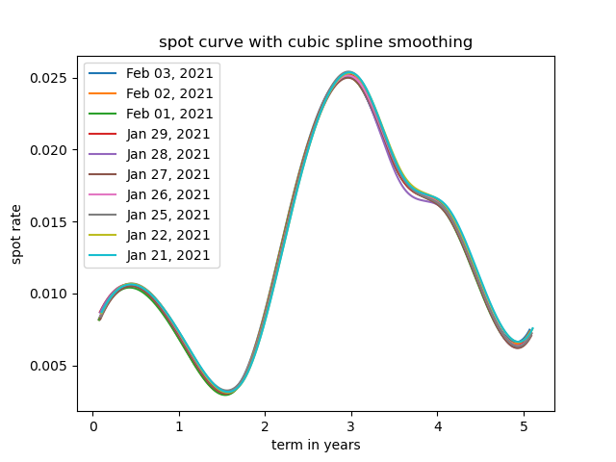

### (c)

1. take the results from step b) and interpolate for spot rate of year1

2. calculate continuously compounding forward rate by . Note that i is the time of spot rates calculated in part b)

3. interpolate and plot the forward curve.

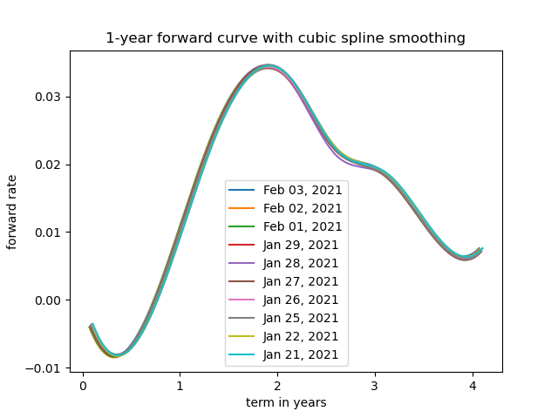

## 5.

My X matrix is organized like this:

X=

So, to calculate the covariance matrix, I will first normalize each column by its mean.

Then covariance matrix X

This is covariance matrix for forward rate

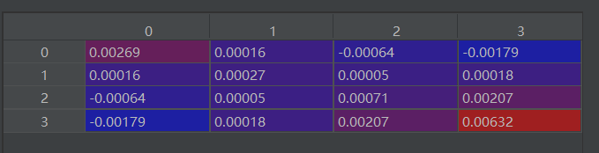

This is covariance matrix for spot rate

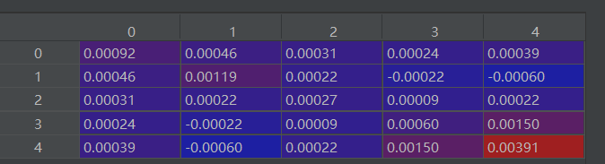

## 6.

**For spot rates:**

Eigenvalues

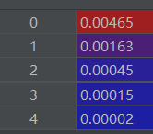

Eigenvectors

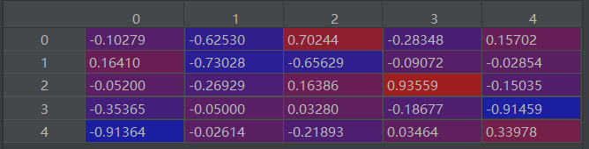

Proportion of variance explained by the first eigenvector = eigvalues[0]/sum(eigvalues)

The dimension from the first eigenvector can explain 67% of variance in data

**For forward rates:**

Eigenvalues

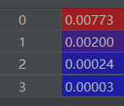

Eigenvectors

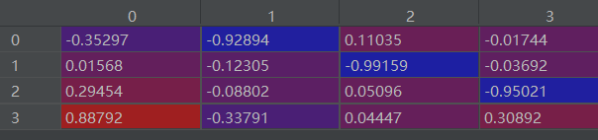

The dimension from the first eigenvector can explain 77% of variance in data

## References and GitHub Link to Code

**References**

https://numpy.org/doc/stable/user/index.html

http://lagrange.univ-lyon1.fr/docs/scipy/0.17.1/tutorial/optimize.html#root-finding

<https://docs.scipy.org/doc/scipy/reference/generated/scipy.interpolate.CubicSpline.html>

**GitHub Link to Code**

https://github.com/travelwithwind/APM466/blob/master/a1/a1.py