# Abstract

In LCR experiment, I attempt to learn about the behavior of inductors and capacitors.

In experiment 1, I conducted RC circuit, LR circuit and LC circuit. The time constant observed in RC circuit while the theoretical time constant is 0.0032s. The time constant observed in RL circuit while the theoretical time constant is . In LC circuit, the observed frequency is while the theoretical frequency is 5000. I found that capacitance is positively related to time constant and inductance is inversely related to time constant.

In experiment 2, I measured impedance of RC, RL and RCL circuit. Then impedance is plot against frequency to get the estimates of capacitance and inductance. In RC circuit, estimated capacitance is nF while the actual capacitance is 22nF. In RL circuit, estimated inductance is mH while the actual inductance is 42.6mH. I found that impedance of capacitors is negatively related to frequency and impedance of inductors is positively related to frequency.

# Introduction

In this experiment, we will try to understand the behavior of inductors and capacitors.

An RLC circuit is an electrical circuit consisting of a resistor, an inductor, and a capacitor. We will carry out experiments that involve different variations of RLC circuits, for example, RC is a circuit that only involves capacitor and inductor.

In the experiment 1, we set up different RLC circuits and observe how voltages changes over time with different setups. RLC components all consume voltage, and according to Kirchhoff’s Law, their voltage consumption sums up to the terminal voltage. The relative size between resistance, inductance and capacitance leads to different damping conditions.

In the experiment 2, we will measure the impedance of different RLC components. Impedance extends the concept of resistance to AC circuits. Impedance is calculated in similar way as Resistance, except, voltage and current are oscillating. The phasor, which is voltage over current, is a function of R, L, C. So, plotting the phasor can reveal the values of inductance and capacitance.

# Equipment

* Oscilloscope with built in wave generator (Keysight DSOX1204)
* Voltmeter
* Electrical components board with capacitor, inductor and resistors
* Battery

## Units

* Voltage: V
* Time: S
* Resistance: Ohm
* Inductance: H
* Capacitance: F

## Uncertainties

Amplitude accuracy 0.25% of reading. The time-based accuracy is 50 ppm ± 5 ppm per year (aging). (<https://www.keysight.com/us/en/assets/7018-06411/data-sheets/5992-3484.pdf>)

The precision error for time and amplitude are both 0.000001.

For time, precision error is obviously the dominant source of uncertainties and so we will use it as the uncertainties of time.

For amplitude, I will use two different ways of defining uncertainties.

In experiment 1, my initial thought is to use the bigger value of precision error and accuracy error at each data point as the uncertainty. However, this produces bad fitting. For example, the curve fitting plot for RC circuit looks like this:

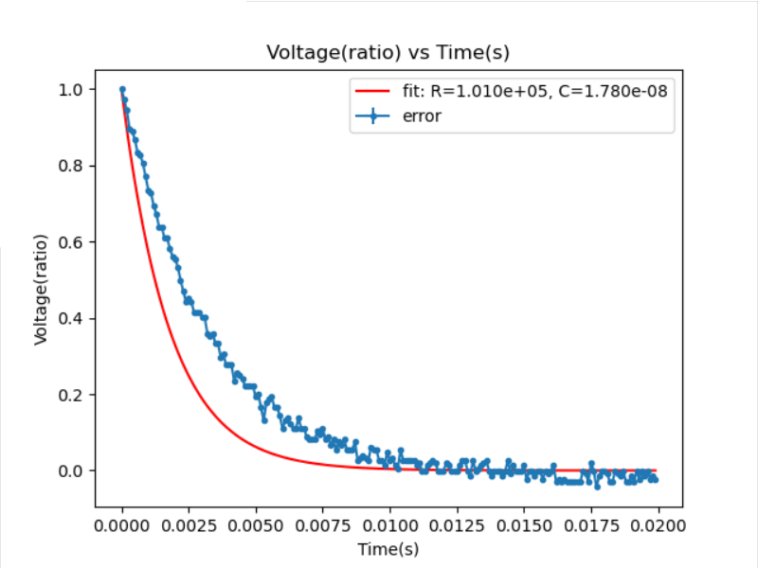

If we use just the precision error as the uncertainty, the fitting looks like this:

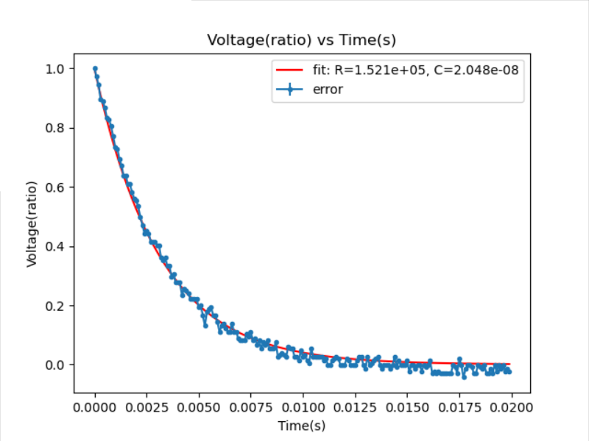

I don’t have a proper explanation for why this happens.

For the sake of better fitting I will also use the precision error as uncertainty for voltage.

In experiment 2, the oscilloscope has a hard time measuring amplitudes and phases. The numbers keep jumping back and forth. Thus, I decided to use half of the jump as the uncertainties of the data points. For example, if the oscilloscope jumps between 3.6 mV and 3.8 mV, I will take 3.7mV as the reading and 0.05mV as the uncertainty.

# Experimental Procedure and Results

## Experiment 1

### RC circuit with battery

We’ll use a manual switch to change the applied voltage between a battery (1.5 V) and no applied voltage (0 V). Construct an RC circuit using the 1 µF capacitor and the 100 kΩ resistor, as shown in Figure 3. Measure the applied voltage VT and the voltage across the capacitor VC. Connect the oscilloscope across the resistance R.

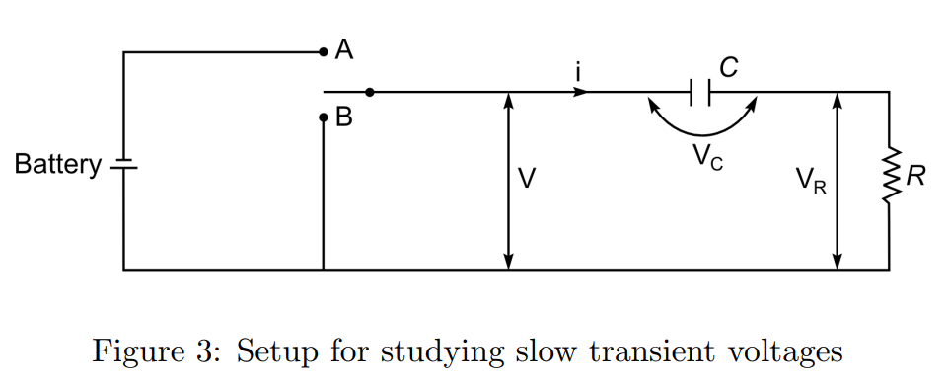

The theoretical time constant is RC=0.1 s.

Let’s take a look at the plot of voltage vs time.

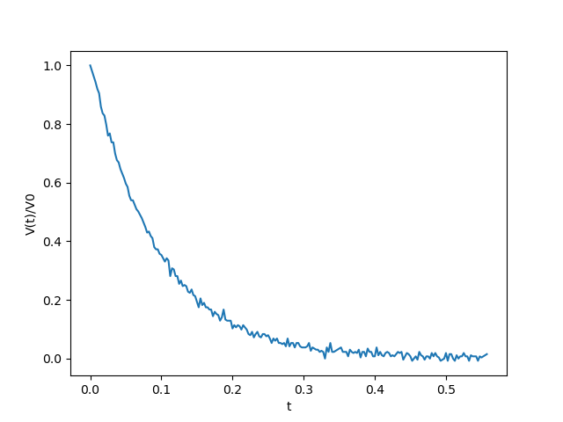

Visually, we can identify the observed time constant to be approximately 0.09s.

We can also obtain an estimate of time constant through curve fitting with the formula . Curve fitting will yield parameter estimates R and C, which can be multiplied together to yield the estimated time constant.

Below is a plot from curve fitting.

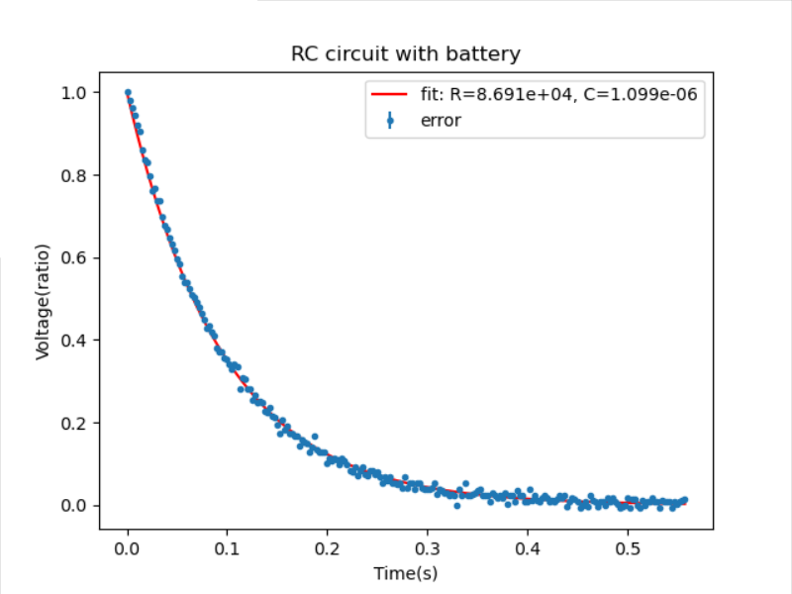

The curve fitting yields estimated parameters resistance(r) and capacitance(c) to be

[8.69083727e+04, 1.09853205e-06],

and the corresponding covariance matrix is

[[ 5.06324398e+12, -6.40000000e+01],

[-6.40000000e+01, 8.08967535e-10]]

The estimate of resistance (86 kΩ) is very different than the actual values (100 kΩ) while the estimate of capacitance (1.1 µF) is fairly close to the actual values (1 µF).

Now, let’s find the time constant. Using first order Taylor expansion on RC, we can estimate the uncertainty of RC. Thus, the time constant estimated is . The variance of the estimate is enormous. However, time constant estimate is close to the theoretical value.

In the rest of experiment 1, we will use a function generator to switch the  
applied voltage VT between +V and -V, as shown in Figure 4 below.

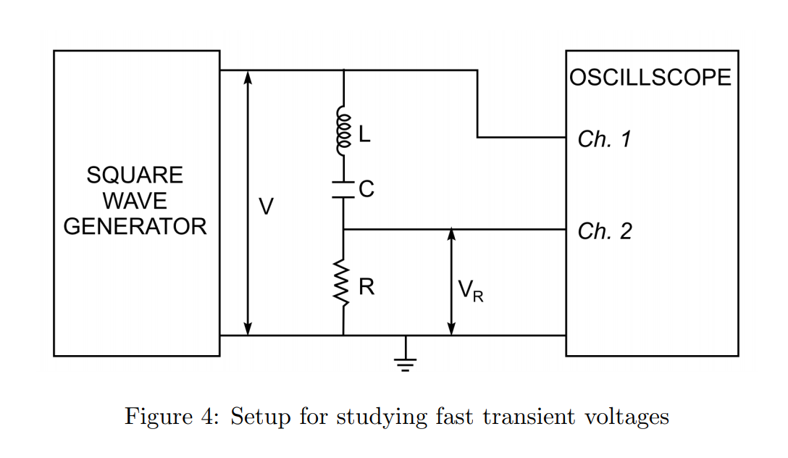

### RC circuit

I use a 0.022 capacitor and 100 resistor. The theoretical time constant is RC=0.0032 s.

Below is a plot from curve fitting.

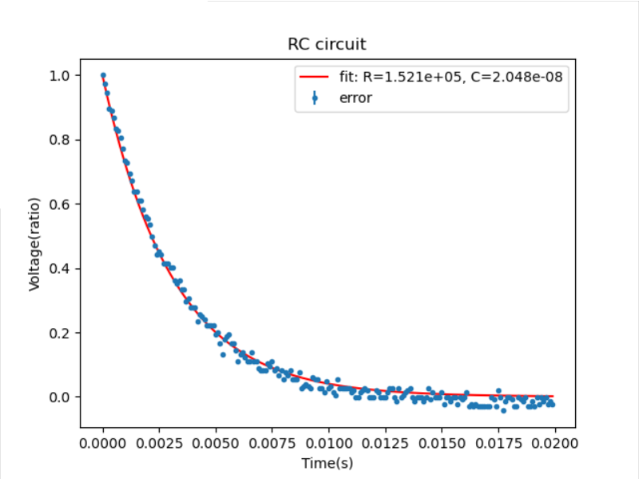

The curve fitting yields estimated parameters resistance(r) and capacitance(c) to be

[1.52092459e+05, 2.04810525e-08]

and the corresponding covariance matrix is

[inf, inf],

[inf, inf]]

Again, the parameter estimates are a bit off from the actual values. However, it is not a big issue since we are more interested in the time constant than these two parameters. What is troubling is that the covariance matrix is infinite, which I have no idea what went wrong and how to fix it.

Nonetheless, we can obtain the estimated time constant , which is close to the theoretical value.

### LR circuit

I use the 42.6 mH inductor and 3 resistor.

The theoretical relationship is

Thus, theoretical time constant is L/R=1.42e-8.

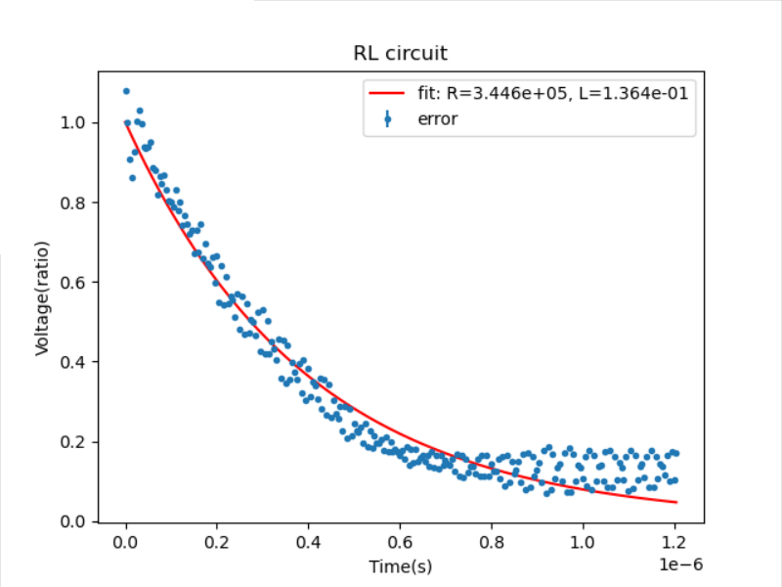

The curve fitting yields estimated parameter to be

[3.44586288e+05, 1.36385290e-01],

and the corresponding covariance matrix is

[[1.05972184e+13, 4.19430400e+06],

[4.19430400e+06, 1.66007582e+00]]

The time constant estimated is. Again, the error is too big. This time, our time constant estimate is quite different than the theoretical value, which is understandable given the large error.

### LC circuit

42.6 mH inductore and 0.022 capacitor are used.

Below is a plot with voltage across measured in yellow.

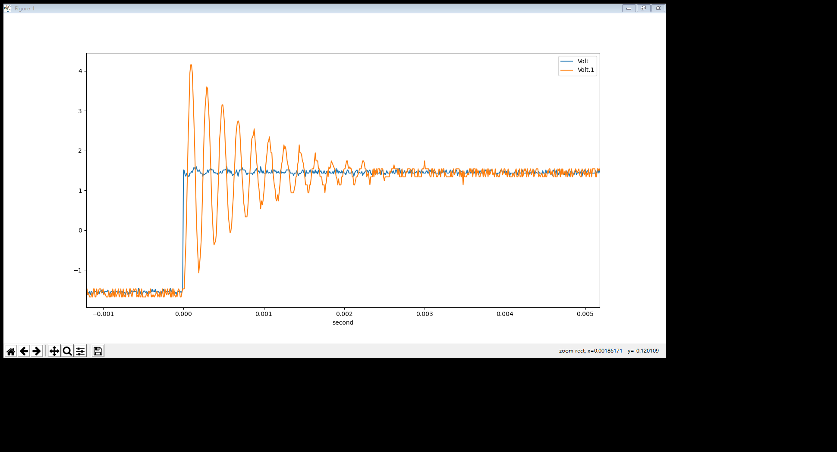

Theoretically, frequency .

According to the plot above, we can observe 10 cycles in 0.002 seconds. So approximately the observed 5000.

Below is another plot with voltage across capacitor measured in yellow.

We can see the plot is very similar to the previous one. And if we measure the frequency again, it turns out to be approximately 5000 as well.

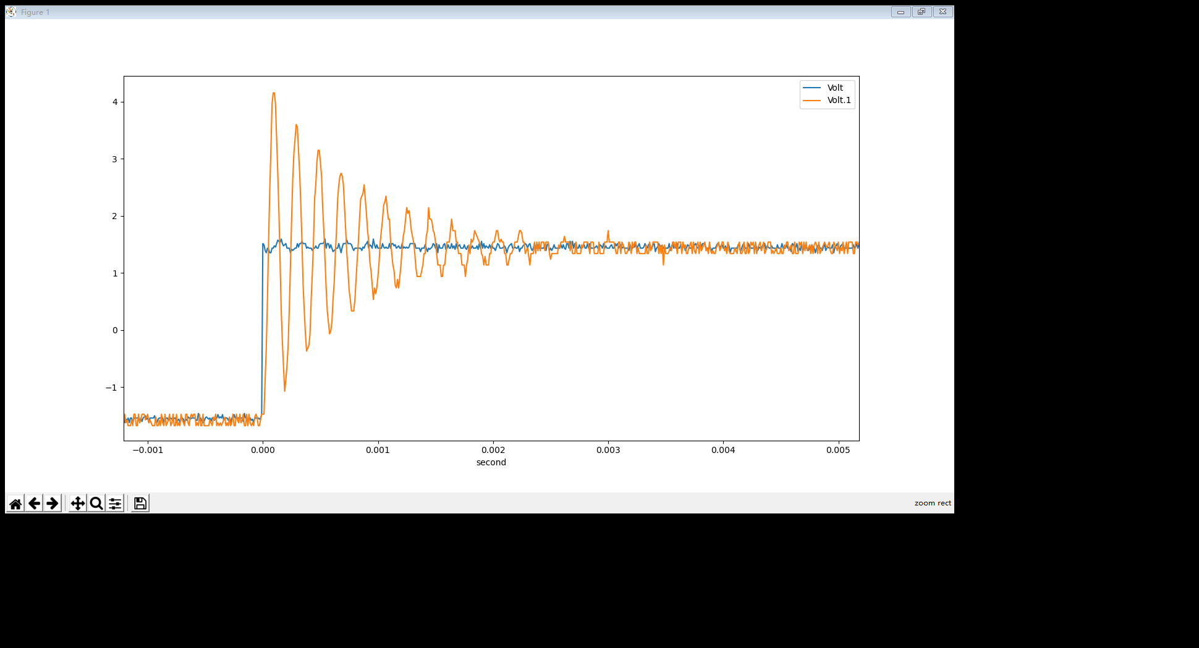

The observed values are close to theoretical values.

## Experiment 2

Now, we’ll use our circuits to directly measure the impedance of some circuit elements.

### RC circuit

An RC circuit can be built as in Figure 6:  
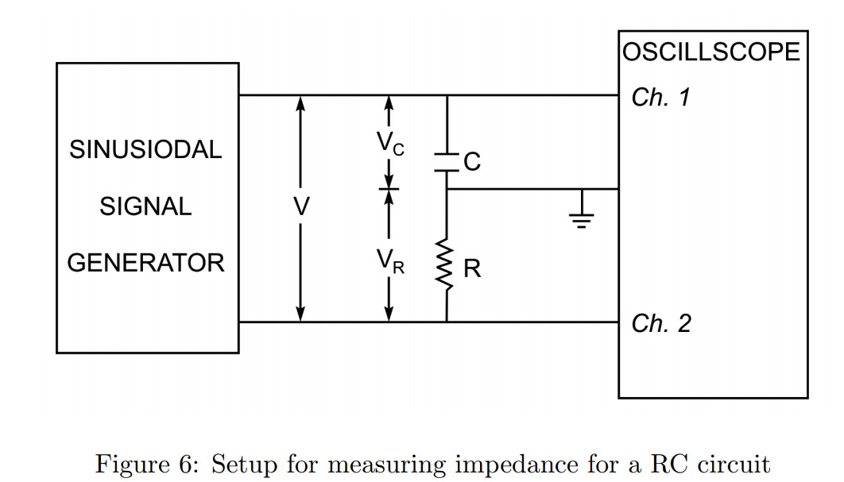

I have chosen resistor and capacitor .

Let’s denote the voltage measured in channel 1 as and that in channel 2.

As , the impedance of capacitor is and impedance of the entire circuit is

Let’s take a look at plot of impedance based on data collected vs the theoretical values. Note that in all the plots for experiment 2, the y axis is the impedance of the entire circuit.

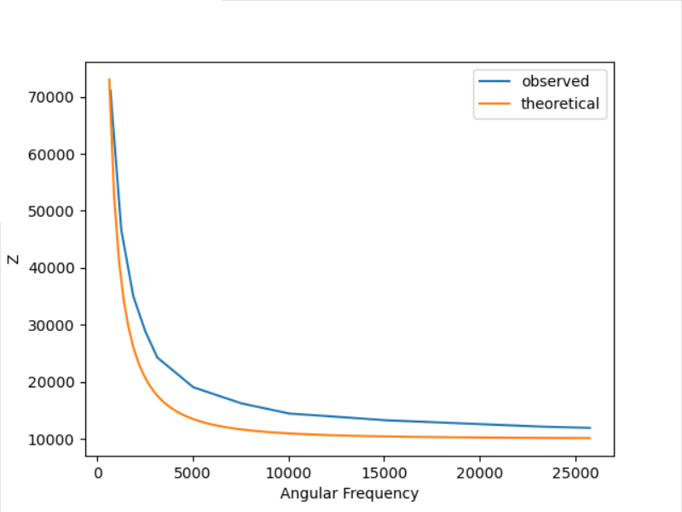

We can see observed values are not exactly close to the theoretical values, but the shapes of curves are similar.

Now, let’s fit curve to data to estimate parameters.

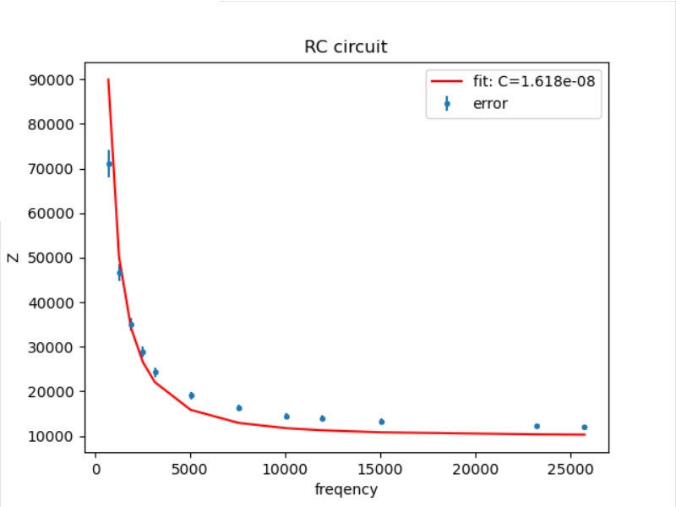

The capacitance estimated is F or nF. The estimated region does not contain the correct value 22nF. Thus, the fit is bad.

### RL circuit

An RC circuit can be built as in Figure 7 without the inductor:

I have used resistor and capacitor . The impedance of the entire circuit is

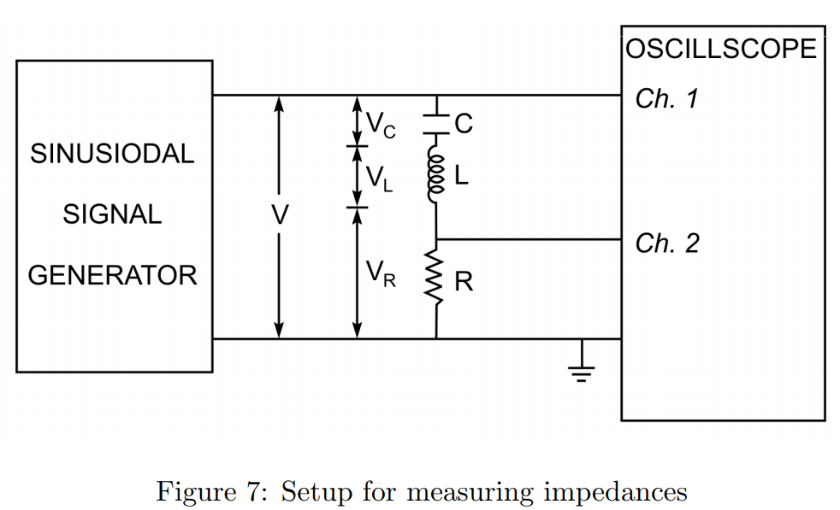

Below is a plot of impedance based on collected data and theoretical values against angular frequency.

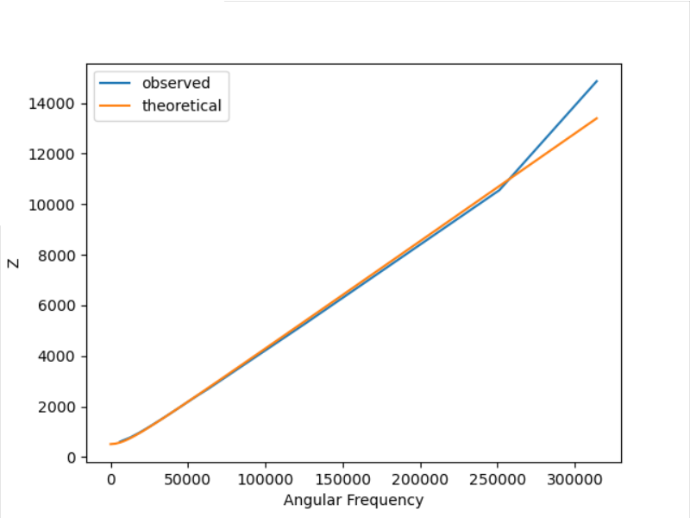

The observed data and theoretical values are perfectly aligned except the last couple observations.

Now, let’s fit curve to data to estimate parameters.

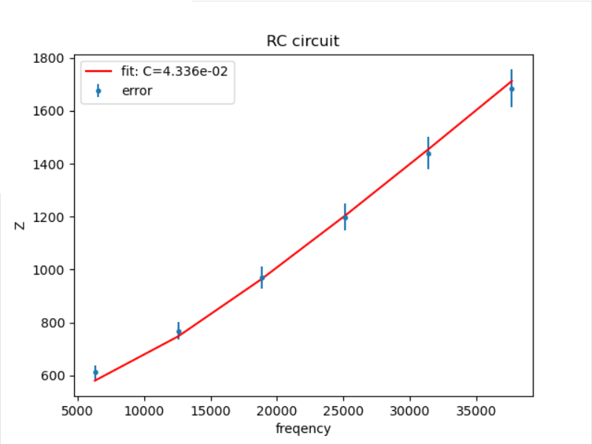

The capacitance estimated is H. We can see the fit is fairly good. All the bands of the observations contain the fitted curve.

### RCL circuit

An RC circuit can be built as in Figure 7 without the inductor:

I have used resistor and capacitor . The impedance of the entire circuit is

Let’s plot the observed impedance vs the theoretical values.

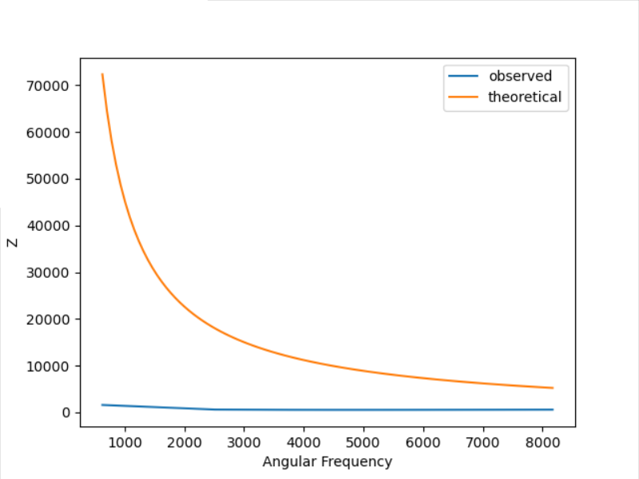

The two curves are not even close. That means my collected data is garbage. The reason I thought my data was good is that I thought I had observed “resonance curve”. I did not. My data ranges from 100hz to 1.3 kHz. The theoretical resonant frequency can be found by setting

Solving it gets the theoretical resonant frequency to be about 5.2 kHz. Thus, it’s not possible to have observed “resonance curve” based on my data.

The only thing I can do now is to plot the theoretical impedance values that contains the resonant frequency below.

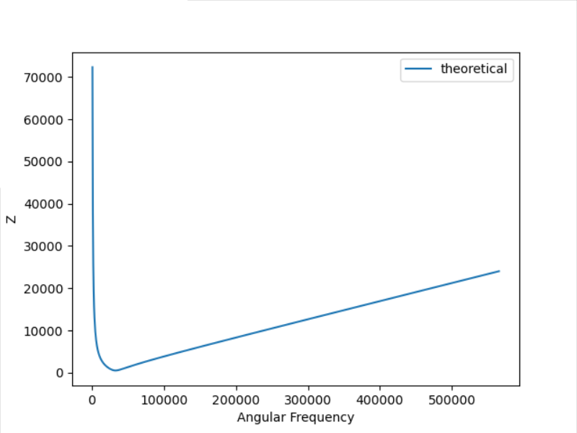

# Discussion

## Experiment 1

In experiment 1, I have learned the functions of capacitor and inductor and their effect on voltage in the circuit. Capacitor is an instrument to store charges, and it’s characterized by capacitance. Holding resistor constant, the larger the capacitance, the more charges the capacitor holds, and the longer it takes for the capacitor to discharge. This is reflected in that time constant in RC circuit is calculated as RC. Note that the first “RC” refers to the circuit setup and the later “RC” refers to the corresponding resistance and capacitance.

On the other hand, inductance tends to sustain voltage. Any changes in current would induce emf in the inductor to counter the change. The characteristics of inductor is inductance L. As we’ve seen earlier in LR circuit, the larger the inductance, the larger the time constant, i.e. the longer voltage in circuit can sustain. It also produces an oscillating pattern we have observed in LC circuit.

I have also learned the importance of choosing the right resistor. For example, in LR circuit, the time constant is equal to L/R. That implies that if we choose a large resistor, the decay in voltage may be too fast to be observed on the oscilloscope. This is why on the instruction sheet, we are asked to use the smallest resistor available for that part of the experiment.

Regrettably, the curving fitting algorithm does not work well. I use the same algorithm that we have been using for this course. The convergence of the algorithm depends heavily on the initial guess of the parameters. Often, I have to use the actual values as the initial guess to get convergence. Using a slightly different initial value may lead to different result or overflow error. Another related problem is the large variance in estimates. In the extreme case as we saw in the RC circuit, the variance in estimates are infinity.

## Experiment 2

In experiment 2, I might have underestimated the uncertainties of data. I used smoothing because the data is noisy and that sort of suppressed the error. In addition, very often, the oscilloscope has a hard time measuring amplitudes and phases. The numbers keep jumping back and forth. Thus, I decided to use half of the jump as the uncertainties of the data points. Yet, this is not enough to reflect the noisy nature of the data. For example, it is obvious that in the RC circuit curve fitting, the parameter variance is too small to explain the bad fit. I need to come up with a way to factor the smoothing effect on uncertainties.

Nonetheless, the experiments have revealed the nature of conductor and inductors. The impedance of conductor decreases as we increase frequency, and the impedance of inductor increases as we increase frequency. The impedance of the entire circuit is the sum of impedance of each component in series. Thus, we should be able to observe resonant frequency in RCL circuit.

# Conclusion

We have met the objective of trying to understand the behavior of inductors and capacitors.

Capacitors store charges. In RC circuit, we found capacitance is positively related to time constant and its impedance is negatively related to frequency.

Inductors tend to slow down changes in voltage. In RL circuit, inductance is inversely related to time constant, and its impedance is positively related to frequency.

The main difficulty in this experiment is how to determine the uncertainties of data.