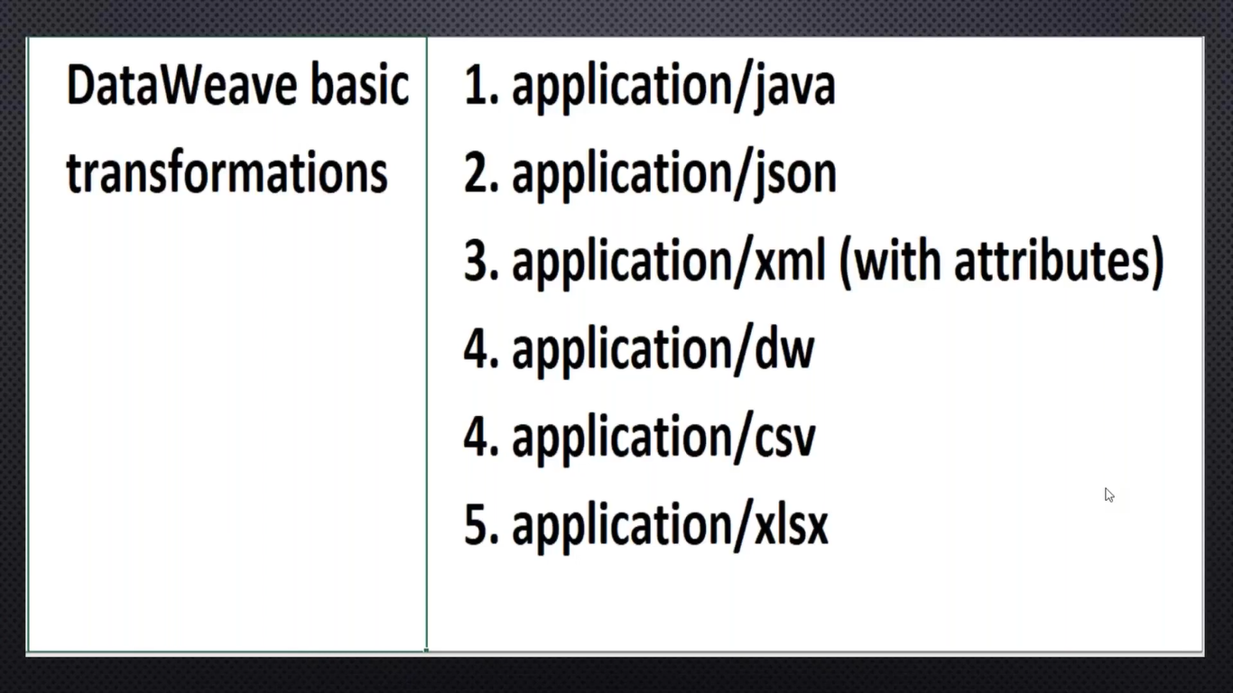

The default Data Type is Application/java because If we do conversion from XMl to JSON or JSON with XML in B/W java will do marshaling and marshaling when we will use payload.(Dot) operatior .If there is any conversion required then only we can go with JSON/XML until that beter we can keep JAVA only why because in Realtime performance will be improved

**Inbound Metadata:** Request towards to Transformer

**Out Bound Meta data:** What ever data we will form in required format from Request

Example1 :

Input:

{

"EmpName":"Ravi Kumar",

"EmpId":"12345",

"EmpGare":34,

"EmpSal":100000,

"EmpEmail":"abc@abc.com"

}

Json to XML:

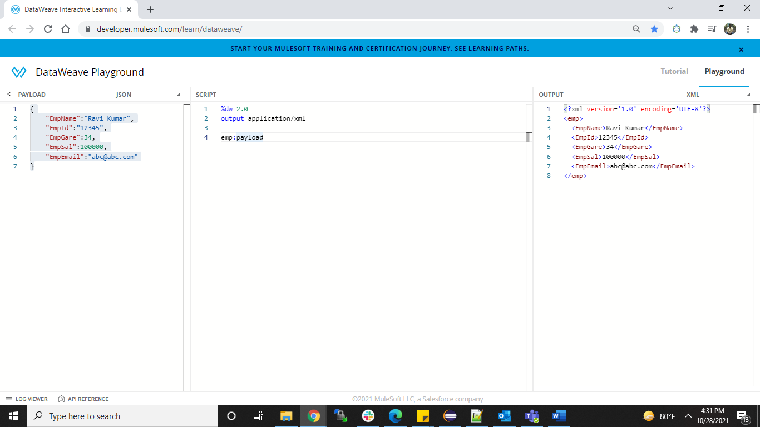

JSON to CSV:

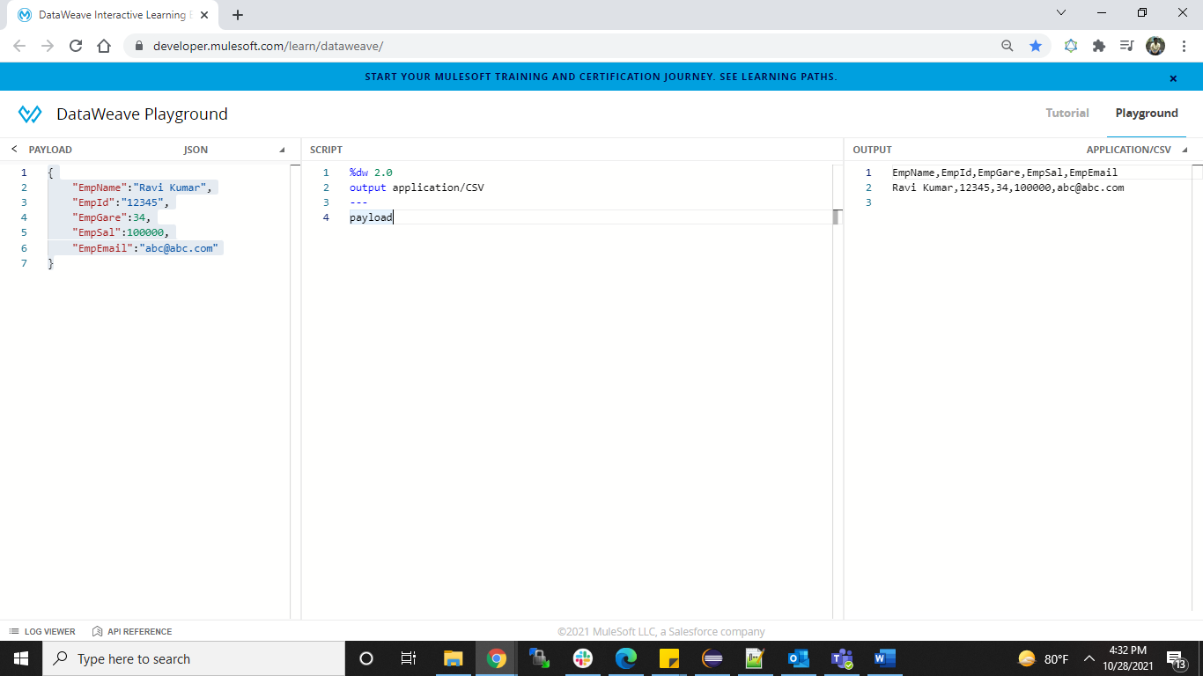

JSON to JAVA:

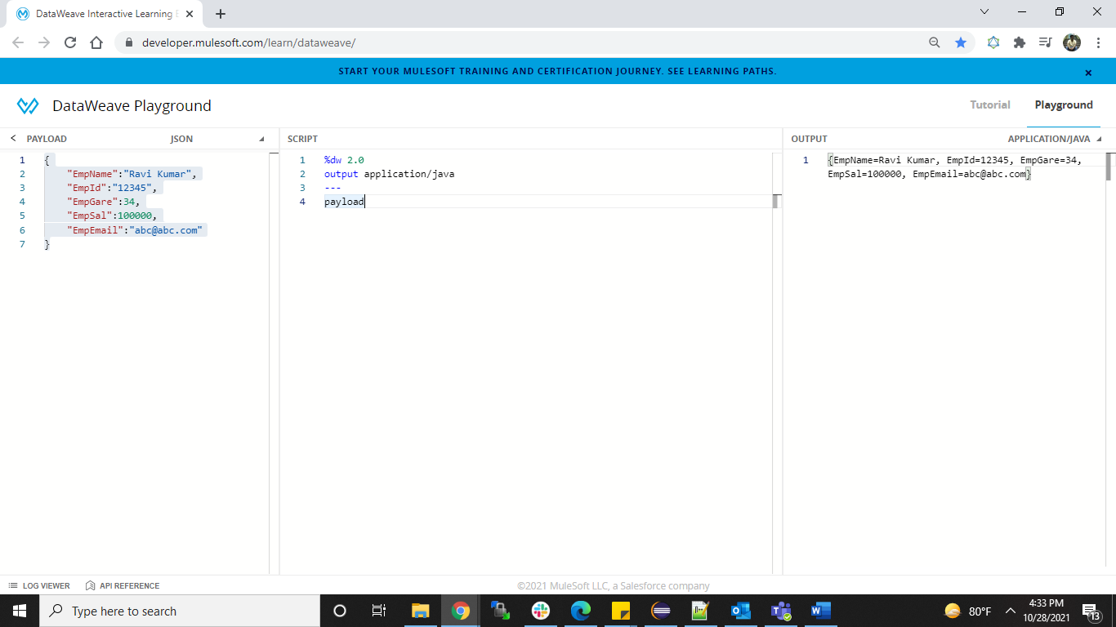

**XML to JSON:**

**Input:**

<book>

<title lan="en">JAVA SCJP</title>

<year>2010</year>

<price>1000</price>

<author loc="usa">Santhosh Kumar</author>

</book>

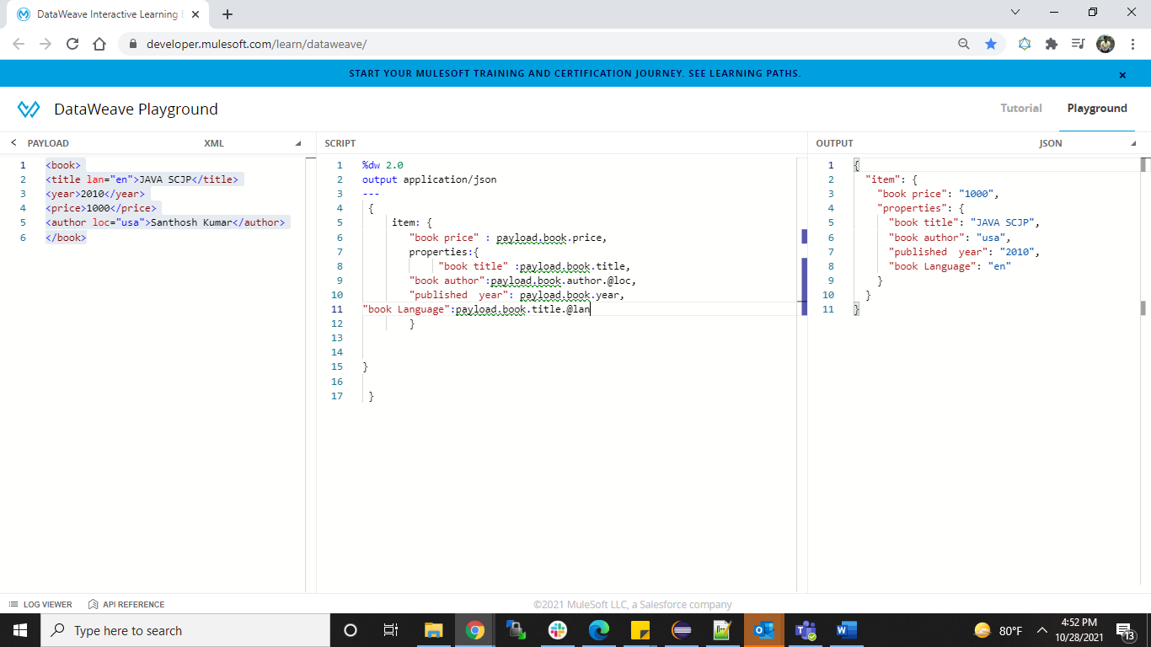

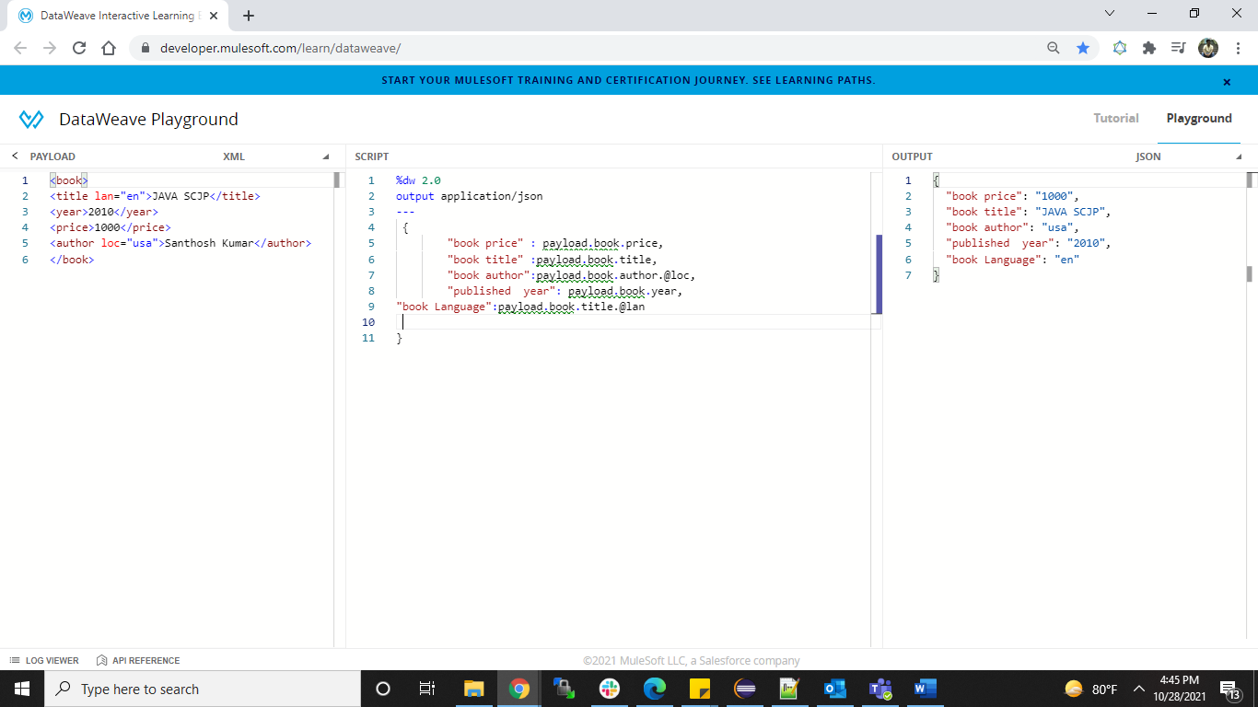

JSON to XML:

Input: {

"item": {

"bookprice": "1000",

"properties": {

"booktitle": "JAVA SCJP",

"bookauthor": "Santosh Kumar",

"bookauthorlanguage": "usa",

"bookLanguage": "en"

},

"publishedyear": "2010"

}

}

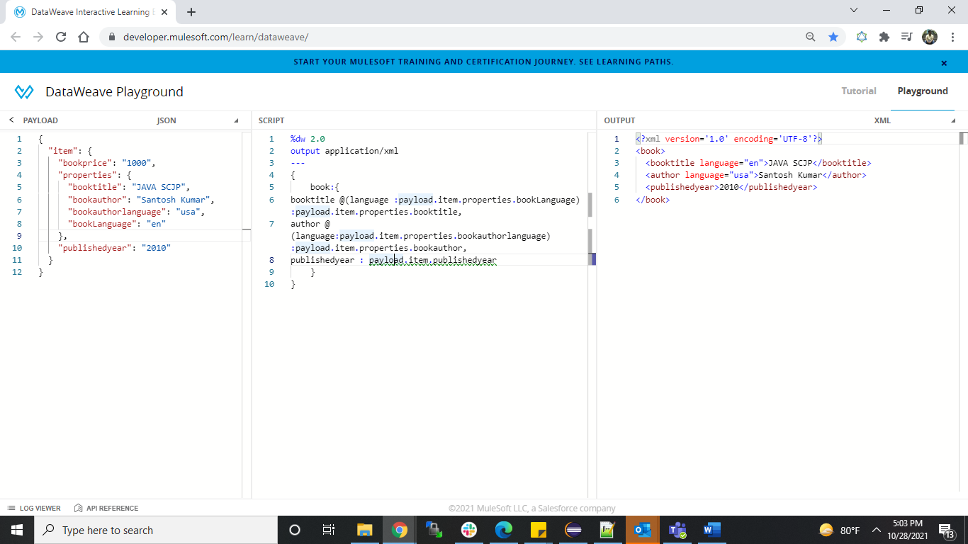

JSON to CSV:

