A
PROJECT REPORT
ON
CAR BOOKING
A website on CAR BOOKING

SUBMITTED TO
SARDAR PATEL UNIVERSITY MANDI
In the partial fulfilment of the requirements for the Diploma of
PGDCA (POST GRADUATE DIPLOMA OF COMPUTER APPLICATIONS)

Under Supervision Of: Submitted By: RAVINA THAKUR AND VENIKA
Mrs Sushila Saphiya

Developed At:
Department of Computer Science


ACKNOWLEDGEMENT
We would like to express our sincere gratitude all those who have contributed to the success completion of this project on CAR BOOKING and a website on mandi.
Firstly, we would like to thank our project guide Mrs Sushila Saphiya for their invaluable guidance and support throughout the duration of this project. Their expertise and willingness to share their knowledge have been instrumental in making this project a success.
We would also like to extend our gratitude to the team at CAR BOOKING , who were generous with their time and resources and provided us with the necessary information and materials for the case study.
Lastly, we would like to thank our college Vallabh Government College Mandi for providing us with the opportunity to work on this project and the necessary resources to complete it successfully.
In conclusion, we are deeply grateful to everyone who has contributed to the successful completion of our project. Thank you all for your invaluable support and guidance.

(RAVINA THAKUR and VENIKA)

CERTIFICATE-I

This is certified that RAVINA THAKUR , Uni. Roll No.202515014400033 and VENIKA , Roll No.202515014400034 students of PGDCA has submitted their project entitled CAR BOOKING, a website based on CAR BOOKING in Mandi (H.P.). It is certified that project work carried out under our supervision and no part of this project work has been submitted for any other Diploma course.

Dated….06../…01…/…2025….. Under Supervision:

Mrs Sushila Saphiya

CERTIFICATE-II

The Project report entitled CAR BOOKING – website based on CAR BOOKING submitted to department of computer application VGC Mandi in Partial fulfilment of the requirement for the Degree of PGDCA from SPU.

Signature of Candidates:

RAVINA THAKUR

VENIKA

DECLARATION
We, RAVINA THAKUR , Uni. Roll No. 202515014400033 and VENIKA , Roll No.202515014400034 are the student of VGC Mandi declare that we are submitted this project entitled with CAR BOOKING has been prepared by us during our PGDCA academic year 2025-2026.
Project work was done under the guidance of Mrs Sushila Saphiya our project guide, who has guided us very well throughout our graduation period.
The said Project work was done under the guidance of Mrs Sushila saphiya our project Guide, who has helped and guided us very well throughout our Project.
We declare that this submitted work is done solely by us and has been successfully done during our PGDCA Course in this esteemed college.
We also declare that all the information collected from various secondary sources has been duly acknowledged in this project report.

HARDWARE / SOFTWARE SPECIFICATION:

HAREWARE SPECIFICTION: (5 Concurrent Users)

PROCESSOR: 1GHz CPU (x86 or x64)
RAM: 512 MB (minimum), 1 GB(Recommended)
Hard disk: up to 200 MB of available space may be required.
Network Interface Card(NIC) for internet connectivity
Display Monitor with a minimum resolution of 1024x768 pixels

SOFTWARE SPECIFICATION:-

OPERATING SYSTEM:LINUX, UNIX, WINDOWS, MAC
Web Server software such as Apache or Nginx
Database Management System such as MySQL and MarianDb
DEVELOPING TOOL:VS CODE, LARAGON
LANGUAGES USED:–

Front end:HTML, CSS, Bootstrap, JavaScript
Backend:PHP, MySQL

INDEX

- Introduction To College
- Introduction To Project
- Scope Of The Project
- Project Management
- Content Strategy
- Copyright
- Information Design
- Front-End & Back-End Coding
- Further Scope Of The Project
- Conclusion

INTRODUCTION OF COLLEGE
Vallabh Government College is a well-known higher education institution located in Mandi, Himachal Pradesh, India. The college was established in 1949 and is affiliated Sardar Patel UniversityMandi

The college offers undergraduate and postgraduate courses in various fields such as science, commerce, arts, and computer applications. It also provides various certificate courses and add-on courses to enhance the knowledge and skills of the students.
The campus is spread over 35 acres of land and has state-of-the-art infrastructure facilities including a library, laboratories, computer center, sports complex, auditorium, and hostels for both boys and girls.
The college has a dedicated faculty of highly qualified and experienced professors who are committed to providing quality education to their students. The college also encourages students to participate in extracurricular activities such as sports, cultural events, and social service activities.
Overall, Vallabh Government College is a prestigious institution that has been contributing to the education sector of the state for over seven decades and continues to strive for excellence in all aspects of higher education.

TO PROJECT INTRODUCTION
Hospital
Welcome to the official website of [CAR BOOKING],
The Online Car Booking Website is a web-based application designed to provide users with an easy and efficient way to book cars online. In today’s fast-paced digital world, people prefer quick and convenient services, and online car booking systems help save time and effort compared to traditional booking methods.
This project allows users to view available cars, select their preferred vehicle, choose booking dates, and make reservations through a user-friendly interface. The system also helps administrators manage car details, bookings, and customer information efficiently. By automating the car booking process, the website reduces manual work, minimizes errors, and improves overall service quality.
The main objective of this project is to develop a reliable and secure platform that simplifies the car rental process for both customers and service providers. This project demonstrates the use of web technologies to create a practical real-world application that meets modern transportation needs.

SCOPE OF THE PROJECT

The scope of the Online Car Booking Website project is to design and develop a web-based system that enables users to book cars easily through the internet. The project focuses on providing a user-friendly interface where customers can view available cars, check details such as price and availability, and make bookings based on their requirements.
The system includes features such as user registration and login, car search and selection, booking management, and booking confirmation. It also allows administrators to add, update, and manage car details, monitor bookings, and manage customer information efficiently. This helps in reducing manual work and improving accuracy in managing car rental operations.
The project is limited to online car booking functionality and basic administrative control. Advanced features such as online payment gateways, GPS tracking, or mobile applications may be considered for future enhancements. The scope of this project is to demonstrate the effective use of web technologies to create a reliable and efficient car booking system suitable for real-world use.

PROJECT MANAGEMENT



Project management involves defining project goals, establishing a project plan, identifying necessary resources, managing project budgets, allocating tasks to team members, monitoring progress, and ensuring that the project is completed within the specified time frame and budget while meeting the requirements and expectations of stakeholders. Effective project management can help organizations increase efficiency, reduce costs, and improve the quality of their deliverables.

CONTENT STRATEGY

Content strategy refers to the planning, development, and management of content that is created and published by an organization. The goal of content strategy is to create valuable and relevant content that attracts and engages the target audience, ultimately driving profitable customer action
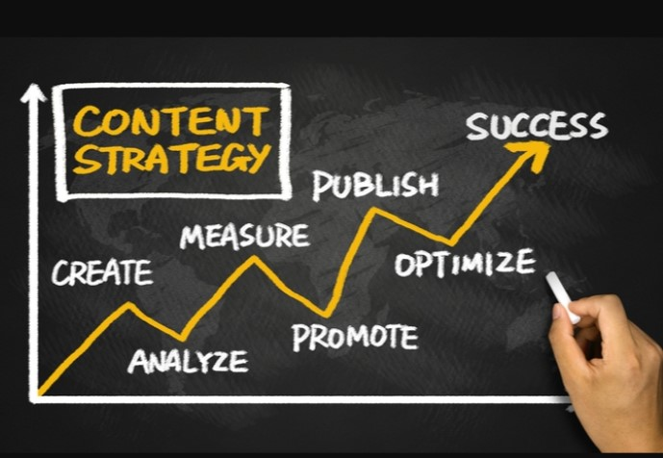

A well-designed content strategy helps an organization achieve its goals by defining what content is needed, who the target audience is, what channels to use, how to create and distribute the content, and how to measure its effectiveness.

COPYRIGHT


Copyright is a legal term that refers to the exclusive right granted to creators of original works to control how their works are used and distributed. Copyright law protects creative works such as literary, musical, and artistic works, as well as computer software, sound recordings used, and movies.
The purpose of copyright law is to promote creativity and protect the rights of creators by giving them the exclusive right to control how their works are and distributed. This allows creators to profit from their works and encourages them to continue producing new creative works.

INFORMATION DESIGN



Information design refers to the process of creating visual representations of information or data to make it more understandable and engaging to the audience. It involves organizing and presenting information in a clear, concise, and visually appealing way to improve.
Information design can take many forms, including charts, graphs, info graphics, diagrams, and maps. The goal is to use visual elements to communicate complex or abstract ideas more effectively and to help the audience better understand the information being presented.
Good information design takes into account the audience's needs, goals, and preferences. It also considers the context in which the information is being presented, such as the medium and platform being used. For example, an info graphic designed for social media will be different from an info graphic designed for a scientific journal.

FRONT-END & BACK-END CODING
Front-End design refers to the process of creating the user interface of a website or application. It involves designing and developing the visual and interactive elements that users see and interact with on the front end of the website or application.
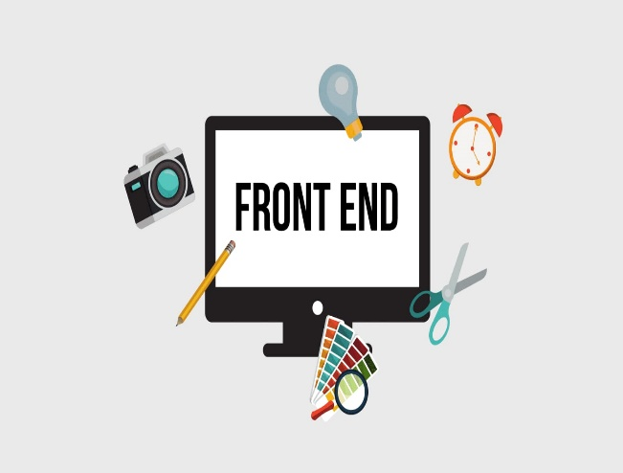
Front-end design typically involves using web technologies such as HTML, CSS &JAVASCRIPTto create a visually appealing and user-friendly interface. The goal is to create a design that is easy to navigate, visually pleasing, and accessible to a wide range of users.
HTML (Hypertext Markup Language)is a standard markup language used for creating web pages and web applications. It provides the basic structure and content of a web page and is responsible for defining the elements and attributes used on a web page.
CSS (Cascading Style Sheets)is a style sheet language used to describe the presentation of web pages written in HTML and XML. CSS is used to style the visual appearance of a web page, including the layout, fonts, colours and other design elements.
JavaScript (often abbreviated as JS) is a programming language that is widely used for both front-end and back-end executed by a web browser or server without requiring a separate compilation step.
Bootstrap is a popular front-end framework for building responsive and mobile-first websites and web applications. It was developed by Twitter and is now maintained as an open-source project.
PHP (Hypertext Pre-processor) is a server-side scripting language that is widely used for web development. It is an open-source language and is very popular for building dynamic websites and web applications.



Backend coding refers to the development of the server-side components of a website or application. This includes the logic and functionality that powers the front-end interface and handles the processing of data and user interactions.
Backend coding typically involves using programming languages such as PHP& MYSQL to develop the application logic and connect it to a database. It involves writing code that can perform tasks such as user authentication, data storage and retrieval, and the handling of user requests and responses.
Some key components of backend coding includes:
- Server architecture: This involves designing the architecture and infrastructure of the server and choosing the appropriate technologies to support the application.
- Database design:This involves designing the structure and schema of the database to store and retrieve data efficiently.
- APIs:APIs (Application Programming Interfaces) are used to allow different components of the application to communicate with each other. Backend coding involves developing APIs to enable the front-end interface to interact with the server.
- Security:Backend coding involves implementing security measures such as encryption and user authentication to protect sensitive data and prevent unauthorized access.

What is Web development?

Web development is the process of creating websites and web applications for the internet. It involves a combination of technical skills, such as programming languages, frameworks, and database management, as well as design and user experience principles.
Web development can be divided into two main categories: front-enddevelopment and back-end development. Front-end development focuses on the user interface and the client-side functionality of the website, while back-end development deals with the server-side processing and database management.


Some of the most common programming languages used in web development include HTML, CSS, JavaScript, PHP .There are also many popular web development frameworks, such as React, Angular, Vue, Django, and Ruby on Rails, that can help streamline the development process and improve code efficiency.
HTML
(Hyper Text Markup Language)


HTMLstands for Hypertext Markup Language and is a standard markup language used for creating web pages and web applications. It provides the basic structure and content of a web page and is responsible for defining the elements and attributes used on a web page.
HTML consists of a series of tags and attributes that are used to define the structure of a web page. Some of the most common HTML tags include:
- <Html>: Defines the start and end of an HTML document.
- <Head>: Contains metadata information about the web page, such as the title and links to external resources.
- <Body>: Contains the main content of the web page, such as text, images, and other multimedia elements.
- <Div>: Defines a section of the web page and is often used for grouping related elements together.
- <p>: Defines a paragraph of text.
- <Img>: Defines an image and its attributes, such as the source and alt text.
HTML is often used in conjunction with other web technologies, such as CSS (Cascading Style Sheets) and JavaScript, to create visually appealing and interactive web pages. CSS is used to define the presentation and layout of the web page, while JavaScript is used to add dynamic functionality and interactivity.
CSS
CSS (Cascading Style Sheets) is a stylesheet language used to describe the visual presentation of HTML and XML documents. CSS provides a way to separate the content from the presentation of a web page, making it easier to manage and update the layout and appearance of a website.

Types of cascading stylesheet (CSS)

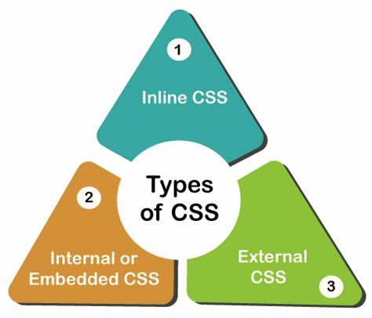

- Inline CSS:
This type of CSS is applied directly to an HTML element using the "style" attribute. Inline CSS overrides any other CSS styles that may be applied to the same element through external or internal stylesheet.
Syntax:

<p style:” colour: red”>

- Internal CSS:
This type of CSS is defined within the head section of an HTML document using the "style" tag. Internal CSS applies to all the elements of the HTML document that are wrapped inside the opening and closing tags of the style element.
Syntax:

<Style>----</style>

- External CSS:
This type of CSS is defined in a separate .css file and linked to an HTML document using the "link" tag. External CSS allows for a more modular and organized approach to styling a website, as the same stylesheet can be applied to multiple HTML pages.
Syntax:
<style.css>

MAINFRAME
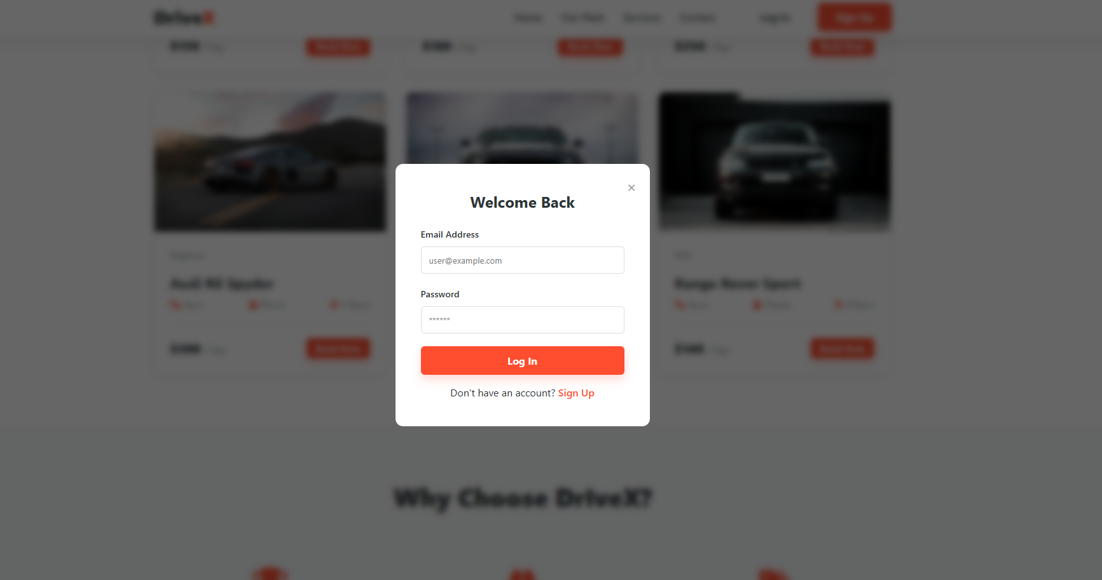
OUR PROJECT’S HTML STRUCTURE
In this webpage creation I use (html, css, js)

<!DOCTYPE html>
<html lang="en">
<head>
<meta charset="UTF-8">
<meta name="viewport" content="width=device-width, initial-scale=1.0">
<title>DriveX - Premium Car Booking</title>
<link rel="stylesheet" href="https://cdnjs.cloudflare.com/ajax/libs/font-awesome/6.4.0/css/all.min.css">

<style>
/* ============================
CSS STYLES
============================ */

/* --- Global Variables & Reset --- */
:root {
--primary-color: #ff4d30;
--secondary-color: #2d3436;
--text-color: #636e72;
--bg-light: #f8f9fa;
--white: #ffffff;
--shadow: 0 5px 20px rgba(0, 0, 0, 0.1);
--transition: all 0.3s ease;
}

* {
margin: 0;
padding: 0;
box-sizing: border-box;
font-family: 'Segoe UI', Tahoma, Geneva, Verdana, sans-serif;
}

html { scroll-behavior: smooth; }
body { color: var(--secondary-color); line-height: 1.6; overflow-x: hidden; }
a { text-decoration: none; color: inherit; }
ul { list-style: none; }

/* --- Buttons --- */
.btn {
padding: 12px 28px;
border-radius: 6px;
cursor: pointer;
font-weight: 700;
transition: var(--transition);
border: none;
font-size: 1rem;
display: inline-block;
text-align: center;
}

.btn-primary {
background-color: var(--primary-color);
color: var(--white);
box-shadow: 0 8px 15px rgba(255, 77, 48, 0.2);
}

.btn-primary:hover {
background-color: #e03e23;
transform: translateY(-2px);
box-shadow: 0 12px 20px rgba(255, 77, 48, 0.3);
}

.btn-transparent {
background: transparent;
color: var(--secondary-color); /* Default for sticky header */
border: 2px solid transparent;
}

/* Header specific button adjustment handled in header section */

.btn-block { width: 100%; }
.btn-sm { padding: 6px 15px; font-size: 0.9rem; }
.btn-outline { border: 2px solid var(--secondary-color); background: transparent; }

/* --- Header & Navigation --- */
header {
position: fixed;
top: 0;
width: 100%;
z-index: 1000;
transition: var(--transition);
padding: 15px 0;
background: transparent;
}

header.scrolled {
background: var(--white);
box-shadow: var(--shadow);
padding: 10px 0;
}

.container {
max-width: 1200px;
margin: 0 auto;
padding: 0 20px;
position: relative;
}

.nav-container {
display: flex;
justify-content: space-between;
align-items: center;
}

.logo {
font-size: 1.8rem;
font-weight: 800;
color: var(--white); /* White initially */
z-index: 1001;
transition: var(--transition);
}

header.scrolled .logo { color: var(--secondary-color); }

.logo span { color: var(--primary-color); }

/* Desktop Nav */
.nav-menu {
display: flex;
align-items: center;
gap: 30px;
}

.nav-links { display: flex; gap: 30px; }

.nav-links a {
font-weight: 600;
color: var(--white);
transition: var(--transition);
position: relative;
}

header.scrolled .nav-links a { color: var(--secondary-color); }

.nav-links a:hover, .nav-links a.active { color: var(--primary-color); }

/* Auth Buttons in Nav */
.auth-buttons button { margin-left: 10px; }
.auth-buttons .btn-transparent { color: var(--white); }
header.scrolled .auth-buttons .btn-transparent { color: var(--secondary-color); }
header.scrolled .auth-buttons .btn-transparent:hover { color: var(--primary-color); }

/* Mobile Hamburger */
.hamburger {
display: none;
flex-direction: column;
cursor: pointer;
z-index: 1001;
}

.hamburger span {
width: 25px;
height: 3px;
background-color: var(--white);
margin: 2px 0;
transition: 0.4s;
border-radius: 2px;
}

header.scrolled .hamburger span { background-color: var(--secondary-color); }

/* --- Mobile Responsive Nav Styles --- */
@media screen and (max-width: 960px) {
.hamburger { display: flex; }

.nav-menu {
position: fixed;
top: 0;
right: -100%; /* Hidden by default */
width: 70%;
height: 100vh;
background-color: var(--white);
flex-direction: column;
justify-content: center;
align-items: center;
transition: 0.5s ease;
box-shadow: -5px 0 15px rgba(0,0,0,0.1);
}

.nav-menu.active { right: 0; }

.nav-links {
flex-direction: column;
text-align: center;
gap: 40px;
margin-bottom: 40px;
}

.nav-links a, header.scrolled .nav-links a {
color: var(--secondary-color);
font-size: 1.5rem;
}

.auth-buttons {
display: flex;
flex-direction: column;
gap: 15px;
width: 80%;
}

.auth-buttons .btn-transparent { color: var(--secondary-color); border: 1px solid #ddd; }

/* Hamburger Animation to X */
.hamburger.toggle span:nth-child(1) { transform: rotate(-45deg) translate(-5px, 5px); background-color: var(--secondary-color); }
.hamburger.toggle span:nth-child(2) { opacity: 0; }
.hamburger.toggle span:nth-child(3) { transform: rotate(45deg) translate(-5px, -5px); background-color: var(--secondary-color); }

.logo { color: var(--white); } /* Keep logo white or adjust based on background */
header.scrolled .logo { color: var(--secondary-color); }
}

/* --- Hero Section --- */
.hero {
height: 100vh;
background: linear-gradient(rgba(0,0,0,0.5), rgba(0,0,0,0.5)), url('https://images.unsplash.com/photo-1449965408869-eaa3f722e40d?ixlib=rb-1.2.1&auto=format&fit=crop&w=1950&q=80') center/cover no-repeat;
display: flex;
align-items: center;
justify-content: center;
text-align: center;
padding: 0 20px;
margin-top: 0;
}

.hero-content {
color: var(--white);
max-width: 800px;
animation: fadeIn Up 1s ease;
}

.hero h1 { font-size: 3.5rem; line-height: 1.2; margin-bottom: 20px; }
.hero .highlight { color: var(--primary-color); }
.hero p { font-size: 1.2rem; margin-bottom: 40px; opacity: 0.9; }

/* Search Box */
.search-box {
background: var(--white);
padding: 25px;
border-radius: 12px;
display: flex;
gap: 15px;
box-shadow: 0 15px 30px rgba(0,0,0,0.2);
align-items: flex-end;
text-align: left;
}

.input-group { flex: 1; display: flex; flex-direction: column; }
.input-group label { font-weight: 700; font-size: 0.9rem; color: var(--secondary-color); margin-bottom: 8px; }
.input-group input { padding: 12px; border: 1px solid #ddd; border-radius: 6px; outline: none; width: 100%; }
.input-group input:focus { border-color: var(--primary-color); }

@media screen and (max-width: 768px) {
.hero h1 { font-size: 2.5rem; }
.search-box { flex-direction: column; width: 100%; }
.input-group { width: 100%; }
.search-btn { width: 100%; margin-top: 10px; }
}

/* --- Car Fleet Section --- */
.section { padding: 80px 0; }
.bg-light { background-color: var(--bg-light); }
.section-header { text-align: center; margin-bottom: 50px; }
.section-header h2 { font-size: 2.5rem; margin-bottom: 10px; font-weight: 800; }
.section-header p { color: var(--text-color); }

.car-grid {
display: grid;
grid-template-columns: repeat(auto-fit, minmax(300px, 1fr));
gap: 30px;
}

.car-card {
background: var(--white);
border-radius: 12px;
overflow: hidden;
box-shadow: 0 5px 15px rgba(0,0,0,0.05);
transition: var(--transition);
border: 1px solid #eee;
display: flex;
flex-direction: column;
}

.car-card:hover { transform: translateY(-10px); box-shadow: var(--shadow); }

.car-image-container { overflow: hidden; height: 220px; }
.car-image { width: 100%; height: 100%; object-fit: cover; transition: transform 0.5s ease; }
.car-card:hover .car-image { transform: scale(1.1); }

.car-details { padding: 25px; flex-grow: 1; display: flex; flex-direction: column; }
.car-title { font-size: 1.4rem; margin-bottom: 5px; font-weight: 700; }
.car-category { color: var(--text-color); font-size: 0.9rem; margin-bottom: 15px; }

.car-specs {
display: flex;
justify-content: space-between;
margin-bottom: 20px;
padding-bottom: 20px;
border-bottom: 1px solid #eee;
}

.spec-item { display: flex; align-items: center; gap: 5px; color: var(--text-color); font-size: 0.9rem; }
.spec-item i { color: var(--primary-color); }

.car-footer { display: flex; justify-content: space-between; align-items: center; margin-top: auto; }
.price { font-size: 1.25rem; font-weight: 800; color: var(--secondary-color); }
.price span { font-size: 0.9rem; color: var(--text-color); font-weight: 400; }

/* --- Footer --- */
footer { background: #1a1a1a; color: #fff; padding: 70px 0 20px; }
.footer-content { display: grid; grid-template-columns: repeat(auto-fit, minmax(250px, 1fr)); gap: 40px; margin-bottom: 40px; }
.footer-col h3 { font-size: 1.5rem; margin-bottom: 20px; color: var(--white); }
.footer-col p { color: #bbb; line-height: 1.8; }
.footer-col ul li { margin-bottom: 12px; }
.footer-col ul li a { color: #bbb; transition: 0.3s; }
.footer-col ul li a:hover { color: var(--primary-color); padding-left: 5px; }
.social-links { display: flex; gap: 15px; margin-top: 20px; }
.social-links a { width: 40px; height: 40px; background: #333; display: flex; justify-content: center; align-items: center; border-radius: 50%; transition: 0.3s; }
.social-links a:hover { background: var(--primary-color); }
.footer-bottom { border-top: 1px solid #333; padding-top: 25px; text-align: center; color: #666; font-size: 0.9rem; }

/* --- Modals (Login/Signup) --- */
.modal-overlay {
position: fixed;
top: 0; left: 0; width: 100%; height: 100%;
background: rgba(0,0,0,0.6);
backdrop-filter: blur(5px);
z-index: 2000;
display: flex; justify-content: center; align-items: center;
opacity: 0; visibility: hidden; transition: 0.3s;
}
.modal-overlay.active { opacity: 1; visibility: visible; }
.modal-content {
background: var(--white); padding: 40px; border-radius: 12px;
width: 400px; max-width: 90%;
position: relative; transform: translateY(-50px); transition: 0.3s;
}
.modal-overlay.active .modal-content { transform: translateY(0); }
.close-modal { position: absolute; top: 15px; right: 20px; font-size: 1.5rem; cursor: pointer; color: #999; }
.close-modal:hover { color: var(--primary-color); }
.modal-content h2 { margin-bottom: 20px; text-align: center; }

.form-group { margin-bottom: 20px; }
.form-group label { display: block; margin-bottom: 8px; font-weight: 600; font-size: 0.9rem; }
.form-group input { width: 100%; padding: 12px; border: 1px solid #ddd; border-radius: 6px; outline: none; }
.form-group input:focus { border-color: var(--primary-color); }

/* Utilities */
.hidden { display: none !important; }
.user-profile { display: flex; align-items: center; gap: 10px; font-weight: 600; }
#user-name { color: var(--white); }
header.scrolled #user-name { color: var(--secondary-color); }
@media screen and (max-width: 960px) {
#user-name { color: var(--secondary-color); } /* In mobile menu */
}
</style>
</head>
<body>

<header id="header">
<div class="container nav-container">
<a href="#" class="logo">Drive<span>X</span></a>

<div class="hamburger" id="hamburger">
<span></span>
<span></span>
<span></span>
</div>

<nav class="nav-menu" id="nav-menu">
<ul class="nav-links">
<li><a href="#home" class="active" onclick="closeMenu()">Home</a></li>
<li><a href="#fleet" onclick="closeMenu()">Our Fleet</a></li>
<li><a href="#services" onclick="closeMenu()">Services</a></li>
<li><a href="#contact" onclick="closeMenu()">Contact</a></li>
</ul>

<div class="auth-buttons" id="auth-buttons">
<button class="btn btn-transparent" id="login-btn" onclick="closeMenu()">Log In</button>
<button class="btn btn-primary" id="signup-btn" onclick="closeMenu()">Sign Up</button>
</div>

<div class="user-profile hidden" id="user-profile">
<span id="user-name">User</span>
<button class="btn btn-sm btn-outline" id="logout-btn" onclick="closeMenu()">Logout</button>
</div>
</nav>
</div>
</header>

<section id="home" class="hero">
<div class="hero-content">
<h1>The Easy Way To Take <br> <span class="highlight">Control</span> Of Your Ride</h1>
<p>Rent high-end vehicles for your next trip. Unbeatable prices, unlimited miles, and flexible pick-up options.</p>

<div class="search-box">
<div class="input-group">
<label><i class="fas fa-map-marker-alt"></i> Location</label>
<input type="text" placeholder="City or Airport">
</div>
<div class="input-group">
<label><i class="far fa-calendar-alt"></i> Pick-up</label>
<input type="date">
</div>
<div class="input-group">
<label><i class="far fa-calendar-alt"></i> Return</label>
<input type="date">
</div>
<button class="btn btn-primary search-btn">Search</button>
</div>
</div>
</section>

<section id="fleet" class="section">
<div class="container">
<div class="section-header">
<h2>Our Premium Fleet</h2>
<p>Top rated vehicles for every occasion.</p>
</div>

<div class="car-grid" id="car-grid">
</div>
</div>
</section>

<section id="services" class="section bg-light">
<div class="container">
<div class="section-header">
<h2>Why Choose DriveX?</h2>
</div>
<div class="car-grid" style="text-align: center;">
<div class="car-card" style="padding: 30px; align-items: center; border:none; box-shadow:none; background: transparent;">
<i class="fas fa-trophy" style="font-size: 3rem; color: var(--primary-color); margin-bottom:20px;"></i>
<h3 style="margin-bottom: 10px;">First Class Service</h3>
<p style="color: #666;">We prioritize your comfort and safety above all else.</p>
</div>
<div class="car-card" style="padding: 30px; align-items: center; border:none; box-shadow:none; background: transparent;">
<i class="fas fa-road" style="font-size: 3rem; color: var(--primary-color); margin-bottom:20px;"></i>
<h3 style="margin-bottom: 10px;">24/7 Road Support</h3>
<p style="color: #666;">Help is just a phone call away, anywhere, anytime.</p>
</div>
<div class="car-card" style="padding: 30px; align-items: center; border:none; box-shadow:none; background: transparent;">
<i class="fas fa-tags" style="font-size: 3rem; color: var(--primary-color); margin-bottom:20px;"></i>
<h3 style="margin-bottom: 10px;">Quality at Minimum</h3>
<p style="color: #666;">Best price guarantee for all our premium vehicles.</p>
</div>
</div>
</div>

</section>

<footer id="contact">
<div class="container footer-content">
<div class="footer-col">
<h3>Drive<span>X</span></h3>
<p>We provide the best cars for you to enjoy your trip safely and comfortably.</p>
<div class="social-links">
<a href="#"><i class="fab fa-facebook-f"></i></a>
<a href="#"><i class="fab fa-twitter"></i></a>
<a href="#"><i class="fab fa-instagram"></i></a>
</div>
</div>
<div class="footer-col">
<h3>Quick Links</h3>
<ul>
<li><a href="#home">Home</a></li>
<li><a href="#fleet">Our Fleet</a></li>
<li><a href="#services">Services</a></li>
<li><a href="#contact">Contact</a></li>
</ul>
</div>
<div class="footer-col">
<h3>Contact</h3>
<ul>
<li><i class="fas fa-map-marker-alt"></i> 123 Street, New York, USA</li>
<li><i class="fas fa-phone"></i> +1 234 567 8900</li>
<li><i class="fas fa-envelope"></i> info@drivex.com</li>
</ul>
</div>
</div>
<div class="footer-bottom">
<div class="container">
<p>&copy; 2024 DriveX. All Rights Reserved.</p>
</div>
</div>
</footer>

<div class="modal-overlay" id="login-modal">
<div class="modal-content">
<span class="close-modal">&times;</span>
<h2>Welcome Back</h2>
<form id="login-form">
<div class="form-group">
<label>Email Address</label>
<input type="email" id="login-email" required placeholder="user@example.com">
</div>
<div class="form-group">
<label>Password</label>
<input type="password" id="login-password" required placeholder="******">
</div>
<button type="submit" class="btn btn-primary btn-block">Log In</button>
<p class="modal-footer-text" style="margin-top:15px; text-align:center;">Don't have an account? <a href="#" id="switch-to-signup" style="color:var(--primary-color); font-weight:600;">Sign Up</a></p>
</form>
</div>
</div>

<div class="modal-overlay" id="signup-modal">
<div class="modal-content">
<span class="close-modal">&times;</span>
<h2>Create Account</h2>
<form id="signup-form">
<div class="form-group">
<label>Full Name</label>
<input type="text" id="signup-name" required placeholder="John Doe">
</div>
<div class="form-group">
<label>Email Address</label>
<input type="email" id="signup-email" required placeholder="john@example.com">
</div>
<div class="form-group">
<label>Password</label>
<input type="password" id="signup-password" required placeholder="Create a password">
</div>
<button type="submit" class="btn btn-primary btn-block">Sign Up</button>
<p class="modal-footer-text" style="margin-top:15px; text-align:center;">Already have an account? <a href="#" id="switch-to-login" style="color:var(--primary-color); font-weight:600;">Log In</a></p>
</form>
</div>
</div>

<script>
/* ============================
JAVASCRIPT LOGIC
============================ */

// Data: Real Unsplash Images
const carsData = [
{
id: 1,
name: "Tesla Model S",
price: 150,
type: "Electric",
transmission: "Auto",
fuel: "EV",
image: "https://images.unsplash.com/photo-1560958089-b8a1929cea89?ixlib=rb-1.2.1&auto=format&fit=crop&w=800&q=80"
},
{
id: 2,
name: "BMW M4 Comp",
price: 180,
type: "Sports",
transmission: "Auto",
fuel: "Petrol",
image: "https://images.unsplash.com/photo-1617531653332-bd46c24f2068?ixlib=rb-1.2.1&auto=format&fit=crop&w=800&q=80"
},
{
id: 3,
name: "Mercedes G-Wagon",
price: 250,
type: "SUV",
transmission: "Auto",
fuel: "Diesel",
image: "https://images.unsplash.com/photo-1549399542-7e3f8b79c341?ixlib=rb-1.2.1&auto=format&fit=crop&w=800&q=80"
},
{
id: 4,
name: "Audi R8 Spyder",
price: 300,
type: "Supercar",
transmission: "Auto",
fuel: "Petrol",
image: "https://images.unsplash.com/photo-1603584173870-7f23fdae1b7a?ixlib=rb-1.2.1&auto=format&fit=crop&w=800&q=80"
},
{
id: 5,
name: "Ford Mustang GT",
price: 110,
type: "Muscle",
transmission: "Manual",
fuel: "Petrol",
image: "https://images.unsplash.com/photo-1494976388531-d1058494cdd8?ixlib=rb-1.2.1&auto=format&fit=crop&w=800&q=80"
},
{
id: 6,
name: "Range Rover Sport",
price: 140,
type: "SUV",
transmission: "Auto",
fuel: "Diesel",
image: "https://images.unsplash.com/photo-1563720223185-11003d516935?ixlib=rb-1.2.1&auto=format&fit=crop&w=800&q=80"
}
];

/* --- Elements --- */
const header = document.querySelector('header');
const hamburger = document.getElementById('hamburger');
const navMenu = document.getElementById('nav-menu');
const carGrid = document.getElementById('car-grid');

/* --- Mobile Navigation --- */
hamburger.addEventListener('click', () => {
hamburger.classList.toggle('toggle');
navMenu.classList.toggle('active');
});

// Close menu when a link is clicked
function closeMenu() {
hamburger.classList.remove('toggle');
navMenu.classList.remove('active');
}

/* --- Scroll Animation --- */
window.addEventListener('scroll', () => {
if (window.scrollY > 50) {
header.classList.add('scrolled');
} else {
header.classList.remove('scrolled');
}
});

/* --- Render Cars --- */
function renderCars() {
carGrid.innerHTML = carsData.map(car => `
<div class="car-card">
<div class="car-image-container">
<img src="${car.image}" alt="${car.name}" class="car-image">
</div>
<div class="car-details">
<span class="car-category">${car.type}</span>
<h3 class="car-title">${car.name}</h3>

<div class="car-specs">
<span class="spec-item"><i class="fas fa-cogs"></i> ${car.transmission}</span>
<span class="spec-item"><i class="fas fa-gas-pump"></i> ${car.fuel}</span>
<span class="spec-item"><i class="fas fa-chair"></i> 4 Seats</span>
</div>

<div class="car-footer">
<div class="price">$${car.price} <span>/ Day</span></div>
<button class="btn btn-primary btn-sm" onclick="bookCar(${car.id})">Book Now</button>
</div>
</div>
</div>
`).join('');
}

/* --- Booking Logic --- */
function bookCar(id) {
const user = JSON.parse(localStorage.getItem('drivex_current_user'));
if (!user) {
alert("Please login to book a car!");
openModal('login');
} else {
const car = carsData.find(c => c.id === id);
alert(`Booking Successful!\nVehicle: ${car.name}\nTotal: $${car.price}\n\nWe will contact you shortly, ${user.name}!`);
}
}

/* --- Auth Modal Logic --- */
const loginModal = document.getElementById('login-modal');
const signupModal = document.getElementById('signup-modal');
const closeModals = document.querySelectorAll('.close-modal');

function openModal(type) {
closeMenu(); // Ensure mobile menu is closed first
if (type === 'login') {
loginModal.classList.add('active');
signupModal.classList.remove('active');
} else {
signupModal.classList.add('active');
loginModal.classList.remove('active');
}
}

function closeModal() {
loginModal.classList.remove('active');
signupModal.classList.remove('active');
}

// Event Listeners
document.getElementById('login-btn').addEventListener('click', () => openModal('login'));
document.getElementById('signup-btn').addEventListener('click', () => openModal('signup'));

closeModals.forEach(btn => btn.addEventListener('click', closeModal));
window.addEventListener('click', (e) => {
if (e.target === loginModal || e.target === signupModal) closeModal();
});

document.getElementById('switch-to-signup').addEventListener('click', (e) => { e.preventDefault(); openModal('signup'); });
document.getElementById('switch-to-login').addEventListener('click', (e) => { e.preventDefault(); openModal('login'); });

/* --- Auth System (LocalStorage) --- */
const DB_KEY = 'drivex_users';
const SESSION_KEY = 'drivex_current_user';

document.getElementById('signup-form').addEventListener('submit', (e) => {
e.preventDefault();
const name = document.getElementById('signup-name').value;
const email = document.getElementById('signup-email').value;
const password = document.getElementById('signup-password').value;
const users = JSON.parse(localStorage.getItem(DB_KEY)) || [];

if (users.find(u => u.email === email)) {
alert("User already exists!");
return;
}

users.push({ name, email, password });
localStorage.setItem(DB_KEY, JSON.stringify(users));
alert("Account created! Please log in.");
openModal('login');
e.target.reset();
});

document.getElementById('login-form').addEventListener('submit', (e) => {
e.preventDefault();
const email = document.getElementById('login-email').value;
const password = document.getElementById('login-password').value;
const users = JSON.parse(localStorage.getItem(DB_KEY)) || [];
const user = users.find(u => u.email === email && u.password === password);

if (user) {
localStorage.setItem(SESSION_KEY, JSON.stringify(user));
checkSession();
closeModal();
alert(`Welcome back, ${user.name}!`);
e.target.reset();
} else {
alert("Invalid credentials!");
}
});

document.getElementById('logout-btn').addEventListener('click', () => {
localStorage.removeItem(SESSION_KEY);
checkSession();
alert("Logged out.");
});

function checkSession() {
const user = JSON.parse(localStorage.getItem(SESSION_KEY));
const authBtns = document.getElementById('auth-buttons');
const userProfile = document.getElementById('user-profile');
const userName = document.getElementById('user-name');

if (user) {
authBtns.classList.add('hidden');
userProfile.classList.remove('hidden');
userName.textContent = `Hi, ${user.name.split(' ')[0]}`;
} else {
authBtns.classList.remove('hidden');
userProfile.classList.add('hidden');
}
}

// Initialize
renderCars();
checkSession();

</script>
</body>
</html>

FINAL WEBSITE CAME OUT THROUGH ABOVE CODING:
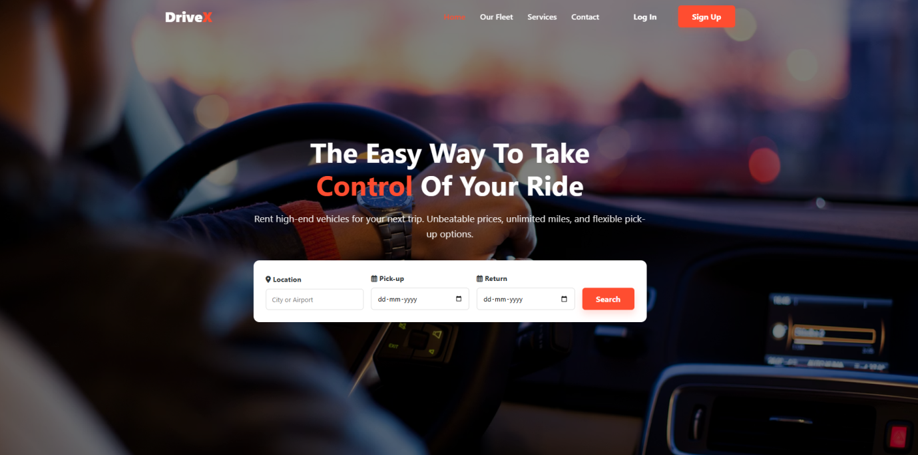



FURTHER SCOPE OF THE PROJECT

The Online Car Booking Website can be further enhanced in the future by adding advanced features and technologies to improve functionality and user experience. One possible enhancement is the integration of an online payment gateway, allowing users to make secure payments through credit cards, debit cards, or digital wallets. This would make the booking process faster and more convenient.
The project can also be expanded by developing a mobile application for Android and iOS platforms, enabling users to book cars using their smartphones. Additional features such as GPS tracking, real-time vehicle availability, and route navigation can be included to improve service efficiency. Customer feedback and rating systems can also be added to help improve service quality.
In the future, the system may support multiple branches, dynamic pricing, and integration with third-party services such as maps and notification systems. These enhancements would make the system more scalable, flexible, and suitable for large-scale commercial use.

CONCLUSION
The Online Car Booking Website project successfully provides a simple and efficient platform for booking cars through the internet. The system automates the car booking process, making it easier for users to search for available vehicles, select suitable options, and complete bookings without manual effort. This helps save time and improves overall convenience for customers.
The project also benefits administrators by providing an organized way to manage car details, customer information, and booking records. By reducing paperwork and manual errors, the system increases accuracy and operational efficiency. The user-friendly design and structured functionality make the website easy to use and reliable.
Overall, this project demonstrates the effective use of web technologies in developing a practical real-world application. The Online Car Booking Website meets its objectives and can be further enhanced in the future by adding advanced features to improve performance and scalability.

