# Travis Payne

# Information Visualization

Investigation into factors increasing risk of suicide

**Motivation**

According to the U.S. Centers for Disease Control and Prevention (CDC), 1 million adults report making a suicide attempt, and worldwide the World Health Organization reports that 800,000 die every year from suicide. Whilst sometimes seemingly unpreventable, suicide victims could perhaps receive the treatment they need before it’s too late, if the more at-risk groups could be identified more quickly.

**Audience**

The intended audience for this project is organizations that specialize in mental health that could use this data to consolidate their efforts to try and maximize the impact they have, by targeting the more at-risk groups potentially identified in this project.

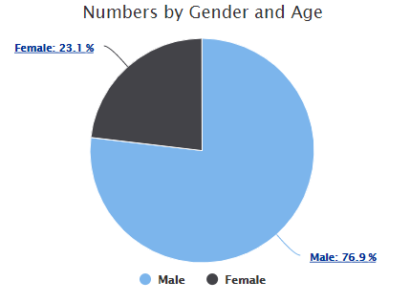**Technologies**

A combination of conventional web development technologies was used in this project such asHTML, CSS and JavaScript. In order to produce the visualizations, the Highcharts JavaScript library was used. Highcharts makes it extremely easy to quickly create elegant and interactive visualizations. A disadvantage of this is the method of giving data to Highcharts, if it cannot be downloaded in the correct format from a server, it becomes incredibly difficult and tedious to input data into Highcharts.

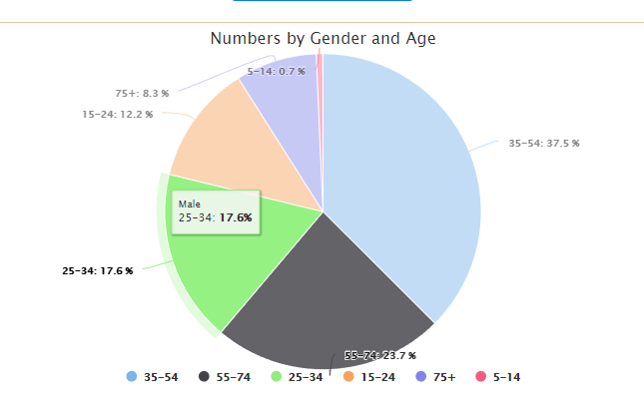**Visualizations - Page 1**

The visualizations aim to allow the user to look at different human factors and the impact they have on suicide rates. Figure 1 shows the first visualization display the disparity of suicides among genders. After clicking on any slice of the pie, the visualization breaks down into suicides by age group for each gender. There is also the option of having both age groups side by side to visually compare the two genders.

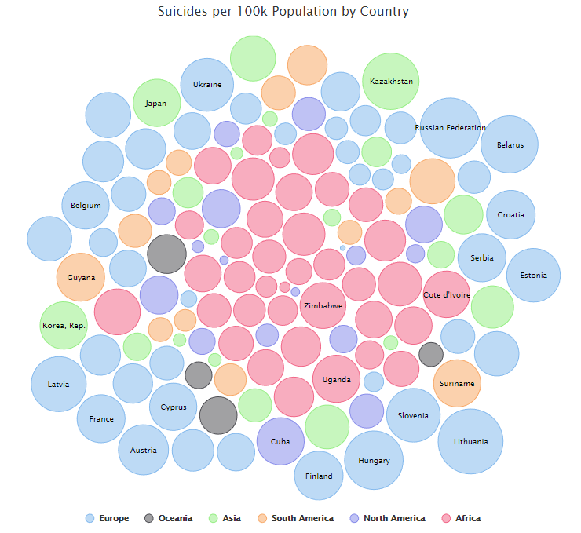**Visualizations - Page 2**

Page 2 aims to draw links between geographic region and suicide rates per 100k population. A bubble chart is used as an innovative way to noticeably display the countries with the highest rates. The rate is directly proportional to the size of the bubble. Any country with a rate above a certain threshold has its name display on the bubble, and the rate can be found simply by hovering over the bubble.

An alternative view simply groups the countries larger bubbles by continent, so users can easily see if a continent tends to have larger bubbles than another.

Finally, a user can opt to look at a world map view, with countries that have higher rates having a darker shading.

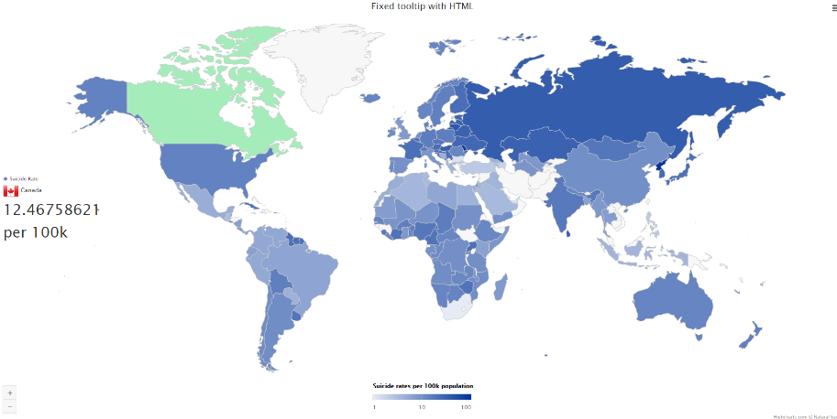**Visualizations - Page 3**

Page 3 looks to show trends between a countries GDP and its suicide rates. On other side of the page there are bar charts of the countries with the 10 highest and lowest suicide rates, overlaid with a bar chart of the countries GDP, in a stacked bar chart style. In the middle there is a line graph plotting these variables against each other, with the option to look at either the 10 highest, or the 10 lowest suicide rates.

