TYPES OF DOWNTOWN (D) REGULATIONS

Development of property in the D zones is governed by:

General zone development standards and use regulations and those specific to a particular zone, including standards and conditions for physical development and uses, regardless of the geographic location of a property within the zone;

Location-specific regulations that apply to a property that is located in a sub-area specified in Subtitle I, Chapter 6 and has frontage on one (1) or more of the sub-area’s designated street segments, regardless of the zone district in which the property is located;

Site-plan, design, massing, or review standards in a limited number of zones or sub-areas; and

An optional process for zones other than D-1-R or D-2 to achieve bonus density or to shift the location of required uses within a trading area, as specified in Subtitle I, Chapters 8 and 9.

Figure I § 101.2 illustrates the general boundaries of the D zones and the designated street segments. Precise zone boundaries are provided by District of Columbia Zoning Map.

FIGURE I §101.2: GENERAL BOUNDARIES OF THE D ZONES
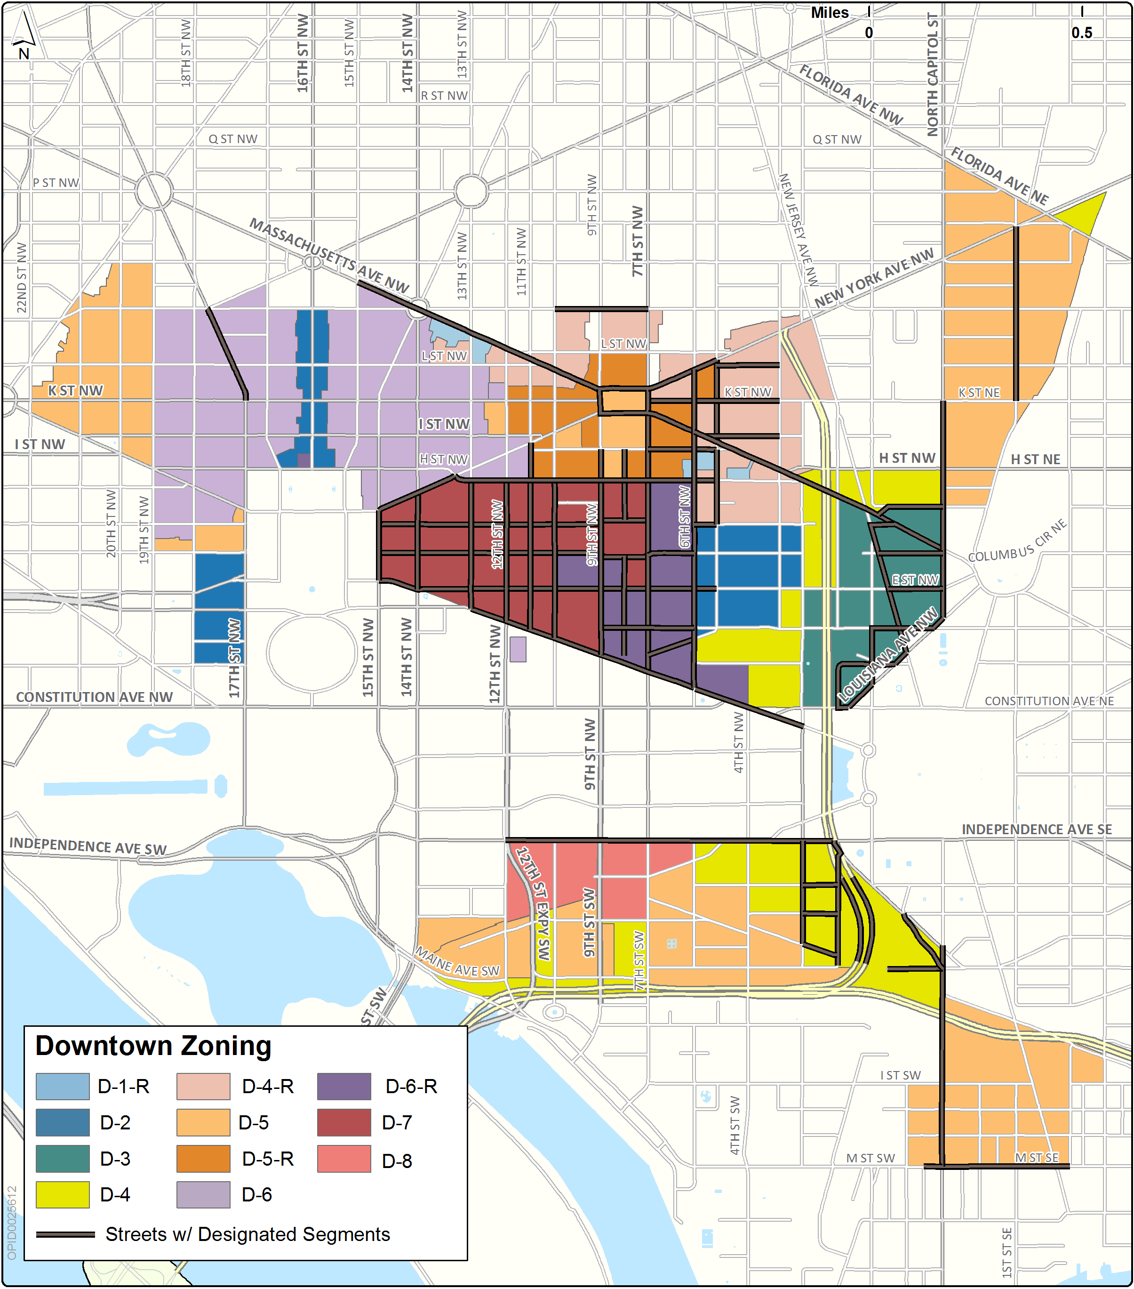

SOURCE: Final Rulemaking published at 63 DCR 2447, 3041 (March 4, 2016 – Part 2).

