GENERAL USE REQUIREMENTS FOR BUILDINGS ON PRIMARY AND SECONDARY DESIGNATED STREET SEGMENTS

FIGURE I § 601(a): ILLUSTRATION OF DESIGNATED PRIMARY STREET SEGMENTS

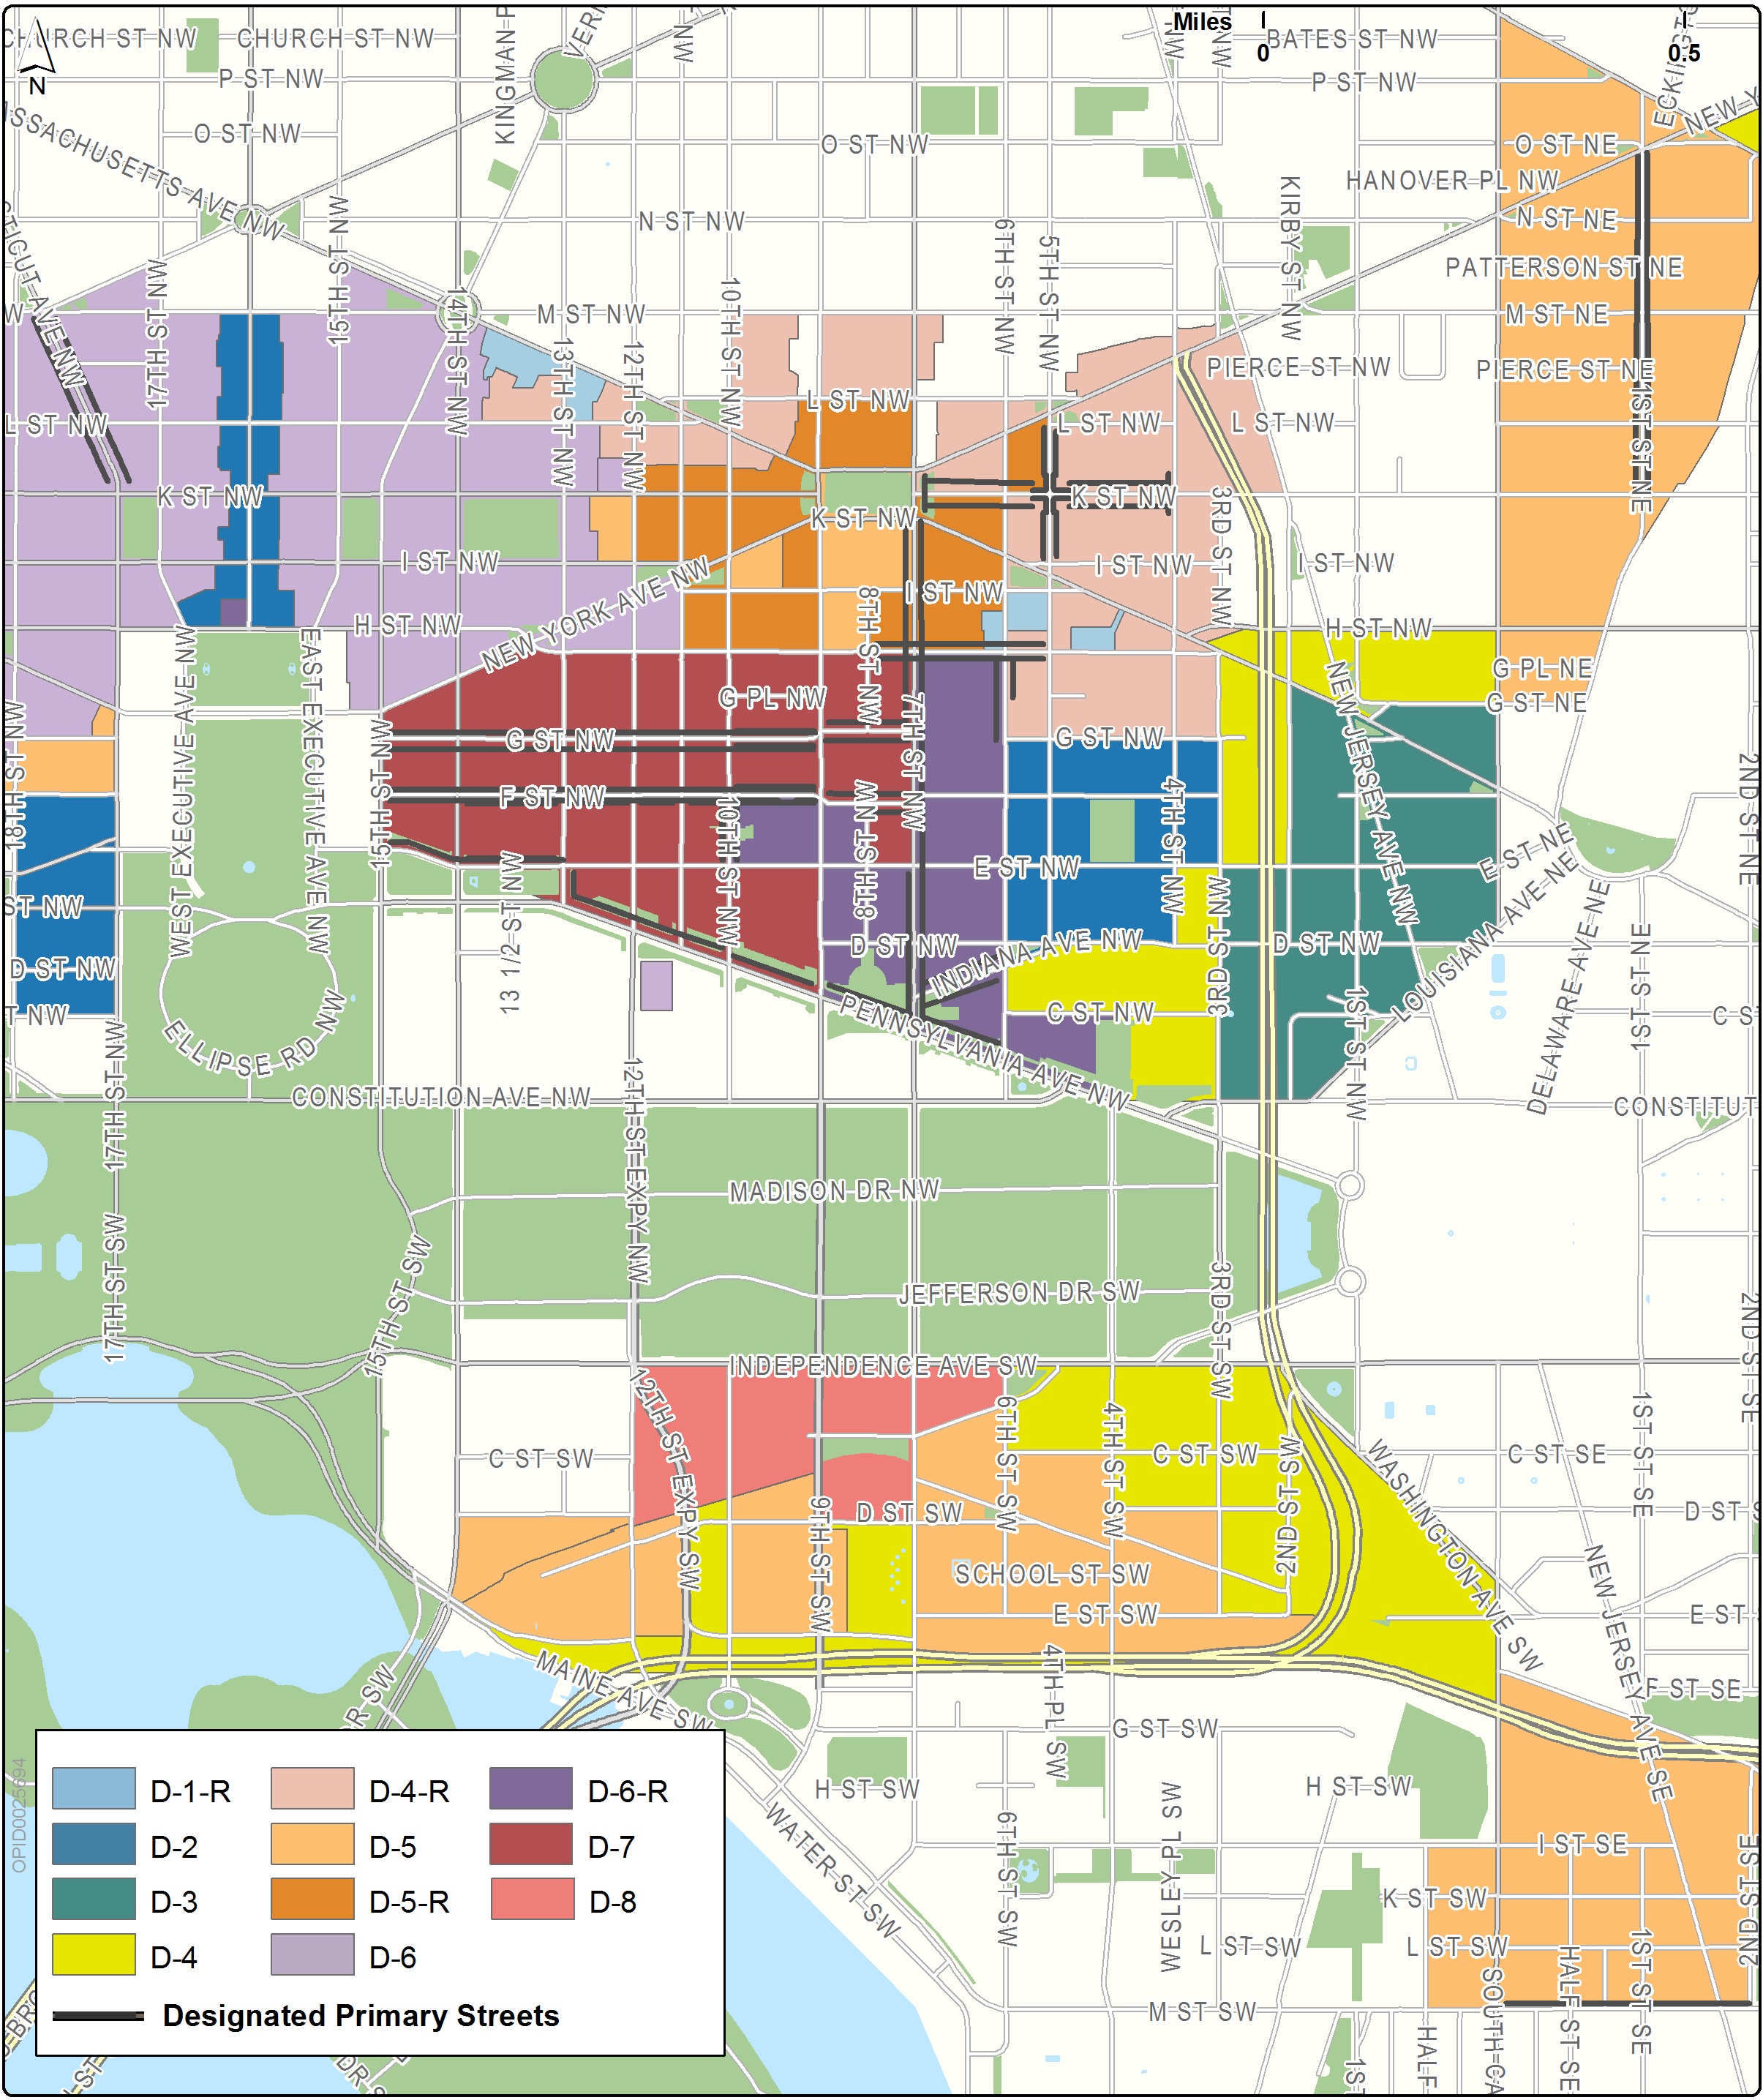
FIGURE I § 601(b): ILLUSTRATION OF DESIGNATED SECONDARY STREET SEGMENTS

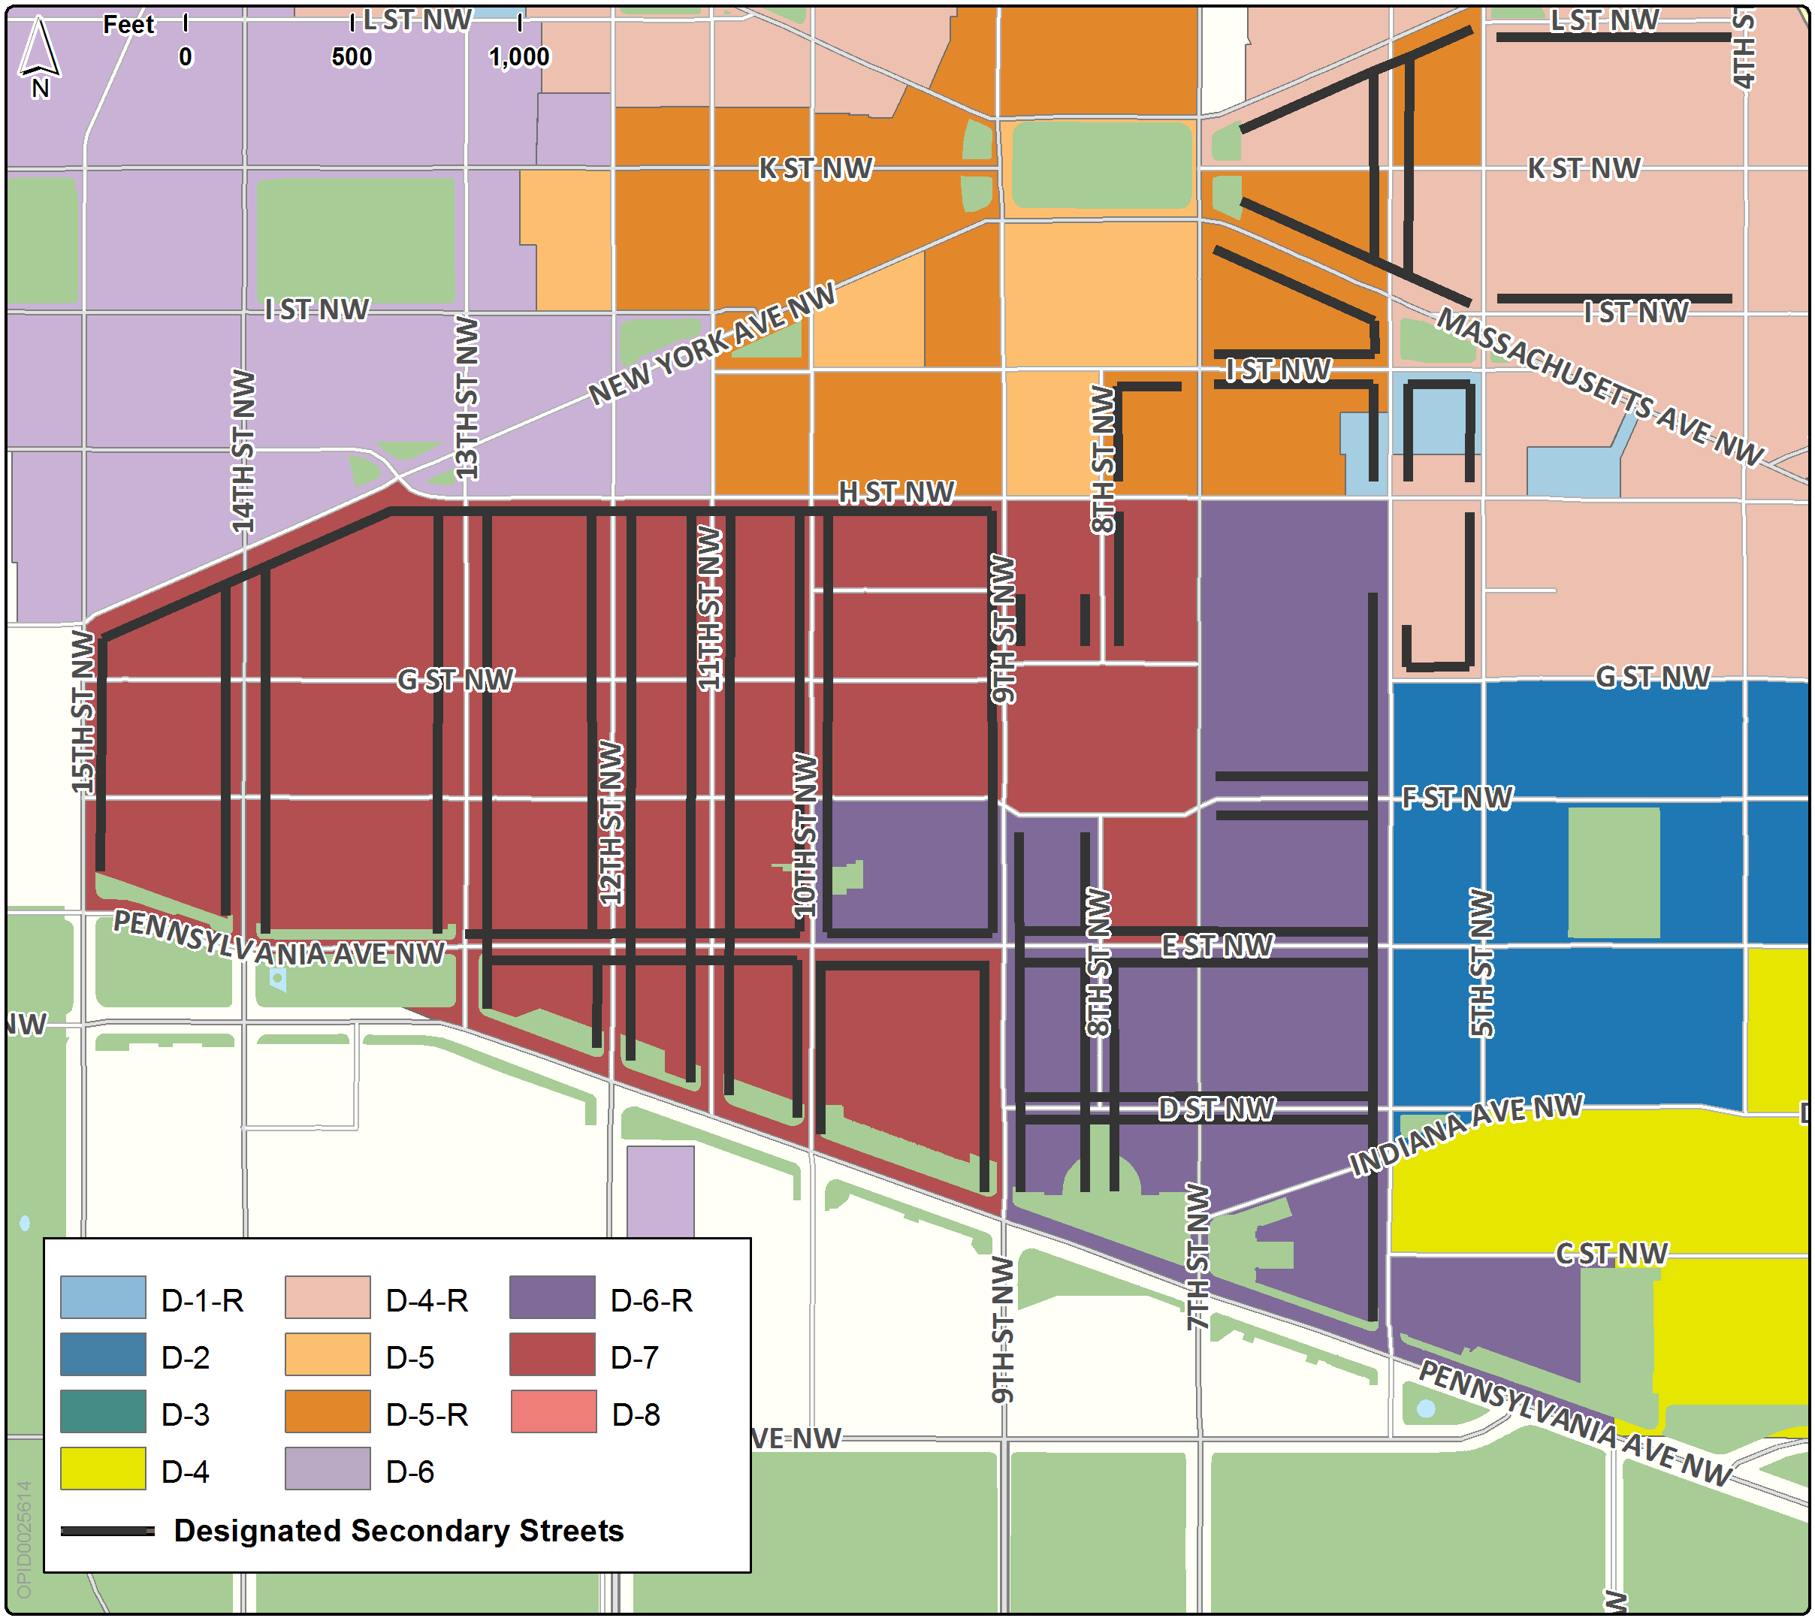

The use requirements in Subtitle I § 601 shall apply to a building or structure on a lot with frontage on a designated primary or a secondary street segment unless otherwise modified within this section or by the use requirements for a designated street segment in a particular sub-area.

A building or structure with frontage on a primary or a secondary designated street segment shall, unless otherwise modified within this section or by the use requirements for a designated street segment in a particular sub-area:

Devote not less than fifty percent (50%) of the ground floor gross floor area to one (1) or more of the following use categories:

Retail;

Entertainment, assembly, and performing arts;

Eating and drinking establishments;

Arts, design, and creation; or

Services, including both general and financial services;

(b) Devote no more than twenty percent (20%) of the ground floor gross floor area uses required in Subtitle I § 601.2(a) to services (financial), fast food establishment, travel, or ticket offices; and

(c) Devote one hundred percent (100%) of the building's street frontage along the primary designated street segment to required uses identified in Subtitle I § 601.2(a) except for space required for fire control or devoted to building entrances for pedestrians, or for vehicular parking and loading entrances that are:

Permitted by Subtitle I § 610.4 within the Massachusetts Avenue and Mount Vernon Square Sub-Area;

Required by DDOT; or

Permitted by the Board of Zoning Adjustment by special exception evaluated according to Subtitle I § 601.2(a).

The requirements of Subtitle I § 601.2 shall not apply to buildings devoted entirely to residential uses, theaters, or places of worship.

The net leasable area occupied by the uses required on primary or secondary designated street segments, or uses generating credits pursuant to Subtitle I, Chapter 8, shall be no less than eighty percent (80%) of the gross floor area allocated to these uses.

SOURCE: Final Rulemaking published at 63 DCR 2447, 3041 (March 4, 2016 – Part 2); as amended by Final Rulemaking published at 63 DCR 10932 (August 26, 2016).

