BUILDINGS ON DESIGNATED TERTIARY STREETS: GENERAL USE AND DESIGN REQUIREMENTS

Figure I § 603.1 illustrates the designated tertiary street segments:

FIGURE I § 603.1: ILLUSTRATION OF DESIGNATED TERTIARY STREET SEGMENTS
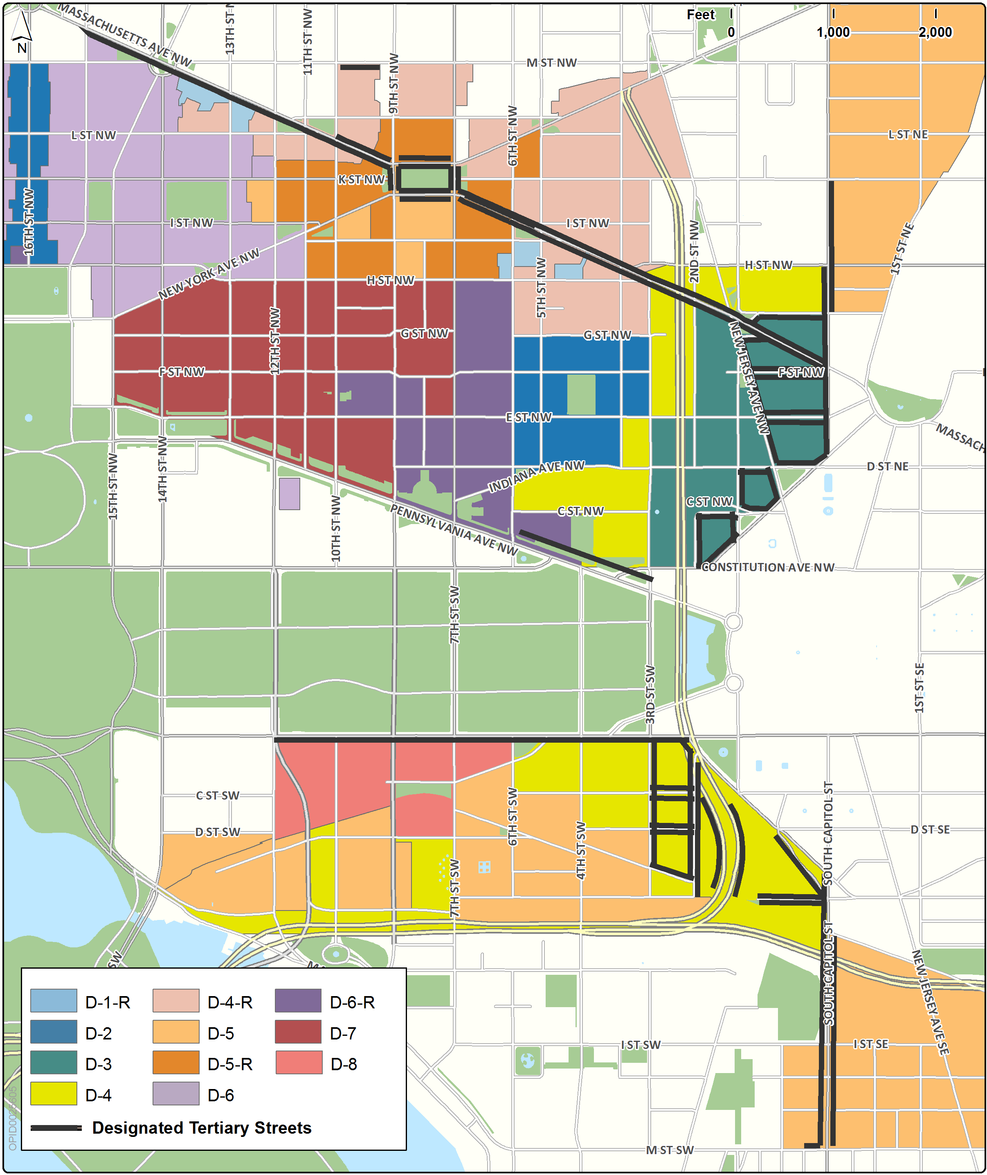

There are no use regulations specific to frontage on any designated tertiary street segment, with the following exceptions:

A building with frontage on the south side of the 600 block of Massachusetts Avenue, N.W. is also subject to the designated secondary street segment use regulations in Subtitle I § 601 and in the Chinatown Sub-Area in Subtitle I § 609; or

A building with frontage on the north side of the 500 or 600 block of Massachusetts Avenue, N.W. is also subject to the designated secondary street segment use regulations in Subtitle I § 601 and the design regulations in the Mount Vernon Triangle Sub-Area in Subtitle I § 611,

Modifications to dimensional requirements for designated tertiary street segments are located in the regulations for the following sub-areas:

The Capitol Security Sub-Area in Subtitle I § 605;

The Massachusetts Avenue Corridor and Mount Vernon Square Sub-Area in Subtitle I § 610;

The Mount Vernon Triangle Sub-Area in Subtitle I § 611 for the north side of the 500 and 600 blocks of Massachusetts Avenue, N.W.;

The Blagden Alley Residential Transition Area Sub-Area in Subtitle I § 613 for the south side of the 900 block of M Street, N.W.;

The South Capitol and M Streets Sub-Area in Subtitle I § 616; and

The North Capitol Street Sub-Area in Subtitle I § 617.

SOURCE: Final Rulemaking published at 63 DCR 2447, 3041 (March 4, 2016 – Part 2).

