CAPITOL SECURITY SUB-AREA

The objectives of the Capitol Security Sub-Area are to protect public safety and the security of those using the properties within the U.S. Capitol complex and associated office buildings and libraries.

The general location of the Capitol Security Sub-Area is the area adjacent to the northwest and southwest perimeter of the U.S. Capitol grounds, including all of Squares 625, 626, 628, 630, 631 574, 577, 579, 581, 582, 640, and 641, as outlined in Figure I § 605: Illustration of Capitol Security Sub-Area and Designated Street Segments. Review of this sub-area is required by the Architect of the Capitol or the Capitol Police.

The designated street segments are as generally indicated with green lines in Figure I § 605: Illustration of Capitol Security Sub-Area and Designated Street Segments and are detailed in Subtitle I § 605.4.
FIGURE I § 605: ILLUSTRATION OF CAPITOL SECURITY SUB-AREA AND DESIGNATED STREET SEGMENTS
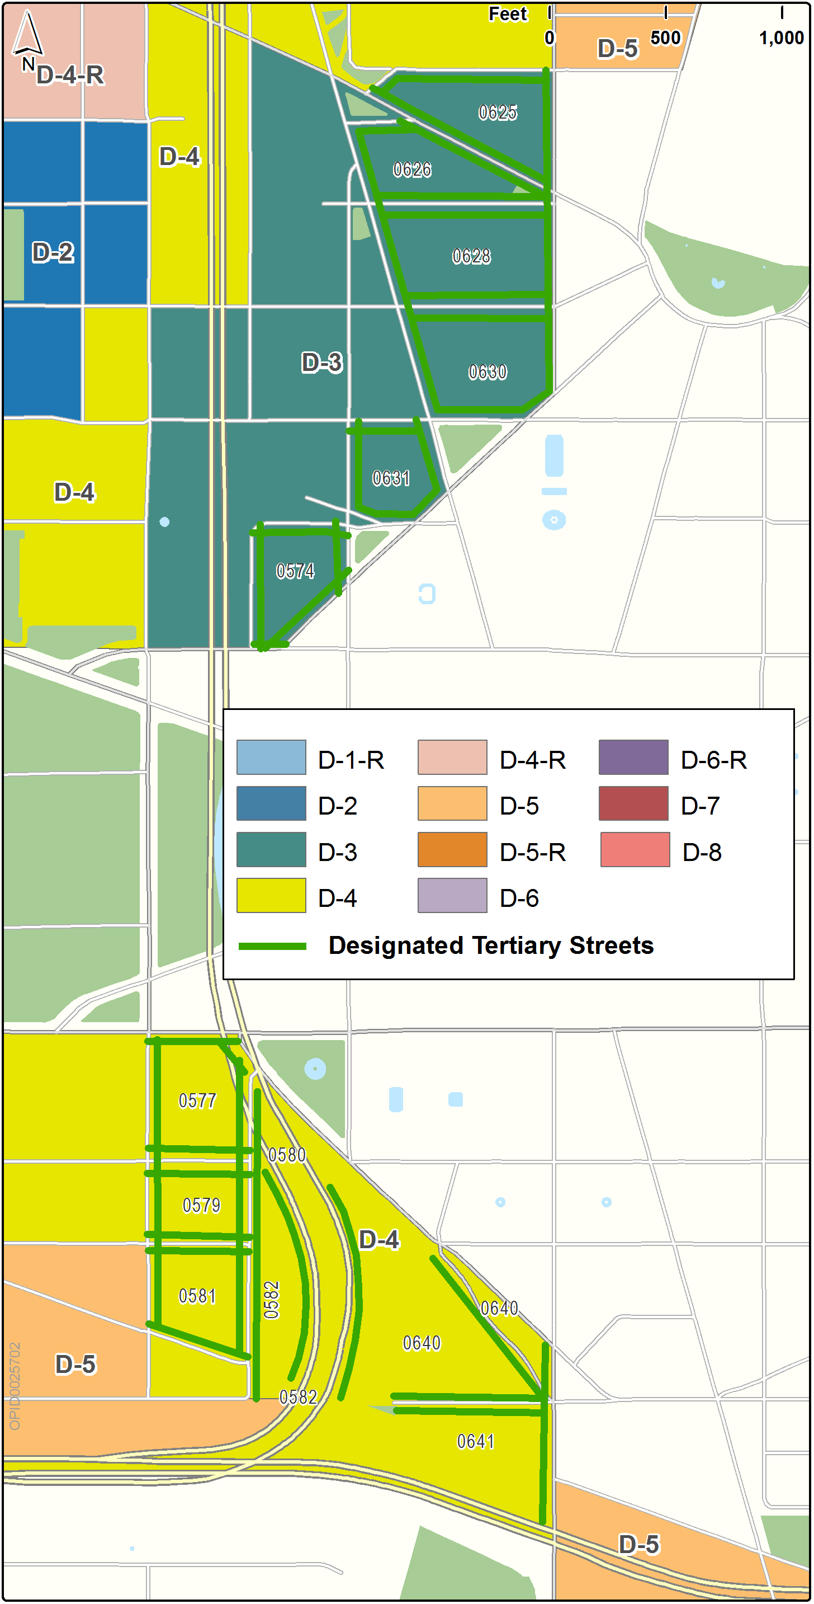

The Capitol Security Sub-Area includes the following designated street segments and adjacent zoning:

TABLE I § 605.4: CAPITOL SECURITY SUB-AREA DESIGNATED STREET SEGMENTS AND ADJACENT ZONING

Designated Street | Side of Street | Adjacent Zone | Segment Boundary 1 (northern or eastern) | Segment Boundary 2 (southern or western) | Segment Classification
G St., N.W. | South | D-3 | North Capitol St., N.W. | New Jersey Ave., N.W. | Tertiary
Massachusetts Ave., N.W. | North | D-3 | North Capitol St., N.W. | New Jersey Ave., N.W. | Tertiary
Massachusetts Ave., N.W. | North | D-3 | North Capitol St., N.W. | G St., N.W. | Tertiary
F St., N.W. | Both | D-3 | North Capitol St., N.W. | New Jersey Ave., N.W. | Tertiary
E St., N.W. | Both | D-3 | North Capitol St., N.W. | New Jersey Ave., N.W. | Tertiary
D St., N.W. | North | D-3 | North Capitol St., N.W. | New Jersey Ave., N.W. | Tertiary
C St., N.W. | North | D-3 | New Jersey Ave., N.W. | 1st St., N.W. | Tertiary
C St., N.W. | South | D-3 | 1st St., N.W. | 2nd St., N.W. | Tertiary
Constitution Ave., N.W. | North | D-3 | 1st St., N.W. | 2nd St., N.W. | Tertiary
Independence Ave., S.W. | South | D-4 | 2nd St., S.W. | 3rd St., S.W. | Tertiary
C St., S.W. | Both | D-4 | 2nd St. S.W. | 3rd St., S.W. | Tertiary
C St., S.W. | South | D-4 | Washington Ave., N.W. | 2nd St., S.W. | Tertiary
D St., S.W. | Both | D-4 | 2nd St., S.W. | 3rd St., S.W. | Tertiary
Virginia Ave., S.W. | North | D-4 | 2nd St., S.W. | 3rd St., S.W. | Tertiary
Virginia Ave., S.W. | North | D-4 | South Capitol St., S.W. | 2nd St., S.W. | Tertiary
E St., S.W. | Both | D-4 | South Capitol St., S.W. | 1st St., S.W. | Tertiary
Washington Ave., S.W. | South | D-4 | Independence Ave., S.W. | South Capitol St., S.W. | Tertiary
North Capitol St., N.W. | West | D-3 | G St., N.W. | D St., N.W. | Tertiary
South Capitol St., S.W. | West | D-4 | Washington Ave., S.W. | Virginia Ave.,/ I-395, S.W. | Tertiary
New Jersey Ave., N.W. | East | D-3 | G St., N.W. | D St., N.W. | Tertiary
1st St., N.W. | East | D-3 | D St., N.W. | C St., N.W. | Tertiary
1st St., N.W. | West | D-3 | C St., N.W. | Constitution Ave., N.W. | Tertiary
1st St., S.W./I-395 ramps | Both | D-4 | D St., S.W. | Virginia Ave., S.W. | Tertiary
2nd St., N.W. | East | D-3 | C St., N.W. | Constitution Ave., S.W. | Tertiary
2nd St., S.W. | West | D-4 | Independence Ave., S.W. | D St., S.W. | Tertiary
2nd St., S.W. | Both | D-4 | D St., S.W. | E St., S.W. | Tertiary
3rd St., S.W. | East | D-4 | Independence Ave., S.W. | Virginia Ave., S.W. | Tertiary

Within the Capitol Security Sub-Area, the use regulations of the zone shall govern.

In the Capitol Security Sub-Area, a proposed new structure or existing structure proposed for substantial renovation shall be considered as a special exception consistent with Subtitle X, Chapter 9 and the criteria in Subtitle I §§ 605.7 through 605.10, if:

The lot has frontage on a designated street segment in the sub-area and the building has a proposed or existing height of ninety feet (90 ft.) or more; and

It is of any height and includes roof decks, terraces, or balconies.

In an application for a special exception subject to this section, the Board of Zoning Adjustment shall also consider whether the proposed development is:

Compatible with the present and proposed development of the neighborhood;

Consistent with the goals and mandates of the United States Congress in Title V of the Legislative Branch Appropriation Act, 1976 (Master Plan for Future Development of the Capitol Grounds and Related Areas), approved July 25, 1975 (Pub. L. No. 94-59, 89 Stat. 288); and

Does not present a security risk to the grounds under the authority of the Architect of the Capitol.

Upon receipt of the application, the Board of Zoning Adjustment shall submit the application to the Architect of the Capitol for review and report.

Upon receipt of the application, the Board of Zoning Adjustment shall submit the application to the Office of Planning for coordination, review, report, and impact assessment, along with reviews in writing of all relevant District departments and agencies including the Departments of Transportation, Housing and Community Development, and, if a historic district or historic landmark is involved, the Historic Preservation Office.

The Board of Zoning Adjustment may require special treatment and impose reasonable conditions as it deems necessary to mitigate any adverse impacts identified in the consideration of the application.

SOURCE: Final Rulemaking published at 63 DCR 2447, 3041 (March 4, 2016 – Part 2).

