DOWNTOWN RETAIL CORE SUB-AREA

The objectives of the Downtown Retail Core Sub-Area are to create the highest concentrations of retail, arts, and street-activating uses within the D zones, to achieve continuous provision of these uses, employ design standards that ensure buildings reinforce and activate pedestrian areas through continuous street frontages, generous display windows, frequent pedestrian entrances, and designated street-facing entrances for parking and loading only when necessary.

The general location of the retail core is between 9th and 15th streets, N.W., between E and H Streets, N.W., including Squares 223, 224, 225, 252, 253, 254, 288, 289, 290, 319, 320, 321, 345, 346, 347, 375, 376, and 377, as outlined in in Figure I § 606: Illustration of the Downtown Retail Core Sub-Area and Designated Street Segments.

The designated street segments are as generally indicated with red or blue lines in Figure I § 606: Illustration of the Downtown Retail Core Sub-Area and Designated Street Segments, and are detailed in Subtitle I § 606.4:

FIGURE I § 606: ILLUSTRATION OF THE DOWNTOWN RETAIL CORE SUB-AREA AND DESIGNATED STREET SEGMENTS
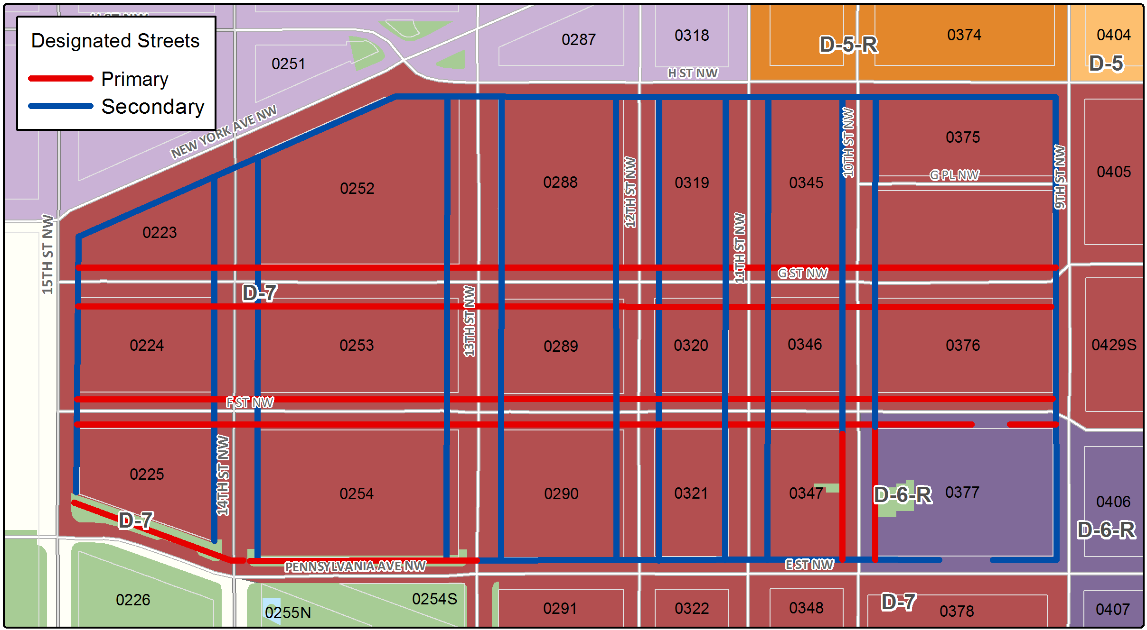

The Downtown Retail Core Sub-Area includes the following designated street segments and adjacent zoning:
TABLE I § 606.4: DOWNTOWN RETAIL CORE SUB-AREA DESIGNATED STREET SEGMENTS AND ADJACENT ZONING

Designated Street | Side of Street | Adjacent Zone | Segment Boundary 1 (northern or eastern) | Segment Boundary 2 (southern or western) | Segment Classification
9th St., N.W. | West | D-6 | H St., N.W. | E St., N.W. | Secondary
10th St., N.W. | Both | D-6 | H St., N.W. | F St., N.W. | Secondary
10th St., N.W. | Both | D-6 | F St., N.W. | E St., N.W. | Primary
11th St., N.W. | Both | D-6 | H St., N.W. | E St., N.W. | Secondary
12th St., N.W. | Both | D-6 | H St., N.W. | E St., N.W. | Secondary
13th St., N.W. | Both | D-6, D-7 | H St., N.W. | E St., N.W. | Secondary
14th St., N.W. | Both | D-6, D-7 | New York Ave., N.W. | E St. / Pennsylvania Ave., N.W. | Secondary
15th St., N.W. | East | D-6, D-7 | New York Ave., N.W. | Pennsylvania Ave., N.W. | Secondary
Pennsylvania Ave., N.W. (including E Street) | North | D-7 | 13th St., N.W. | 15th St., N.W. | Primary
E St., N.W. | North | D-6, D-6-R | 9th St., N.W. | 13th St., N.W. | Secondary
F St, N.W. | Both | D-6, D-7 | 9th St., N.W. | 15th St., N.W. | Primary
G St., N.W. | Both | D-6 | 9th St., N.W. | 15th St., N.W. | Primary
H St., N.W. | South | D-6 | 9th St., N.W. | New York Ave., N.W. | Secondary
New York Ave., N.W. | South | D-6 | 13th St., N.W. | 15th St., N.W. | Secondary

A building with frontage on a designated primary or secondary street segment is subject to the general use regulations in Subtitle I § 601, unless otherwise noted in this section or subtitle.

If a building has frontage on one (1) of the following streets, fifty percent (50%) of the use requirements shall be met by the provision of arts uses or entertainment, assembly, and performing arts uses, as defined in Subtitle B:

The north side of E Street, N.W. between 10th and 13th Streets, N.W.;

The north side of Pennsylvania Avenue, N.W. (including E Street, N.W.) between 13th and 14th Streets, N.W.;

The south side of F Street, N.W. between 10th and 14th Streets, N.W.;

The north and south side of G Street, N.W. between 9th and 10th Streets, N.W.;

The west side of 9th Street, N.W. between E and F Streets, N.W.;

The east and west sides of 11th, 12th, and 13th Street, N.W. between E and F Streets, N.W.; and

The east side of 14th Street, N.W. between E and F Streets, N.W.

A building with frontage on Pennsylvania Avenue, N.W. is subject to the height regulations of Subtitle I §§ 608.9 and 608.10.

A building located on Square 225 or 254 is also subject to the Pennsylvania Avenue Development Corporation (PADC) Plan of 1974, as amended.

A building with frontage on a designated primary or secondary street segment shall also be subject to Subtitle I § 608.10.

SOURCE: Final Rulemaking published at 63 DCR 2447, 3041 (March 4, 2016 – Part 2).

