DOWNTOWN ARTS SUB-AREA

The objectives of the Downtown Arts Sub-Area are to create strong arts and-entertainment corridors including a spine of theaters, movie theaters, restaurants, nightclubs, and arts-related retail uses along E Street from 6th to 14th Street, N.W.; and a pedestrian-oriented concentration of museums, art galleries, other performing or visual arts uses, and festive retail-entertainment uses along 7th Street from Pennsylvania Avenue to north of G Street.

The general location of the Downtown Arts sub-area is between 6th and 14th Streets, N.W. between Pennsylvania Avenue, N.W. and G Place, N.W., including all or parts of Squares 254, 290, 291, 321, 322, 347, 348, 375, 376, 377, 405, 406, 407, 408, 429, 431, 455, 456, 457, 458, and 459 as outlined in Figure I § 607: Illustration of the Downtown Arts Sub-Area and Designated Street Segments.

The designated street segments are as generally indicated with red or blue lines in Figure I § 607: Illustration of the Downtown Arts Sub-Area and Designated Street Segments and detailed in Subtitle I § 607.4.

FIGURE I § 607: ILLUSTRATION OF THE DOWNTOWN ARTS SUB-AREA AND DESIGNATED STREET SEGMENTS
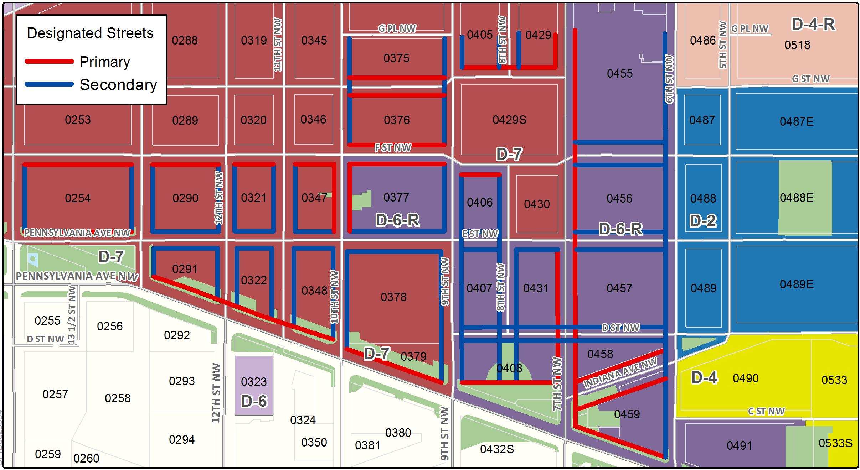

The Downtown Arts Sub-Area includes the following designated street segments and adjacent zoning.

TABLE I § 607.4: DOWNTOWN ARTS SUB-AREA DESIGNATED STREET SEGMENTS AND ADJACENT ZONING

Designated Street | Side of Street | Adjacent Zone | Segment Boundary 1 (northern or eastern) | Segment Boundary 2 (southern or western) | Segment Classification
6th St., N.W. | West | D-6-R | A line extending eastward from G Pl., N.W. | Pennsylvania Ave., N.W. | Secondary
7th St., N.W. | West | D-7 | G Pl., N.W. | G St., N.W. | Primary
7th St., N.W. | East | D-6-R | G Pl., N.W. | E St., N.W. | Primary
7th St., N.W. | Both | D-6-R | E St., N.W. | Pennsylvania Ave., N.W. | Primary
8th St., N.W. | Both | D-6 | A line extending eastward from G Pl., N.W. | G St., N.W. | Secondary
8th St., N.W. | West | D-6-R | F St., N.W. | E St., N.W. | Secondary
8th St., N.W. | Both | D-6-R | E St., N.W. | Pennsylvania Ave., N.W. | Secondary
9th St., N.W. | Both | D-7 | A line extending eastward from G Pl., N.W. | G St., N.W. | Secondary
9th St., N.W. | West | D-7 | F St., N.W. | E St., N.W. | Secondary
9th St., N.W. | East | D-6-R | F St., N.W. | Pennsylvania Ave., N.W. | Secondary
9th St., N.W. | West | D-7 | F St. N.W. | Pennsylvania Ave., N.W. | Secondary
10th St., N.W. | East | D-7 | G Pl., N.W. | F St., N.W. | Secondary
10th St., N.W. | Both | D-7 | F St., N.W. | E St., N.W. | Primary
10th St., N.W. | Both | D-7 | E St., N.W. | Pennsylvania Ave., N.W. | Secondary
11th St., N.W. | Both | D-7 | F St., N.W. | Pennsylvania Ave., N.W. | Secondary
12th St., N.W. | Both | D-7 | F St., N.W. | Pennsylvania Ave., N.W. | Secondary
13th St., N.W. | Both | D-7 | F St., N.W. | Pennsylvania Ave., N.W. | Secondary
14th St., N.W. | East | D-7 | F St., N.W. | E St., N.W. | Secondary
G St., N.W. | North | D-6 | 7th St., N.W. | 9th St., N.W. | Primary
G St., N.W. | Both | D-6-R | 9th St., N.W. | 10th St., N.W. | Primary
F St., N.W. | Both | D-6-R | 6th St., N.W. | 7th St., N.W. | Secondary
F St., N.W. | South | D-6-R | 8th St., N.W. | 9th St., N.W. | Primary
F St., N.W. | North | D-7 | 9th St., N.W. | 10th St., N.W. | Primary
F St., N.W. | South | D-6-R | 9th St., N.W. | 10th St., N.W. | Primary
F St., N.W. | South | D-7 | 10th St., N.W. | 14th St., N.W. | Primary
E St., N.W. | Both | D-6-R | 6th St., N.W. | 7th St., N.W. | Secondary
E St., N.W. | South | D-6-R | 7th St., N.W. | 8th St., N.W. | Secondary
E St., N.W. | Both | D-6-R | 8th St., N.W. | 9th St., N.W. | Secondary
E St., N.W. | North | D-6-R | 9th St., N.W. | 10th St., N.W. | Secondary
E St., N.W. | South | D-7 | 10th St., N.W. | 13th St., N.W. | Secondary
E St., N.W. | Both | D-7 | 9th St., N.W. | 10th St., N.W. | Secondary
E St., N.W. | North | D-7 | 13th St., N.W. | 14th St., N.W. | Primary
D St., N.W. | Both | D-6-R | 6th St., N.W. | 9th St., N.W. | Secondary
Indiana Ave., N.W. | Both | D-6-R | 6th St., N.W. | 7th St., N.W. | Primary
Pennsylvania Ave., N.W. | North | D-6-R  D-7 | 6th St., N.W.  9th St., N.W. | 9th St., N.W.  14th St., N.W. | Primary

Arts uses shall comprise the arts uses listed in Subtitle U, § 700.5.

A building or structure on a lot with frontage on a designated primary street segment in the Downtown Arts Sub-Area shall provide the following, either on-site or by securing arts credits pursuant to Subtitle I, Chapters 8 and 9:

At least 1.0 FAR or floor area equivalent ratio (FAER), as defined in Subtitle I § 607.15, of arts uses; and

Of this amount at least 0.25 FAR or FAER shall be devoted to one (1) or more arts uses listed in Subtitle U §§ 700.2(a) through (d) and (g) through (j).

The following actions count, cumulatively, towards meeting the use and FAR or FAER requirements of Subtitle I § 607.6(a), but shall not count towards meeting the requirements of Subtitle I § 607.6(b):

Providing either on-site or by obtaining arts credits pursuant to Subtitle I, Chapters 8 and 9, between 0.5 and 1.0 FAR or FAER of arts uses;

Providing, either on-site or by obtaining residential credits pursuant to Subtitle I § 803, at least 1.5 more residential FAR than is required by this chapter and devoting at least 0.25 FAR or FAER equivalent to the arts uses listed in Subtitle I § 607.6(b); and

Providing an arts exhibition area that:

Comprises at least twenty percent (20%) of the FAR required by Subtitle I § 607.7(b);

Is open to the public at least five (5) days a week for fifty (50) weeks per year;

Accommodates permanent art installations in no more than twenty percent (20%) of the space required by Subtitle I § 607.6(a); and

Changes the installation of the art at least four (4) times a year in the eighty percent (80%) of the space not-permitted permanent installations, and has each of the different installations professionally curated.

The gross floor area of a cellar devoted to the uses required by this section shall count towards the minimum requirement without affecting the permitted maximum bulk of the building, and shall count towards the generation of credits provided for by Subtitle I, Chapter 8.

The requirements of this section shall not apply to historic landmarks or buildings where the primary use is religious worship.

If a building in Square 254, 290, 321, 347, 375, 376, or 377 has frontage on one (1) of the following designated street segments, up to, but not including, fifty percent (50%) of the FAR or FAER for uses required by Subtitle I § 607.6 shall be met by the retail core uses required by Subtitle I §§ 606.5:

The north side of E Street, N.W. between 10th and 13th Streets, N.W.;

The north side of Pennsylvania Avenue, N.W. (including E Street, N.W.) between 13th and 14th Streets, N.W.;

The south side of F Street, N.W. between 10th and 14th Streets, N.W.;

The north and south side of G Street, N.W. between 9th and 10th Streets, N.W.;

The west side of 9th Street, N.W. between E and F Streets, N.W.;

The east and west sides of 11th, 12th, and 13th Street, N.W. between E and F Streets, N.W.; or

The east side of 14th Street, N.W. between E and F Streets, N.W.

A building with no more than six (6) above-grade floors on a lot not exceeding five thousand square feet (5,000 sq. ft.) shall provide at least 0.75 FAR or FAER of retail, arts, eating and drinking, or service uses.

A building with frontage on Pennsylvania Avenue, N.W., is subject to the height regulations of Subtitle I §§ 608.9 and 608.10.

A building within Square 254, 291, 322, 348, 378, 379, 406, 407, 408, 431, 457, 458, or 459 is also subject to Subtitle I § 608.10.

A building with frontage on a designated primary or secondary street segment shall be subject to the design regulations of Subtitle I § 602.

Floor area equivalent is defined, for the purposes this section, as the amount of floor area that a volume occupies, with the first fourteen (14 ft.) of clear height in a volume counting as one (1) floor and each ten feet (10 ft.) of additional clear height within that volume counting as a floor.

FAER is a numerical figure that expresses the total gross floor area of a volume as a multiple of the area of the lot. It is determined by dividing the total of the gross floor area and floor area equivalent of the building(s) on a lot by the area of the lot.

SOURCE: Final Rulemaking published at 63 DCR 2447, 3041 (March 4, 2016 – Part 2); as amended by Final Rulemaking published at 63 DCR 10932 (August 26, 2016); as amended by Final Rulemaking published at 64 DCR 8596 (September 1, 2017).

