PENNSYLVANIA AVENUE SUB-AREA

The objectives of the Pennsylvania Avenue Sub-Area are to maintain Pennsylvania Avenue as a mixed-use monumental but lively street with additional height on its north side and active ground floor uses to bridge the downtown with the National Mall and the monumental core.

The general location area is the north side of Pennsylvania Avenue, N.W. and between one (1) and three (3) blocks north, between 3rd and 15th Streets, N.W. incorporating the areas, within the boundaries of the Pennsylvania Avenue Development Corporation (PADC) Plan (1974, as amended), including all or parts of squares from 6th through 14th streets, N.W., between Pennsylvania Avenue, N.W. and G Place, N.W., including Squares 225, 254, 291, 322, 348, 378, 379, 406, 407, 408, 430, 431, 432S, 457, 458, 459, 460, 491, and 533S, as outlined in Figure I § 608: Illustration of the Pennsylvania Avenue Sub-Area and Designated Street Segments.

The designated street segments are as generally indicated with red, blue, and green lines in Figure I § 608: Illustration of the Pennsylvania Avenue Sub-Area and Designated Street Segments and detailed in Subtitle I § 608.4.

FIGURE I § 608: ILLUSTRATION OF THE PENNSYLVANIA AVENUE SUB-AREA AND DESIGNATED STREET SEGMENTS
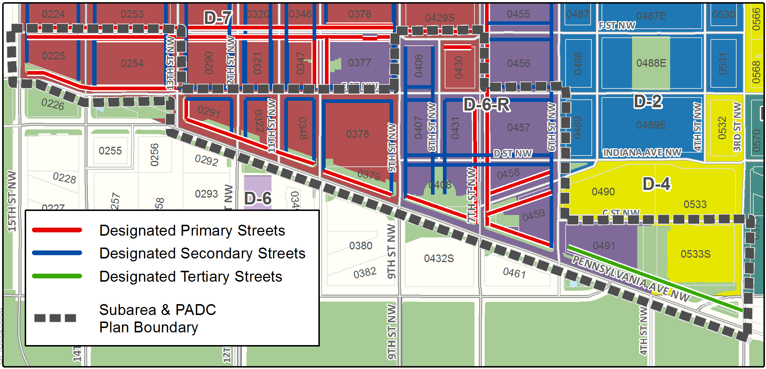

The Pennsylvania Avenue Sub-Area includes the following designated street segments and adjacent zoning:

TABLE I § 608.4: PENNSYLVANIA AVENUE SUB-AREA DESIGNATED STREET SEGMENTS AND ADJACENT ZONING

Designated Street | Side of Street | Adjacent Zone | Segment Boundary 1 (northern or eastern) | Segment Boundary 2 (southern or western) | Segment Classification
3rd St., N.W. | West | D-4 | C St., N.W. | Pennsylvania Ave., N.W. | n/a
6th St., N.W. | East | D-6-R | C St., N.W. | Pennsylvania Ave., N.W. | n/a
6th St., N.W. | West | D-6-R | E St., N.W. | Pennsylvania Ave., N.W. | Secondary
7th St., N.W. | East | D-6-R | F St., N.W. | E St., N.W. | Primary
7th St., N.W. | Both | D-6-R | E St., N.W. | Pennsylvania Ave., N.W. | Primary
8th St., N.W. | West | D-6-R | F St. N.W. | E St., N.W. | Secondary;  (Also in Downtown Arts Sub-Area)
8th St., N.W. | East | D-7 | F St. N.W. | E St., N.W. | Not Designated
8th St., N.W. | Both | D-6-R | E St. N.W. | Pennsylvania Ave., N.W. | Secondary;  (Also in Downtown Arts Sub-Area)
9th St., N.W. | East | D-6-R | F St. N.W. | Pennsylvania Ave., N.W. | Secondary;  (Also in Downtown Arts Sub-Area)
9th St., N.W. | West | D-6 | F St. N.W. | E St., N.W. | Secondary;  (Also in Downtown Arts & Retail Sub-Areas)
9th St., N.W. | West | D-7 | E St., N.W. | Pennsylvania Ave., N.W. | Secondary;  (Also in Downtown Arts Sub-Area)
10th St., N.W. | Both | D-7 | E St. N.W. | Pennsylvania Ave., N.W. | Secondary;  (Also in Downtown Arts Sub-Area)
11th St., N.W. | Both | D-7 | E St. N.W. | Pennsylvania Ave., N.W. | Secondary;  (Also in Downtown Arts Sub-Area)
12th St., N.W. | Both | D-7 | E St., N.W. | Pennsylvania Ave., N.W. | Secondary;  (Also in Downtown Arts Sub-Area)
13th St., N.W. | Both | D-7 | E St., N.W. | Pennsylvania Ave., N.W. | Secondary  (Also in Downtown Arts & Retail Sub-Areas)
13th St., N.W. | West | D-7 | E St., N.W. | F St., N.W. | Secondary  (Also in Downtown Arts & Retail Sub-Areas)
14th St., N.W. | West | D-7 | F St., N.W. | Pennsylvania Ave., N.W. | Secondary  (Also in Downtown Arts & Retail Sub-Areas)
14th St., N.W. | West | D-7 | F St., N.W. | Pennsylvania Ave., N.W. | Secondary  (Also in Downtown Retail Sub-Area)
15th St., N.W. | East | D-7 | F St., N.W. | Pennsylvania Ave., N.W. | Secondary  (Also in Downtown Retail Sub-Area)
F St. N.W. | South | D-7 | 7th St., N.W. | 8th St., N.W. | Primary
F St., N.W. | South | D-6-R | 8th St., N.W. | 9th St., N.W. | Primary;  (Also in Downtown Arts Sub-Area)
F St. ,N.W. | South | D-7 | 13th St., N.W. | 14th St., N.W. | Primary  (Also in Downtown Arts & Retail Sub-Areas)
F St., N.W. | South | D-7 | 14th St., N.W. | 15th St., N.W. | Primary  (Also in Downtown Retail Sub-Area)
E St., N.W. | South | D-6-R | 6th St., N.W. | 7th St., N.W. | Secondary  (Also in Downtown Arts Sub-Area)
E St., N.W. | South | D-6-R | 7th St., N.W. | 8th St., N.W. | Secondary;  (Also in Downtown Arts Sub-Area)
E St., N.W. | North | D-6-R | 7th St., N.W. | 8th St., N.W. | Not Designated
E St., N.W. | Both | D-6-R | 8th St., N.W. | 9th St., N.W. | Secondary;  (Also in Downtown Arts Sub-Area)
E St., N.W. | South | D-7 | 9th St., N.W. | 13th St., N.W. | Secondary;  (Also in Downtown Arts Sub-Area)
D St., N.W. | Both | D-6-R | 6th St., N.W. | 9th St., N.W. | Secondary
C St., N.W. | Both | D-4 | 3rd St., N.W. | 4th St., N.W. | Not Designated
C St., N.W. | North | D-4 | 3rd St., N.W. | 4th St., N.W. | Not Designated
C St., N.W. | South | D-7 | 4th St., N.W. | 5th St., N.W. | Not Designated
Indiana Ave., N.W. | Both | D-6-R | 6th St., N.W. | 7th St., N.W. | Primary
Pennsylvania Ave., N.W. | North | D-4 | 3rd St., N.W. | 5th St., N.W. | Tertiary
Pennsylvania Ave., N.W. | North | D-6-R | 5th St., N.W. | 6th St., N.W. | Primary
Pennsylvania Ave., N.W. | North | D-6-R | 6th St., N.W. | 9th St., N.W. | Primary
Pennsylvania Ave., N.W. | North | D-6 | 9th St., N.W. | 10th St., N.W. | Primary;  (Also in Downtown Arts Sub-Area)
Pennsylvania Ave., N.W.  (including E St., N.W.) | North | D-7 | 10th St., N.W. | 13th St., N.W. | Primary;  (Also in Downtown Arts Sub-Area)
Pennsylvania Ave., N.W.  (including E St., N.W.) | North | D-7 | 13th St., N.W. | 14th St., N.W. | Primary  (Also in Downtown Arts & Retail Sub-Areas
Pennsylvania Ave., N.W.  (including E St., N.W.) | North | D-7 | 14th St., N.W. | 15th St., N.W. | Primary;  (Also in Downtown Arts Sub-Area)

Buildings with frontage on designated primary or secondary street segments in this sub-area are subject to the use regulations of Subtitle I § 601.

Buildings in Squares 254, 291, 322, 347, and 378 are subject to the use regulations of the Downtown Arts Sub-Area in Subtitle I § 607.

Buildings in Squares 225 and 254, are subject to the use regulations of the Downtown Retail Sub-Area in Subtitle I § 606.

Buildings with frontage on primary or secondary designated street segments in this sub-area are subject to the design regulations in Subtitle I § 602.

The height of the building or structure fronting on Pennsylvania Avenue shall be measured from the Pennsylvania Avenue curb at the middle of the front of the building or other structure to the highest point of the roof or parapet exclusive of any structure on the roof.

A building within the Pennsylvania Avenue sub-area is also governed by the Pennsylvania Avenue Development Corporation (PADC) Plan of 1974, as implemented by the Pennsylvania Avenue Development Corporation General Guidelines and Uniform Standards 36 C.F.R. §§ 910.1 et seq.

SOURCE: Final Rulemaking published at 63 DCR 2447, 3041 (March 4, 2016 – Part 2); as amended by Final Rulemaking published at 63 DCR 10932 (August 26, 2016).

