CHINATOWN SUB-AREA

The objectives of the Chinatown Sub-Area are to protect and enhance downtown's only ethnic cultural area by maintaining and expanding the existing concentration of retail uses emphasizing Chinese or Asian cultural and community facilities, as well as merchandise and related wholesale operations serving residents, visitors, tourists, and business travelers.

The general location of the Chinatown Sub-Area is from 5th to 8th Streets, N.W., between Massachusetts Avenue and H Street, N.W., including all or parts of Squares 425, 428, 429, and 454, as in Figure I § 609: Illustration of the Chinatown Sub-Area and Designated Street Segments.

The designated street segments are as generally indicated with red or blue lines in Figure I § 609: Illustration of the Chinatown Sub-Area and Designated Street Segments and detailed in Subtitle I § 609.4.

FIGURE I § 609: ILLUSTRATION OF THE CHINATOWN SUB-AREA AND DESIGNATED STREET SEGMENTS

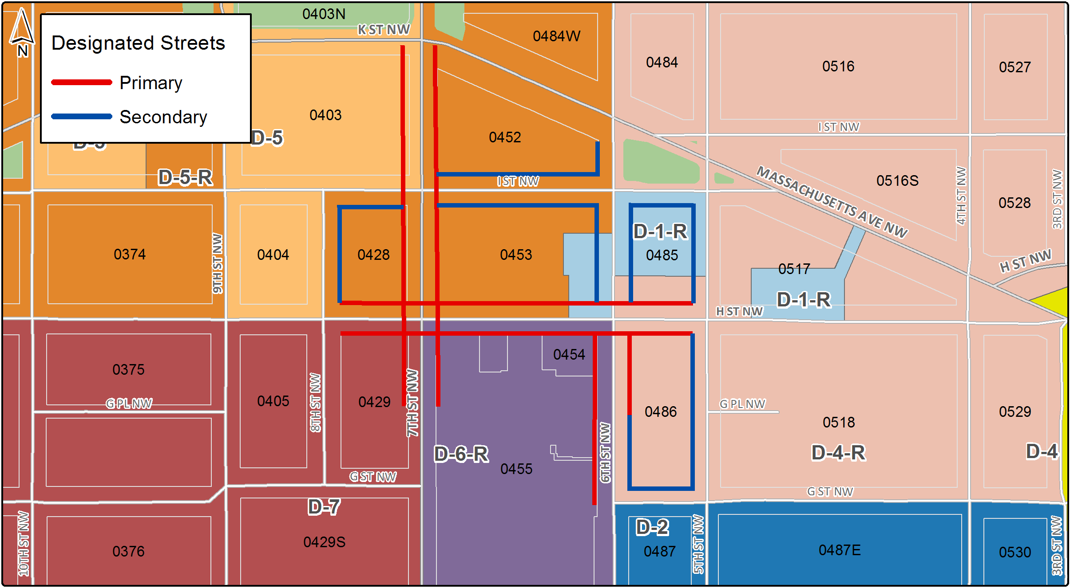

The Chinatown Sub-Area includes the following designated street segments and adjacent zoning:

TABLE I § 609.4: CHINATOWN SUB-AREA DESIGNATED STREET SEGMENTS AND ADJACENT ZONING

Designated Street | Side of Street | Adjacent Zone | Segment Boundary 1 (northern or eastern) | Segment Boundary 2 (southern or western) | Segment Classification
5th St., N.W. | West | D-1-R  D-4-R | I St., N.W. | G St., N.W. | Secondary
6th St., N.W. | West | D-5-R | Massachusetts Ave., N.W. | I St., N.W. | Secondary
6th St., N.W. | Both | D-1-R  D-5-R | I St., N.W. | H St., N.W. | Secondary
6th St., N.W. | Both | D-1-R  D-5-R | H St., N.W. | A line extending eastward from G Pl., N.W. | Primary
6th St., N.W. | East | D-4-R | A line extending eastward from G Pl., N.W. | G St., N.W. | Secondary
6th St., N.W. | West | D-4-R | A line extending eastward from G Pl., N.W. | G St., N.W. | Primary
7th St., N.W. | East | D-5-R | Massachusetts Ave., N.W. | I St., N.W. | Primary
7th St., N.W. | West | D-5 | Massachusetts Ave., N.W. | I St., N.W. | Primary
7th St., N.W. | Both | D-5-R | I St., N.W. | H St., N.W. | Primary
7th St., N.W. | East | D-6-R | H St., N.W. | A line extending east from G Pl., N.W. | Primary
7th St., N.W. | West | D-7 | H St., N.W. | A line extending east from G Pl., N.W. | Primary
8th St., N.W. | East | D-5-R | I St., N.W. | H St., N.W. | Secondary
Massachusetts Ave., N.W. | South | D-5-R | 6th St., N.W. | 7th St., N.W. | Secondary (Also in Massachusetts Avenue and Mt. Vernon Square Sub-Area)
I St., N.W. | South | D-1-R | 5th St., N.W. | 6th St., N.W. | Secondary
I St., N.W. | Both | D-5-R | 6th St., N.W. | 7th St., N.W. | Secondary
I St., N.W. | South | D-5-R | 7th St., N.W. | 8th St., N.W. | Secondary
H St., N.W. | Both | D-1-R  D-5-R  D-7 | 5th St., N.W. | 8th St., N.W. | Primary
G St., N.W. | North | D-4-R | 5th St., N.W. | 6th St., N.W. | Secondary

A building or structure on a lot with frontage on a designated primary street segment shall:

Devote not less than one hundred percent (100%) of the ground floor gross floor area to uses identified in Subtitle I § 601.2 or to wholesaling accessory to those uses, provided that the requirement shall be 0.5 FAR equivalent for a building in the D-1-R, D-4-R, or D-5-R zone;

Devote no more than twenty-five percent (25%) of the ground floor gross floor area retail requirement to services (financial); and

Devote one hundred percent (100%) of the building's street frontage along the primary street to required uses, except for space devoted to building entrances or required for fire control; except that the requirements of this sub-section shall not apply to buildings devoted entirely to residential uses, theaters, historic landmarks, or places of worship.

A building or structure on a lot with frontage only on a designated secondary street segment shall:

Devote not less than fifty percent (50%) of the ground floor gross floor area to on-site required uses identified in Subtitle I § 601.2;

Devote one hundred percent (100%) of the building's street frontage along the designated secondary street to required uses, except for space devoted to building entrances or required for fire control; and

The requirements of this sub-section shall not apply to buildings devoted entirely to residential uses, theaters, historic landmarks, or places of worship.

A building fronting on a designated primary or secondary street segment is subject to the design regulations in Subtitle I § 602.

A building fronting on Massachusetts Avenue, N.W., is subject to the height regulations in Subtitle I § 610.7.

SOURCE: Final Rulemaking published at 63 DCR 2447, 3041 (March 4, 2016 – Part 2).

