MASSACHUSETTS AVENUE CORRIDOR AND MT. VERNON SQUARE SUB-AREA

The objectives of the Massachusetts Avenue Corridor and Mt. Vernon Square Sub-Area are to encourage a boulevard and park-like openness for the Massachusetts Avenue corridor, linking the Capitol to the embassy district through upper story setbacks that increase the amount of light available to pedestrians and to public space plantings.

The general location of the Massachusetts Avenue Corridor and Mt. Vernon Square Sub-Area is along Massachusetts Avenue from North Capitol Street to 15th Street, N.W., including Mount Vernon Place, K Street, 7th and 9th Streets N.W. surrounding Mount Vernon Square, including all or parts of Squares 212-214, 245-247, 282, 283, 315, 342, 370-372, 402, 403, 426, 451, 452, 484W, 484, 516S, 517, 528, 529, 562S, 563-565, and 624-626, in Figure I § 610: Illustration of the Massachusetts Avenue Corridor and Mt. Vernon Square Sub-Area and Designated Street Segments.

The designated street segments are as generally indicated with the blue and green lines in Figure I § 610: Illustration of the Massachusetts Avenue Corridor and Mt. Vernon Square Sub-Area and Designated Street Segments and detailed in Subtitle I § 610.4.

FIGURE I § 610: ILLUSTRATION OF THE MASSACHUSETTS AVENUE CORRIDOR AND MT. VERNON SQUARE SUB-AREA AND DESIGNATED STREET SEGMENTS

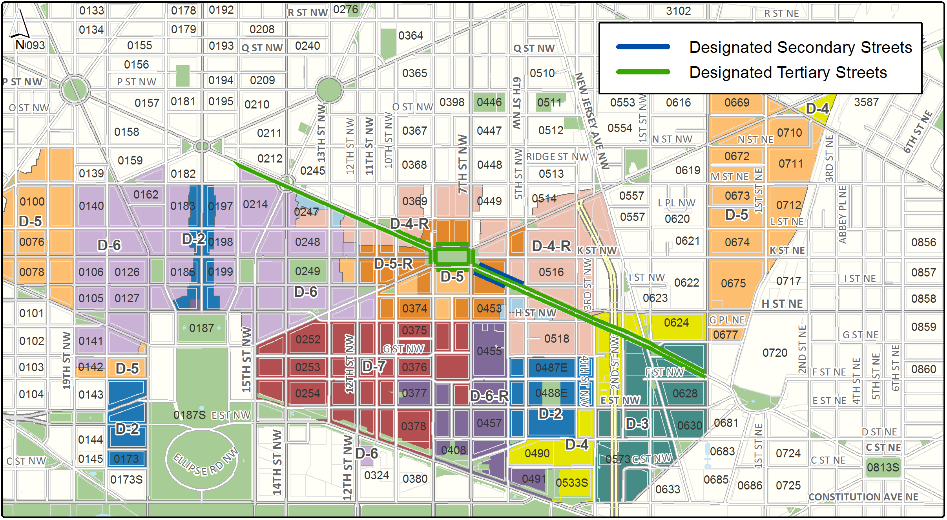

The Massachusetts Avenue Corridor and Mt. Vernon Square Sub-Area includes the following designated street segments and adjacent zoning:

TABLE I § 610.4: MASSACHUSETTS AVENUE CORRIDOR AND MT. VERNON SQUARE SUB-AREA DESIGNATED STREET SEGMENTS AND ADJACENT ZONING

Designated Street | Side of Street | Adjacent Zone | Segment Boundary 1 (northern or eastern) | Segment Boundary 2 (southern or western) | Segment Classification
7th St., N.W. | Both | D-4-R  D-5-R | Mt. Vernon Pl. / New York Ave., N.W. | K St. / Massachusetts Ave., N.W. | Tertiary
9th St., N.W. | Both | D-4-R  D-5-R | Mt. Vernon Pl. / Massachusetts Ave., N.W. | K St. / New York Ave., N.W. | Tertiary
Massachusetts Ave., N.W. | Both | D-2-R  D-3  D-4  D-4-R | North Capitol St., N.W. | 5th St., N.W. | Tertiary
Massachusetts Ave., N.W. | South | D-4-R | 5th St., N.W. | 6th St., N.W. | Tertiary
Massachusetts Ave., N.W. | North | D-4-R  D-5-R | 5th St., N.W. | 6th St., N.W. | Tertiary, and Secondary per Mount Vernon Triangle Sub-Area
Massachusetts Ave., N.W. | South | D-R-5 | 6th St., N.W. | 7th St., N.W. | Tertiary, and Secondary per Chinatown Sub-Area
K St., N.W. | Both | D-5 | 7th St., N.W. | 9th St., N.W. | Tertiary
Mt. Vernon Place, N.W. | Both | D-5-R | 7th St., N.W. | 9th St., N.W. | Tertiary
Massachusetts Ave., N.W. | Both | D-4-R  D-5-R | 9th St., N.W. | 10th St., N.W. | Tertiary
Massachusetts Ave., N.W. | South | D-2-R  D-4-R | 10th St., N.W. | 15th St., N.W. | Tertiary

A building with frontage on the south side of Massachusetts Avenue, N.W., between 6th and 7th Streets, N.W., shall be subject to Subtitle I § 609.6, the Chinatown Sub-Area use requirements for a designated secondary street segment.

A building with frontage on the north side of Massachusetts Avenue, N.W., between 5th and 7th Streets, N.W., shall be subject to the use requirements in Subtitle I § 601 for a designated secondary street segment.

No part of a building with frontage on Mount Vernon Square or on Massachusetts Avenue between North Capitol Street and 15th Street N.W. shall project above a plane drawn at a forty-five degree (45°) angle from a line located one hundred ten feet (110 ft.) above the property line abutting Massachusetts Avenue or Mount Vernon Square.

A building with frontage on the north side of Massachusetts Avenue, N.W., between 5th and 7th Streets, N.W., shall also be subject to the design requirements in Subtitle I §§ 602 and 611.10 for a designated secondary street segment in the Mount Vernon Triangle Sub-Area.

SOURCE: Final Rulemaking published at 63 DCR 2447, 3041 (March 4, 2016 – Part 2).

