MOUNT VERNON TRIANGLE (MVT) SUB-AREA

The objective of the Mount Vernon Triangle Sub-Area is to promote the development of ground floor level retail, service, food and beverage and entertainment uses that serve the immediate and nearby neighborhoods, as well as the Convention Center and downtown, in street frontages that will be active, pedestrian-friendly places, particularly along K and 5th Streets, N.W.

The general location of the Mount Vernon Triangle Sub-Area is from 4th to 7th Streets, N.W., from L Street and New York Avenue to Massachusetts Avenue and I Street, N.W., but not including the intersection of 5th and Streets, N.W., incorporating all or parts of Squares 451, 484W, 483, 484, 515, and 516, in Figure I § 611: Illustration of the Mount Vernon Triangle Sub-Area and Designated Street Segments. This sub-area does not include the Mount Vernon Triangle Principal Intersection Area sub-area regulated by Subtitle I § 612.

The designated street segments are as generally indicated with red, blue, and green lines in Figure I § 611: Illustration of the Mount Vernon Triangle Sub-Area and Designated Street Segments and detailed in the Subtitle I § 611.4.

FIGURE I § 611: ILLUSTRATION OF THE MOUNT VERNON TRIANGLE SUB-AREA AND DESIGNATED STREET SEGMENTS
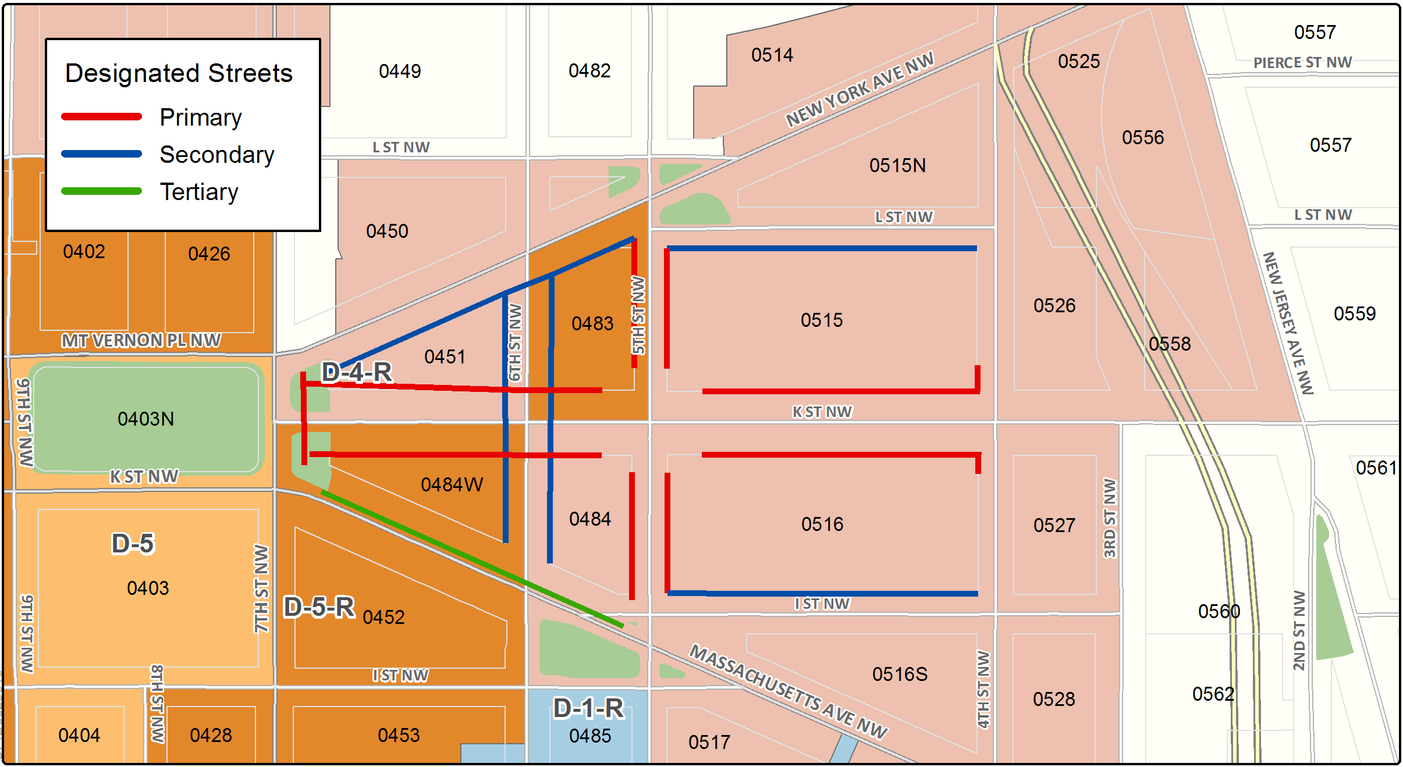

The Mt. Vernon Triangle Sub-Area includes the following designated street segments and adjacent zoning.

TABLE I § 611.4: MOUNT VERNON TRIANGLE SUB-AREA DESIGNATED STREET SEGMENTS AND ADJACENT ZONING

Designated Street | Side of Street | Adjacent Zone | Segment Boundary 1 (northern or eastern) | Segment Boundary 2 (southern or western) | Segment Classification
4th St., N.W. | West | D-4-R | L St., N.W. | 36 feet north of K St., N.W. | Tertiary, with vehicle entry restrictions per Subtitle I § 611.4(f)
4th St., N.W. | West | D-4-R | 36 feet north of K St., N.W. | 36 feet south of K St., N.W. | Primary, with vehicle entry restrictions per Subtitle I § 611.4(f)
5th St., N.W. | Both | D-4-R, D-5-R | New York Ave., N.W. | 72 ft. north of lot line on north side of K St., N.W. | Primary, with portions subject to vehicle entry restrictions per Subtitle I §§ 611.4(d), (e), (f)
5th St., N.W. | Both | D-4-R | 72 ft. south of lot line on south side of K St., N.W. | Massachusetts Ave., N.W. | Primary, with portions subject to vehicle entry restrictions per Subtitle I §§ 611.4(d), (e), (f)
6th St., N.W. | Both | D-4-R, D-5-R | New York Ave., N.W. | Massachusetts Ave., N.W. | Secondary, with vehicle entry restrictions per Subtitle I § 611.4(f)
7th St., N.W. | East | D-4-R, D-5-R | New York Ave., N.W. | Massachusetts Ave., N.W. | Primary, with vehicle entry restrictions per Subtitle I § 611.4(f) and Tertiary, per Massachusetts Avenue / Mt. Vernon Square Subtitle I § 610.4
Massachusetts Ave., N.W. | North | D-5-R | 5th St., N.W. | 7th St., N.W. | Secondary, with vehicle entry restrictions per Subtitle I § 611.4(f) and  Tertiary, per Massachusetts Avenue / Mt. Vernon Square Subtitle I § 610.4
K St. N.W. | North | D-4-R | 4th St., N.W. | 5th St., N.W. | Secondary, with vehicle entry restrictions per Subtitle I § 611.4(f)
K St., N.W. | Both | D-4-R, D-5-R | 4th St., N.W. | 72 ft. east of lot line on east side of 5th St., N.W. | Primary, with vehicle entry restrictions per Subtitle I §§ 611.4(c), (d), (f)
K St., N.W. | Both | D-4, D-5 | 72 ft. west of lot line on west side of 5th St., N.W. | 7th St., N.W. | Primary, with vehicle entry restrictions per Subtitle I § 611.4(c), (f)
L St., N.W. | South | D-4-R | 4rd St., N.W. | 5th St., N.W. | Secondary, with vehicle entry restrictions per Subtitle I§ 611.4(f)
New York Ave., N.W. | South | D-4-R, D-5-R | 5th St., N.W. | 7th St., N.W. | Secondary, with vehicle entry restrictions per Subtitle I§ 611.4(f)

Use regulations for a building with frontage on designated primary or secondary street segments are contained in Subtitle I § 601.

With the exception of garage or loading entrances or exits regulated in Subtitle I §§ 611.7 through 611.11, design regulations for a building with frontage on a designated primary or secondary designated streets are contained in Subtitle I § 602.

There shall be no vehicular garage or loading entrance or exit constructed on the portions of the façade of a building fronting on the north or south side of K Street, N.W. between 5th Street, N.W. and 7th Street, N.W.

Among all buildings within each of the following designated street segments there shall be no more than one (1) vehicular garage or loading entrance or exit constructed, unless otherwise required by DDOT:

The north side of K Street between 4th Street and 5th Street, N.W.;

The south side of K Street between 4th Street, N.W. and an alley existing on the effective date of this title located approximately three hundred and seventy-five (375) feet west of 4th Street, N.W.; and

The east side of 5th Street, N.W. between Eye Street and L Street, N.W., other than the area defined in Subtitle I § 612.

Among all buildings within each of the following designated street segments, there shall be no more than two (2) vehicular garage or loading entrances or exits constructed on the portions of façades adjacent to the following streets, unless otherwise necessitated by a written opinion or decision by DDOT pertinent to the site where the façade would be located:

The west side of 5th Street between I Street and K Street; and

The west side of 5th Street between K Street and L Street.

For designated street segments in the Mount Vernon Triangle Sub-Area that are not governed by Subtitle I §§ 611.7 through 611.9, no more than one (1) vehicular garage or loading entrance or exit driveway may be constructed within the length of an individual building, unless the building extends the entire length of the square, in which case the following shall apply:

No more than two (2) vehicular garage or loading entrance or exit driveways may be constructed within the total length of all building façades adjacent to a public street on any side of a property Square; and

Each vehicular garage or loading entrance or exit shall be separated by no less than sixty feet (60 ft.), unless lesser distances between curb cuts are permitted for the location by DDOT.

Exceptions from the requirements of Subtitle I §§ 611.7 through 611.10 shall be permitted only if granted as a special exception by the Board of Zoning Adjustment under Subtitle X, Chapter 9, provided the applicant also demonstrates that:

There is no practical alternative means of serving the parking, loading, or drop-off needs of the building to be served by the proposed vehicular garage or loading entrances or exits, such as signage approved by DDOT, that would direct vehicles to an alternative entrance point within the same square;

Access to the vehicular garage or loading entrances or exits will not impede the flow of pedestrian traffic on a designated primary street segment; and

The proposed vehicular garage or loading entrances or exits is not inconsistent with DDOT landscape plans for the public rights-of-way on the designated street frontage as such plans exist at the time of the special exception application.

Design regulations for designated primary and secondary street segments are contained in Subtitle I § 602.

Design regulations for the designated tertiary street segments on Massachusetts Avenue, N.W. are contained in Subtitle I § 610.

SOURCE: Final Rulemaking published at 63 DCR 2447, 3041 (March 4, 2016 – Part 2).

