MOUNT VERNON TRIANGLE PRINCIPAL INTERSECTION AREA SUB-AREA

The objective of the Mount Vernon Triangle Principal Intersection Sub-Area is to require uses and building design that provide a focal point for food and beverage, entertainment, and accessory uses in the Mount Vernon Triangle.

The Mount Vernon Triangle Principal Intersection Sub-Area generally comprises the square-shaped area measuring seventy-two feet (72 ft.) on a side on each of the four (4) corners of the intersection of K and 5th Streets, N.W in Squares 483, 484, 515, and 516, where two (2) designated primary street segment sides are contiguous with the property lines adjacent to each corner of the intersection, as indicated in Figure I § 612(a): Illustration of the Mount Vernon Triangle Principal Intersection Sub-Area and Designated Street Segments and Figure I § 612(b): Illustration of the Mount Vernon Triangle Principal Intersection Sub-Area Corners and Modules.

FIGURE I § 612(a): ILLUSTRATION OF THE MOUNT VERNON TRIANGLE PRINCIPAL INTERSECTION SUB-AREA CORNERS AND MODULES

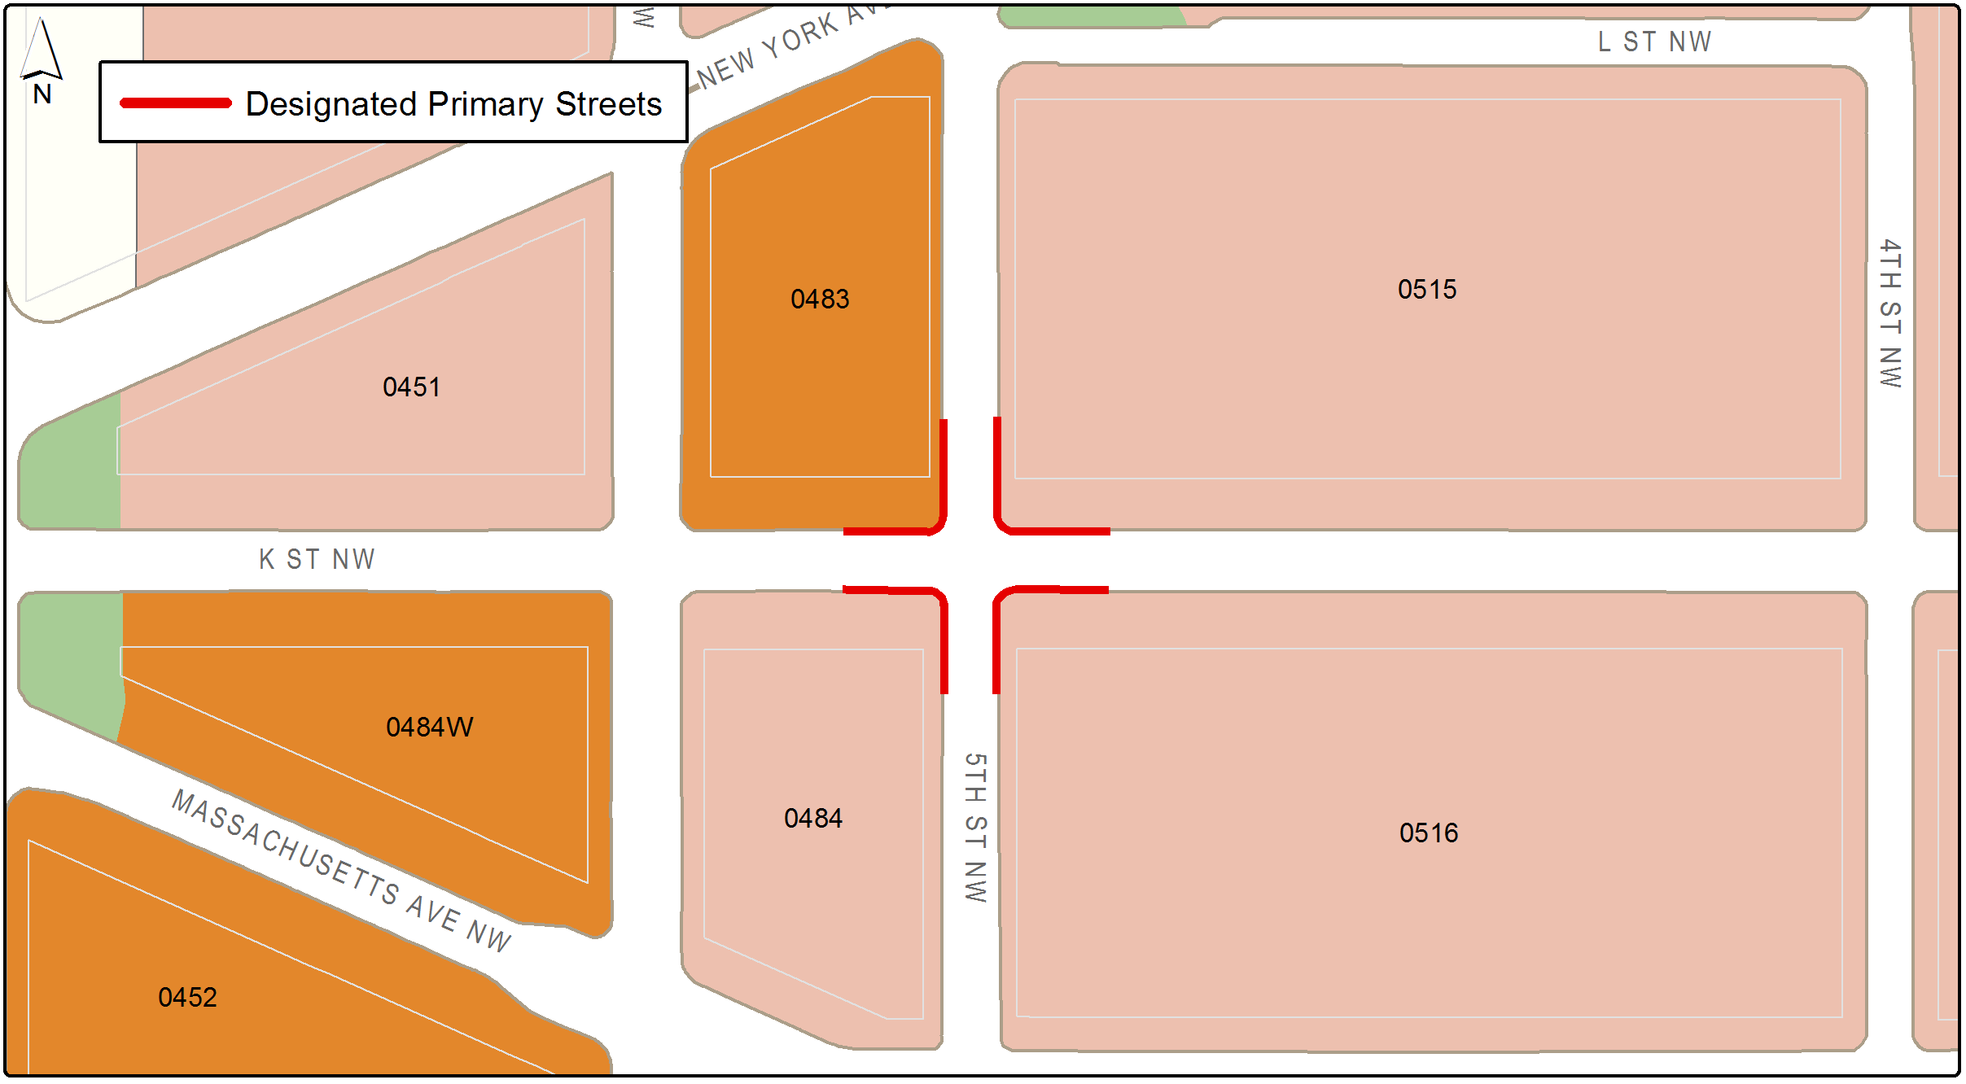
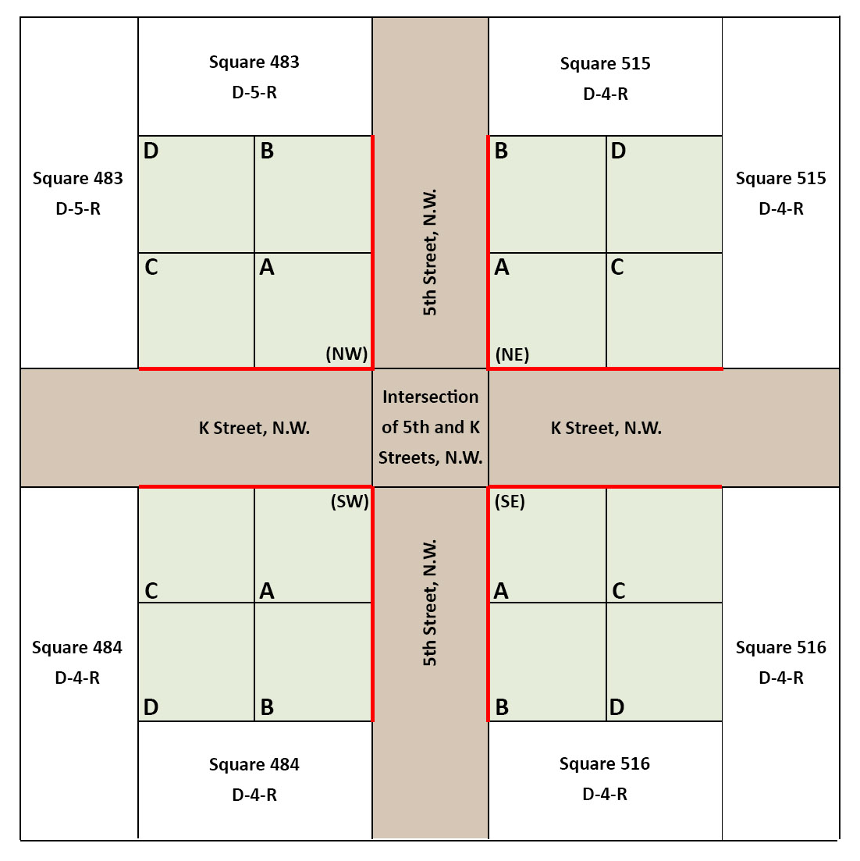
FIGURE I § 612(b): ILLUSTRATION OF THE MOUNT VERNON TRIANGLE PRINCIPAL INTERSECTION AREA CORNERS AND MODULES

The designated street segments and property within the Mt. Vernon Triangle Principal Intersection Area Sub-Area includes the following:

In Figure I § 612(b): Illustration of the Mount Vernon Triangle Principal Intersection Sub-Area Corners and Modules, "K Street" defines the east and west directions; and "5th Street" defines the north and south directions. The northwest corner is Square 483; the northeast corner is Square 515; the southwest corner is Square 484; and the southeast corner is Square 516;

At each corner there are four (4) modules labeled A, B, C, and D. Each block in the chart labeled A, B, C, or D represents a thirty-six-foot by thirty-six-foot (36 ft. x 36 ft.) area within the respective seventy-two-foot by seventy-two-foot (72 ft. x 72 ft.);

The "A" modules are the thirty-six-foot by thirty-six-foot (36 ft. x 36 ft.) modules nearest to the intersections. The "B" modules are the thirty-six-foot by thirty-six-foot (36 ft. x 36 ft.) modules fronting on 5th Street that are between thirty-six feet (36 ft.) and seventy-two feet (72 ft.) north and south of K Street. The "C" modules are the thirty-six-foot by thirty-six-foot (36 ft. x 36 ft.) modules fronting on K Street that are between thirty-six feet (36 ft.) and seventy-two feet (72 ft.) east and west of 5th Street. The "D" modules are the thirty-six-foot by thirty-six- foot (36 ft. x 36 ft.) interior modules that have frontage on neither K Street nor 5th Street; and

Each designated street segment in the sub-area is a designated primary street segment, with adjacent property in Square 484, 515, and 516 being zoned D-4-R, and adjacent property in Square 483 being zoned D-5-R.

The portion of a building within the Mt. Vernon Triangle Principal Intersection Area Sub-Area is subject to the following height regulations in addition to those governing the property’s zone districts:

TABLE I § 612.4: MAXIMUM PERMITTED BUILDING HEIGHT
Module | Maximum Height | Minimum Clear Floor-to Ceiling Height
A | Except in Square 515, no higher than 50 ft. above grade | 22 ft.
B & C | No more than 50% of the portions of a building within each of the B and C modules shall be more than 50 ft. above grade | 22 ft. for at least 50% of its ground floor
D | As permitted by zone | 14 ft.

612.5 With the exception of a building that is a designated historic landmark or that is included within a historic district, the portion of a building within the Mt. Vernon Triangle Principal Intersection Area Sub-Area is subject to the following streetwall design regulations in addition to those governing the property’s zone district and designated primary street classification:

Each building shall devote not less than sixty-five percent (65%) of the surface area of the streetwall(s) at the ground level, to a height of at least twenty-two feet (22 ft.) feet, to display windows with clear and/or low-emissivity glass, except for decorative or architectural accent and entrances to commercial uses or to the building;

Each building shall devote not less than sixty-five percent (65%) of the surface area of the streetwall between eighteen feet (18 ft.) and twenty-two feet (22 ft.) above grade to clear and/or low-emissivity glass;

There shall be no direct entrances to lobbies serving residential or office uses; and

There shall be no vehicular garage or loading entrances or exits in portions of façades within the principal intersection area, unless otherwise required DDOT.

Roof terraces, whether open to the sky or covered with awnings or canopies, that are atop the portions of a building within the A, B, or C modules, as defined in Subtitle I § 612.2, shall not be included in the maximum floor area ratio calculations.

Within the boundaries of the sub-area, a building shall dedicate one hundred percent (100%) of its ground floor and mezzanine to uses permitted on designated primary streets by Subtitle I § 601, with at least fifty percent (50%) of that area being devoted to one (1) or more of the following uses:

Bookstore, including restaurant;

Cabaret; or

Eating and drinking establishment, including bar, nightclub, or cocktail lounge, and restaurant.

At least forty percent (40%) of the linear frontage of the ground floor and mezzanine fronting on a designated primary street within the sub-area shall be devoted to a use required by Subtitle I § 612.7.

SOURCE: Final Rulemaking published at 63 DCR 2447, 3041 (March 4, 2016 – Part 2); as amended by Final Rulemaking published at 64 DCR 340 (January 13, 2017).

