BLAGDEN ALLEY RESIDENTIAL TRANSITION SUB-AREA

The objective of the Blagden Alley Residential Transition Sub-Area is to ensure a height transition between the medium density, primarily commercial, public and lodging uses south of M Street and the more residential uses on the north of M Street.

The Blagden Alley Residential Transition Sub-Area consists of the D-4-R zoned property with frontage on the designated tertiary street segment on the south side of M Street N.W., between 9th and 10th Streets, N.W., including portions of Square 369 as generally indicated with the green line in Figure I § 613: Illustration of the Blagden Alley Residential Transition Sub-Area and Designated Street Segments.
FIGURE I § 613: ILLUSTRATION OF THE BLAGDEN ALLEY RESIDENTIAL TRANSITION SUB-AREA AND DESIGNATED STREET SEGMENTS

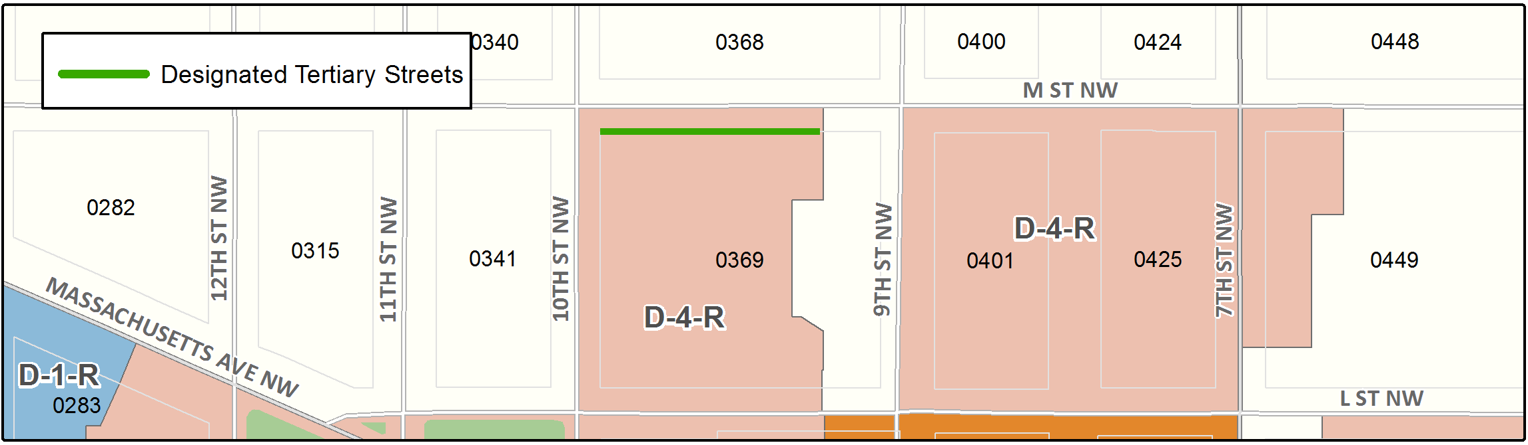

The zone district use regulations shall govern the sub-area.

A building constructed on a lot fronting on the south side of M Street, N.W., between 9th Street, N.W. and 10th Street, N.W., shall be limited to a maximum height of sixty feet (60 ft.) to a depth of forty feet (40 ft.) from the lot line on M Street, N.W.

SOURCE: Final Rulemaking published at 63 DCR 2447, 3041 (March 4, 2016 – Part 2).

