LOWER CONNECTICUT AVENUE CORRIDOR SUB-AREA

The objective of the Lower Connecticut Avenue Corridor Sub-Area is to support the continued concentration of active, high-quality ground floor retail uses along the Connecticut Avenue corridor between K Street, N.W. and Dupont Circle.

The Lower Connecticut Avenue Corridor Sub-Area consists of the D-6-zoned property with frontage on either side of the designated primary street segments of Connecticut Avenue between K Street, N.W. and M Street, N.W., including all or parts of Squares 161, 162, 163, and 164 as generally indicated with the red lines in Figure I § 614: Illustration of the Lower Connecticut Avenue Corridor Sub-Area and Designated Street Segments.

FIGURE I § 614: ILLUSTRATION OF THE LOWER CONNECTICUT AVENUE CORRIDOR SUB-AREA AND DESIGNATED STREET SEGMENTS

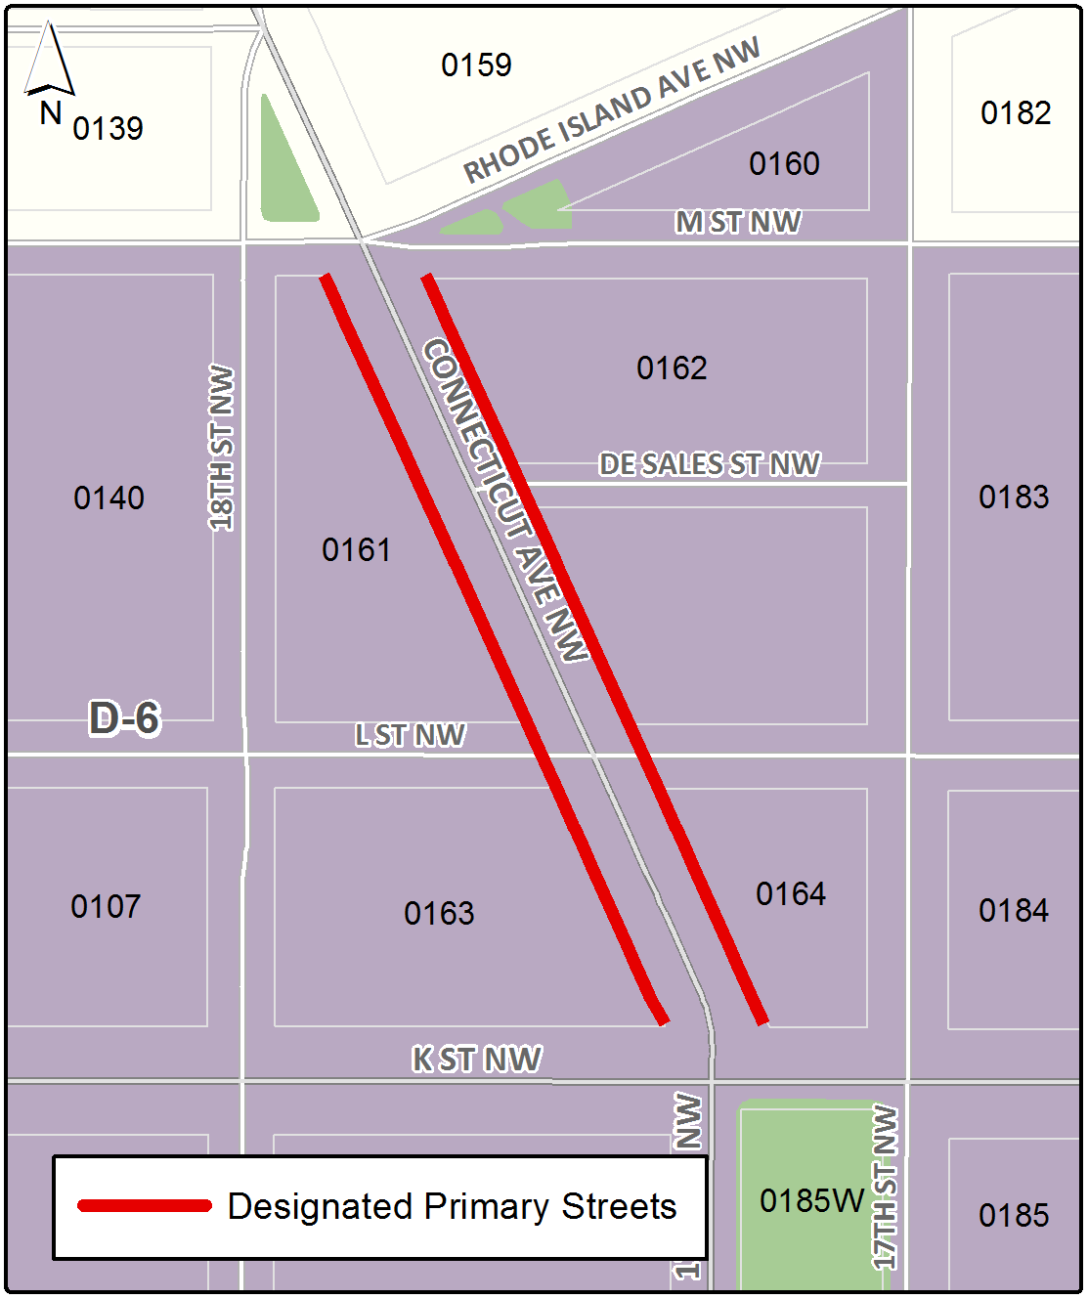

The zone district and the designated primary street segment use regulations in Subtitle I § 601 shall govern uses in buildings with frontage on a designated street segment.

The designated primary street design regulations in Subtitle I § 602 shall govern the ground floor design of a building with frontage on a designated street segment in the sub-area.

SOURCE: Final Rulemaking published at 63 DCR 2447, 3041 (March 4, 2016 – Part 2).

