NORTH OF MASSACHUSETTS AVENUE (NOMA) SUB-AREA

The objective of the North of Massachusetts Avenue (NoMA) Sub-Area is to further the transition of the former light industrial area into a high-density commercial and residential neighborhood with a concentration of ground floor level retail, service, food and beverage, and entertainment uses on 1st Street, N.E.

The NoMA Sub-Area consists of the D-5-zoned property with frontage on 1st Street, N.E., the designated primary street between K Street, N.E. and New York Avenue, N.E., including all or parts of Squares 671, 672, 673, 674, 710, 711, 712, and 713, as generally indicated with the red lines in Figure I § 615: Illustration of the North of Massachusetts Avenue (NoMA) Sub-Area and Designated Street Segments.

FIGURE I § 615: ILLUSTRATION OF THE NORTH OF MASSACHUSETTS AVENUE (NOMA) SUB-AREA AND DESIGNATED STREET SEGMENTS
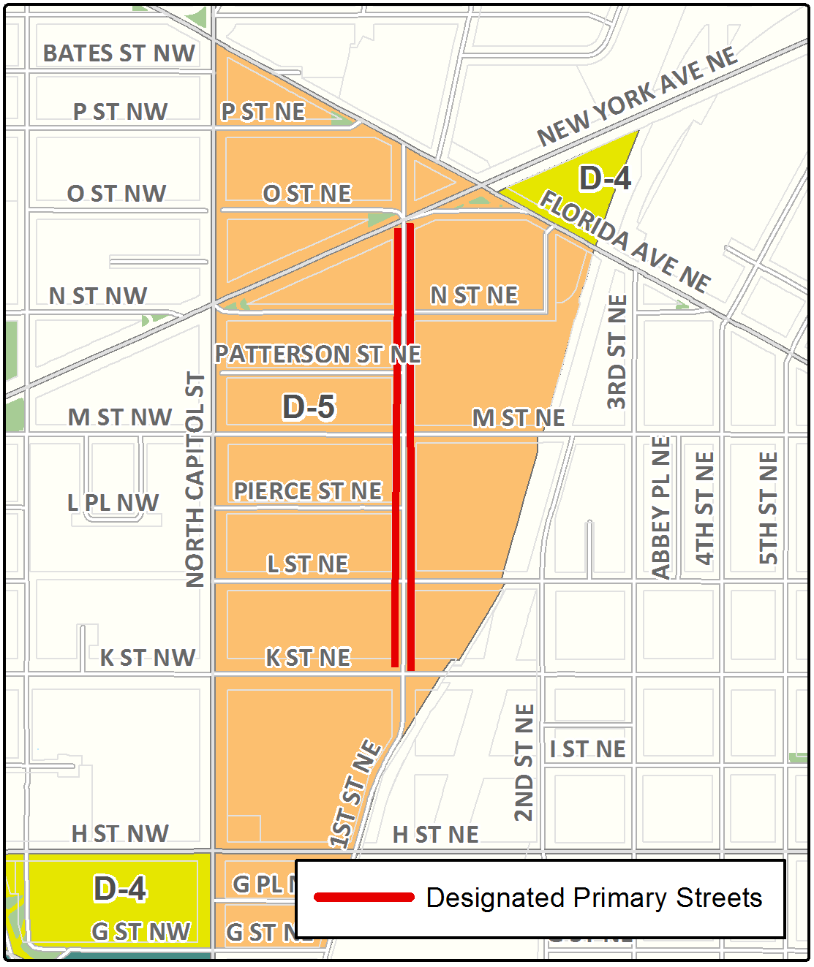

The designated primary street use regulations in Subtitle I § 601 shall govern uses in a building with frontage on a designated street segment, to a depth of one hundred fifty feet (150 ft.) from the building line on the designated street.

The designated primary street design regulations in Subtitle I § 602 shall govern the ground floor design of a building with frontage on a designated street segment in the sub-area.

SOURCE: Final Rulemaking published at 63 DCR 2447, 3041 (March 4, 2016 – Part 2).

