M AND SOUTH CAPITOL STREETS SUB-AREA

The objectives of the M and South Capitol Streets Sub-Area are to ensure the preservation of the historically important axial view of the Capitol Dome and further the development of a high-density mixed-use corridor north of the Capitol Gateway neighborhood.

The general location of the M and South Capitol Streets Sub-Area is the D-5 zoned property with frontage on either side of the designated tertiary street segments of South Capitol Street corridor north of M Street, as indicated with the green lines in Figure I § 616: Illustration of the M and South Capitol Streets Sub-Area and Designated Street Segments, and the D-5 zone property with frontage on the designated primary street segments on the north side of M Street, S.E., between South Capitol Street and the Canal Blocks Park, as indicated by the red line in Figure I § 616, and detailed in Subtitle I § 616.3, including all or parts of Squares 640, 641, 643E, 644, 646, 648 649, 695, 695W, 697N, 697, 698, 699, 742, and 743N.

FIGURE I § 615: ILLUSTRATION OF THE M AND SOUTH CAPITOL STREETS SUB-AREA AND DESIGNATED STREET SEGMENTS
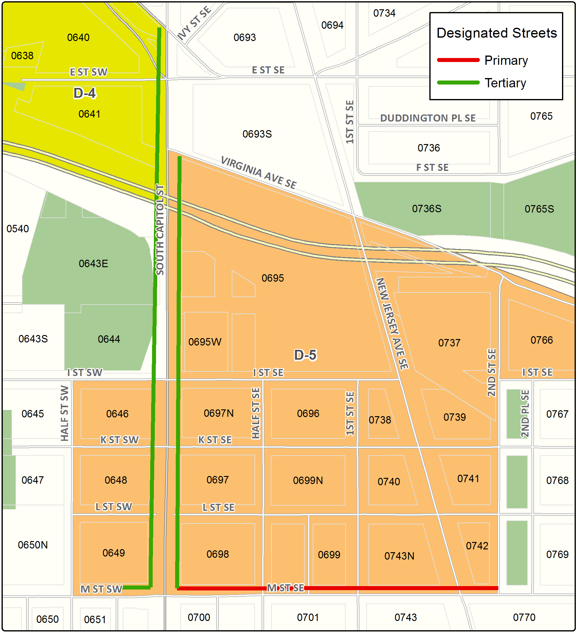

The M and South Capitol Streets Sub-Area includes the following designated street segments and adjacent zoning:

TABLE I § 616.3: M AND SOUTH CAPITOL STREETS SUB-AREA DESIGNATED STREET SEGMENTS AND ADJACENT ZONING

Designated Street | Side of Street | Adjacent Zone | Segment Boundary 1 (northern or eastern) | Segment Boundary 2 (southern or western) | Segment Classification
South Capitol St. | West | D-5 | Washington Ave., S.W | M St., S.W. | Tertiary; with Design Review
South Capitol St. | East | D-5 | Virginia Ave., S.E. | M St., S.E. | Tertiary; with Design Review
M St., S.E. | North | D-5 | 2nd St., S.E. | South Capitol St., S.E. | Primary
M St., S.W. | North | D-5 | South Capitol St., S.W. | 200 ft. west of the centerline of South Capitol St., S.W. | Tertiary

The uses for a building with frontage on a designated primary street segment is governed by Subtitle I § 601.

The uses for a building with frontage on a designated tertiary street segment are governed by the zone district.

A building with frontage on the designated primary street segments of M Street, S.E. shall:

Follow the design regulations in Subtitle I § 602;

Setback the entire length and height of each building face fronting on M Street, S.E., not less than fifteen feet (15 ft.), as measured from the face of the adjacent curb; and

Be subject to review of its proposed ground floor uses by the Zoning Commission, simultaneous with its review under Subtitle I § 616.8.

The streetwall on the eastern and western sides of South Capitol Street shall be set back for its entire height and frontage not less than fifteen feet (15 ft.), from the property line adjacent to South Capitol Street, with the following exceptions:

There shall be no setback on the west side of South Capitol Street in Square 649 between L and M Streets, S.W.;

(b) There shall be a setback of seventy-three and one-half feet (73.5 ft.) from the centerline of South Capitol Street on its west side in Square 648 between K and L Streets, S.W.;

There shall be a setback of eighty-one feet (81 ft.) from the centerline of South Capitol Street on its west side in Square 643 between I Street and I-395;

Any portion of a building that exceeds one hundred ten feet (110 ft.) in height shall provide an additional one-to-one (1:1) setback from the building line along South Capitol Street;

There shall be no openings in building frontages adjacent to South Capitol Street that provide entrances or exits for vehicular parking or loading;

A minimum of seventy-five percent (75%) of the street-wall on the east side of South Capitol Street shall be constructed on the setback line; and

A minimum of sixty percent (60%) of the street-wall on the west side of South Capitol Street shall be constructed on the setback line.

All proposed buildings and structures, or any proposed exterior renovation to any existing buildings or structures that would result in an alteration of the exterior designs facing the street segments in the sub-area shall be subject to review and approval by the Zoning Commission in accordance with the provisions in Subtitle I, Chapter 7.

SOURCE: Final Rulemaking published at 63 DCR 2447, 3041 (March 4, 2016 – Part 2); as amended by Final Rulemaking published at 63 DCR 10932 (August 26, 2016).

