NORTH CAPITOL STREET CORRIDOR SUB-AREA

The objective of the North Capitol Street Corridor Sub-Area is to ensure the preservation of the historically important axial view of the Capitol Dome.

The general location of the North Capitol Street Corridor Sub-Area is one (1) or both sides of the designated primary street segments North Capitol Street between Louisiana Avenue, N.W. and K Streets, N.W. and N.E., indicated with green lines in Figure I § 617: Illustration of the North Capitol Street Corridor Sub-Area and Designated Street Segments, and detailed in Subtitle I § 617.3 and including all or parts of Squares: 624, 625, 626, 628, 630, 675, 676, and 677.

FIGURE I § 617: ILLUSTRATION OF THE NORTH CAPITOL STREET CORRIDOR SUB-AREA AND DESIGNATED STREET SEGMENTS

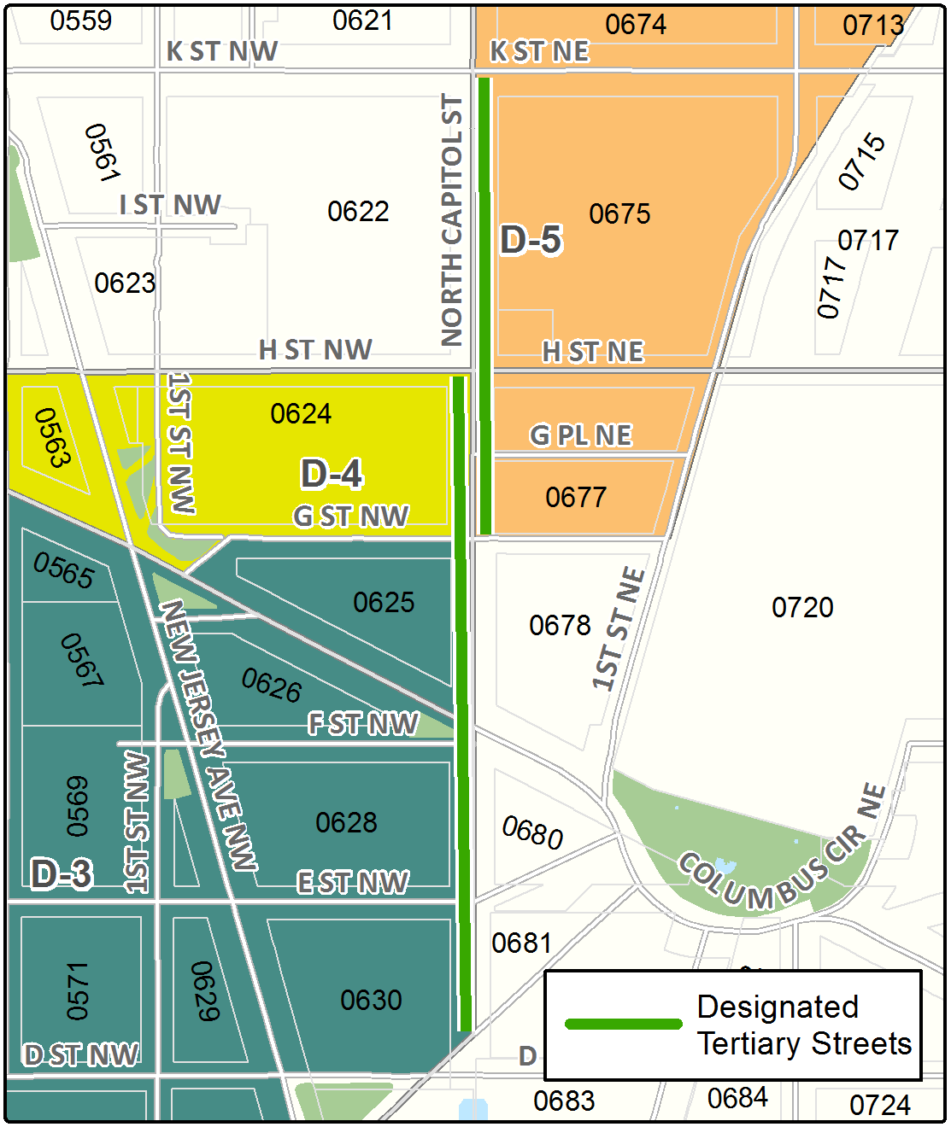

The North Capitol Street Corridor Sub-Area includes the following designated street segments and adjacent zoning:

TABLE I § 617.3: NORTH CAPITOL STREET CORRIDOR SUB-AREA DESIGNATED STREET SEGMENTS AND ADJACENT ZONING

Designated Street | Side of Street |  | Adjacent Zone |  | Segment Boundary 1 (northern or eastern) |  | Segment Boundary 2 (southern or western) |  | Segment Classification
North Capitol St. |  | West |  | D-4 |  | H Street, N.W. |  | G Street, N.W. |  | Tertiary
North Capitol St. |  | West |  | D-3 |  | G Street, N.W. |  | D Street, N.W. |  | Tertiary; (also in Capitol Security Sub-Area)
North Capitol St. |  | East |  | D-5 |  | K Street, N.E. |  | G Street, N.E. |  | Tertiary

The zone district use regulations shall govern uses in a building with frontage on a designated street segment.

Not less than seventy-five percent (75%) of each newly constructed building wall to a height of at least fifteen feet (15 ft.) that fronts a designated tertiary street segment shall be constructed to, or within four feet (4 ft.) of, the property line between the subject lot and the abutting street right-of-way.

Any portion of a building frontage on a designated tertiary street that exceeds one hundred ten feet (110 ft.) in height shall provide an additional one-to-one (1:1) setback from the building line along North Capitol Street.

617.7 All proposed buildings, and structures, or any proposed exterior renovation to any existing buildings or structures that would result in an alteration of the exterior designs facing the street segments noted in Subtitle I § 617.3 shall be subject to review and approval by the Zoning Commission in accordance with the provisions in Subtitle I, Chapter 7.

SOURCE: Final Rulemaking published at 63 DCR 2447, 3041 (March 4, 2016 – Part 2); as amended by Final Rulemaking published at 63 DCR 10932 (August 26, 2016); as amended by Final Rulemaking published at 71 DCR 009667 (August 2, 2024).

