INDEPENDENCE AVENUE

The objective of the Independence Avenue Sub-Area is to protect the viewshed of the National Mall.

The general location of the Independence Avenue Sub-Area is the property with frontage on the designated tertiary street of Independence Avenue, S.W., between 2nd and 12th Streets, S.W., including all or parts of Squares 351, 351N, 383, 409, 433, 462N, 492N, 492, 534, and 577, as indicated with the green line Figure I § 618: Illustration of the Independence Avenue Sub-Area and Designated Street Segments, and as detailed in Subtitle I § 618.3.

FIGURE I § 618: ILLUSTRATION OF THE INDEPENDENCE AVENUE SUB-AREA AND DESIGNATED STREET SEGMENTS

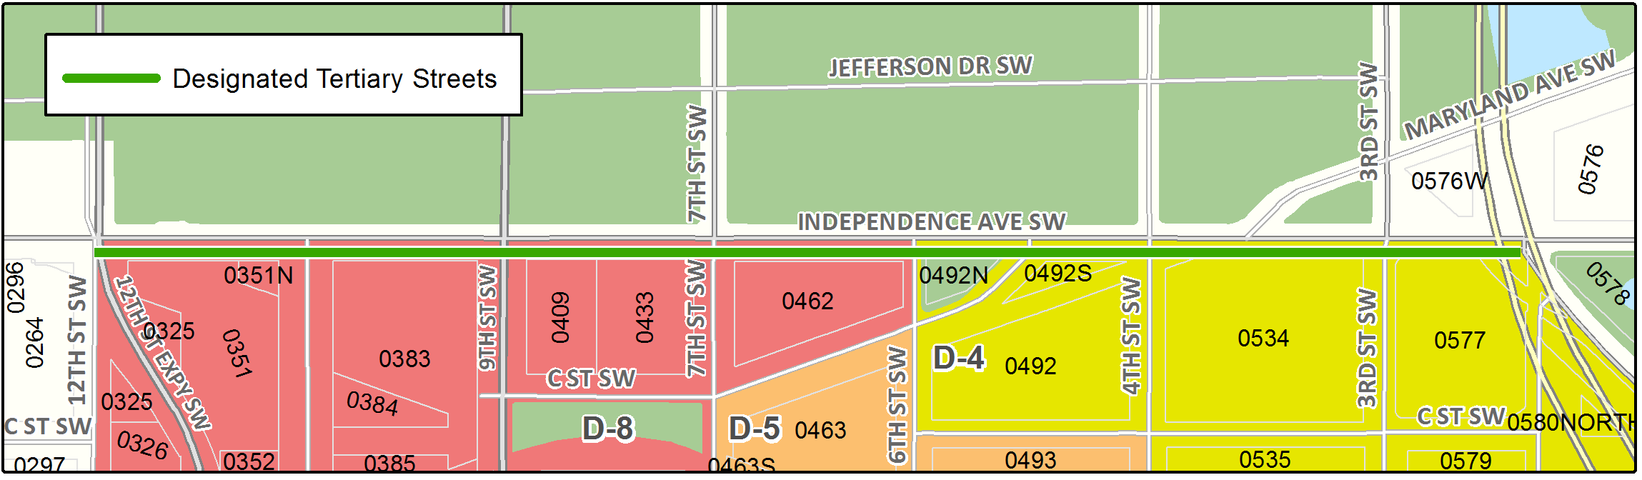

The Independence Avenue Sub-Area includes the following designated street segments and adjacent zoning:

TABLE I § 617.3: INDEPENDENCE AVENUE SUB-AREA DESIGNATED STREET SEGMENTS AND ADJACENT ZONING

Designated Street | Side of Street | Adjacent Zone | Segment Boundary 1 (northern or eastern) | Segment Boundary 2 (southern or western) | Segment Classification
Independence Ave., S.W. | South | D-4 | Washington Ave/3rd St. S.W. | 6th Street, S.W. | Tertiary; (also Capitol Security Sub-Area between Washington Ave. and 3rd St., S.W.
Independence Ave., S.W. | South | D-8 | 6th Street, S.W. | 12th Street, S.W. | Tertiary

The use regulations for a building with frontage on a designated street segment are those applicable to the zone.

A building or structure with frontage on Independence Avenue, S.W.in the sub-area:

Shall have a building setback of eighty-eight feet (88 ft.) from the centerline of Independence Avenue;

Shall setback, at a one-to-one (1:1) ratio from the face of the building’s frontage on Independence Avenue, S.W., the height of any building story more than one-hundred ten feet (110 ft.), as measured from the building line on Independence Avenue;

Shall setback any penthouse or rooftop structure at a two-to-one (2:1) ratio from each exterior wall of the roof upon which it is located;

Shall not have the total area of structures listed in Subtitle I § 618.5(c) exceed one-third (1/3) of the total roof area upon which it or they are located;

Shall have all mechanical equipment placed in one (1) enclosure that shall harmonize with the main structure in architectural character, material and color;

Shall not include any tower, dome, minaret or other architectural embellishment taller than the main building; and

Shall complement, not compete with, the Smithsonian buildings when viewed from the National Mall and Independence Avenue, S.W.

All proposed buildings, and structures, or any proposed exterior renovation to any existing buildings or structures that would result in an alteration of the exterior designs facing the street segments noted in Subtitle I § 618.4 shall be subject to review and approval by the Zoning Commission in accordance with the provisions in Subtitle I, Chapter 7, and, if located between 6th and 12th Streets, S.W., shall be referred to the National Capital Planning Commission for comment.

SOURCE: Final Rulemaking published at 63 DCR 2447, 3041 (March 4, 2016 – Part 2); as amended by Final Rulemaking published at 68 DCR 013834 (December 24, 2021).

