HEIGHT (USN)
      - The maximum permitted building height, not including the penthouse or rooftop structure, shall not exceed one hundred thirty feet (130 ft.), except that:
        - The maximum permitted building height, not including the penthouse or rooftop structure, of any portion of a building or structure that is both north of the centerline of Eye Street and east of a north-south line located two hundred feet (200 ft.) west of the eastern boundary of Lot 7002 in Square 717 shall not exceed ninety feet (90 ft.);
        - Within the area defined in Subtitle K § 305.1(a), a building height of greater than ninety feet (90 ft.) and no more than one hundred ten feet (110 ft.) shall be permitted if reviewed and approved by the Zoning Commission pursuant to the procedures set forth in Subtitle K §§ 315 and 317, and subject to the following:
          - The Zoning Commission will make a preliminary decision whether to approve the additional height as part of its Stage 1 review;
          - The preliminary approval will become final unless modified or disapproved during the Stage 2 review;
          - In making its decision, the Zoning Commission shall consider the design review criteria set forth in Subtitle K §§ 323.1(b), 323.1(d), 323.1(g), 325.1(b), and 325.1(h);
          - The Zoning Commission must find that the building unit or units located within the defined area exhibit exceptional architectural quality; and
          - The Zoning Commission may require upper story setbacks or other design modifications that it deems necessary;
        - The maximum permitted building height, not including the penthouse or rooftop structure, of any portion of a building or structure that is both north of the southern property line of Lot 7000 in Square 720 and south of a parallel line one hundred fifty feet (150 ft.) from the southern property line (as that area is depicted in Figure K § 305.1) shall not exceed ninety feet (90 ft.);
        - Within the area defined in Subtitle K § 305.1(c), a building height of greater than ninety feet (90 ft.) and no more than one hundred ten feet (110 ft.) shall be permitted if reviewed and approved by the Zoning Commission pursuant to the procedures set forth in Subtitle K §§ 315 and 317, and subject to the criteria of Subtitle K §§ 305.1(b)(1) through 305.1(b)(5);
        - The maximum permitted building height, not including the penthouse or rooftop structure, of any portion of a building or structure that is both north of a line parallel to and one hundred fifty feet (150 ft.) from the southern property line of Lot 7000 in Square 720 and south of a parallel line three hundred feet (300 ft.) from the southern property line (as that area is depicted in Figure K § 305.1) shall not exceed one hundred ten feet (110 ft.);
        - Within the area defined in Subtitle K § 305.1(e), a building height of greater than one hundred ten feet (110 ft.) and no more than one hundred thirty feet (130 ft.) shall be permitted if reviewed and approved by the Zoning Commission pursuant to the procedures set forth in Subtitle K §§ 315 and 317, and subject to the criteria of Subtitle K §§ 305.1(b)(1) through 305.1(b)(5).

FIGURE K § 305.1
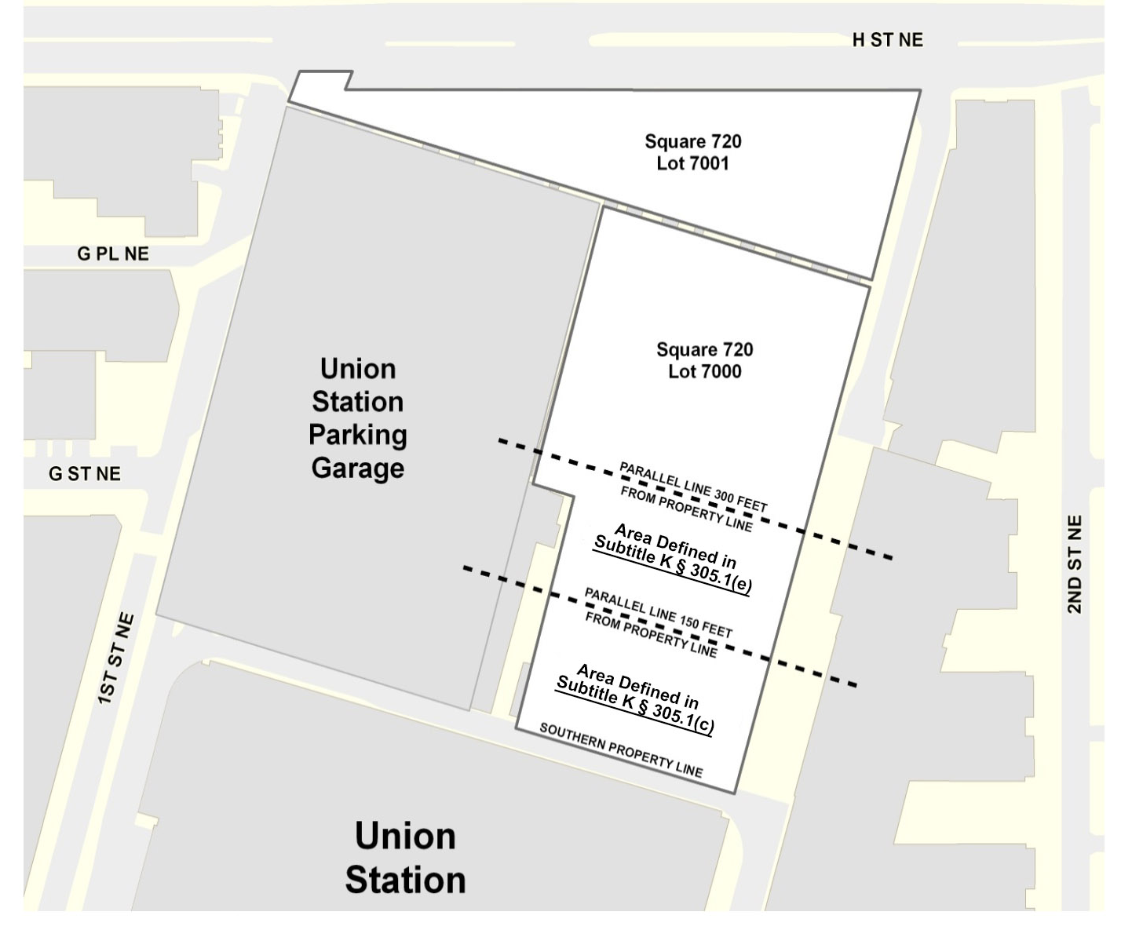
      - The measurement of building height shall be taken from the elevation of the sidewalk on H Street at the middle of the front of the building, to the highest point of the roof or parapet rather than from grade as would otherwise be required by Subtitle B, Chapter 3.
      - The matter-of-right height permitted in Subtitle K § 305.1 shall serve as the maximum permitted height for a planned unit development (PUD).

SOURCE: Final Rulemaking published at 63 DCR 2447, 3176 (March 4, 2016 – Part 2); as amended by Final Rulemaking published at 65 DCR 8555 (August 17, 2018); as amended by Final Rulemaking published at 65 DCR 11927 (October 26, 2018); as amended by Final Rulemaking published at 68 DCR 013834 (December 24, 2021).

