GENERAL PROVISIONS (HE)
      - The purposes of the Hill East (HE) zones (HE-1 through HE-4) are to:
- Connect and integrate Reservation 13 with adjacent neighborhoods, and the new waterfront park along the Anacostia River;
- Utilize the site to meet a diversity of public needs, including health care, education, employment, government services and administration, retail, recreation, and housing;
- Extend the existing pattern of local streets to and through the site to create simple, well-organized city blocks and appropriately scaled development;
- Maintain a human-scale of building heights that match existing neighborhood buildings and increase in height as the site slopes downward to the Anacostia waterfront;
- Connect the Hill East neighborhood and the city at large to the waterfront via tree-lined public streets, recreational trails, and increased access to waterfront parklands;
- Demonstrate environmental stewardship through environmentally-sensitive design, ample open spaces, and a waterfront park that serve as public amenities and benefit the neighborhood and the city;
- Promote the use of mass transit by introducing new uses near Metro stations, and create an environment where the pedestrian, bicycle, and auto are all welcome, complementary, and unobtrusive, reducing the impact of traffic on adjacent neighborhood streets;
- Limit the Central Detention Facility and the Correction Treatment Facility to areas south of Massachusetts Avenue; and
- Create attractive “places” of unique and complementary character including:
- A new, vital neighborhood center around the Metro station at C and 19th Streets that serves the unmet neighborhood commercial needs of the community and extends to the waterfront with a new residential district;
- Massachusetts Avenue as a grand Washington ‘boulevard’ in the tradition of the L’Enfant plan;
- A district for city-wide uses and services, such as health care, education, and recreation along Independence Avenue; and
(4) A grand public waterfront park incorporating monumental places and quiet natural retreats accessed by a meandering park drive set back from the Anacostia River.
      - The HE zones shall constitute the Zoning Regulations for the geographic area referred to in Subtitle K §§ 400.7 and 400.8. Where there are conflicts between this chapter and other parts of the Zoning Regulations, the provisions of this chapter shall govern.
      - Unless specifically exempted, the requirements of the HE zones shall apply to all new buildings and to all other buildings where any additions, alterations, or repairs within any twelve (12) month period exceed one hundred percent (100%) of the assessed value of the building as set forth in the records of the Office of Tax and Revenue as of the date of a building permit application, provided:
        - The cost basis for alterations or additions to an existing building shall be the amount indicated by the applicant on the application for a building permit; and
        - In the case of an addition, the requirements and incentives of this chapter apply only to the addition.
      - Any reference to a street shall be deemed to include a reference to the Southeast (S.E.) quadrant.
      - For the purposes of this chapter, the terms:
        - “Primary street” shall mean Independence Avenue, Massachusetts Avenue, and Water Street; and
FIGURE K § 400.5(a): Primary Street Frontages
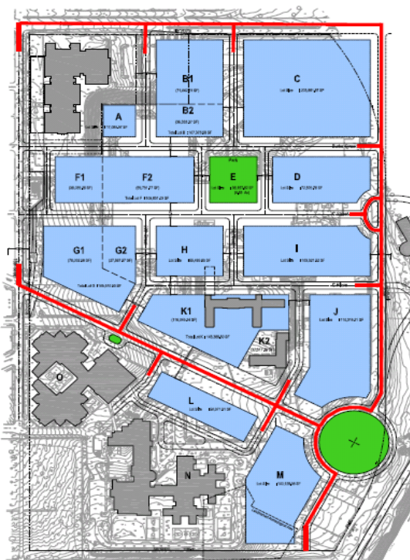

        - “Secondary street” shall refer to 19th Street, 20th Street, 21st Street, Burke Street, C Street, and C Place.
FIGURE K § 400.5(b): SECONDARY Street Frontages
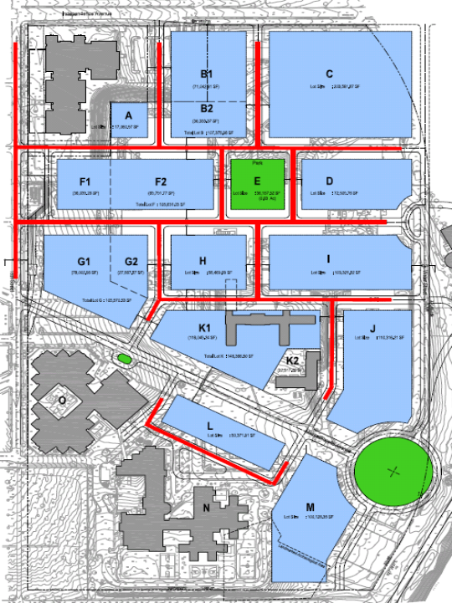

      - The boundaries of the HE zones correspond to Federal Reservation 13, which is generally bounded by Independence Avenue on the north, 19th Street on the west, Water Street on the east, and the Congressional Cemetery on the south.
      - The HE zones are divided into the following four (4) zones for the purpose of lot occupancy, floor area ratio (FAR) and building height:
        - HE-1 (19th Street), which includes squares with frontage onto 19th Street, between Independence Avenue, and Massachusetts Avenue;
        - HE-2 (20th Street), which includes squares with frontage on 20th Street;
        - HE-3 (Water Street), which includes squares with frontage on Water Street; and
        - HE-4 (Corrections), which includes Squares N and O.
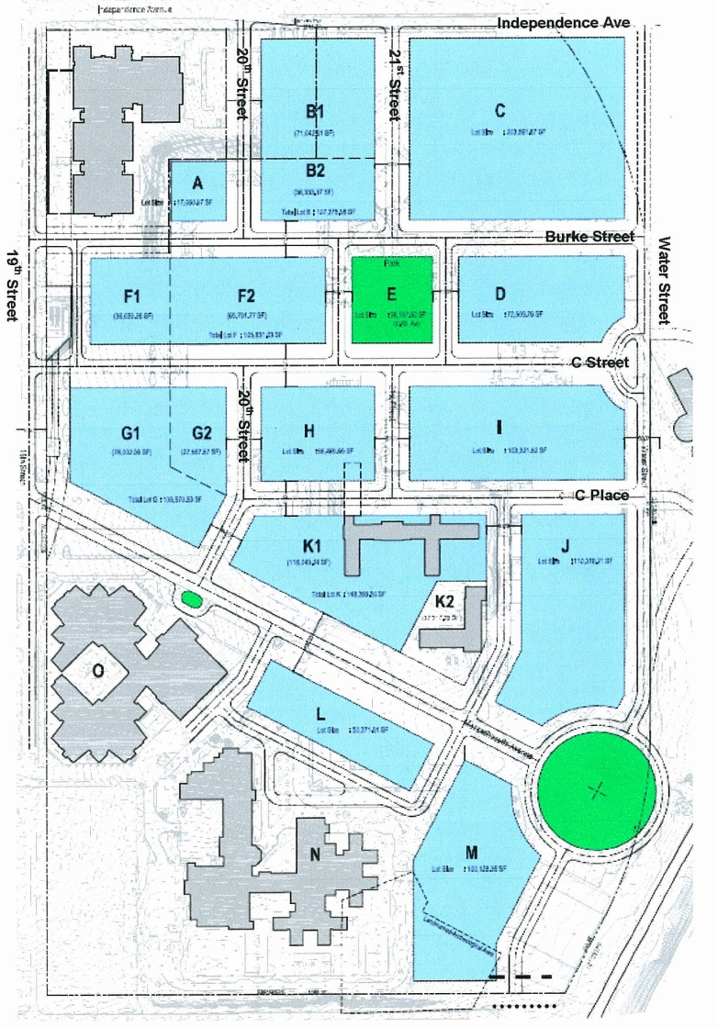
FIGURE K § 400.7: HE ZONES
      - Development in the HE zones shall be in accordance with the development standards found at Subtitle K § 402.

SOURCE: Final Rulemaking published at 63 DCR 2447, 3176 (March 4, 2016 – Part 2).

