WR-1 ZONE
FIGURE K § 901: ILLUSTRATION OF BOUNDARIES OF THE WR-1 ZONE
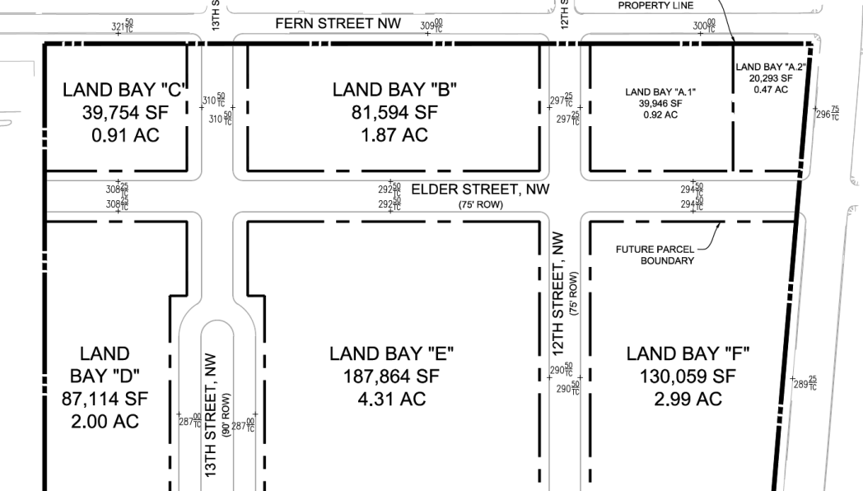
      - The WR-1 zone is intended to:
        - Provide for residential development that complements the character of nearby established residential neighborhoods;
        - Transition from the low- to moderate-scale residential uses north of Fern Street to the medium-density commercial and residential uses proposed for south of Elder Street; and
        - Discourage driveway access directly from the street to private off-street parking.
      - The development standards for the WR-1 zone are set forth in the following table:
TABLE K § 901.2: WR-1 DEVELOPMENT STANDARDS
WR-1
Sub-Area  (Land Bays A.1, B and C) | Lot Width (min.) | Building  Height (max.) | Stories (max.) | Lot Occupancy (max.) | Pervious Surface (min.) | Side Yard (min.) | Rear Yard (min.)
Lots with any frontage on Fern Street | 18 ft. | 45 ft. | 4 | 70% | 10% | None required; 4 ft. if provided | None required
Any other lot | 18 ft. | 55 ft. | 5 | 70% | 10% | None required; 4 ft. if provided | None required
      - The maximum number of permitted dwelling units on any lot shall be two (2), which includes both principal and accessory units.
      - For any inclusionary or affordable residential unit that is administered through the Department of Housing and Community Development, the minimum lot width shall be sixteen feet (16 ft.).
      - Height shall be measured in accordance with Subtitle B §§ 308, except that for any building fronting on Elder Street, the building height measuring point may be established at the finished grade at the middle of the front of the building.
      - No building shall be located between Fern and Elder Streets within fifty feet (50 ft.) of the western boundary of the WR zone.
      - In the WR-1 zone, no driveway or garage entrance providing access to parking or loading areas shall be permitted from a public or private street.
      - In the WR-1 zone, any private driveway shall be constructed of pervious materials. This does not apply to a private alley.
      - An addition to a single dwelling unit or flat, or a new or enlarged accessory structure on the same lot as a single dwelling unit or flat, shall be permitted, even though the addition or accessory structure does not comply with all of the requirements of Subtitle K § 901.2, as a special exception if approved by the Board of Zoning Adjustment under Subtitle X, Chapter 9, subject to the provisions of this subsection:
        - The addition or accessory structure shall not have a substantially adverse effect on the use or enjoyment of any abutting or adjacent dwelling or property, in particular:
          - The light and air available to neighboring properties shall not be unduly affected;
          - The privacy of use and enjoyment of neighboring properties shall not be unduly compromised;
          - The addition or accessory structure, together with the original building, as viewed from the street, alley, and other public way, shall not substantially visually intrude upon the character, scale, and pattern of houses along the subject street frontage; and
          - In demonstrating compliance with paragraphs (a), (b), and (c) of this subsection, the applicant shall use graphical representations such as plans, photographs, or elevation and section drawings sufficient to represent the relationship of the proposed addition or accessory structure to adjacent buildings and views from public ways;
        - The lot occupancy of all new and existing structures on the lot shall not exceed eighty percent (80%); and
        - The Board of Zoning Adjustment may require special treatment in the way of design, screening, exterior or interior lighting, building materials, or other features for the protection of adjacent or nearby properties.

SOURCE: Final Rulemaking published at 63 DCR 2447, 3176 (March 4, 2016 – Part 2).

