WR-2 ZONE
FIGURE K § 902: ILLUSTRATION OF BOUNDARIES OF THE WR-2 ZONE
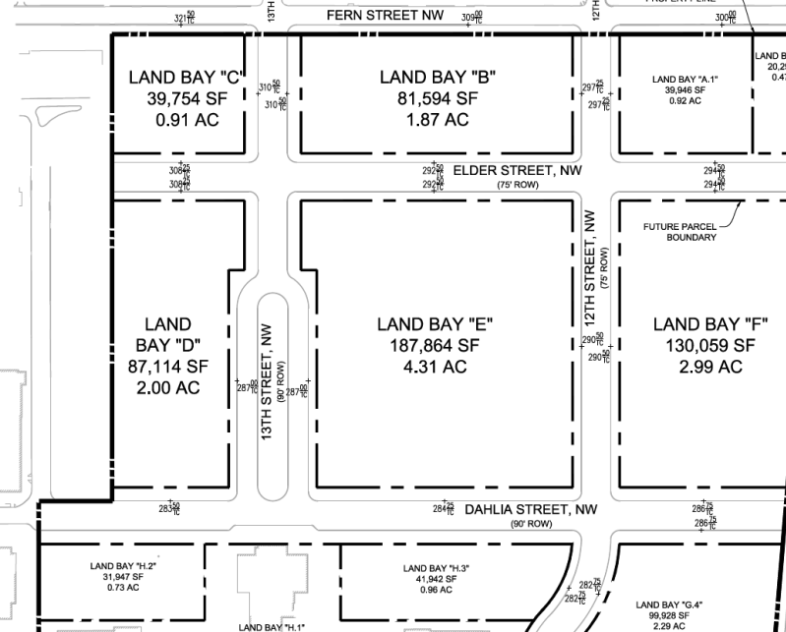
      - The WR-2 zone is intended to:
        - Create a vibrant and pedestrian-oriented commercial and residential center to serve as a housing, commercial, and retail anchor for the Walter Reed campus, adjacent neighborhoods, and the District.
        - Promote an engaging streetscape to activate adjacent uses and users;
        - Encourage clear visibility of retail uses along 12th Street from Georgia Avenue; and
        - Create new passive and active open space amenities to accommodate residential and retail uses.
      - The development standards for the WR-2 zone are set forth in the following table:
TABLE K § 902.2: WR-2 DEVELOPMENT STANDARDS
WR-2
Sub-Area | Building Height (max.) | Stories (max.) | Floor Area Ratio (max.) |  | Residential Lot Occupancy Above the First Two Stories (max.)
Sub-Area | Building Height (max.) | Stories (max.) | Total | Non-Residential Use | Residential Lot Occupancy Above the First Two Stories (max.)
Land Bay D | 85 ft. | 7 | 2.5 | 1.0 | 80%
Land Bay E | 85 ft. | 7 | 3.75 | 1.0 | 80%
      - The non-residential maximum FAR requirement shall be measured per sub-area, as opposed to per building.
      - Lot occupancy on the first two (2) stories is permitted up to one hundred percent (100%), regardless of use.
      - If less than 3.75 FAR is developed in Land Bay E, excess floor area can be transferred to Land Bay K.1 in the WR-3 zone, or Land Bay F in the WR-3 zone, or Land Bay D in the WR-2 zone, or a combination of those land bays, subject to the requirements of this subsection:
        - No more than one hundred fifty thousand square feet (150,000 sq. ft.) of floor area may be transferred in total, of which no more than fifty thousand square feet (50,000 sq. ft.) may be non-residential floor area;
        - The maximum total FAR and the maximum non-residential FAR on Land Bay E shall be reduced by the total amount of floor area transferred and the amount of non-residential floor area transferred, respectively;
        - The maximum total FAR and the maximum non-residential FAR on the receiving land bays shall be increased by the total amount of floor area transferred and the amount of non-residential floor area transferred, respectively;
        - The allowable building height and lot occupancy on the receiving parcels shall not be increased, but the total FAR and the non-residential FAR of the receiving land bays may be increased to the amounts listed in the following table:
TABLE K § 902.5 (d): WR-1 DEVELOPMENT STANDARDS
Land Bay | Maximum FAR  (Total) | Maximum FAR  (Non-residential uses)
K.1 | 3.5 | 1.25
F | 2.5 | 1.25
D | 3.5 | 1.25
        - Before the transfer may occur, the applicant shall record in the Land Records of the District of Columbia a covenant running with the land, found technically sufficient by the Zoning Administrator and legally sufficient by the Office of Zoning Legal Division for each property by the owner or owners for the benefit of the District of Columbia that states the size, in square feet, of Land Bays E, K.1, F, and D, the maximum FAR and non-residential FAR permitted as a matter of right for Land Bays E, K.1, F, and D, the total amount of floor area being transferred, the amount of non-residential floor area being transferred, and the resulting maximum FAR and nonresidential FAR for both Land Bays E, K.1, F, and D; and
        - The applicant for any building permit for Land Bays E, K.1, F, or D shall submit with the permit application the covenant required by sub-paragraph (e) as well as any and all calculations used to derive the matter of right and resulting FARs for the land bays.
      - In the WR-2 zone, no less than one hundred percent (100%) of the façade of buildings located along Elder Street, Dahlia Street, 12th Street, and 13th Street shall be built to within ten feet (10 ft.) of the property lines abutting the subject street to a height of not less than twenty-five feet (25 ft.), except that:
        - The requirements of this subsection shall not apply to the portions of building façades that front on a plaza located along 12th Street;
        - The height requirement of this subsection may be reduced to eighteen feet (18 ft.) if the roof immediately above the eighteen (18)-foot façade is occupied by a public or private outdoor terrace; and
        - Relief from the build-to requirements of this subsection may be granted by the Board of Zoning Adjustment as a special exception subject to the requirements of Subtitle X, Chapter 9, provided that the applicant adequately demonstrates that:
          - The proposed design meets the intent of creating a streetwall along the street in question; and
          - The area set back from the property line does not unduly restrict access by the public by a gate, fence, wall, or other barrier.
      - In the WR-2 zone, all portions of the ground floor devoted to non-residential uses shall be subject to the following requirements:
        - The minimum floor-to-ceiling clear height shall be fourteen feet (14 ft.), except for those spaces within the ground floor of any building devoted to the following uses: mechanical, electrical, and plumbing; storage; fire control; loading; parking; and retail corridors and service corridors;
        - The surface of any streetwall or wall fronting on a plaza shall devote at least fifty percent (50%) of the surface area at the ground floor to display windows with clear glass or pedestrian entrances;
        - Each non-residential use with frontage on a public street or plaza shall have an individual public pedestrian entrance directly accessible from a sidewalk or plaza upon which the use has frontage;
        - Pedestrian entrances or areas where future entrances to non-residential uses could be installed without structural changes shall be located no more than an average distance of forty feet (40 ft.) apart on all façades fronting a public street or plaza;
        - On 12th Street, no single non-residential occupancy shall occupy more than one hundred (100) consecutive linear feet of ground-floor building frontage. On other streets, no single non-residential occupancy shall occupy more than fifty (50) consecutive linear feet of ground-floor building frontage; and
        - One (1) or more building frontages of a grocery store may be exempt from the requirements of paragraph (e) provided that:
          - The grocery store contains as an ancillary use a café, restaurant or similar use, or a seating area within the grocery store where food and beverages purchased on-site may be consumed;
          - The use described in sub-paragraph (1) is located directly against the subject building frontage;
          - Clear glass allows the plain view of the use from the exterior of the building;
          - The use is open to the public at least during normal grocery store hours; and
          - In no case shall a single non-residential occupancy occupy more than two hundred (200) consecutive linear feet of ground-floor building frontage on 12th Street or one hundred feet (100 ft.) on any other street.

SOURCE: Final Rulemaking published at 63 DCR 2447, 3176 (March 4, 2016 – Part 2); as amended by Final Rulemaking published at 67 DCR 13131 (November 6, 2020); as amended by Final Rulemaking published at 69 DCR 000930 (February 4, 2022).

