WR-3 ZONE
FIGURE K § 903: ILLUSTRATION OF BOUNDARIES OF THE WR-3 ZONE
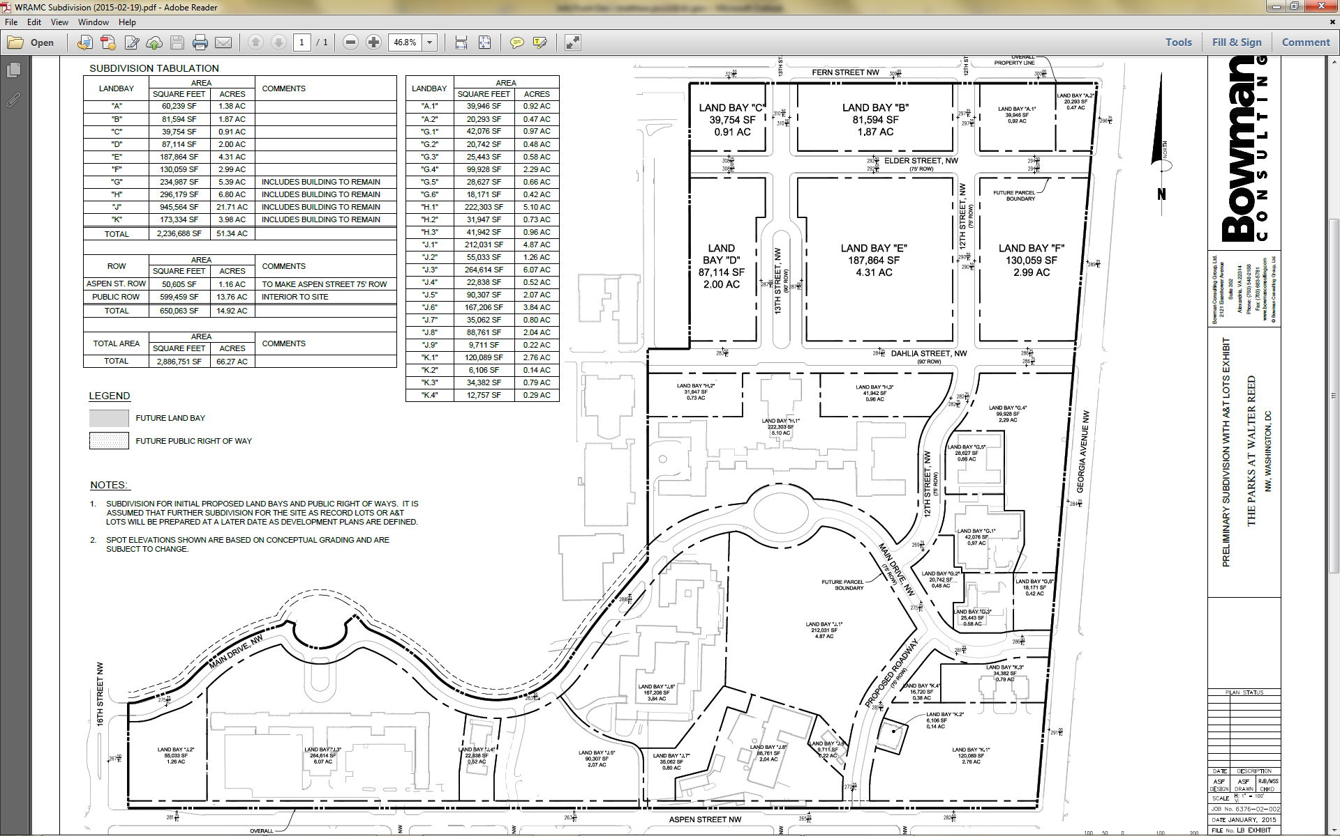

      - The WR-3 zone is intended to:
        - Provide for moderate- to medium-density commercial and residential development that activates Georgia Avenue frontage through enhanced ground-floor retail opportunities, a more uniform street wall, and publicly accessible plazas;
        - Maintain a sensitive scale of development in relation to properties on the east side of Georgia Avenue as appropriate; and
        - Preserve existing and encourage new green and open space to activate the site, and to allow for recreation opportunities as appropriate.
      - The development standards for the WR-3 zone are set forth in the following table:
TABLE K § 903.2: WR-3 DEVELOPMENT STANDARDS
WR-3
Sub-Area | Building Height (max.) | Stories (max.) | Floor Area Ratio (max.) |  | Residential Lot Occupancy Above the First Two Stories (max.) | Setbacks
Sub-Area | Building Height (max.) | Stories (max.) | Total | Non-Residential Use | Residential Lot Occupancy Above the First Two Stories (max.) | Setbacks
Land Bay A.2 | 70 ft. | 5 | 3.5 | 1.0 | 80% | n/a
Land Bay F | See § 903.3 | 6 | 1.75 | 1.0 | 80% | n/a
Land Bay G.4 | 75 ft. | 6 | 3.0 | 1.0 | 80% | n/a
Land Bay K.1 | 70 ft. | 5 | 2.75 | 1.0 | 80% | See § 903.7
      - For Land Bay F, the maximum height of buildings or structures shall be sixty (60) feet within one hundred feet (100 ft.) of Georgia Avenue, and seventy-five feet (75 ft.) elsewhere.
      - For Land Bays F, G.4, and K.1, the non-residential maximum FAR requirement shall be measured by sub-area, as opposed to per building.
      - Lot occupancy on the first two (2) stories is permitted up to one hundred percent (100%), regardless of use, and except as limited by Subtitle K § 903.10.
      - Non-residential uses or building entrances to any use shall occupy one hundred percent (100%) of the ground-floor building façades facing the plaza constructed pursuant to Subtitle K § 903.10.
      - In Land Bay K.1, any new construction shall be set back no less than twenty feet (20 ft.) from the Aspen Street property line as it exists as of January 1, 2015.
      - In the WR-3 zone, no less than seventy percent (70%) of the façade of buildings located along Fern Street, Elder Street, Dahlia Street, Aspen Street, and Georgia Avenue shall be built to the property lines abutting the subject street right-of-way to a height of not less than twenty-five feet (25 ft.), except that:
        - The requirements of this subsection shall not apply to the portions of building façades that front on a plaza established pursuant to Subtitle K § 903.10;
        - The requirements of this subsection shall not apply to portions of building façades that are set back from the right-of-way for the purpose of preserving existing mature trees and for which trees the applicant for a building permit shall provide a permanent plan, approved by the Urban Forestry Administration, for tree maintenance and replacement;
        - The height requirement of this subsection may be reduced to eighteen feet (18 ft.) if the roof immediately above the eighteen (18)-foot façade is occupied by a public or private outdoor terrace; and
        - Relief from the build-to requirements of this subsection may be granted by the Board of Zoning Adjustment as a special exception subject to the requirements of Subtitle X, Chapter 9, provided that the applicant adequately demonstrates that:
          - The proposed design meets the intent of creating a streetwall along the street in question; and
          - The area set back from the property line does not unduly restrict access by the public by a gate, fence, wall, or other barrier.
      - In the WR-3 zone, all portions of the ground floor devoted to non-residential uses shall be subject to the following requirements:
        - The minimum floor-to-ceiling clear height shall be fourteen feet (14 ft.), except for those spaces within the ground floor of any building devoted to the following uses: mechanical, electrical, and plumbing; storage; fire control; loading; parking; and retail corridors and service corridors;
        - The surface of any streetwall or wall fronting on a plaza shall devote at least fifty percent (50%) of the surface area at the ground floor to display windows with clear glass or pedestrian entrances;
        - Each non-residential use with frontage on a public street or plaza shall have an individual public pedestrian entrance directly accessible from a sidewalk or plaza upon which the use has frontage; and
        - Pedestrian entrances or areas where future entrances to non-residential uses could be installed without structural changes shall be located no more than an average distance of forty feet (40 ft.) apart on all facades fronting a public street or plaza.
      - In Land Bay F, a plaza shall be provided which meets the criteria of this subsection:
        - No part of a building above grade shall cover the areas described below, as illustrated in the diagram below. The resulting plaza is the minimum open space, and building façades need not front immediately upon or follow the boundaries of the prescribed open space:
          - The central two hundred feet (200 ft.) of the frontage on Georgia Avenue between Dahlia and Elder Streets to a depth of one hundred fifty feet (150 ft.) west of Georgia Avenue, with the depth measured at the midpoint between Dahlia and Elder Streets and drawn parallel to Dahlia and Elder Streets; and
          - The central one hundred feet (100 ft.) of frontage on 12th Street between Dahlia and Elder Streets and extending east to connect to the open space described in Subtitle K § 903.10(a)(1); and
FIGURE K § 903.10(a)(2): ILLUSTRATION OF WR-3 OPEN SPACE
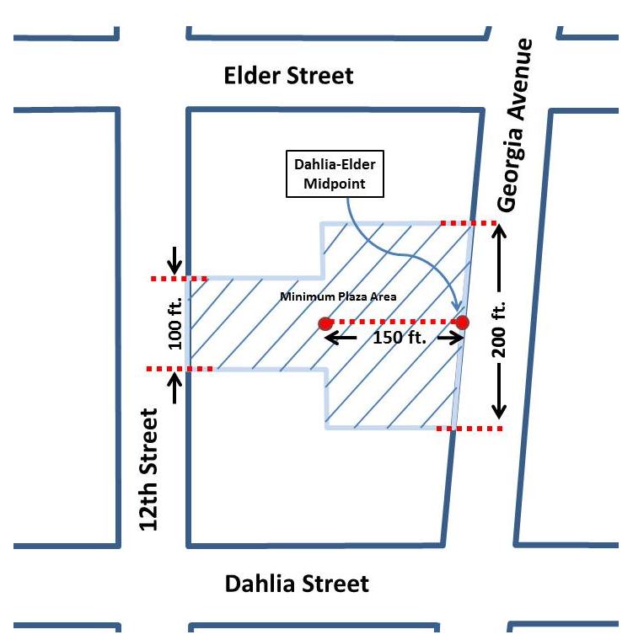
        - The open space described in Subtitle K § 903.10(a) shall constitute a plaza that must:
          - Be open to the sky;
          - Be open and available to the general public on a continuous basis;
          - Be lighted and landscaped;
          - Preserve at least ninety percent (90%) of the existing mature, healthy trees; and
          - Provide at least fifty percent (50%) pervious surface, including any water feature.

SOURCE: Final Rulemaking published at 63 DCR 2447, 3176 (March 4, 2016 – Part 2).

