WR-4 ZONE
FIGURE K § 904: ILLUSTRATION OF BOUNDARIES OF THE WR-4 ZONE
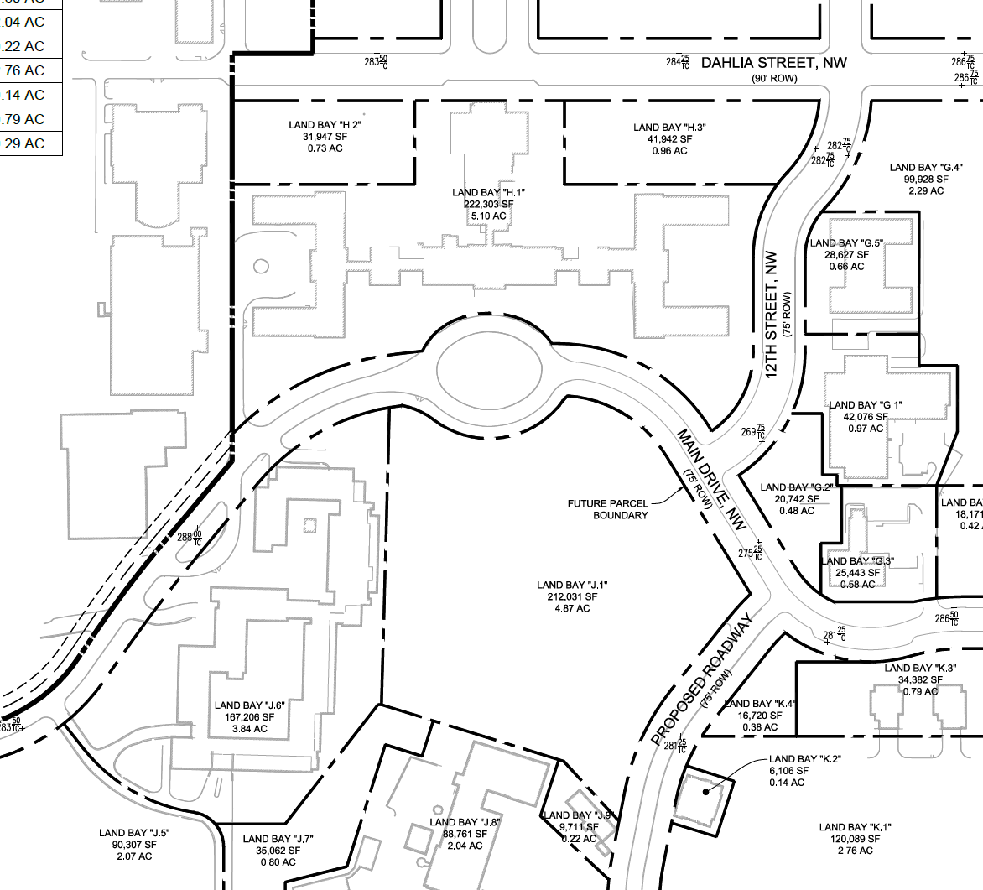

      - The WR-4 zone is intended to:
        - Provide for moderate-density commercial and residential development that adaptively reuses and sensitively develops proximate to historic resources; and
        - Maintain the campus-like setting of Building 1 and other buildings through preservation of certain nearby open spaces.

The development standards for the WR-4 zone are set forth in the following table:

TABLE K § 904.2: WR-4 DEVELOPMENT STANDARDS
WR-4
Sub-Area | Building Height (max.) | Stories (max.) | Floor Area Ratio (max.) | Lot Occupancy (max.) | Setbacks
Land Bay H.1 | 40 ft. | 3 | 1.0 | 60% | See § 904.3
Land Bays H.2 and H.3 | 40 ft. | 3 | 2.0 | N/A | See § 904.3
Land Bays G.1 and G.5 | 50 ft. | 4 | 1.75 | 75% | n/a
Land Bay G.3 | 40 ft. | 4 | 0.9 | 60% | See § 904.4
Land Bay J.6 | 55 ft. | 4 | 1.15 | 50% | n/a
      - In Land Bays H.1, H.2, and H.3, no building or portion of a building shall be constructed east of the easternmost point of existing Building 1.
      - In Land Bay G.3, no building or portion of a building shall be constructed south of the southernmost point of existing Building 12.
      - In Land Bay H.3, no surface parking lot is permitted east of the easternmost point of existing Building 1.

SOURCE: Final Rulemaking published at 63 DCR 2447, 3176 (March 4, 2016 – Part 2); as amended by Final Rulemaking published at 63 DCR 10620 (August 19, 2016).

