WR-5 ZONE
FIGURE K § 905: ILLUSTRATION OF BOUNDARIES OF THE WR-5 ZONE

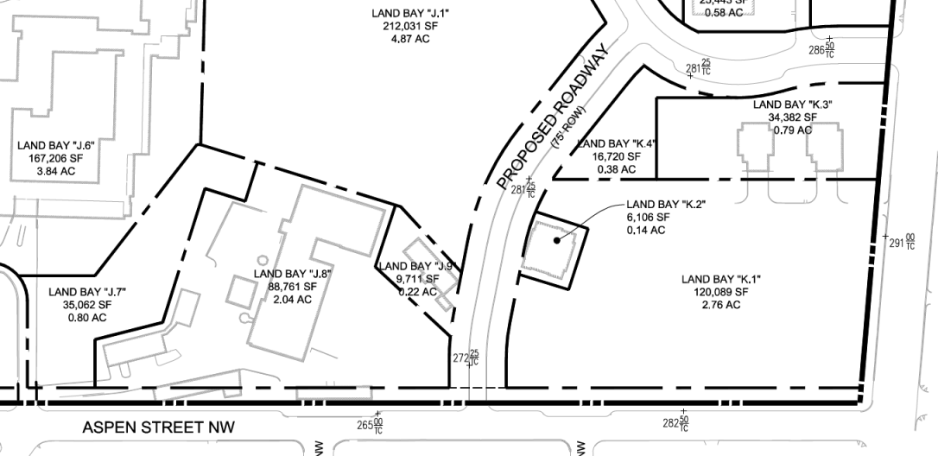
      - The WR-5 zone is intended to:
        - Provide moderate-density residential and commercial development that also supports arts and cultural uses; and
        - Encourage continuous east/west green connections and passive and active recreation opportunities.
      - The development standards for the WR-5 zone are set forth in the following table:
TABLE K § 905.2: WR-5 DEVELOPMENT STANDARDS
WR-5
Sub-Area | Building Height (max.) | Stories (max.) | FAR (max.) | Lot Occupancy (max.) | Setbacks
Land Bay K.3 | 50 ft. | 3 | 1.0 | 35% | See § 905.3
Land Bays J.9 and K.2 | 35 ft. | 2 | 0.75 | 75% | n/a
Land Bay J.8 | 35 ft. | 2 | 0.4 | 40% | See § 905.4
      - In Land Bay K.3, no building or portion of a building shall be constructed north of the northernmost point of existing Buildings 8 or 9, or east of the easternmost portion of Building 8.
      - In Land Bay J.8, any new construction shall be set back no less than twenty feet (20 ft.) from the Aspen Street property line as it exists on January 1, 2015. Existing buildings may be renovated and adaptively reused, even if within the setback area.
      - For new construction in Land Bay J.8, all portions of the ground floor devoted to non-residential uses shall have a minimum floor-to-ceiling height of fourteen feet (14 ft.), except for those spaces within the ground floor of any building devoted to the following uses: mechanical, electrical, and plumbing; storage; fire control; loading; parking; and retail and service corridors.

SOURCE: Final Rulemaking published at 63 DCR 2447, 3176 (March 4, 2016 – Part 2).

