WR-6 ZONE
FIGURE K § 906: ILLUSTRATION OF BOUNDARIES OF THE WR-6 ZONE

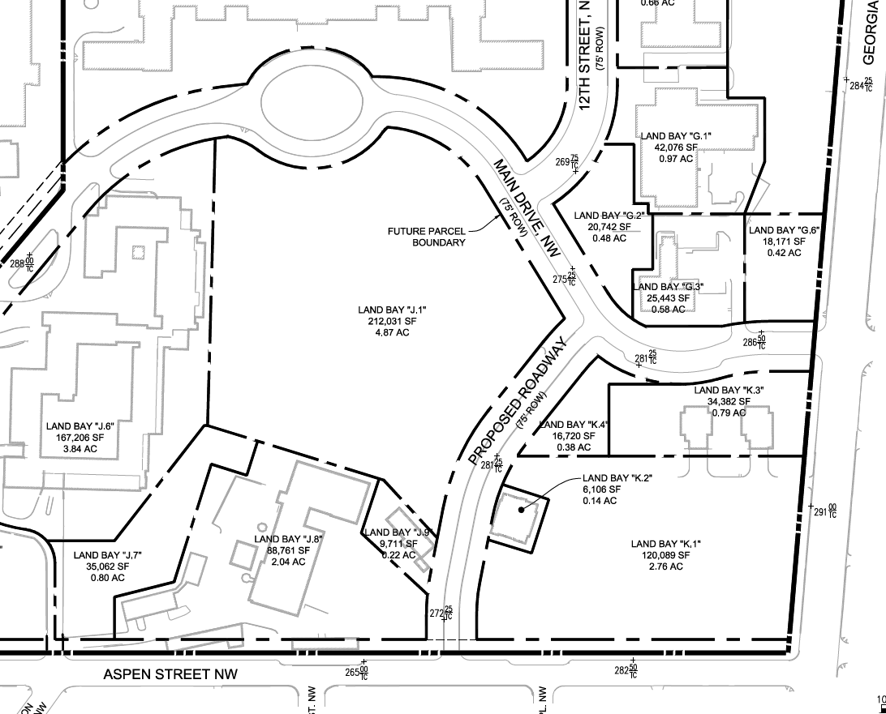
      - The WR-6 zone is intended to:
        - Preserve the unique character of the Great Lawn and maintain the campus atmosphere at the heart of the historic Walter Reed campus, including the landscaped entrances to the WR zone around Main Drive and East and West Cameron Drives;
        - Assure that the Great Lawn’s permanent use is for its primary natural function as well as for enjoyment by the general public; and
        - Encourage continuous east/west green connections.
      - The development standards for the WR-6 zone are set forth in the following table:
TABLE K § 906.2: WR-6 DEVELOPMENT STANDARDS
WR-6
Sub-Area | FAR (max.)
Land Bays J.1, J.7, G.2, G.6, and K.4 | 0
      - In the WR-6 zone, no new surface parking lots are permitted.
      - Notwithstanding the restriction of Subtitle K § 906.2, temporary structures may be erected to house any temporary use, subject to the temporary use provisions of Subtitle K § 922.6.
      - Notwithstanding the restriction of Subtitle K § 906.2, up to five (5) permanent structures, of no more than four hundred square feet (400 sq. ft.) each, may be constructed for the general purpose of food and beverage sales, or other retail or service use ancillary to the role of the WR-6 as an open space zone. This section shall not imply approval by the Historic Preservation Review Board or any other permitting authority.
      - In Land Bay J.7, a FAR of 0.5 is permitted for a Parks and Recreation use, or a similar use operated by a non-governmental entity.
      - In Land Bay J.7, any new construction built pursuant to Subtitle K § 906.5 shall be set back no less than twenty feet (20 ft.) from the Aspen Street property line as it exists on January 1, 2015.

SOURCE: Final Rulemaking published at 63 DCR 2447, 3176 (March 4, 2016 – Part 2).

