WR-7 ZONE
FIGURE K § 907: ILLUSTRATION OF BOUNDARIES OF THE WR-7 ZONE
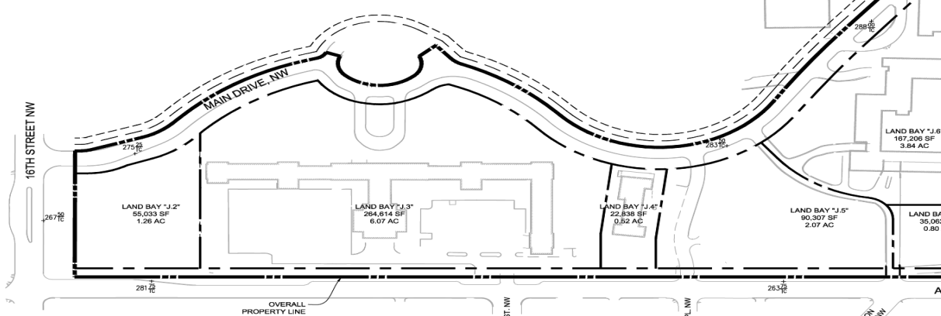
      - The WR-7 zone is intended to:
        - Provide medium-density residential development that is sensitive to existing development on the south side of Aspen Street;
        - Encourage adaptive reuse of existing buildings to accommodate, among other uses, institutions; and
        - Encourage open and green space suitable for sustainable infrastructure and amenities as appropriate.
      - The development standards for the WR-7 zone are set forth in the following table:
TABLE K § 907.2: WR-7 DEVELOPMENT STANDARDS
WR-7
Sub-Area | Building Height (max.) | Stories (max.) | FAR (max.) | Lot Occupancy (max.) | Setbacks
Land Bay J.5 | 55 ft. | 5 | 1.25 | 50% | See § 907.3
Land Bay J.4 | 25 ft. | 2 | 1.0 | 50% | See § 907.3
Land Bay J.3 | 45 ft. | 4 | 0.75 | 40% | See § 907.3  See § 907.4
      - In the WR-7 zone, any new construction shall be set back no less than twenty feet (20 ft.) from the Aspen Street property line as it exists on January 1, 2015.
      - In Land Bay J.3, no building or portion of a building shall be constructed north of the northernmost point of existing Building 11.

SOURCE: Final Rulemaking published at 63 DCR 2447, 3176 (March 4, 2016 – Part 2).

