WR-8 ZONE
FIGURE K § 908: ILLUSTRATION OF BOUNDARIES OF THE WR-8 ZONE
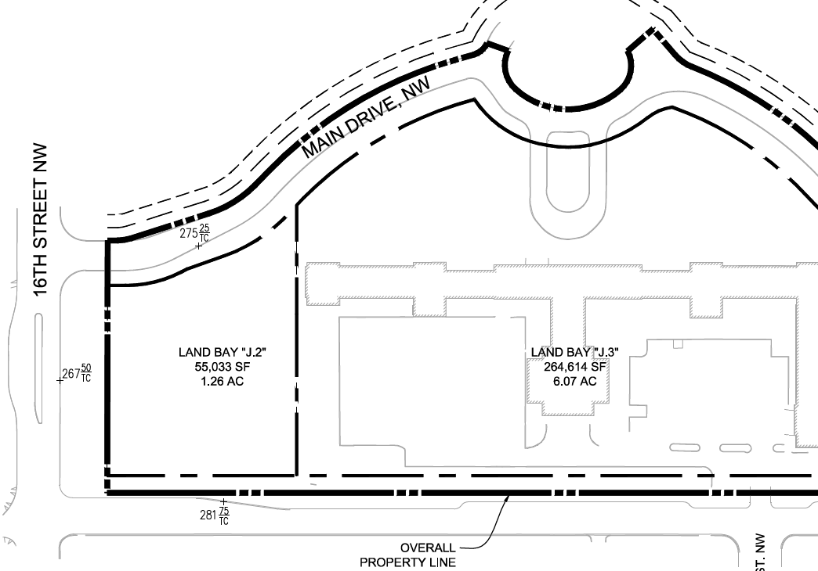
      - The WR-8 zone is intended to:
        - Provide medium-density residential development that is sensitive to existing development on the south side of Aspen Street; and
        - Encourage open and green space suitable for sustainable infrastructure and amenities as appropriate.
      - The development standards for the WR-8 zone are set forth in the following table:
TABLE K § 908.2: WR-8 DEVELOPMENT STANDARDS
WR-8
Sub-Area | Building Height (max.) | Stories (max.) | FAR (max.) | Lot Occupancy (max.) | Setbacks
Land Bay J.2 | See § 3508.3 | 5 | 3.25 | 80% | See § 908.4
      - In the WR-8 zone, the maximum height of buildings or structures shall be as follows:
        - Within twenty-five feet (25 ft.) of the setback specified in Subtitle K § 908.4, fifty feet (50 ft.) above the finished grade at the middle of the Aspen Street building façade; and
        - Elsewhere, sixty-five feet (65 ft.) as measured from whichever measuring point is chosen for the building for the purpose of measuring height.
      - In the WR-8 zone, any new construction shall be set back no less than twenty feet (20 ft.) from the Aspen Street property line, as it exists on January 1, 2015.

SOURCE: Final Rulemaking published at 63 DCR 2447, 3176 (March 4, 2016 – Part 2).

