Staffing Plan Generator POC – Technical Map and Data Flow

1. Overview
This document summarizes the technical architecture, end‑to‑end data flow, technologies used, and implementation notes for the Staffing Plan Generator proof‑of‑concept (POC). It reflects the actual structure of the Streamlit app, including its four core functions.

1.a Streamlit App – Core Functions
- Upload SOW: Upload PDF/DOCX, extract structured data (including staffing) and export.
- Historical Analog: Retrieve similar/historically relevant SOWs to inform recommendations.
- Search: Explore indexed SOWs using lexical, semantic, or hybrid vector search.
- Staffing Plan Generator (Demo): Prototype that synthesizes a skeleton plan from analogs and heuristics.

2. Architecture and Components
Core components and their roles:
- Streamlit App (`streamlit_app/app.py`): Interactive UI with four functions (Upload, Historical Analog, Search, Generator).
- SOW Extraction Service (`streamlit_app/services/sow_extraction_service.py`): Parses SOWs and extracts structured fields using Azure OpenAI; optionally leverages Azure Document Intelligence for layout/tables.
- Azure Document Intelligence Wrapper (`streamlit_app/services/document_intelligence_service.py`): High‑fidelity layout and table extraction for PDFs/DOCX.
- Azure Cognitive Search Services: REST clients for lexical/semantic and hybrid/vector queries (`streamlit_app/services/azure_search_service.py`, `vector_search_service.py`, `hybrid_search_service.py`).
- Indexing Scripts (`scripts/indexing/*.py`): Create and populate indexes like `octagon-sows-parsed` and `octagon-sows-hybrid`.
- Standalone/CLI extractors (`scripts/extraction/*.py`): Focused extraction flows (e.g., staffing‑specific extractor).
Key functions involved in generation:
- Extraction: `SOWExtractionService.extract_sow_data(...)` with a targeted system prompt for staffing tables, normalization helpers (e.g., percentage/hour parsing on 1800‑hour FTE basis).
- UI Trigger (Generator Demo): In `app.py`, the “Generate Skeleton Staffing Plan” flow calls `analyze_staffing_patterns(...)` and `generate_skeleton_staffing_plan(...)`.
- Search Integration: Higher‑quality analogs are retrieved from Azure Search indices (lexical, semantic, or hybrid vector) to inform plan suggestions.

3. End‑to‑End Data Flow
Aligned with the four Streamlit functions:
- Upload SOW: The app processes PDF/DOCX via Azure Document Intelligence (layout/tables) and Azure OpenAI (extraction prompt) to produce structured JSON (client, project metadata, scope, deliverables, exclusions, staffing).
- Historical Analog: Uses Azure Cognitive Search (lexical/semantic/hybrid) to retrieve similar SOWs; results feed into downstream analysis.
- Search: Provides free‑form search across indexed SOW fields; supports filters and different search modes.
- Staffing Plan Generator (Demo): Combines patterns from analogs with simple heuristics to propose a skeleton staffing plan.
- Normalization: Staffing allocations normalized to percentages (1800‑hour/year basis) for consistency.
- Storage/Indexing (optional): Parsed artifacts can be persisted to Azure Storage and indexed via scripts into `octagon-sows-parsed` / `octagon-sows-hybrid`.
- Export/Review: Users can export results and iterate.

Diagram:
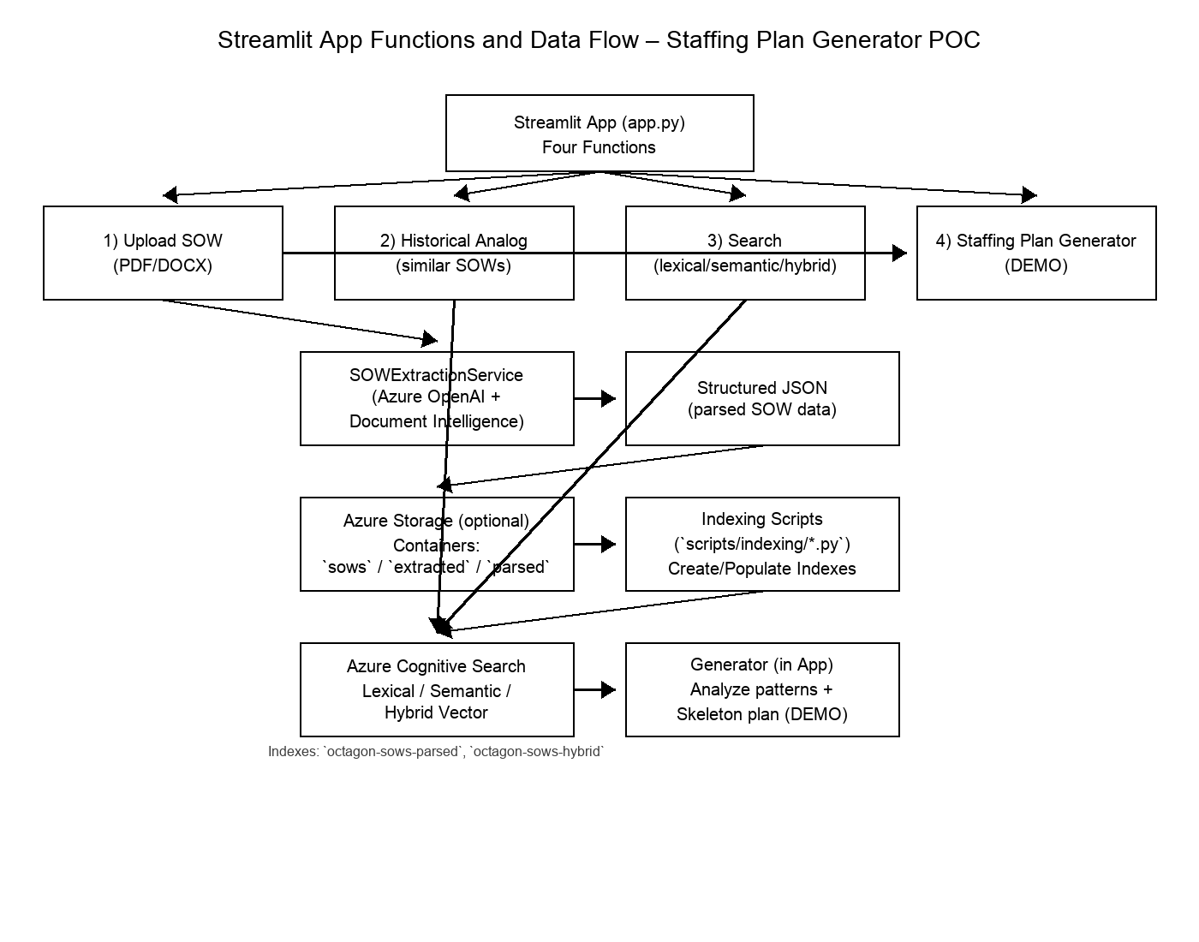

4. Configuration and Secrets
Environment variables (via .env) drive connectivity:
- Azure OpenAI: `AZURE_OPENAI_API_KEY`, `AZURE_OPENAI_ENDPOINT`, `AZURE_OPENAI_DEPLOYMENT`, `AZURE_OPENAI_API_VERSION`
- Azure Storage: `AZURE_STORAGE_CONNECTION_STRING` or `AZURE_STORAGE_ACCOUNT_URL` (+ `AZURE_STORAGE_KEY` or SAS)
- Azure Cognitive Search: `SEARCH_ENDPOINT`, `SEARCH_KEY`
- Azure Document Intelligence: `AZURE_DOCINT_ENDPOINT`, `AZURE_DOCINT_API_KEY`, `AZURE_DOCINT_API_VERSION`

5. Technologies Used
- Python, Streamlit UI
- Azure OpenAI (extraction prompts, embeddings for vector/hybrid search)
- Azure Document Intelligence (prebuilt-layout) for layout/tables
- Azure Storage (Blob) for source/extracted/parsed artifacts
- Azure Cognitive Search (lexical, semantic, vector/hybrid indexes)

6. Challenges Encountered
Variability in SOW Standardization
- The SOWs varied significantly in file format, structure, and terminology.
- Staffing tables were inconsistently formatted (some Excel, some embedded PDFs, some inline text), and key terms like role, level, or allocation were defined differently across documents.
- This lack of standardization made it difficult to apply a single parsing or extraction schema across all files.
Highly Redacted White-Labeled SOWs
- Many of the SOWs provided were heavily redacted, removing client names, project details, and other contextual anchors.
- These redactions disrupted Azure Document Intelligence’s layout and entity recognition, which relies on contextual cues to classify tables and associate text with labels.
- As a result, extracted outputs often required extensive manual cleanup or were incomplete.
Incomplete or Non-Uniform Staffing Tables
- The staffing tables themselves were inconsistent: some listed specific employees with identifiable titles and hourly rates, while others referenced only generic role levels (e.g., “Senior Strategist – 0.5 FTE”).
- In many cases, tables were so project-specific (e.g., event-based staffing or unique deliverable structures) that they lacked any analogous pattern to map against other projects, limiting the model’s ability to generalize.
Insufficient Organizational Data for Mapping
- The org chart provided included only generalized levels (e.g., “Manager,” “Director”) without individual names or reporting relationships.
- This absence of identifiable personnel data prevented any intelligent role-mapping or network analysis between past and proposed staffing configurations.
Human Heuristics and Domain Knowledge Dependency
- Building a genuinely intelligent staffing plan generator ultimately requires embedded heuristics—the unwritten rules and decision frameworks used by senior planners.
- Much of this expertise is tacit and gatekept by key decision-makers, making it difficult for AI to replicate accurately without significant institutional knowledge transfer.
- As a result, while the system can approximate staffing recommendations, the final output still benefits heavily from human-in-the-loop validation.

7. Where to Start
- Install dependencies: `pip install -r streamlit_app/requirements.txt`.
- Create `.env` at repo root with Azure keys for OpenAI, Storage, Search, and Document Intelligence.
- Indexing: use scripts in `scripts/indexing/` to create/populate Azure Search indexes.
- Run the UI: `cd streamlit_app && streamlit run app.py`.
- Use the four functions—Upload a SOW, explore Historical Analogs, run Search, then (optionally) generate a demo skeleton staffing plan.

8. AI Prompt Detail
The app uses Azure OpenAI with structured prompts and a JSON schema to extract client, project title, dates, project length, scope summary, deliverables, exclusions, and staffing. Deliverables and exclusions are extracted by the model per prompt + schema (no custom heuristics). Post‑processing is minimal (e.g., compute project length from dates, normalize staffing allocations).

Prompts (General SOW Extraction)
system_prompt:
You are an expert SOW analyst. Extract the requested information from the SOW document.

Guidelines:
- Extract only information that is explicitly stated in the document
- If dates are not provided, leave start_date and end_date as null
- For project_length, look for explicit duration mentions first (e.g., "12 months", "6 weeks"). If not found but dates are available, calculate the duration
- For exclusions, look for sections titled "Exclusions", "Not Included", "Out of Scope", or similar language

CRITICAL - For staffing_plan extraction:
- Look for explicit "Staffing Plan", "Staff Plan", or similar sections first
- ALSO look for staffing data in sections titled "Fees", "Resources", "Personnel", "Team", or any table containing:
* Personnel/Staff names (even if redacted as [BLACKED OUT])
* Job levels/roles (EVP, VP, Director, Manager, etc.)
* Time allocations (% Time, FTE, hours, days, months)
* Locations (US, UK, etc.)
- Extract structured tables that show:
* Personnel names (use "N/A" if redacted/blacked out)
* Roles/titles/levels
* Allocations (hours, percentages, FTE, days, months)
- Look for patterns in tables with columns like:
* "Name" + "Title/Role" + "Hours/%/FTE"
* "Personnel" + "Level" + "% Time" + "hours"
* "Staff" + "Position" + "Allocation"
- Include ANY structured data that shows who is working on the project and how much time they're allocated
- Be thorough - staffing information may be in fee tables, resource tables, or other sections

EXAMPLES of what to extract:
- "David Hargis, SVP, 45 hours, 2.50%" -> name: "David Hargis", role: "SVP", allocation: "45 hours (2.50%)"
- "[BLACKED OUT], EVP, 1%, 9 hours" -> name: "N/A", role: "EVP", allocation: "9 hours (1%)"
- Table with columns "Personnel", "Level", "% Time", "hours" -> extract each row as staffing plan entry
- "Vice President Client Services 67 Sr. Project Manager Client Services 265" ->
[{"name": "Vice President", "role": "Client Services", "allocation": "67 hours"}, {"name": "Sr. Project Manager", "role": "Client Services", "allocation": "265 hours"}]
- "Title Discipline Hours Vice President Client Services 67 Sr. Vice President Strategy 194" -> extract each role as separate entry

- Be precise and accurate - do not infer or assume information
- Return null for fields that cannot be determined from the text
- If absolutely no staffing information is found, return an empty array
user_prompt:
Extract the following information from this SOW document:

Document: {file_name}

<<<SOW_TEXT_BEGIN>>>
{text[:15000]} # Limit text to avoid token limits
<<<SOW_TEXT_END>>>

IMPORTANT: Do NOT extract staffing_plan information - that will be handled separately.
Focus on extracting client_name, project_title, scope_summary, deliverables, and exclusions.

Please extract the structured data according to the schema.

Schema Enforcement via response_format
response = await self.openai_client.chat.completions.create(
model="gpt-5-mini",
messages=messages,
response_format={"type": "json_schema", "json_schema": {"name": "sow_extraction", "schema": json_schema}}
)

JSON Schema (as defined in code)
{
"type": "object",
"properties": {
"client_name": {"type": "string", "description": "Name of the client company"},
"project_title": {"type": "string", "description": "Title of the project"},
"start_date": {"type": "string", "description": "Project start date (YYYY-MM-DD format)"},
"end_date": {"type": "string", "description": "Project end date (YYYY-MM-DD format)"},
"project_length": {"type": "string", "description": "Project duration in months, weeks, or other time units"},
"scope_summary": {"type": "string", "description": "Brief summary of project scope"},
"deliverables": {
"type": "array",
"items": {"type": "string"},
"description": "List of project deliverables"
},
"exclusions": {
"type": "array",
"items": {"type": "string"},
"description": "List of explicitly mentioned exclusions or items not included"
},
"staffing_plan": {
"type": "array",
"items": {
"type": "object",
"properties": {
"name": {"type": "string", "description": "Employee or role name"},
"role": {"type": "string", "description": "Job title or role"},
"allocation": {"type": "string", "description": "FTE percentage, hours, or time allocation"}
},
"required": ["name", "role", "allocation"]
},
"description": "Project staffing plan with employee details"
}
},
"required": ["client_name", "project_title", "scope_summary", "deliverables", "exclusions", "staffing_plan"]
}

Date → Project Length Post‑processing
def calculate_project_length(self, start_date_str: str, end_date_str: str) -> str:
if not start_date_str or not end_date_str:
return None
start_date = datetime.strptime(start_date_str, "%Y-%m-%d").date()
end_date = datetime.strptime(end_date_str, "%Y-%m-%d").date()
days = (end_date - start_date).days
if days >= 365:
months = round(days / 30.44)
return f"{months} months"
elif days >= 30:
weeks = round(days / 7)
return f"{weeks} weeks"
else:
return f"{days} days"

