Rogue Chess

Travis Head

Jose Herrera

**Concept of Operations**

REVISION – 1

1 February 2022

Concept of Operations

for

Rogue Chess

Team <15>

Approved by:

_____________________________

Project Leader Date

_____________________________

Prof. S. Kalafatis Date

_____________________________

T/A Date

**Change Record**

|  |  |  |  |  |
| --- | --- | --- | --- | --- |
| **Rev.** | **Date** | **Originator** | **Approvals** | **Description** |
| **0.0** | 02/01/2022 | Jose Herrera |  | Draft Release |
| **1.0** | 2/23/2022 | Travis Head |  | Revision 1 |

Table of Contents

Table of Contents ……………………………………………………………………………………………………………………..4

List of Figures…………………………………………………………………………………………………………………………… 5

1. Excecutive Summary………………………………………………………………………………………………………………6

2. Introduction ………………………………………………………………………………………………………………………….6

2.1 Background………………………………………………………………………………………………………………………6

2.2 Overview………………………………………………………………………………………………………………………….7

2.3 Referenced Documents and Standards ……………………………………………………………………………. 7

3 Operating Concept ….………………………………………………………………………………………………………………8

3.1 Scope …..……………………………………………………………………………………………………………………. 8

3.2 Operational Description and Constraints ..…………………………………………………………………. 8

3.3 System Description ……………………………………………………………………………………………………. 9

3.4 Modes of Operations …………………………………………………………………………………………………. 9

3.5 Users .…..……………………………………………………………………………………………………………………. 9

3.6 Support ..……………………………………………………………………………………………………………………. 9

4. Scenerios …………………………………………………………………………………………………………………………… 10

4.1 Single Player Game …………………………………………………………………………………………………. 10

4.2 Easy Mode ………………………………………………………………………………………………………………. 10

4.3 Medium Mode …………………………………………………………………………………………………………. 10

4.4 Hard Mode ………………………………………………………………………………………………………………. 10

5. Analysis ……………………………………………………………………………………………………………………………… 10

5.1 Summary of Improvements ……………………………………………………………………………………… 10

5.2 Disadvantages and Limitations …………………………………………………………………………………. 11

5.3 Alternatives ……………………………………………………………………………………………………………… 11

5.4 Impact ……………………………………………………………………………………………………………………… 11

List of Figures

Figure 1: Disobedient Piece Movement…………………….……………………………………6

Figure 2: Neural Network …...……………………………………………………………….……9

Figure 3: Highlighted Boxes of Available Moves ………………………………………….……9

# Executive Summary

The sponsor, Prunav Dhulipala, has requested development of a Rogue Chess phone app. This app will behave like traditional chess except that there is a chance the user’s pieces will not obey commands and will choose their own movements. The randomization is determined by the user selecting one of three difficulty settings at the start of the match. There will be an easy, medium, and hard mode that corresponds to a disobedience chance of 10%, 30%, and 50% respectively. The opponent’s artificial intelligence will not be affected by the difficulty setting. It will play in a traditional style using the neural net algorithm which, learns the players moves and predicts the next move the player will make. The artificial intelligence will make its decisions relatively quickly to keep the user engaged; this time will be less than 2 seconds. The app will assist the player in their valid move choices by highlighting available spaces on the chess board. The app will be available to android smartphones that have connection to the internet. This program is only intended for a single player to use at a time for proof of concept. The storage space will be kept to a minimum of 20 MB. A game timer will show users how fast they beat the opponent which will provide a reference for their skill.

# Introduction

The purpose of this document is to present the development of a Rogue Chess App, an app of a new chess variation for Android products. This chess variance will occasionally ignore the instructions of the user and choose a random valid movement choice for the chess piece chosen against a traditional artificial intelligence for chess. This will challenge the user’s typical strategies in chess and provide a unique experience that is unavailable elsewhere online or in person.

## Background

The game of chess has existed for around 1500 years and has since spread all across the world in popularity. Both tournaments and casual games have been a large factor in propagating its success. In modern times, people have frequently looked towards apps and websites to host the game for practice and personal enjoyment. As such, there are several websites and apps that provide the player with customizable traditional versions or unconventional games modes.

Chess has long-standing popularity amongst veterans of the game and consistently has new players eager to learn. While there are millions of possible outcomes during a single game, there are still players seeking new experiences. Many variations in board design, number of pieces, and types of pieces have all been adapted to alter the player’s experience. Nevertheless, there is not a widely available variation of chess where the pieces “go rogue” and do not listen to the user consistently.

## Overview

Our chess app will fill the void amongst existing variations of chess. The board and chess pieces of the app will be standard for play and will be accessed via an android smartphone. The user will be able to select the difficulty of the game; harder modes raise the chance of the user’s pieces disobeying commands. If a piece is determined to disobey, it will choose a random valid position instead. If the King is in check, all pieces will listen to the user for that round. The King will always listen to the user. The opponent’s artificial intelligence (AI) will use an alpha-beta algorithm and cost functions to determine the best possible moves. The AI will be uploaded into the Cloud for faster decision making.

**Figure 1: Disobedient Piece Movement**

## Referenced Documents and Standards

<https://www.javatpoint.com/ai-alpha-beta-pruning>

<https://developer.android.com/studio>

<https://www.chess.com/terms/chess-pieces>

# Operating Concept

## Scope

Rogue Chess is a unique way of playing the game of chess due to the unexpected change of piece movements. An algorithm will be implemented to the chess pieces which will create a randomization percentage depending on the game mode the user is on, which will determine whether the chess piece will listen to the user or not. The implementation will keep the user thinking ahead in order to adapt to the different scenarios the chess pieces may have. An AI (Artificial Intelligence) will be implemented to the single player game in order to play against the player. The AI response time will be two seconds or less in order to keep the player engaged. A function will be implemented to highlight the available chess piece moves so the player plays according to the official rules of chess. The game will be uploaded to the Cloud to be able to be made into an app every android user could use.

## Operational Description and Constraints

The Rogue Chess will be a phone application that may be used by any android user. The game will follow the rules of chess except for the user’s piece’s constraints. The pieces have the option whether to follow the user’s instructions or make a random move while following the valid move set of the chosen piece. The legal moves the pieces may make will be highlighted in yellow. The game will be a single player mode with three difficulties. The three difficulties will be based on the percentage of obedience of the chess pieces. The game will be a single player mode which means an AI (Artificial Intelligence) will be implemented to make moves for the opposing sides in order to beat the user.

The following constraints include:

* Making a compatible app for android users which is within 20Mb of storage.
* The app is not able to crash when the user exits the app or turns off the phone.
* The game may not crash due to high usage.
* The graphics should be clear and visible to the user.
* The AI response time should be two seconds or less.
* The AI should be intellectual enough to beat the user.
* The randomized piece movements (if any) need to be legal moves.
* If the randomization happens, the piece needs to move to a different space other than the chosen space.
* The randomization factor needs to follow the percentage of the set difficulty.

## System Description

* Android Phone Application: The subsystem will be built in Android Studio which uses the Java coding language. The app will include the graphics of the chess game which includes the board and the chess pieces.
* Application: The application will consist of multiple games modes (easy, medium, and hard) with each consisting of different probabilities.
* 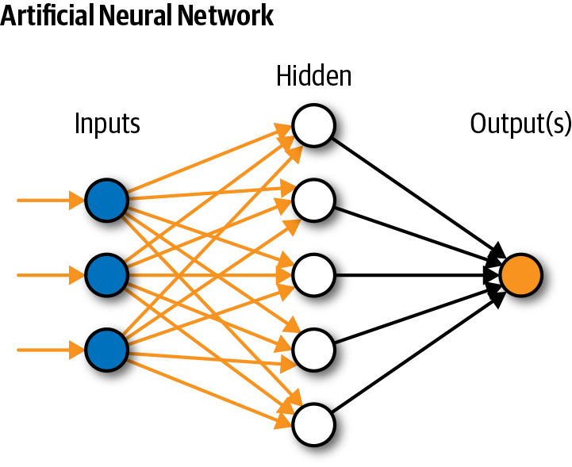Artificial Intelligence: This subsystem is the implementation of an AI which will be playing against the player. The subsystem will consist of a Recurrent Neural Network that will be trained to take in the current board state and output a move that has the highest probability of winning. It will be stored in the Cloud for optimal computation time.

**Figure 2: Neural Network**

## Modes of Operations

The Rogue chess will be composed of an AI system which will provide movements for the single player mode. The AI will have a min/max algorithm imbedded in order to make a move that will benefit the AI the most to beat the player. The player will have a click and move system with the assistance of highlighted boxes to make a legal chess move. However, depending on the difficulty the player is playing in, the chess piece may make a legal random move the player did not choose to do.

## Users

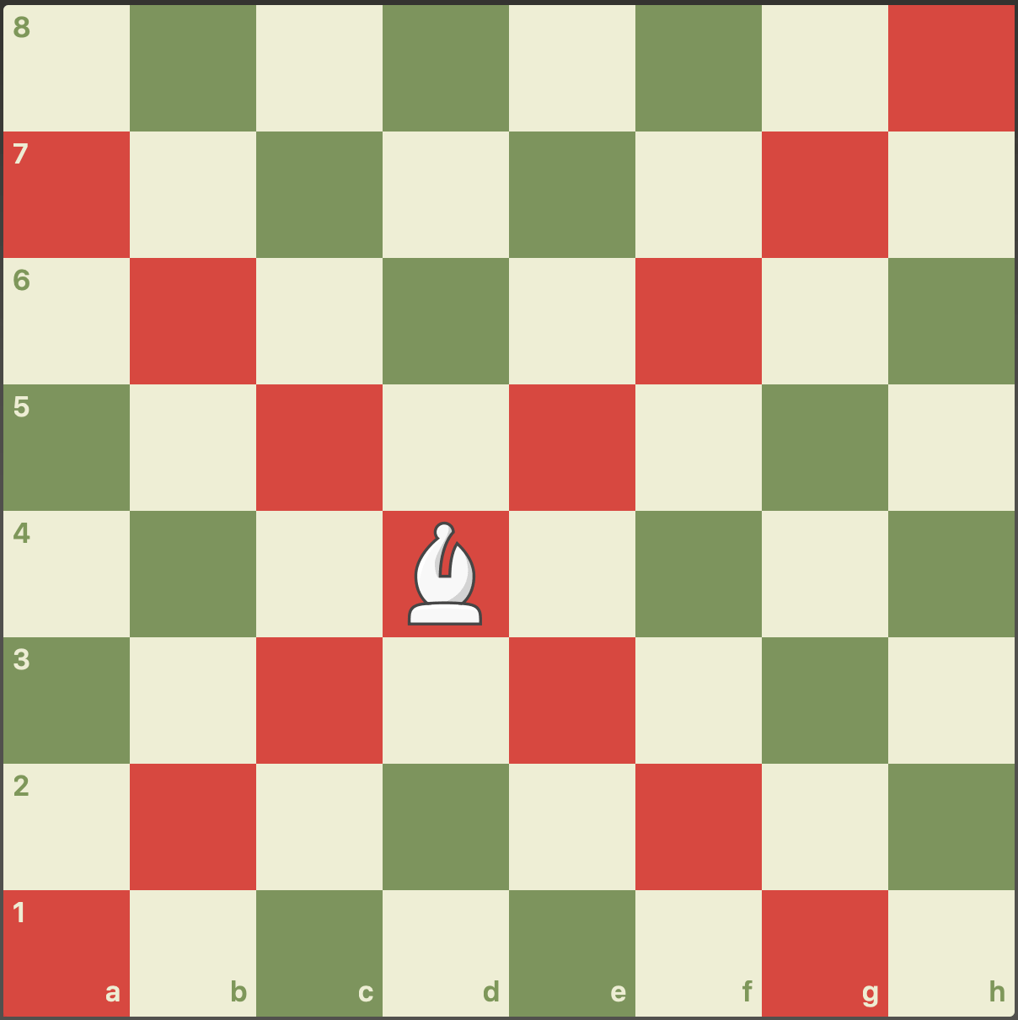The user base will be provided by chess-playing fanatics who want to try a new way of playing chess. The level of training needed for the user to use the application is basic chess knowledge, since the game will provide highlighted boxes of the legal possible moves. The basic instructions will be provided in the beginning of the game. The user will need knowledge on how to download an application via cellular phone. The marketing may be targeted to people who want to challenge themselves and exercise their brain functionality. The application may be monetized by having advertisements or having a payment fee to remove the advertisements.

## Support

A set of instructions with rules and expectations will be provided on the main menu page. There will be an algorithm which will highlight the legal moves the user may make to provide a support system.

**Figure 3: Highlighted Boxes of Available Moves**

# Scenario(s)

## Single Player Game

Rogue chess is a single player chess game which follows the same conventions as a regular chess game. However, the chess piece may or may not want to follow the move the player wants to make depending on the game mode. The king piece will always listen to the player, and when the king piece is in check, all the pieces will listen.

## Easy Mode

When the player selects easy mode, the player has a 90% chance that the chess pieces will listen.

## Medium Mode

When the player selects medium mode, the player has a 70% chance that the chess pieces will listen.

## Hard Mode

When the player selects hard mode, the player has a 50% chance that the chess pieces will listen.

## Brain Teaser

The application may be used as a brain teaser to enhance brain functions such as thinking ahead, or a reflex enhancement in order to react to different unexpected movements. The application also allows the player to enhance patience and adaptation skills.

# Analysis

## Summary of Proposed Improvements

Improvements that the proposed system will provide:

* The game has a randomizer algorithm for the chess pieces.
* The player’s time stamps will be posted in the ending page.
* The AI will be programmed to analyze the best possible steps to beat the player.
* The click and move algorithm would make it easier for the player to move the pieces.
* The highlighted support system will allow someone to learn how to play chess legally.

## Disadvantages and Limitations

Expected disadvantages and limitations that the proposed system will have:

* Making a compatible app for android users which is within 20Mb of storage.
* The app is not able to crash when the user exits the app or turns off the phone.
* The game may not crash due to high usage, not being able to restart, when the app is accidentally closed, or when the phone is turned off.
* The AI should be intellectual enough to beat the user.
* Finding a compatible phone under the budget may be difficult.
* The algorithm will be developed in Java format, which will be a limitation for someone who does not know how to code in Java.

## Alternatives

The alternatives of Rogue Chess include:

* A regular conventional chess game which allows the chess pieces to listen 100% of the time.
* A chess game with different board shapes.
* An algorithm which will make the player’s move for the player in case they get stuck.

## Impact

Concerns may include:

* Collection of personal data without the consent of the user.
* Using software from other works without giving credit to the creator is a violation of proprietary rights.
* Only available to android user limits the audience’s accessibility.

Rogue Chess

Travis Head

Jose Herrera

**Functional System Requirements**

REVISION – Draft

21 February 2022

Functional System Requirements

for

Rogue Chess App

Prepared by:

_____________________________

Author Date

Approved by:

_____________________________

Project Leader Date

_____________________________

John Lusher, P.E. Date

_____________________________

T/A Date

**Change Record**

|  |  |  |  |  |
| --- | --- | --- | --- | --- |
| **Rev.** | **Date** | **Originator** | **Approvals** | **Description** |
| **-** | 02/16/2022 | Travis Head |  | Draft Release |

Table of Contents

Table of Contents 16

List of Tables 17

No table of figures entries found. 3

List of Figures 17

6. Introduction 19

6.1. Purpose and Scope 19

6.2. Responsibility and Change Authority 19

7. Applicable and Reference Documents 21

7.1. Reference Documents 21

7.2. Order of Precedence 21

8. Requirements 21

8.1. System Definition 21

8.2. Characteristics 25

8.2.1. Functional / Performance Requirements 25

8.2.2. Physical Characteristics 26

8.2.3. Electrical Characteristics 26

8.2.4. Environmental Requirements 27

8.2.5. Failure Propagation 28

9. Support Requirements 28

Appendix A Acronyms and Abbreviations 30

Appendix B Definition of Terms 31

List of Tables

Table 1. Reference Documents…………………………………………………………… 20

List of Figures

Figure 2. Rogue Chess Flowchart…………………………………………………………… 19

Figure 2. User Interface and Graphics……………………………………………………… 22

Figure 3. Game Functionality.…………..…….……………………………………………… 23

**Figure 4. Neural Network for Artificial Intelligence……………………………………….. 24**

# Introduction

## Purpose and Scope

The purpose of this project is to improve upon a traditional chess app by making the game more challenging for the user. This app will allow the user to choose between three difficulty settings which correspond to how likely the user’s chosen pieces will disobey the intended movement. The user interface menu will allow for a single or 2-player game mode. Also, rather than using common methods for the opponent’s artificial intelligence, this app will use neural networking to make its decisions in 2 seconds or less. In game, the user’s selected piece’s valid moves should be highlighted to assist the user’s experience.

This specification defines the technical requirements for the development items and support subsystems delivered to the client for the project. Figure 3 shows a representative integration of the project in the proposed CONOPS. The verification requirements for the project are contained in a separate Verification and Validation Plan.

Figure 3. Rogue Chess Flowchart

## Responsibility and Change Authority

Changes to performance requirements will only be made by Prunav Dhulipala, or by all team members with the consent of Prunav Dhulipala. Consensus of all team members is required for any changes to implementation. The team leader, Travis Head, is responsible for the fulfilment of all project requirements. Subsystem owners are responsible for their respective subsystem requirements as shown below:

* Travis Head: Artificial Intelligence
* Jose Herrera: User Interface and Game Functionality

# Applicable and Reference Documents

## Reference Documents

The following documents are reference documents utilized in the development of this specification. These documents do not form a part of this specification and are not controlled by their reference herein.

|  |  |  |
| --- | --- | --- |
| **Document Number** | **Revision/Release Date** | **Document Title** |
| 1 | 3.10.2 | [Python Standard Library](https://docs.python.org/3/library/) |
| 2 | 2.8.0 | [TensorFlow](https://www.tensorflow.org/api_docs) |
| 3 | 2015 | [Official Chess Rules](http://www.uschess.org/index.php/Learn-About-Chess/Learn-to-Play-Chess.html) |

## Order of Precedence

In the event of a conflict between the text of this specification and an applicable document cited herein, the text of this specification takes precedence without any exceptions.

All specifications, standards, exhibits, drawings or other documents that are invoked as “applicable” in this specification are incorporated as cited. All documents that are referred to within an applicable report are considered to be for guidance and information only, except ICDs that have their relevant documents considered to be incorporated as cited.

# Requirements

## System Definition

The Rogue Chess App is a traditional chess app except for that the user’s selected pieces may randomly move to valid spaces not chosen by the user. There will be three difficulty settings that determine the randomness of disobedience. The user will have the option play against an Artificial Intelligence (AI) or against another user in a 2-player mode; both users will have the same difficulty setting applied to their pieces. The project is divided into 3 main subsystems: User Interface, Game Functionality, and Artificial Intelligence.

**Figure 2: User Interface and Graphics**

The user interface will consist of a tappable menu and graphics for the game. The Main Menu will have options for Difficulty, Single Player and 2-Player. When the Difficulty menu is selected, a new menu will replace the original with three tappable options for Easy, Medium, and Hard. The default difficulty will be easy. Once selected, the user will be returned to the Main Menu with the difficulty saved until the app is closed. When the Single Player or 2-Player options are selected, the menu will close, and the game will begin with the user as White and the opponent as Black.

**Figure 3: Game Functionality**

The game functionality consists of the creation of the app and the in-game rule set. When the user selects a piece by tapping, valid move options will be highlighted on the board. The user should then tap the highlighted space which will move the piece to a desired location or re-tap the selected piece to unselect it. Then, after the user selects a highlighted position and depending on the difficulty setting, the chosen piece will move to the indicated position or to another valid position if possible. The king will always listen to the user and all pieces will listen to the user if the King is in check.

**Figure 4: Neural Network for Artificial Intelligence**

The moves of the artificial intelligence of the opponent will be performed using a neural network. The software will be developed using Python with the TensorFlow library and trained using a relatively large sample of board instances as supervised learning. It will be uploaded to Microsoft Azure for faster processing. When the user makes a move in single player mode, the board instance will be sent to the program via wireless internet, a decision will be made, and a signal for the opponent’s piece’s movement will be sent back to the Rogue Chess app to be performed.

## Characteristics

### Functional / Performance Requirements

#### **Data Size Requirements**

The app data size shall not exceed 20Mb.

Rationale: These are system requirements based on sponsor specifications. Smaller data size is easier to download.

#### **Randomization Difficulty**

The probability of obedience for a selected piece in game will correspond to the chosen difficulty; this will be 10% in easy mode, 30% in medium mode and 50% in hard mode.

Rationale: These are system requirements based on sponsor specifications. This provides variation to the game.

#### **Chess Piece Movement**

Each respective chess piece shall move according to the standard rules of chess.

*Rationale: Chess piece movement must be functional and understandable for a chess game.*

#### **App Menu Functionality**

1. On opening the app, a menu with Single Player, 2-Player, and Difficulty will be displayed.
2. Tapping Single Player mode will begin a game against the artificial intelligence.
3. Tapping 2-Player mode will begin a game where both sets of pieces can be selected.
4. Tapping Difficulty will open a replacement menu with options for Easy, Medium, Hard, and Exit.

Rationale: A menu for selecting game modes and difficulty provides the user customization.

#### **App Graphics**

1. The visual chess pieces and board will be recognizable as a chess game.
2. Tiles will be highlighted to indicate valid moves for selected pieces.

Rationale: These are system requirements based on sponsor specifications.

#### **Artificial Intelligence Rating**

The Artificial Intelligence should challenge a chess player of an Elo rating of 1300.

Rationale: The Artificial Intelligence should represent a user that could beat novice opponents on regular occasion.

#### **Artificial Intelligence Movement**

The AI will be able to input a valid piece movement on its turn.

Rationale: The Artificial Intelligence needs to be able to function as a player.

### Physical Characteristics

The Rogue Chess does not have any physical requirement.

Rationale: This project is entirely software and has no physical components.

### Electrical Characteristics

#### **Inputs**

1. The presence or absence of any combination of the input signals in accordance with ICD specifications applied in any sequence shall not damage the Rogue Chess App, reduce its life expectancy, or cause any malfunction, either when the unit is powered or when it is not.
2. No sequence of command shall damage the user’s phone, reduce its life expectancy, or cause any malfunction.

Rationale: By design, should limit the chance of damage or malfunction by user/technician error.

##### External Commands

The Rogue Chess App shall document all external commands in the appropriate ICD.

Rationale: The ICD will capture all moves in a given match.

##### 8.2.3.2. Outputs

##### Data Output

The Rogue Chess App does not store data.

Rationale: The Rogue Chess App does not make use of profiles.

##### Diagnostic Output

The Rogue Chess App may include a diagnostic interface for error logging.

Rationale: Provides the ability to control things for debugging manually and a way to view/download the piece’s movements and obedience.

##### Raw Video Output

The Rogue Chess App does not use any video recording devices.

### Environmental Requirements

The Rogue Chess App does not have any specific environmental requirements.

Rationale: As the app is a software project, there are not any physical elements that it must adhere to.

### Failure Propagation

The Rogue Chess App shall not allow propagation of faults beyond the Rogue Chess App interface.

#### **Failure Detection, Isolation, and Recovery (FDIR)**

##### Built In Test (BIT)

The Rogue Chess App shall have an internal subsystem that will generate test signals and evaluate the Rogue Chess App responses and determine if there is a failure.

###### BIT Critical Fault Detection

The BIT may be able to detect a critical fault in the Rogue Chess App 95 percent of the time.

Rationale: This is an internal prevention to not damage the user’s smartphone.

###### BIT False Alarms

The BIT may have a false alarm rate of less than 5 percent.

Rationale: This requirement will limit the number of errors to the user and ensure stability.

###### BIT Log

The BIT may save the results of each test to a log that shall be stored in the application.

Rationale: This assists the developer to monitor failure rates and trends.

##### Isolation and Recovery

The Rogue Chess App should provide for fault isolation and recovery by enabling subsystems to be reset or disabled based upon the result of the BIT.

Rationale: This will enable a full reset or shutdown of the application in extreme circumstances.

# Support Requirements

The Rogue Chess App requires a functioning smartphone running an Android Operating System that has connection to wireless internet. It also requires connection to Microsoft Azure to interact with the artificial intelligence. User’s must provide a wireless internet connection and power to the smartphone to interact with the program.

# Appendix A: Acronyms and Abbreviations

Below is a list of common acronyms and abbreviations:

BIT Built-In Test

Hz Hertz

ICD Interface Control Document

AI Artificial Intelligence

# Appendix B: Definition of Terms

# Elo Rating The calculated relative skill of players in a zero-sum game of chess.

Rogue Chess

Travis Head

Jose Herrera

**Interface Control Document**

REVISION – 1

February 21, 2022

Interface Control Document

for

Rogue Chess

Prepared by:

_____________________________

Author Date

Approved by:

_____________________________

Project Leader Date

_____________________________

John Lusher II, P.E. Date

_____________________________

T/A Date

**Change Record**

|  |  |  |  |  |
| --- | --- | --- | --- | --- |
| **Rev.** | **Date** | **Originator** | **Approvals** | **Description** |
| **-** | 02/19/2022 | Jose Herrera |  | Draft Release |
| **1** | 02/20/2022 | Jose Herrera |  | Revision 1 |

Table of Contents

Table of Contents ……………………………………………………………………………….35

List of Tables …………………………………………………………………………………….36

List of Figures……………………………………………………………………………………37

10. Overview ……………………………………………………………………………………. 38

11. References and Definitions……………………………………………………………… 38

11.1 References ……………………………………………………………………………… 38

11.2 Definitions ……………………………………………………………………………….. 38

12. Physical Interface …………………………………………………………………………..39

12.1 Weight …..…………………………………………………………………………………39

12.2 Dimensions ………………………………………………………………………………..39

13. Thermal Interface ……………………………………………………………………………39

14. Electrical Interface ………………………………………………………………………….39

14.1 Signal Interface.…………………………………………………………………………..39

14.2 Video Interface..…………………………………………………………………………..39

14.3 CPU Interface……………………………………………………………………………..39

15. Communication/Device Interface Protocols …..……………………………………….39

15.1 Wireless Communication ………………………………………………………………..40

15.2 Video Interface ……………………………………………………………………………40

15.3 User Control Interface …………………………………………………………………..40

15.4 Command Line From User Interface ….………………………………………………..41

List of Tables

Table 1: Video Format/Resolution ………………………………………………………………………………………… 39

Table 2: User Function/Command …………………………………………………………….. 42

List of Figures

Figure 1: Application Diagram ………………………………………………………………………………………………40

# Overview

The following document will provide a detailed description of the subsystems which will be used for the implementation of the Rogue Chess. The first subsystem is the use of the implementation of the Artificial Intelligence with a neural network. The second, will be a description of how the application will be built. Lastly, a description of the device that will be used to test the Rouge Chess application.

# References and Definitions

## References

*Build your first app  :   Android Basics  :   android developers*. Android Developers. (n.d.). Retrieved February 21, 2022, from <https://developer.android.com/training/basics/firstapp>

Carter, D. S. and S. (n.d.). *Tensorflow - Neural Network Playground*. A Neural Network Playground. Retrieved February 21, 2022, from [TensorFlow Example](https://playground.tensorflow.org/#activation=tanh&batchSize=10&dataset=circle®Dataset=reg-plane&learningRate=0.03®ularizationRate=0&noise=0&networkShape=4,2&seed=0.19634&showTestData=false&discretize=false&percTrainData=50&x=true&y=true&xTimesY=false&xSquared=false&ySquared=false&cosX=false&sinX=false&cosY=false&sinY=false&collectStats=false&problem=classification&initZero=false&hideText=false)

Tutorialspoint . (n.d.). *JAVA Tutorial* . Java - Basic syntax. Retrieved February 21, 2022, from

https://www.tutorialspoint.com/java/java_basic_syntax.htm

## Definitions

AI Artificial Intelligence

App Application

CPU Control Processing Unit: portion which retrieves and executes instructions.

Neural Network: A technique for building program that learns from data.

Via: by means of.

# Physical Interface

The physical interface is the android phone which will be used to test the application.

## Weight

152g

## Dimensions (inches)

2.74 x 5.61 x 0.31 (width x height x thickness) These are the dimensions needed for the app due to the backgrounds being set to specific dimensions.

# Thermal Interface

The subsystems written in detail do not require a thermal interface.

# Electrical Interface

The electrical interface will be provided by the phone used in the testing process.

## Signal Interfaces

The signal interface is a touch bar which will be controlled by a sensor.

The Sensor types include: Accelerator, Barometer, Fingerprint sensor, Gyro Sensor, Geomagnetic Sensor, Hall Sensor, HR Sensor, Proximity Sensor, RGB, and Light Sensor.

## Video Interfaces

The Phone uses a proximity sensor to detect every touch the user does. The proximity sensor detects exactly where the user touched.

|  |  |
| --- | --- |
| Video Playing Format | Video Playing Resolution |
| MP4, M4A, 3GP, 3G2, WMV, ASF, AVI, FLV, MKV, WEBM | UHD 4K (3840 x 2160) @ 60 fps |

**Table 1: Video Format/Resolution**

## CPU Interface

Exynos: Octa-core (4x2.3 GHz Mongoose & 4x1.6 GHz Cortex-A53).

# Communications / Device Interface Protocols

The following sections will discuss protocols for communication.

**Figure 1: Application Diagram**

## 15.1 Wireless Communications (WiFi) (Samsung Galaxy s7)

802.11a/b/g/n/ac 2.4G+5GHz, VHT80 MU-MIMO

## Video Interface

The video interface will be the built in phone display from the user. The graphics will be created via software in Android Studio.

## User Control Interface

The user control interface will be provided by a web design which will be uploaded to the cloud. The cloud will then allow adjustments to the game.

## Command Line from User Interface

The user will control the commands the app/ game would like to do. The following commands will be provided by a series of functions implemented with Android Studio.

|  |  |
| --- | --- |
| **Function** | **Command** |
| Start Game | User selects game mode |
| Click on piece | User selects piece |
| Move piece | User selects new position to move |
| Restart game | Restart button |
| Back to main menu | Main Menu function |

**Table 2: User Function/Command**

Rogue Chess

Travis Head

Jose Herrera

**Validation and Execution plan**

REVISION – Draft

21 February 2022

|  |  |  |  |  |  |  |  |  |  |  |  |  |
| --- | --- | --- | --- | --- | --- | --- | --- | --- | --- | --- | --- | --- |
|  | **2/14** | **2/21** | **2/28** | **3/7** | **3/14** | **3/21** | **3/28** | **4/4** | **4/11** | **4/18** | **4/25** | **Date** |
| **System Update 1** |  |  |  |  |  |  |  |  |  |  |  |  |
| **Research** |  |  |  |  |  |  |  |  |  |  | **Completed** |  |
| **Game Menu Appears** |  |  |  |  |  |  |  |  |  |  | **Behind Schedule** |  |
| **Midterm Presentation** |  |  |  |  |  |  |  |  |  |  | **Not Started** |  |
| **Implement a Chess Board** |  |  |  |  |  |  |  |  |  |  | **In Progress** |  |
| **Functional AI** |  |  |  |  |  |  |  |  |  |  |  |  |
| **Functionality of Menus** |  |  |  |  |  |  |  |  |  |  |  |  |
| **System Update 2** |  |  |  |  |  |  |  |  |  |  |  |  |
| **Chess Piece Movement** |  |  |  |  |  |  |  |  |  |  |  |  |
| **AI Training** |  |  |  |  |  |  |  |  |  |  |  |  |
| **AI Rating** |  |  |  |  |  |  |  |  |  |  |  |  |
| **Final Design Presentation** |  |  |  |  |  |  |  |  |  |  |  |  |
| **Final System Demo** |  |  |  |  |  |  |  |  |  |  |  |  |
| **Final Report** |  |  |  |  |  |  |  |  |  |  |  |  |

|  |  |  |  |  |  |
| --- | --- | --- | --- | --- | --- |
| **Paragraph #** | **Test Name** | **Success Criteria** | **Methodology** | **Status** | **Responsible Engineer** |
| **8.2.2.1** | Data Size Requirements | Application is under 20Mb. | View file size and validate. | Untested | Jose |
| **8.2.3.1** | Randomization Difficulty | 90%, 70%, or 50% obedience rate corresponding to Easy, Medium, Hard. | Record obedience successes on 100 moves from each setting. | Untested | Jose |
| **8.2.3.2** | Chess Piece Movement | Each type of Piece moves only to respective ruleset. | Place each piece in the center/edge of an empty board and input a move to expected and unexpected valid tiles. | Untested | Jose |
| **8.2.3.4** | App Menu Functionality | Main Menu is visible, and each option is selectable. Selecting a game mode starts a match. Difficulty option opens a new menu that saves selected setting. | Open the application and validate main menu is visible. Select each option on the menu. | Untested | Jose |
| **8.2.1.5** | App Graphics | Menus, board, pieces, and highlighted tiles are all visible when needed. | Open the application and validate visibility. Start a match in each mode and select/deselect pieces. | Untested | Jose |
| **8.2.1.6** | Artificial Intelligence Rating | Elo Rating of at least 1300. | Run the AI against another chess program for 10 matches at ratings of 900, 1100, 1200, 1300, 1400, and 1500. | Untested | Travis |
| **8.2.1.7** | Artificial Intelligence Movement | Artificial Intelligence can input a valid move on its turn. | Input a board state and run the AI with a written output. | Untested | Travis |