http://www.comp.leeds.ac.uk/andyr/misc/latex/latextutorial4.html

Columns spanning multiple rows
The first thing you need to do is add \usepackage{multirow} to the preamble. This then provides the command needed for spanning rows: \multirow{num_rows}{width}{contents}. The arguments are pretty simple to deduce. With the width parameter, you can specify a fixed with if you wish, or, if you want the natural width (i.e., just wide enough to fit the contents of the column) then simply input an asterisk (*). This approach was used for the following example:
\begin{tabular}{|l|l|l|}  \hline  \multicolumn{3}{|c|}{Team sheet} \\  \hline  Goalkeeper & GK & Paul Robinson \\ \hline  \multirow{4}{*}{Defenders} & LB & Lucus Radebe \\  & DC & Michael Duberry \\  & DC & Dominic Matteo \\  & RB & Didier Domi \\ \hline  \multirow{3}{*}{Midfielders} & MC & David Batty \\  & MC & Eirik Bakke \\  & MC & Jody Morris \\ \hline  Forward & FW & Jamie McMaster \\ \hline  \multirow{2}{*}{Strikers} & ST & Alan Smith \\  & ST & Mark Viduka \\  \hline  \end{tabular} | 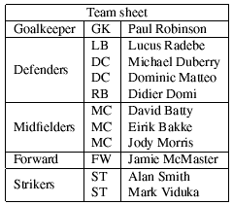
The main thing to note when using \multirow is that for the subsequent rows that are to be spanned, a blank entry for the appropriate cells have to be inserted.

