Scarlet Tanager:

North (Summer) to South (Winter)

Central, Central Eastern US (Summer Months) to Southwestern US (Early Fall/Late Spring Months)

<http://www.allaboutbirds.org/guide/summer_tanager/lifehistory>

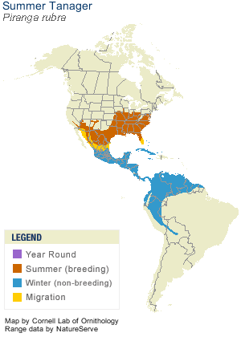

Ruby-throated Hummingbird:

North (Winter) to South (Summer)

Southern Canada (Summer Months) to Southern US (Spring/Fall Months)

<http://www.a-home-for-wild-birds.com/hummingbird-migration-map.html>

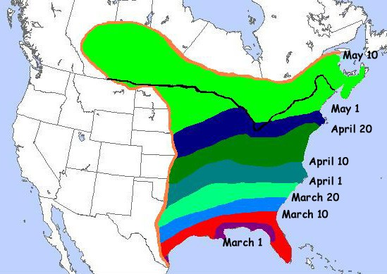

Canada Warbler:

North (Summer) to South (Winter)

Northern Canada, Alaska (Summer Months) to Southern US (Late Fall/Early Spring)

<http://www.borealbirds.org/birdguide/bd0387_map-zoom.shtml>

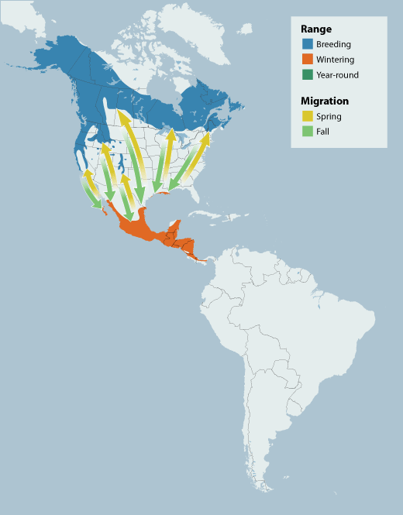

Bobolink:

North (Summer) to South (Winter)

Southern Canada (Summer Months) to Southern US (Fall/Spring Months)

<http://www.allaboutbirds.org/guide/bobolink/lifehistory>

