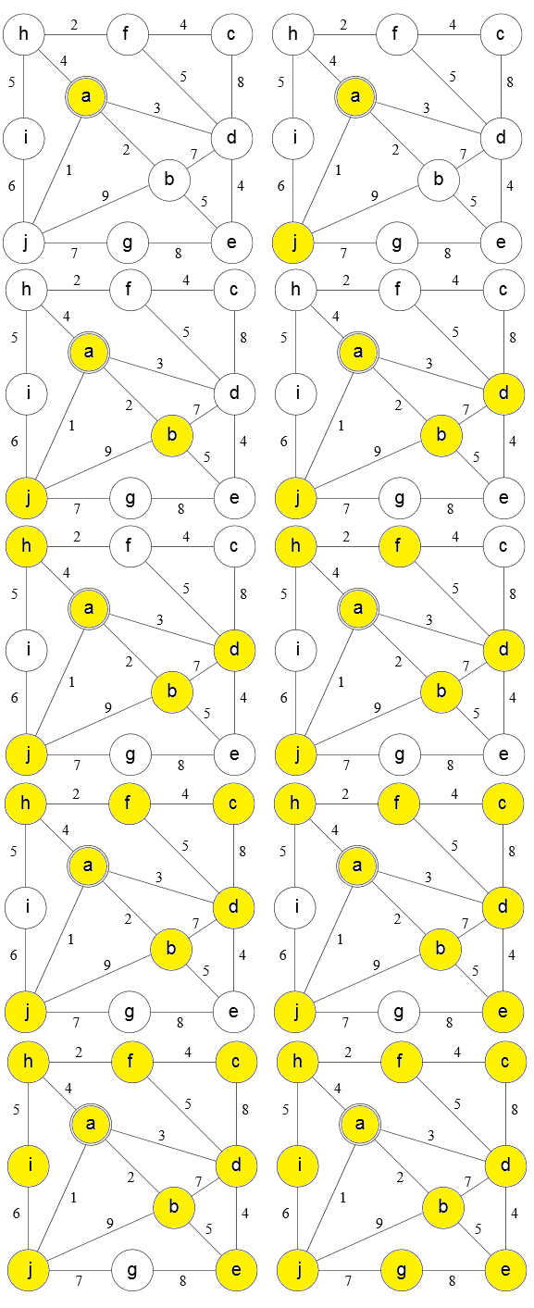
Travis Robinson
CS325
Homework 3
1) minimum:1+2+3+4+2+4+4+5+7=32
2)
a:0, b:2, c:3, d:6
a:0,b:2,c:3, d:6, e:11
a:0, b:2, c:3, d:6, f:7, e:11
a:0, b:2, c:3, d:6, f:7, e:11
a:0, b:2, c:3, d:6, f:7, e:8, h:15
a:0, b:2, c:3, d:6, f:7, e:8, g:9, h:15
a:0, b:2, c:3, d:6, f:7, e:8, g:9, h:10
a:0, b:2, c:3, d:6, f:7, e:8, g:9, h:10

3)
a: The length of the MST changes by the number of edges, since each edge increases by one. The tree itself does not change, however.
Proof: w'(u,v) = w(u,v)+1
MST = Σ_{i=1 t0 n} w(u,v)
MST' = Σ_{i=1 t0 n} w'(u,v) = Σ_{i=1 t0 n} w(u,v)+1 = n*Σ_{i=1 t0 n} w(u,v)>=MST for all n>=1
So the length of the MST changes

The vertices/edges in the tree do not change however; the reason for this is that in order to form the MST, each edge is followed to find the order that it's added, finding the order of edges that will minimize that distance; by adding 1 to all edges, the order doesn't change. Ie, when x<y, x+y<y+1 for all x and y.

b: The shortest path could change, depending on the number of vertices/edges between the source and the destination; because for each edge, we're adding one to the path length. So if one path has a length of 4 with 3 edges, its new length is 7. If another path has a length of 3 with two edges, it's new length is 5. The second path, originally the shorter, is now the longer of the two.

4)
a: Starting from A:
A: 1/12
C: 2/7
E: 3/6
F: 4/5
B: 8/11
D: 9/10

b: Ordering the classes according to finish time will yield the correct order, giving A, B, C, D, E, F

5) Determining if a DAG has a hamiltonian path can be done using a DFS. The DFS will go through every node following the directions of the edges. If it comes across more than one vertex with no exit edges, it returns false, because that mean there are at least two nodes that we would be required to end the path in, but can only end in one; also, after finishing all nodes (or finishing the start node) it compares the number of nodes finished to the number of nodes that exist; if it's less, then we know that there's no path, because not all nodes were connected.

Pseudo-code:
number_total_nodes = total number of nodes in graph
number_finished_nodes = 0
number_nodes_no_exit = 0
Start at node 1:
log it's start time
Follow DFS through all nodes:
log their start times
if(node.current has no exit.edge) //exit.edge == edge pointing to another element
number_nodes_no_exit++
if (number_nodes_no_exit>1)
return false
log their finish times
Log finish time of node 1
if (number_finished_nodes < number_total_nodes)//not all nodes connected to the DAG
return false

return true //alternatively, return nodes in reverse order of finish time to return the path itself

This algorithm runs in O(V+E) running time because this is a DFS algorithm; it processes each node once at the time it finishes (or twice, but constant coefficients are irrelevant in asymptotic time) and it processes each edge once, making it O(V+E) in the worst case, where it follows all nodes and edges to determine if there is a path.

6)
a: I would use dijstra's algorithm.
G:0, E:2, H:3, D:7, F:8, C:9
G:0, E:2, H:3, D:5, F:8, C:9, B:11
G:0, E:2, H:3, D:5, B:6, F:8, C:9
G:0, E:2, H:3, D:5, B:6, F:8, C:8
G:0, E:2, H:3, D:5, B:6, F:8, C:8
G:0, E:2, H:3, D:5, B:6, F:8, C:8, A:15
G:0, E:2, H:3, D:5, B:6, F:8, C:8, A:12
G:0, E:2, H:3, D:5, B:6, F:8, C:8, A:12

b: To select an optimal location, we would use dijkstra's algorithm on all potential starting nodes. Because djikstra's algorithm runs in O(E lg V time), doing this for all nodes would require V O(E lg V) time. This would give us a running time of f*O(r lg f), because the intersections will be treated as nodes and the roads as edges.

c: The optimal location should be the node that minimizes the travel time for the fire department. So after using dijkstra's algoritm on all nodes, you would then sum the travel time for that particular set, and the one with the lowest total will be the location of the fire department. This is as opposed to determining the location based on the farthest distance, which only minimizes travel to that one location.

