Travis Robinson
Project 7
OpenCL/OpenGL Particle System
CS475
Spring 2016

Project Computer

This project was run on my home laptop, an HP Pavilion dv7 with an AMD A8-3520M processor and an AMD Radeon HD 6620G GPU.

Dynamic Color Changing on Particles

For my particle colors, I set them to change color every time they hit one of the bumpers. They start off the color blue, then become red when the hit the first bumper, then green, then back to blue following the same sequence everytime they hit a bumper.

Screen Captures of Running Particle System
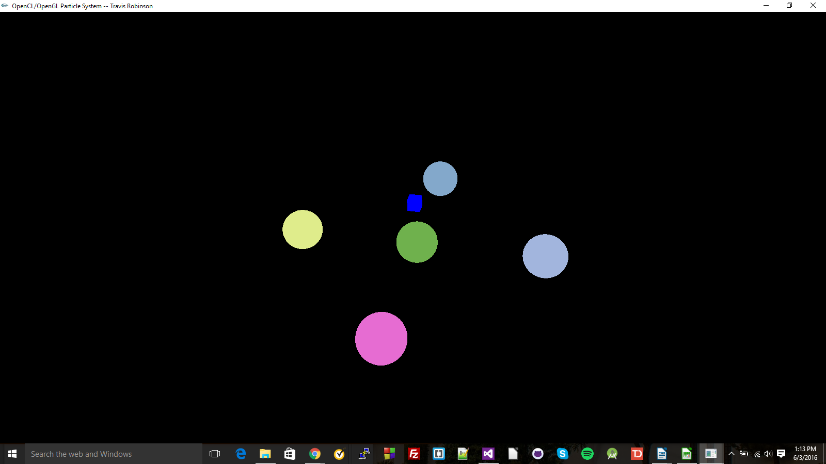

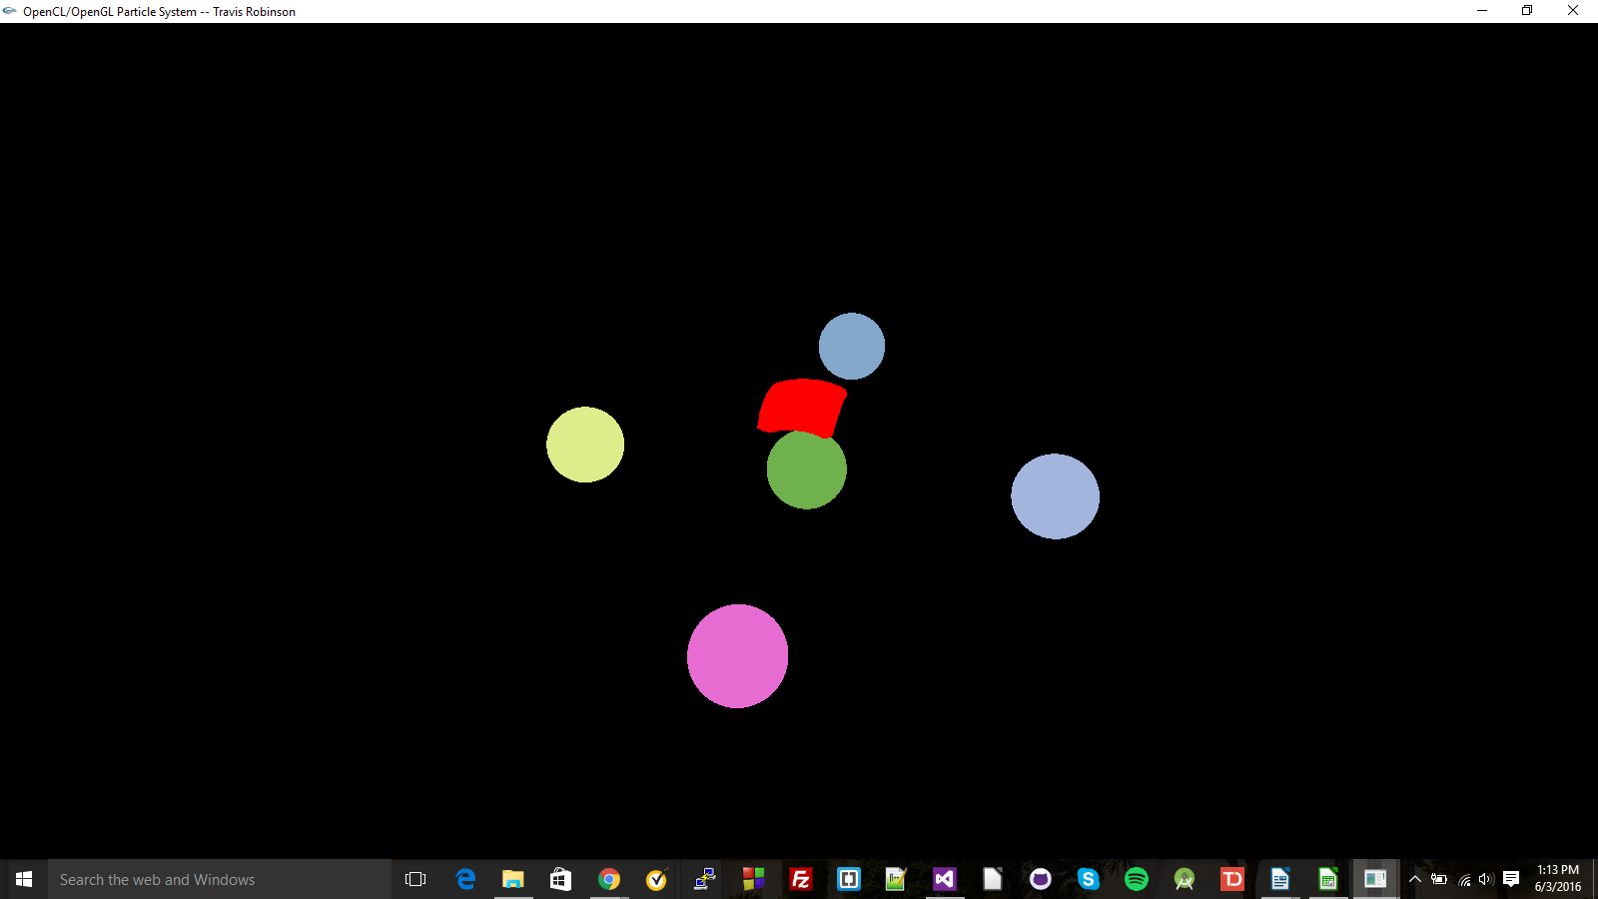

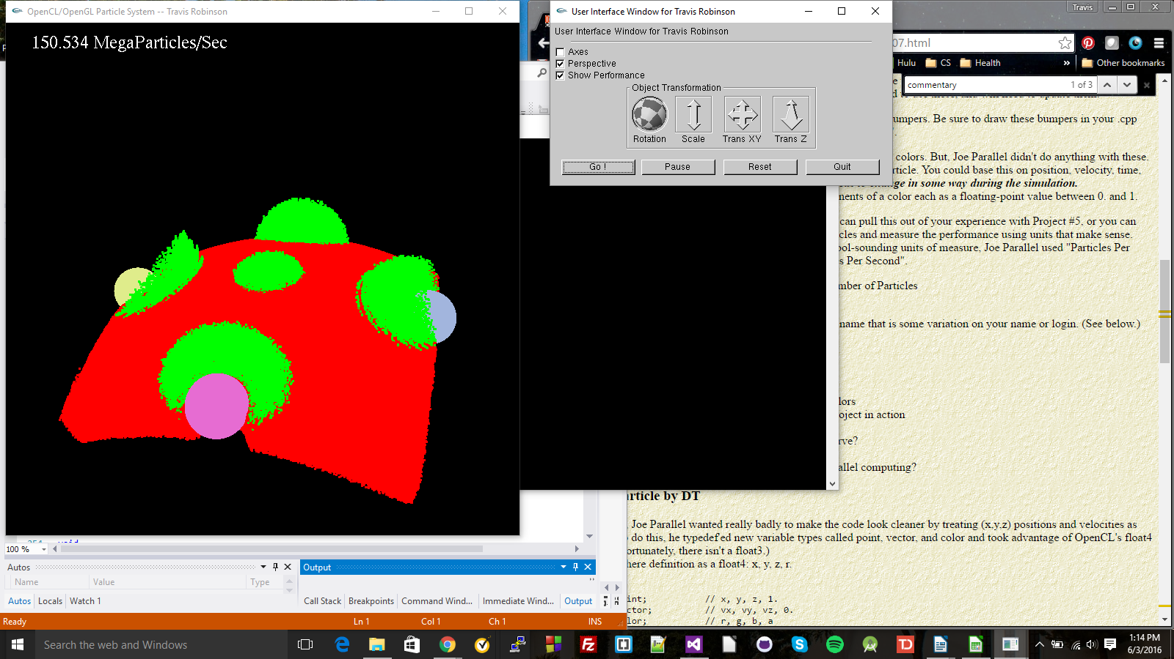

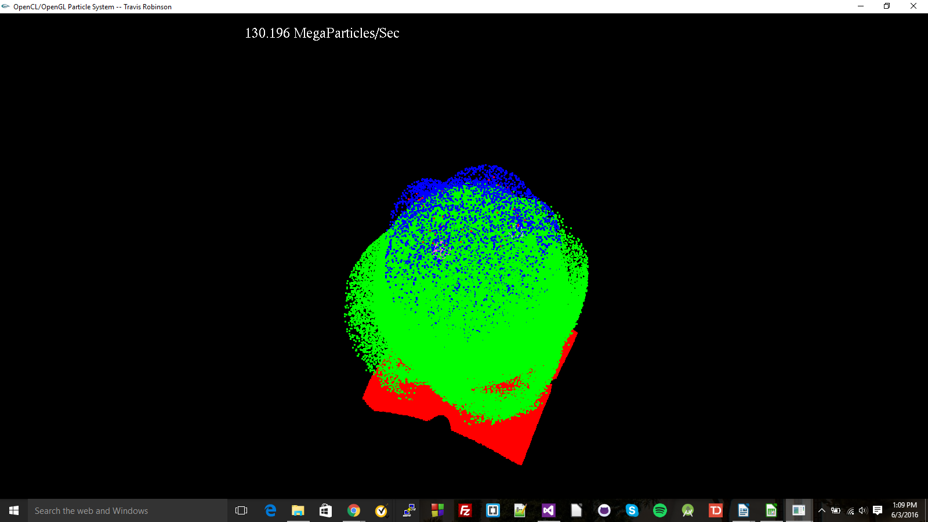

Table and Graph of Project Performance

Patterns in Performance
We see in our performance that as the number of particles gets larger, our performance improves, though we do start to it beginning to level out after a quarter-million particles.

The reason for this is that as we get more particles, the GPU usage is being maximized. At lower particle counts, there's not enough particles for all of the GPU to be utilized, so it's making fewer calculations a second. As we increase the number of particles, though, we see performance increase because more of the GPU is being utilized. We eventually see it starting to level off because we reach the limits of what the GPU is capable of; each processing unit of the GPU can only process so many particles in a second, so having more particles won't improve performance.

What This Means For GPU Computing
What this means for GPU computing is that we'll get our best performance when using more particles/larger inputs, than we will when using smaller inputs. So for us to make the most of our processing time and our hardware, we should use larger amounts of data when doing GPU computing.

