Travis Robinson
CS372
Lab 2
Fall 2016
Oregon State University

1) 1.1 for my browser (red circle), and 1.1 for the server (black circle)
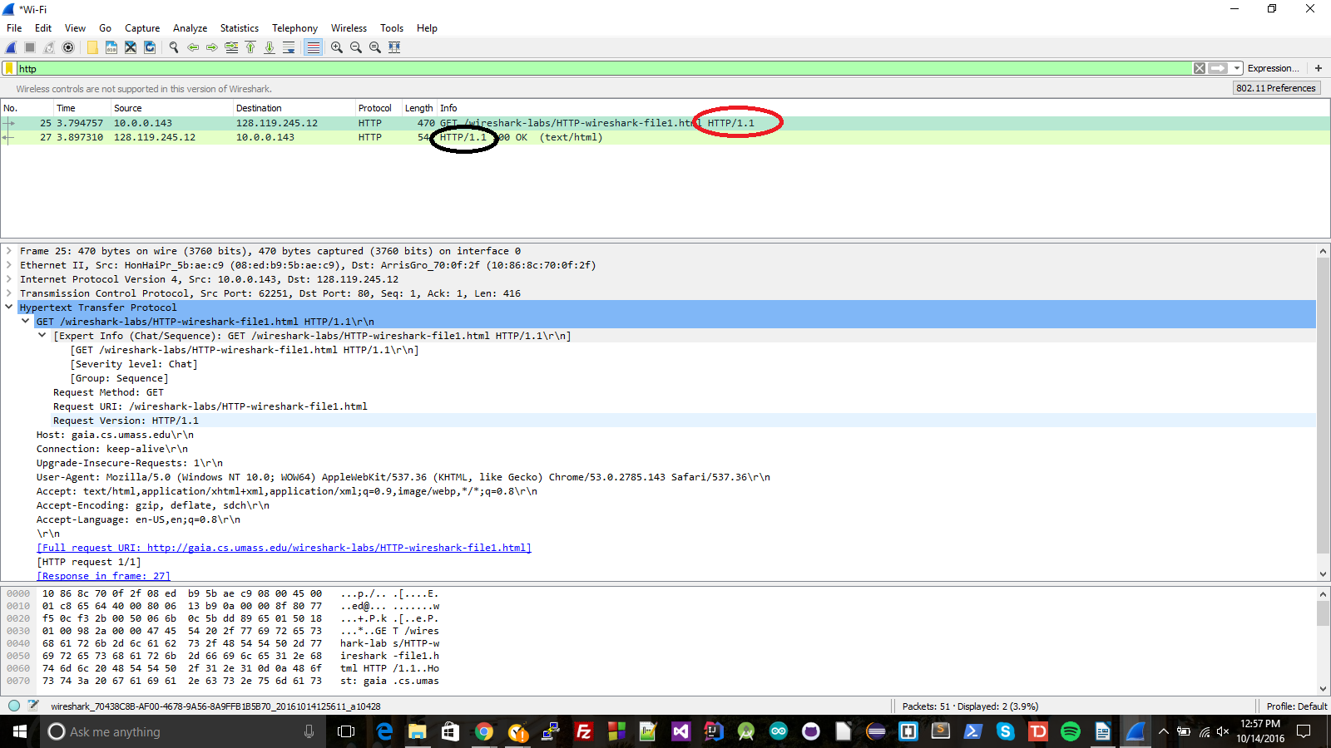
2) It says it will accept text/html, application, xhtml, xml, and image/webp (red box)
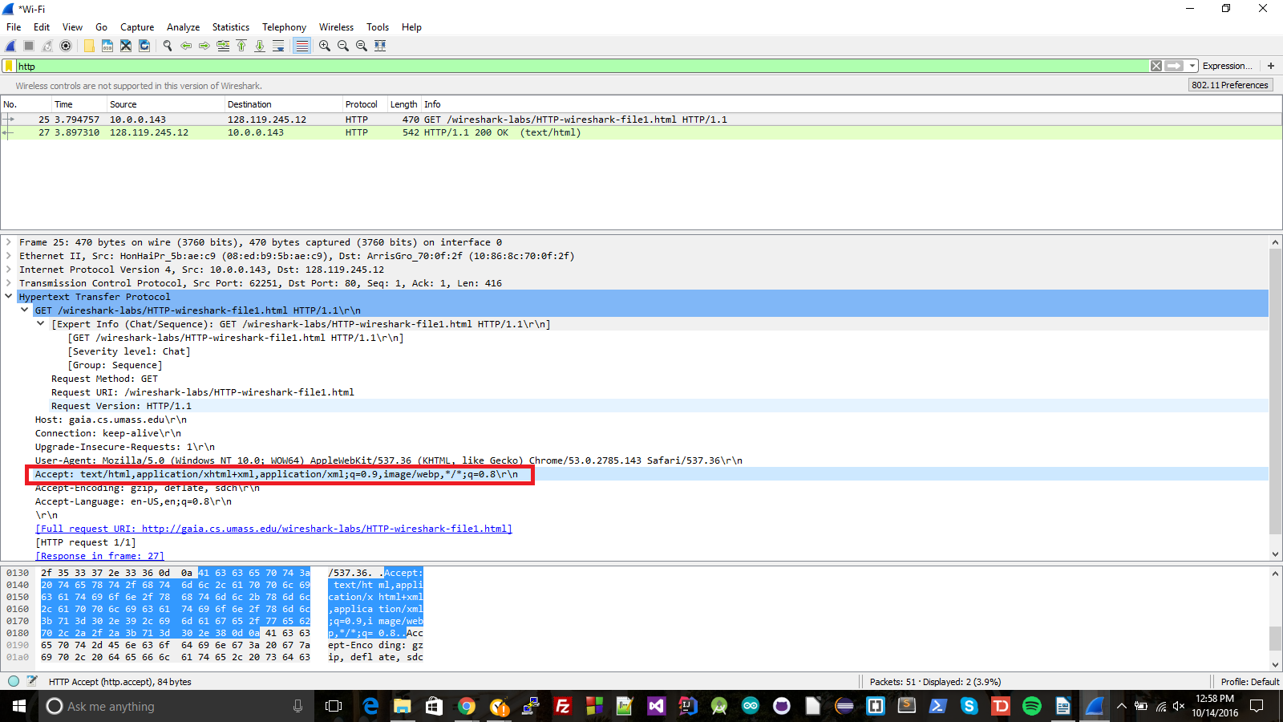

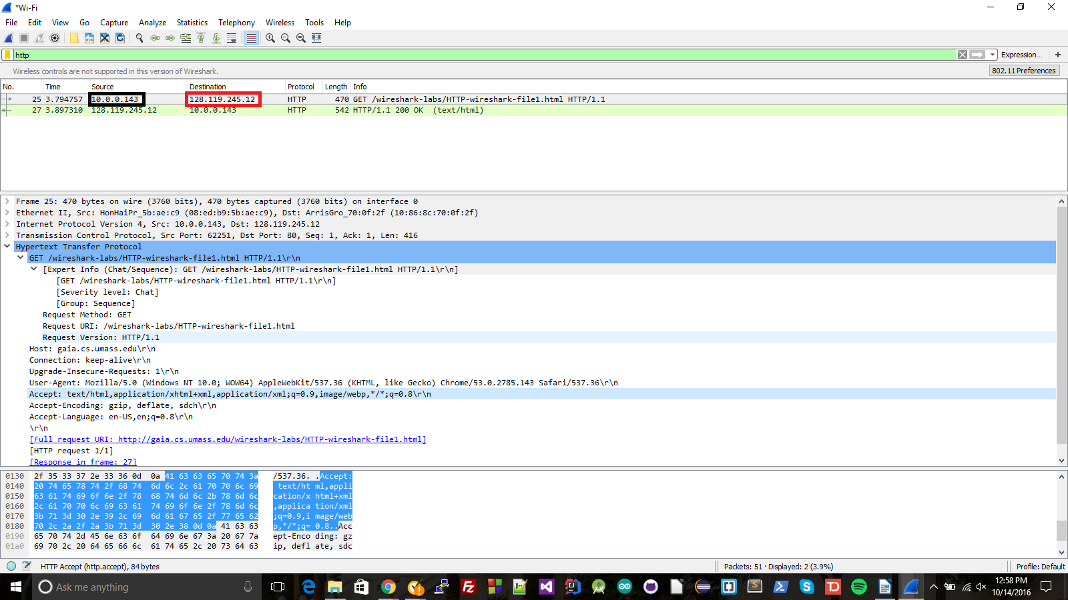
3) My IP address is 10.0.0.143 (black box). The IP address of the server is 128.119.245.12 (red box)

4) 200-OK (orange circle)
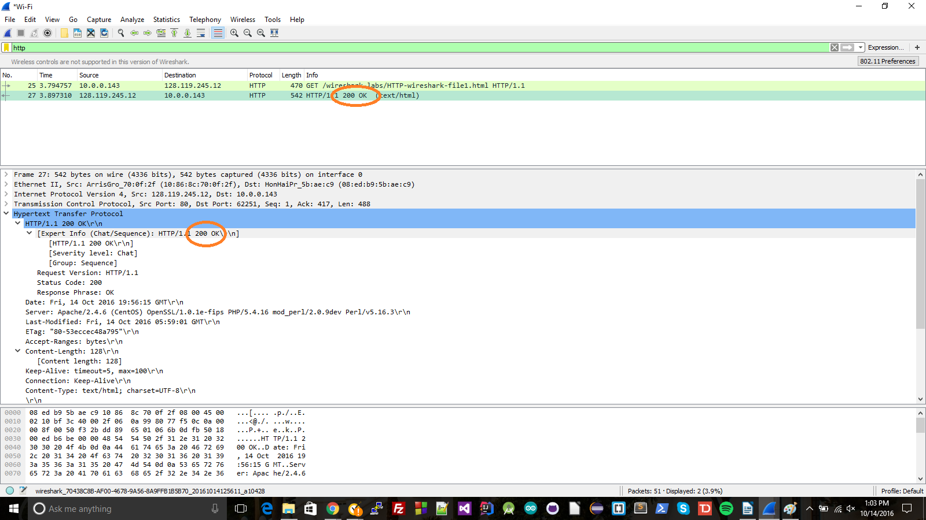

5) The last modified time is Fri, 14 Oct 2016, 5:59:01 GMT (purple box)

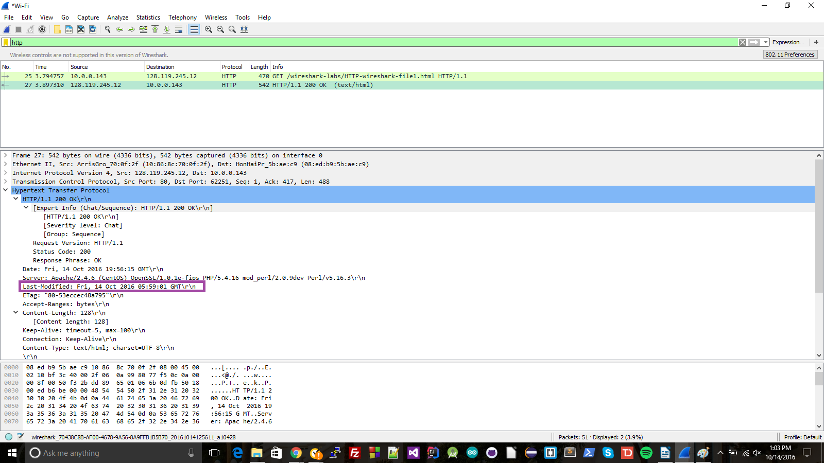

6) According to the HTTP header, 128 bytes (red box)
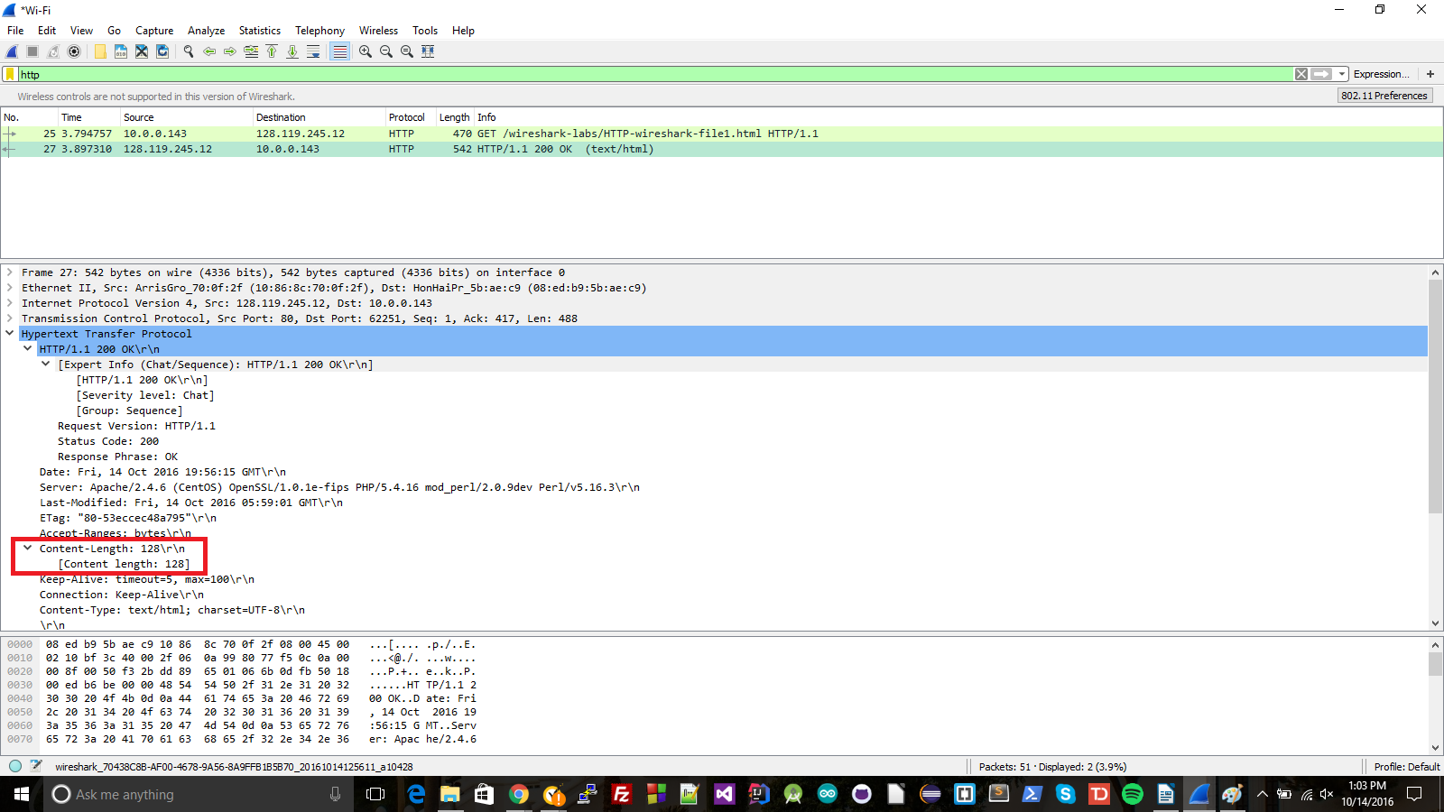
7) There were no headers in the data that weren't already displayed in the packet listing window, though there were some headers that weren't in the data, such as the Full Request URI, the HTTP request number, and the Response in frame. These are in the red box, while the black box shows that the last header included in the raw data was Accepted Languages.

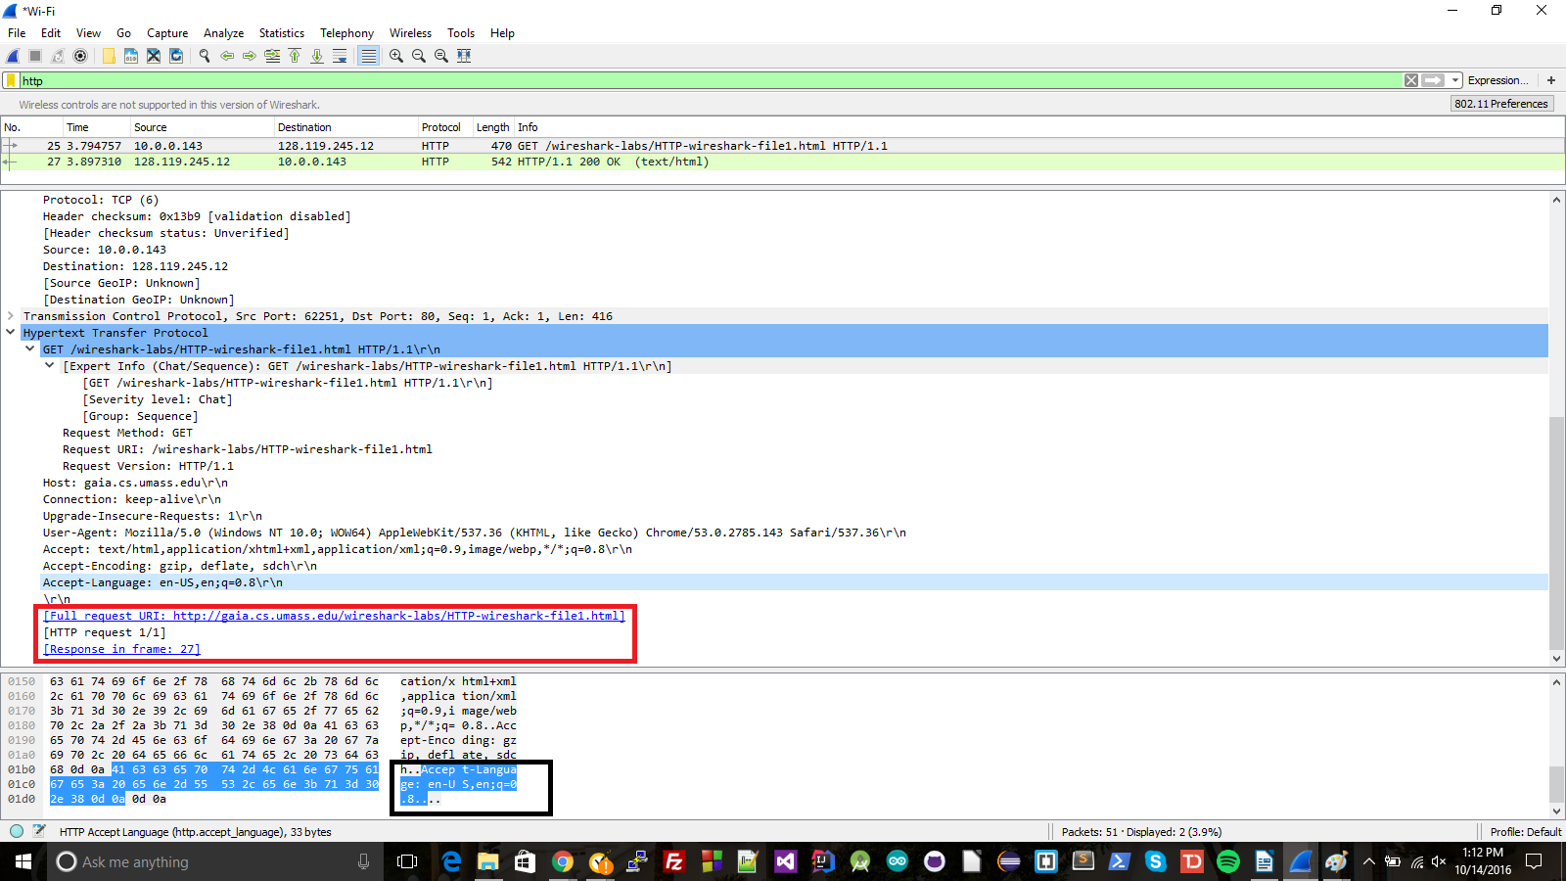
8) There is not:
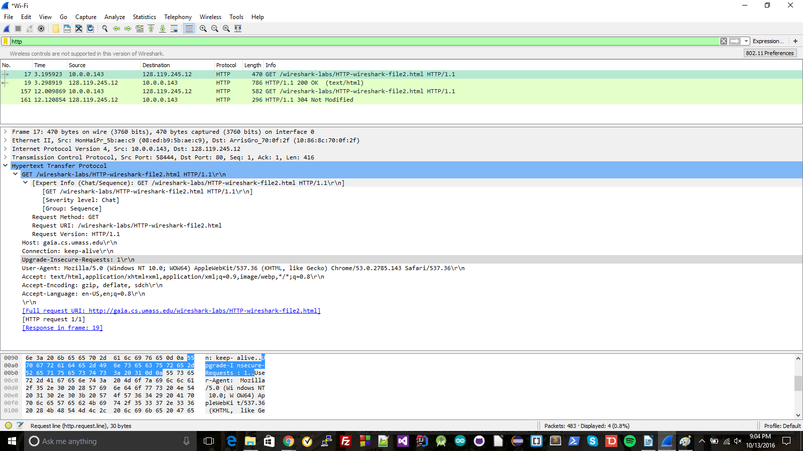
9) It did return the contents of the file: I can tell because the red square contains a content length section saying there was content sent, and because of the HTTP response, which was 200 OK, meaning that the response contains the requested item (in this case an html file)

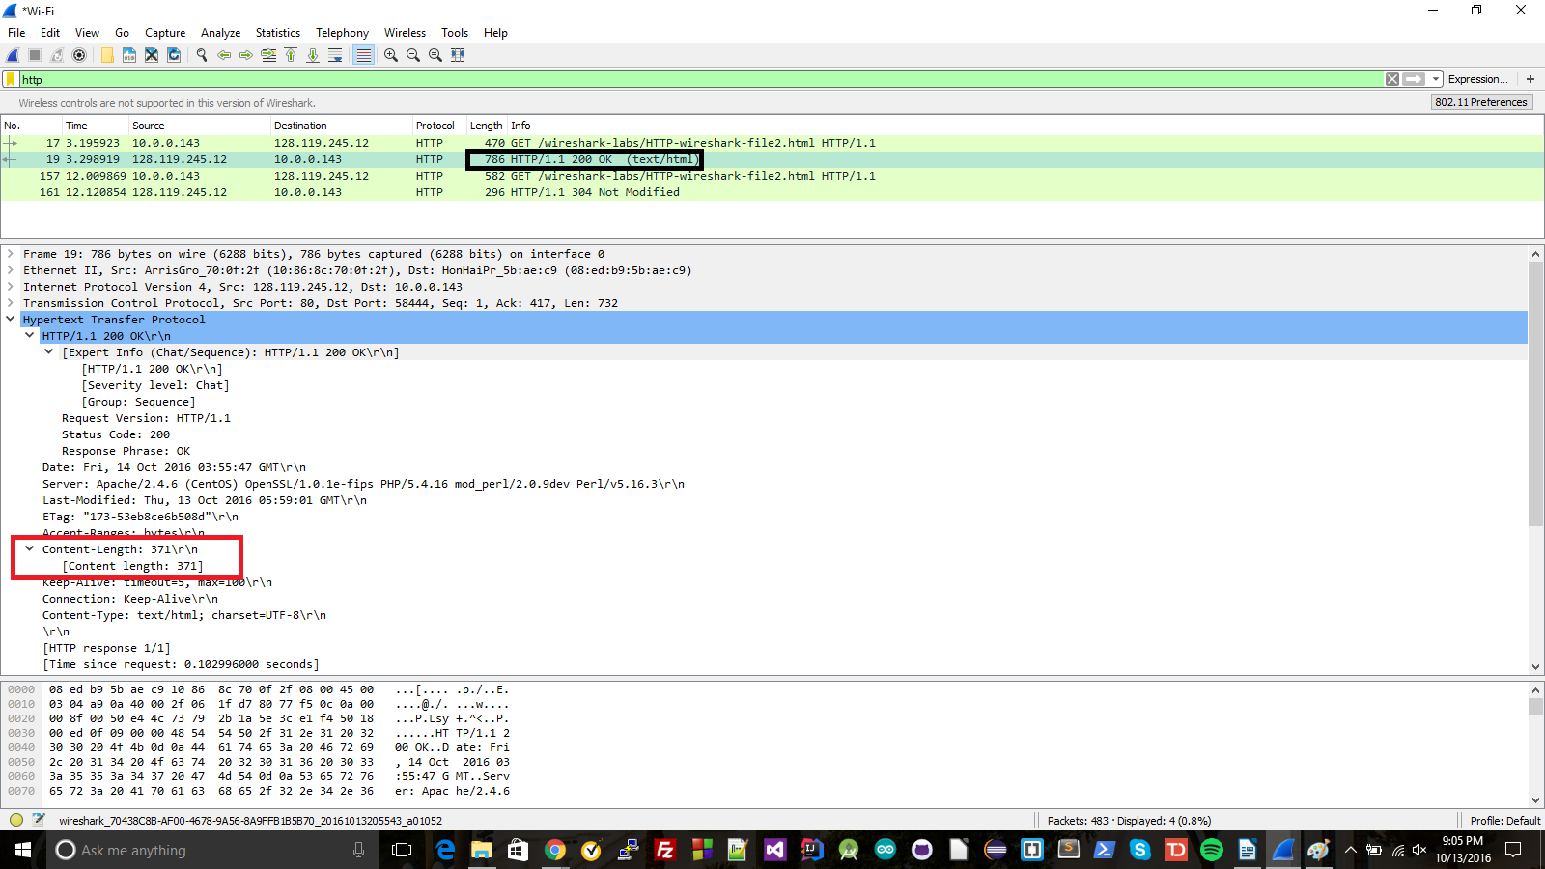

10) There is; the date/time given is 13 Oct 2016, 05:59:01 GMT. This would be the time that I last visited the requested site.
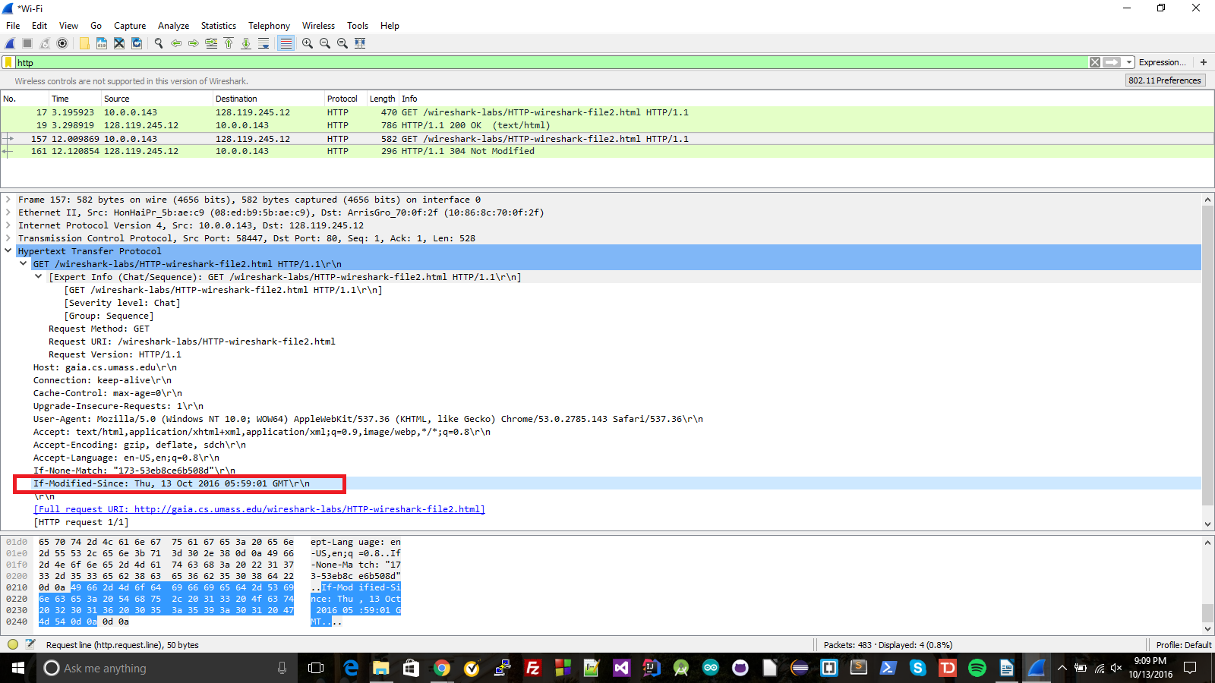
11) The response code is 304 Not Modified. This means the server did not return the contents of the file, because it had not been modified since the last date/time it had been viewed.

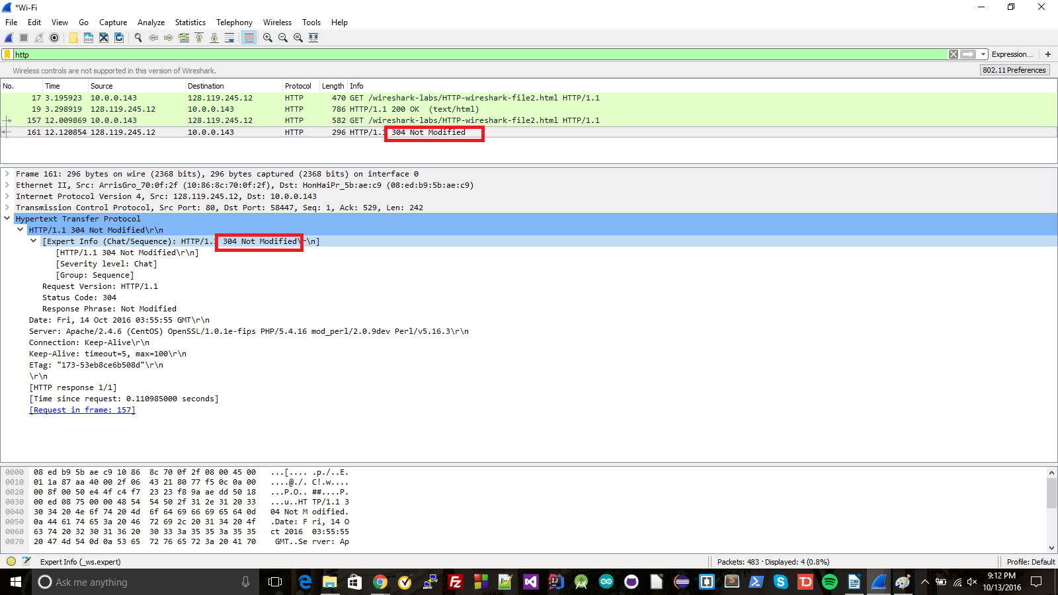
12) There was one GET message sent (black box). The packet number was number 11.

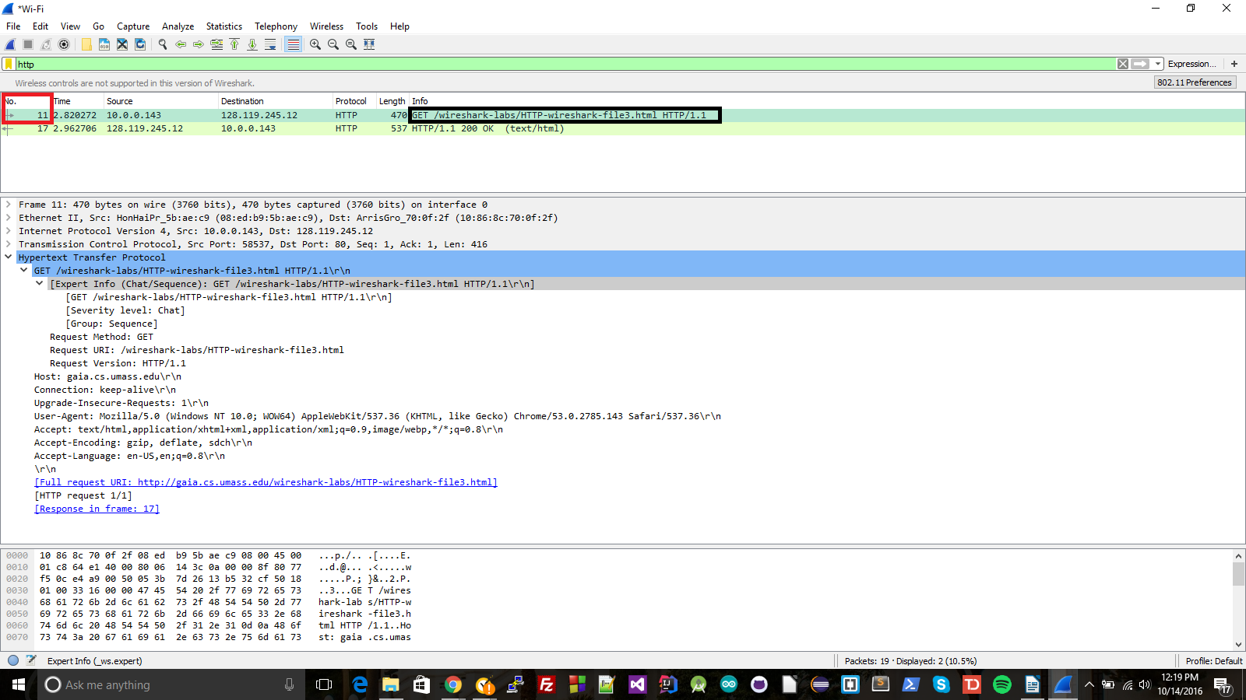

13) The packet number response is 17 (purple box)

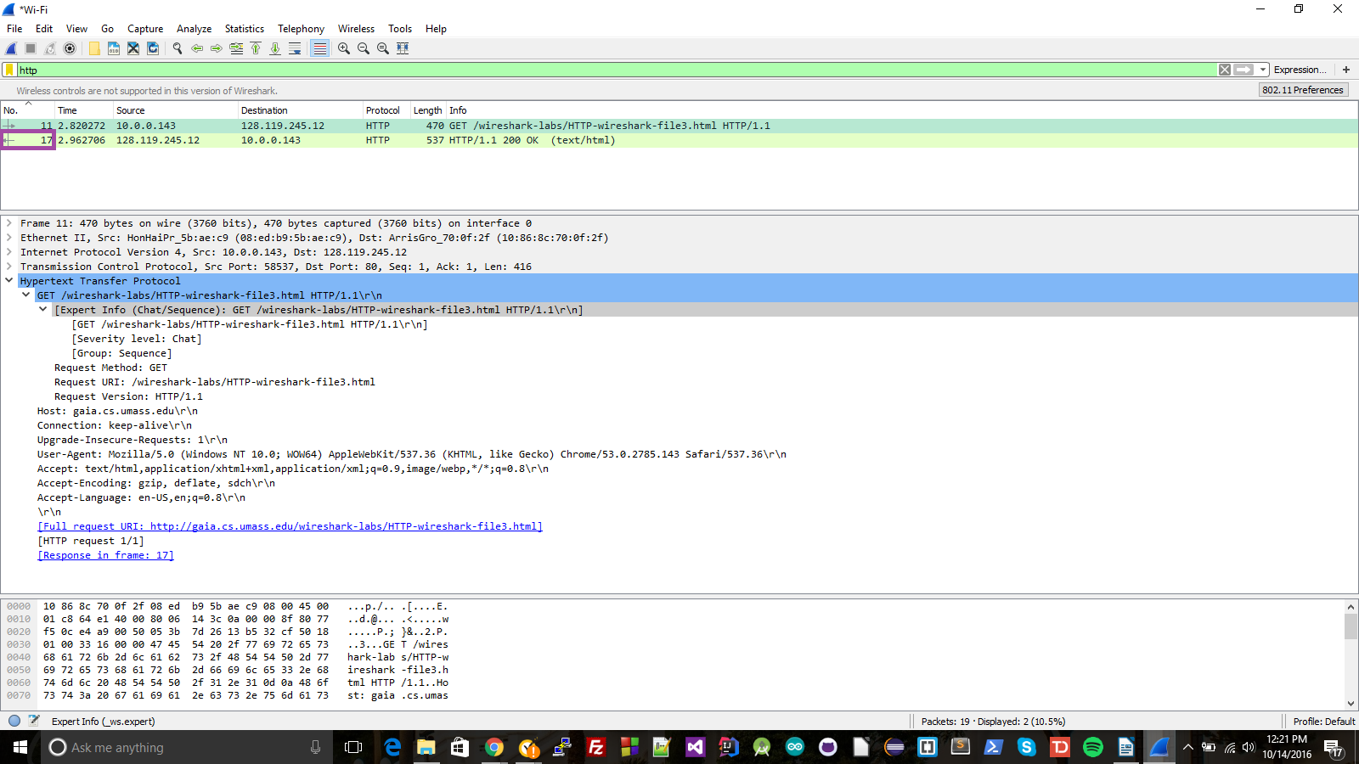
14) The status code and phrase is 200 OK (orange box)

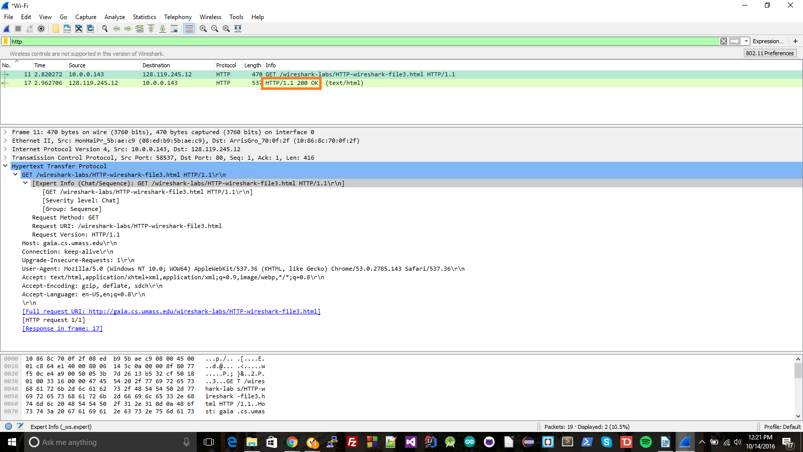

15) There were four TCP segments needed to carry the respons (red box)

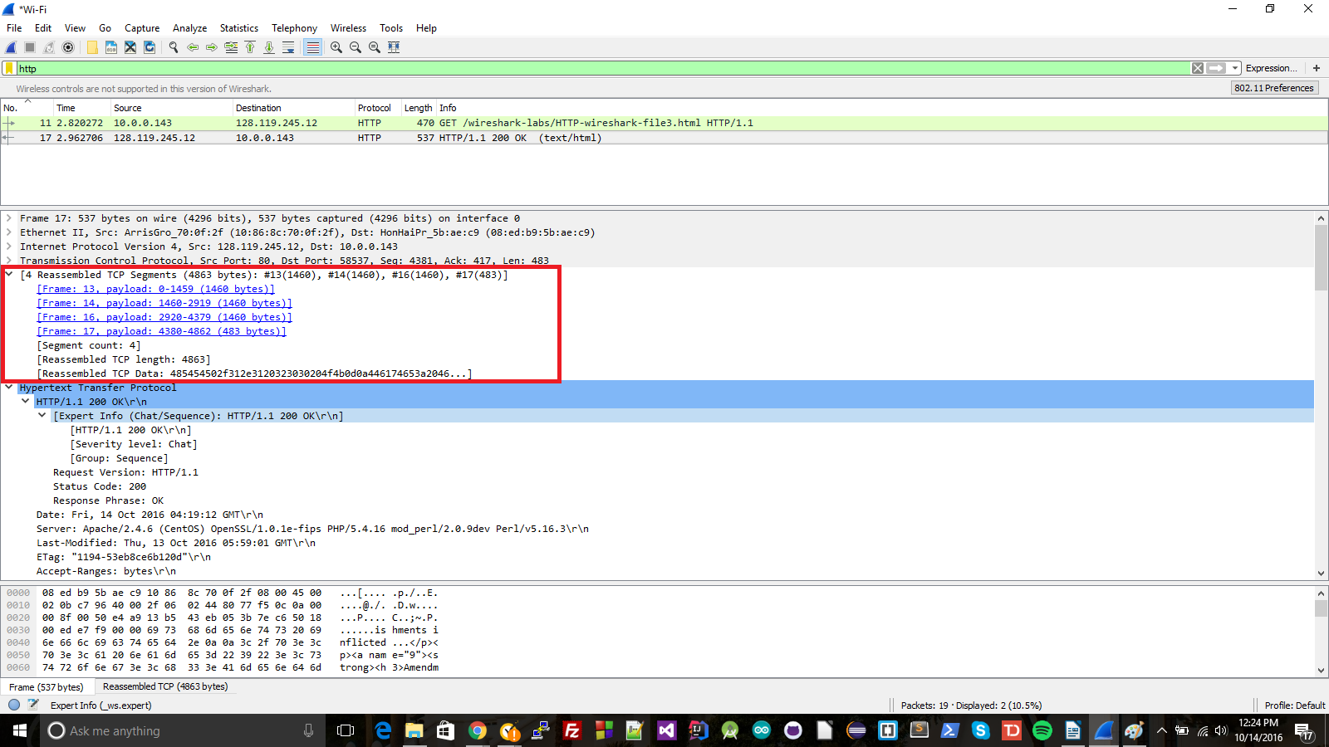
16) Four, all in red boxes

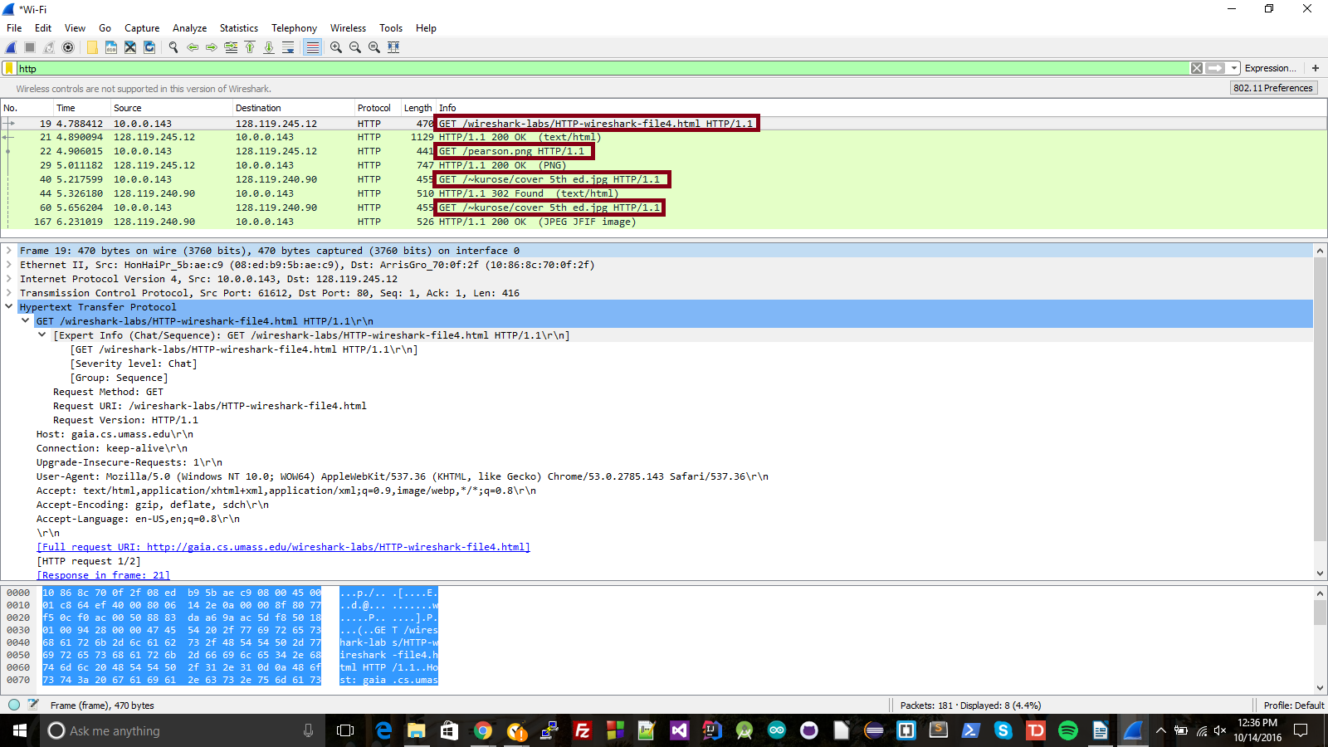

17) They were downloaded serially. I can tell by looking at the time on them. We can see that a GET message isn't sent out until after the reply is received from the previous GET message. In below image, times are in the orange box, and each reply message is underlined with a black line, showing that the time for the next GET is after the time of the response. If images were received in parallel, then GET messages would have been sent out at once (or close to it, anyway)
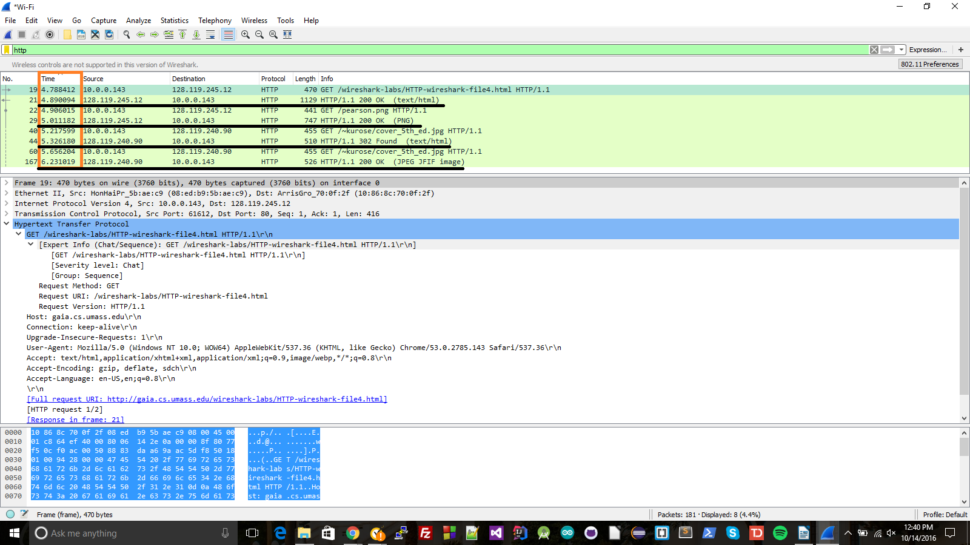

18) 401 Unauthorized (red boxes)
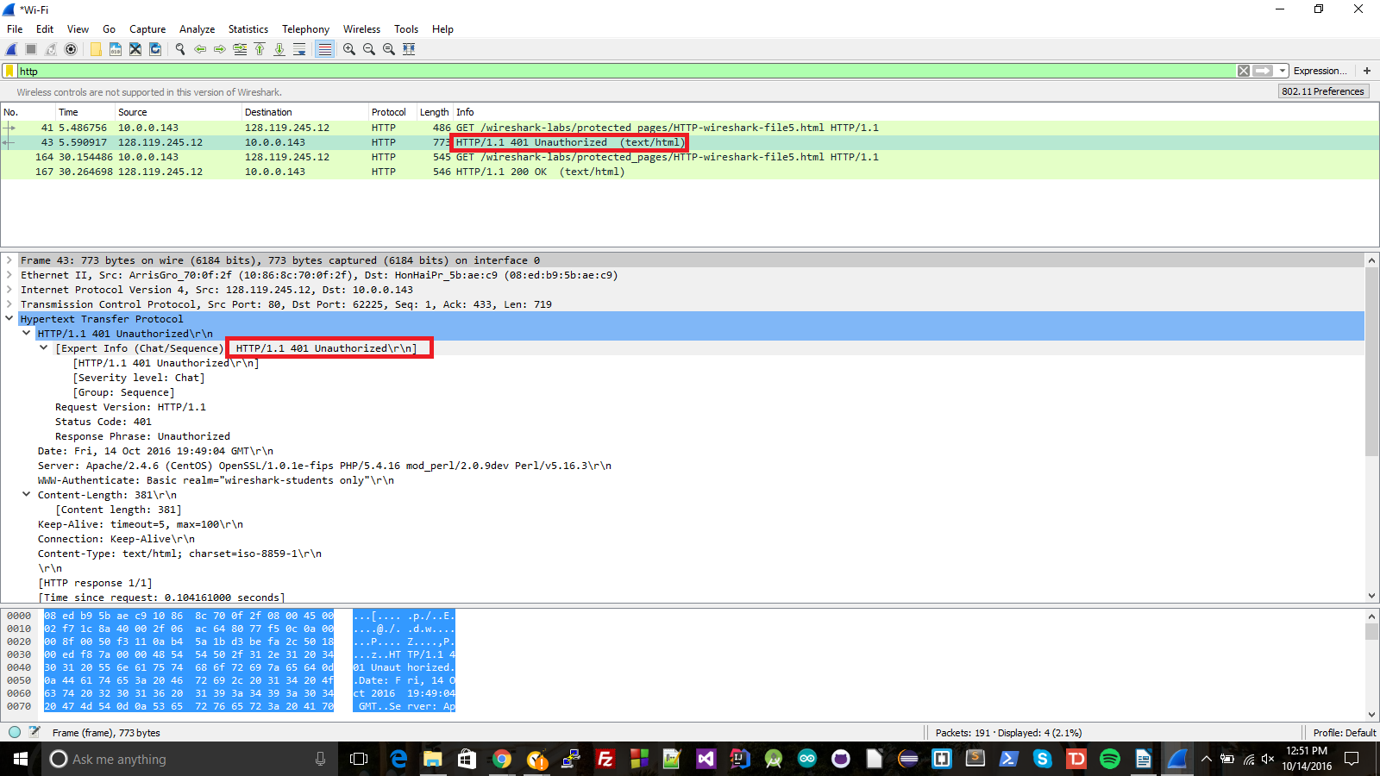
19) Authorization and Credentials (red box)

