Travis Robinon
CS372
Lab 4
Fall 2016
Oregon State University

1) My IP: 10.0.0.143
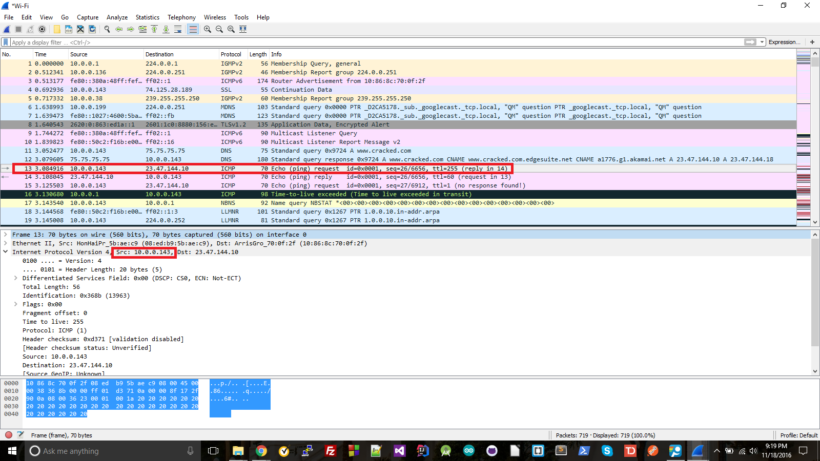
2) The value in the upper layer protocol field is ICMP (1)
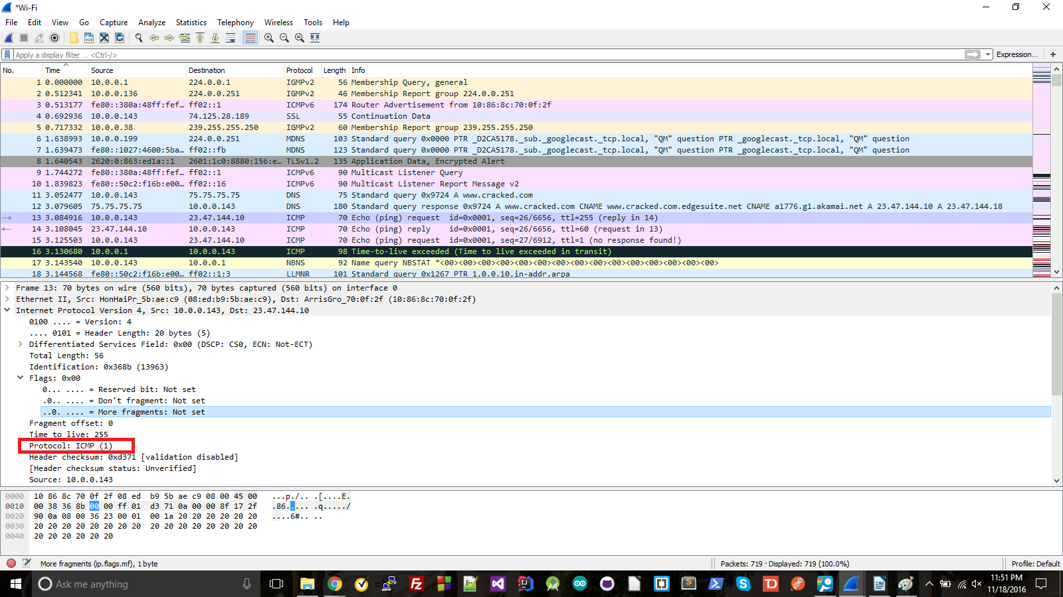
3) There are 20 Bytes in the header; the total length is 56 Bytes; this makes the payload 56 - 20 = 36 Bytes
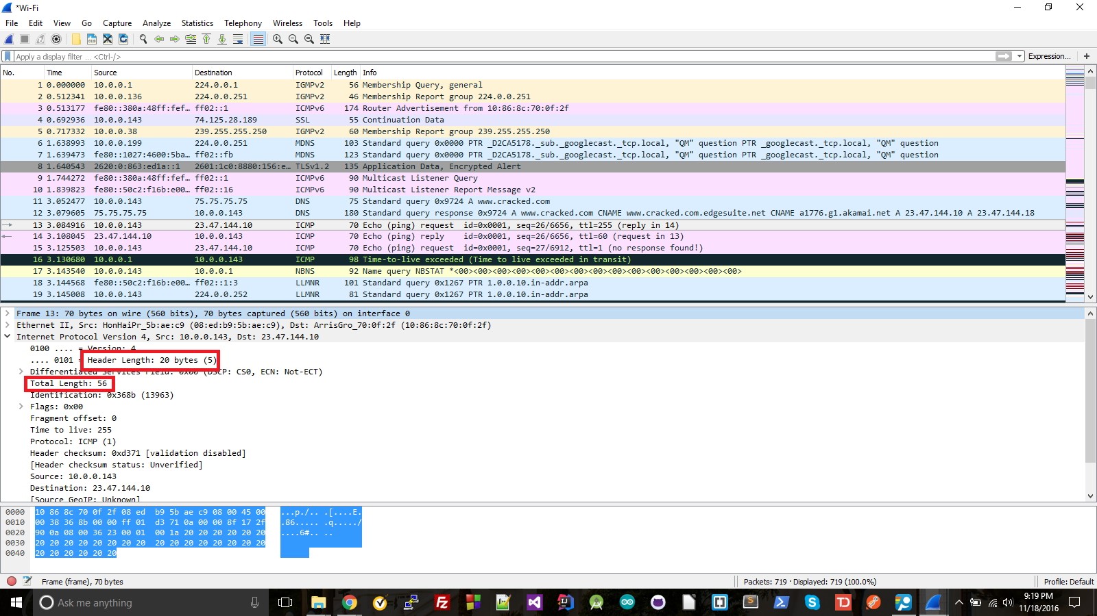
4) It was not fragmented: the more fragments flag was set to 0.
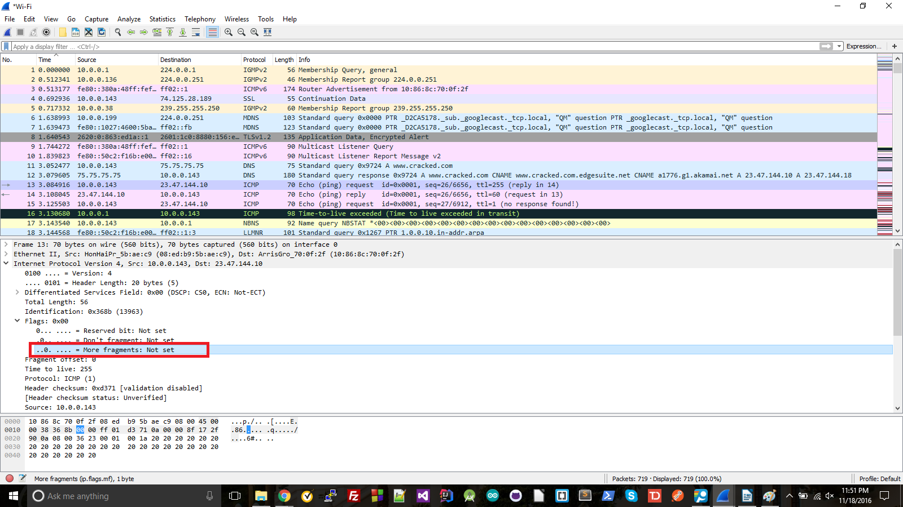
5) The fields that always change are Identification, checksum, and Time to live.

6) The fields that stay constant are Version, Header Length, Differentiated Services Field, Total Length, Protocol, Source, Destination. These must all stay the same, because Version determines what IP version the two hosts are using to communicate, Header Length must stay the same for ICMP, Differentiated Services must stay the same for all of the same protocol, Source since all packets are coming from the same place, destination since all packets are going to the same place.

The fields that must change are Identification since each packet needs its own individual ID, checksum since each datagram will have its own content that needs to be checked, and time to live since each TTL gets incremented.

7) The Identification field is incrementing with each packet that is part of the sequence (13963, 13964, etc)

8) 0 for Identification, 253 for TTL field
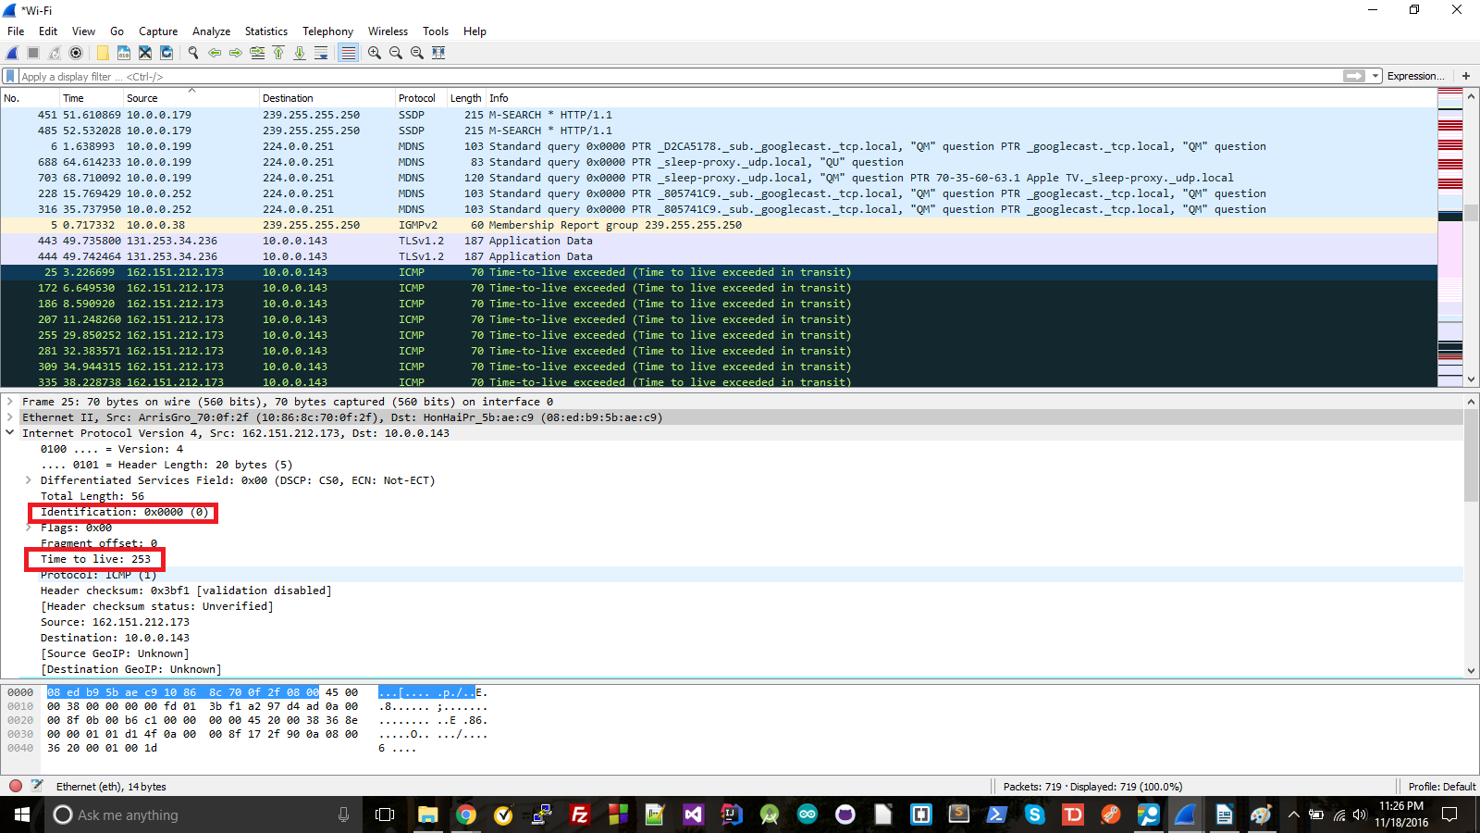

9) They do stay the same. The reason for this is that the hop is always the same distance away.

10) It has. I know this because it says the fragmentation flag was set.
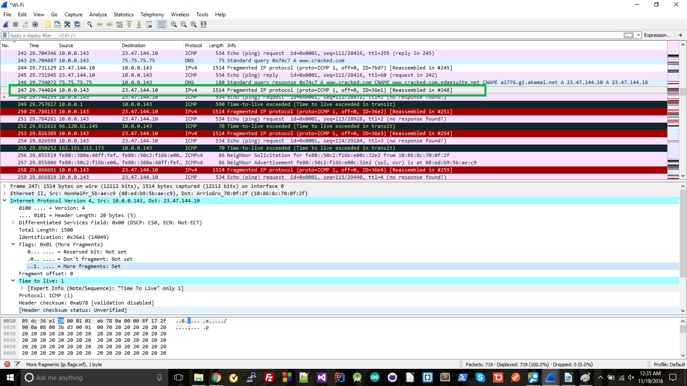
11) The fragment flag is set so we know it's a fragment (red box). We know it's the first because the fragment offset is 0 (yellow box). The datagram is 1500 Bytes (blue box).
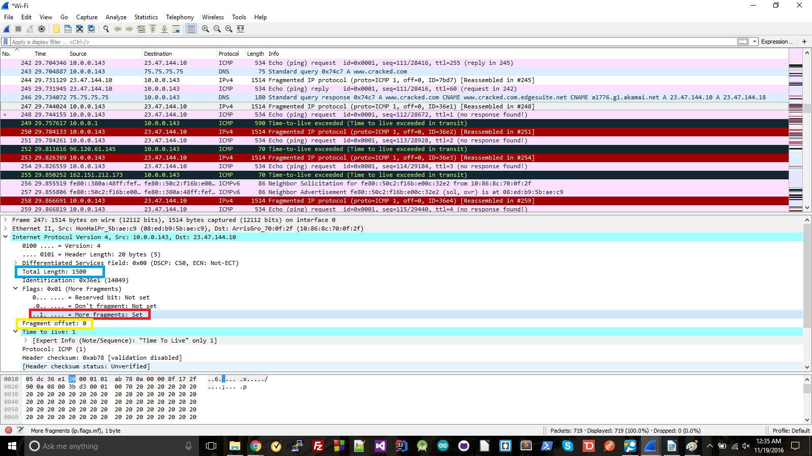

12) I know this is not the first datagram because the offset is not 0 (yellow box). There are no more fragments which we know because the more fragments flag is set to 0 (red box).
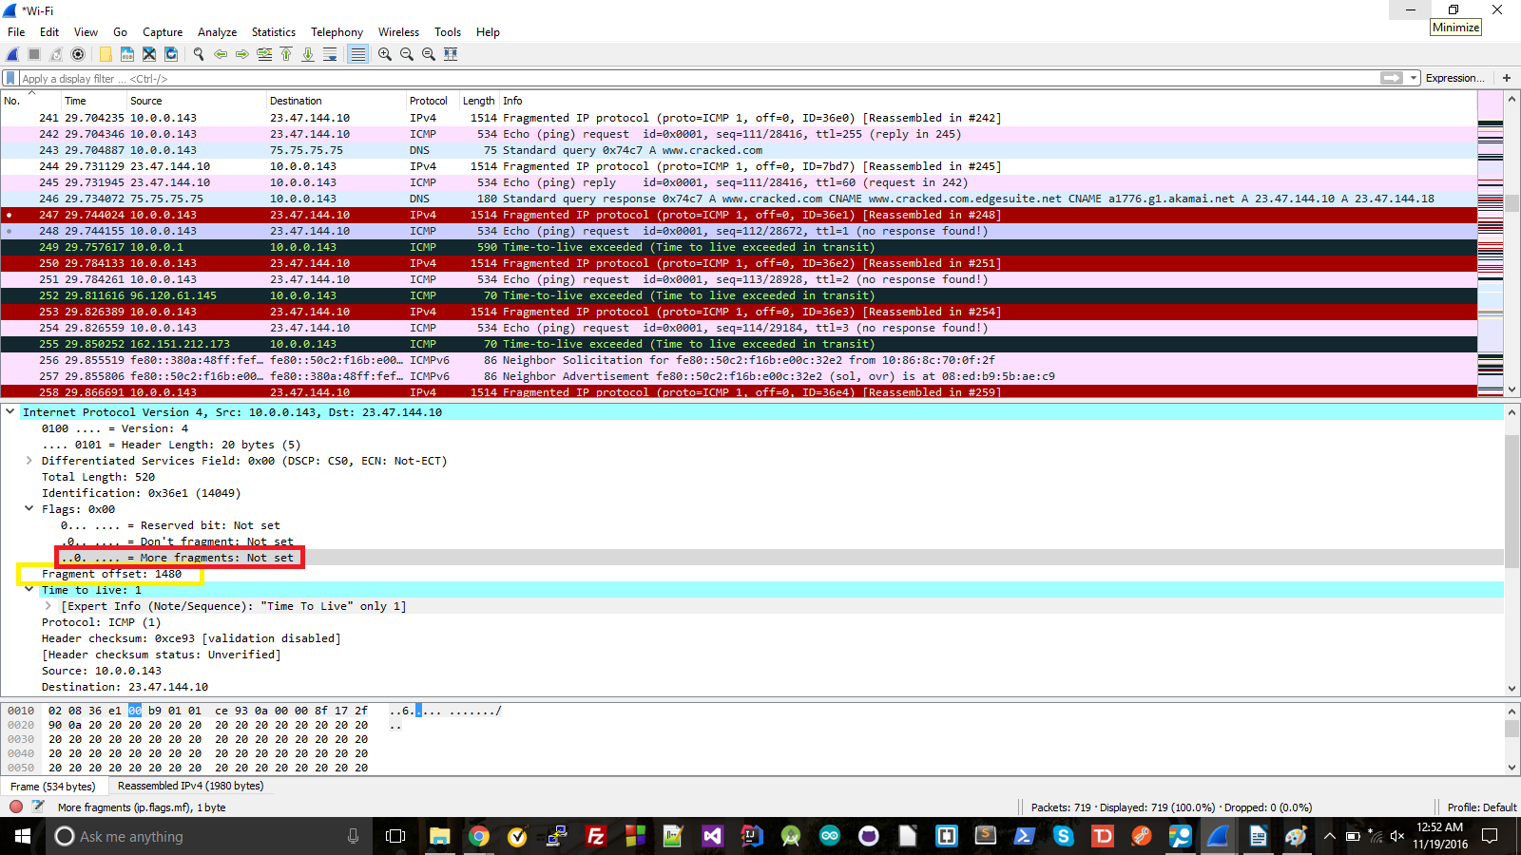
13) The header fields that change are length, identification, more fragments flag, offset, and checksum.

14) Three
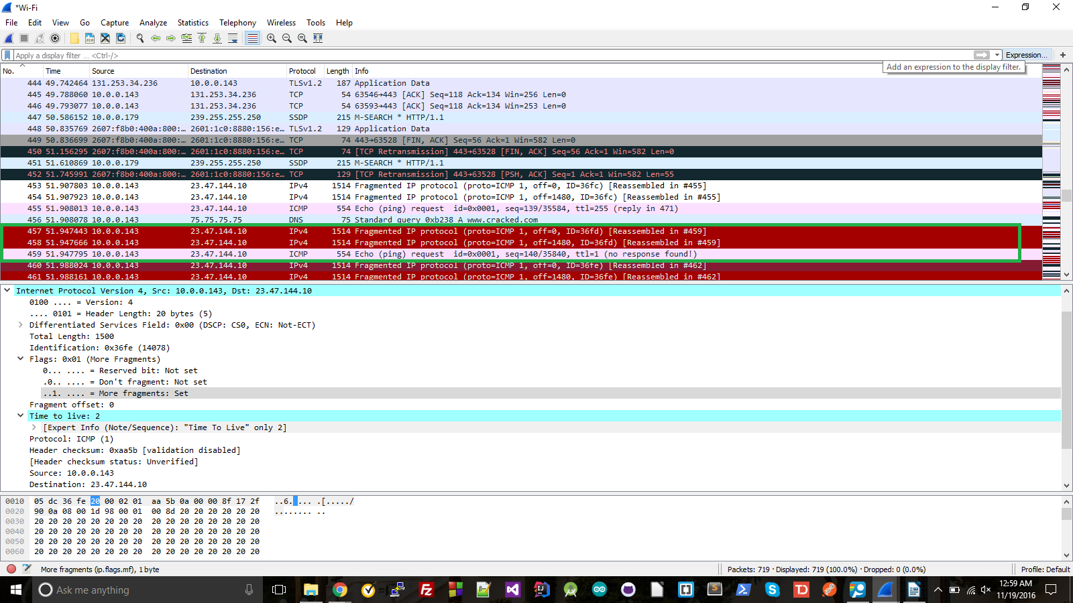
15) The header fields that change are the length, ID, more fragments flag, fragment offset, and checksum.

