Travis Robinson
CS372
Lab 5
Fall 2016
Oregon State University

1) My Ethernet address is: 08:ed:b9:5b:ae:c9
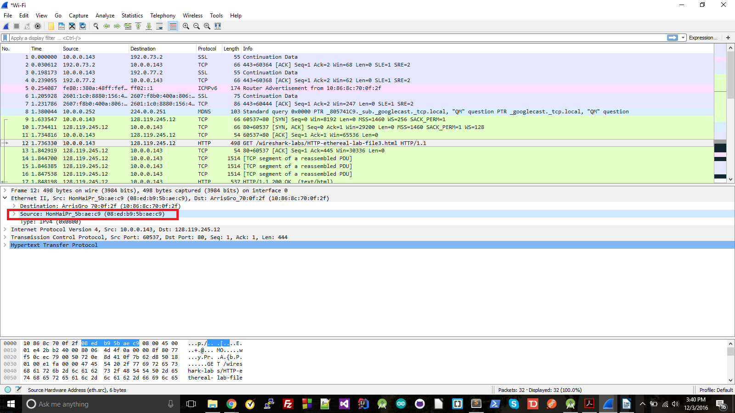
2) The destination Ethernet address is: 10:86:8c:70:0f:2f
This is not the Ethernet address from gaia.cs.umass.edu, it's the Ethernet address of my router.
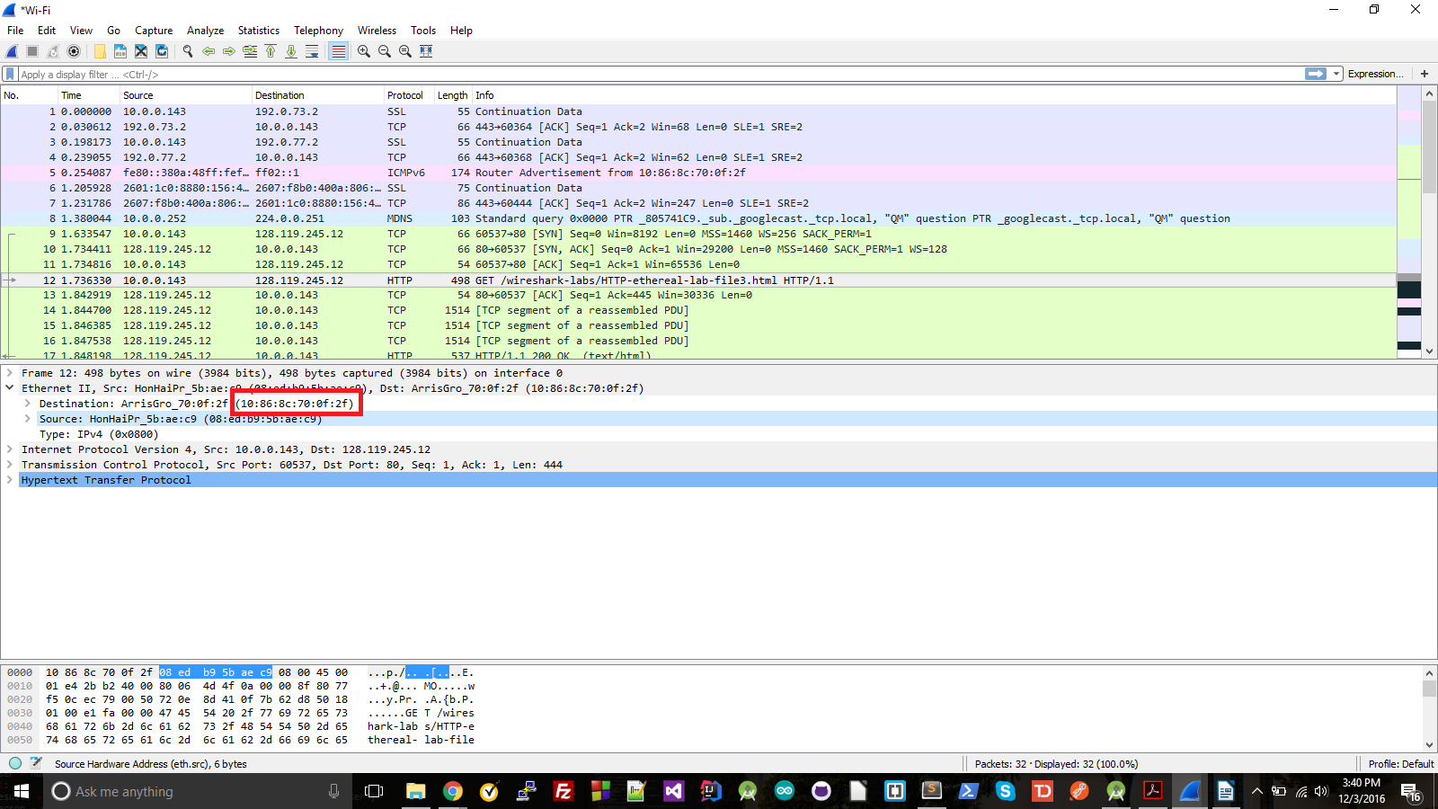

3) The hex value for the Type field is 0x0800. This is IPv4
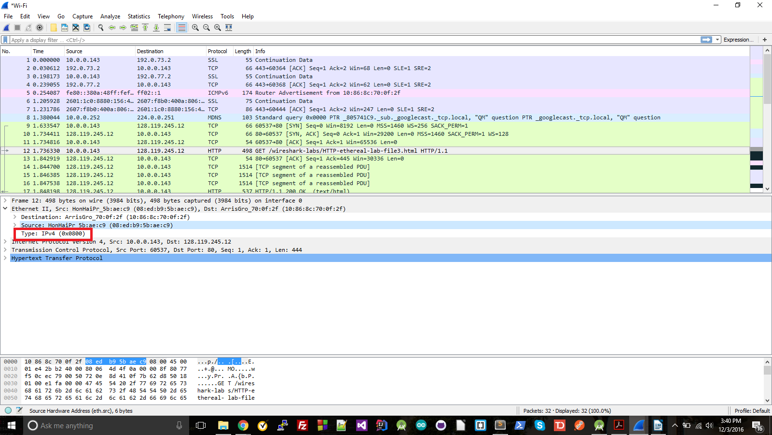
4) The 'G' is the 55th byte; there are 44 bytes before it
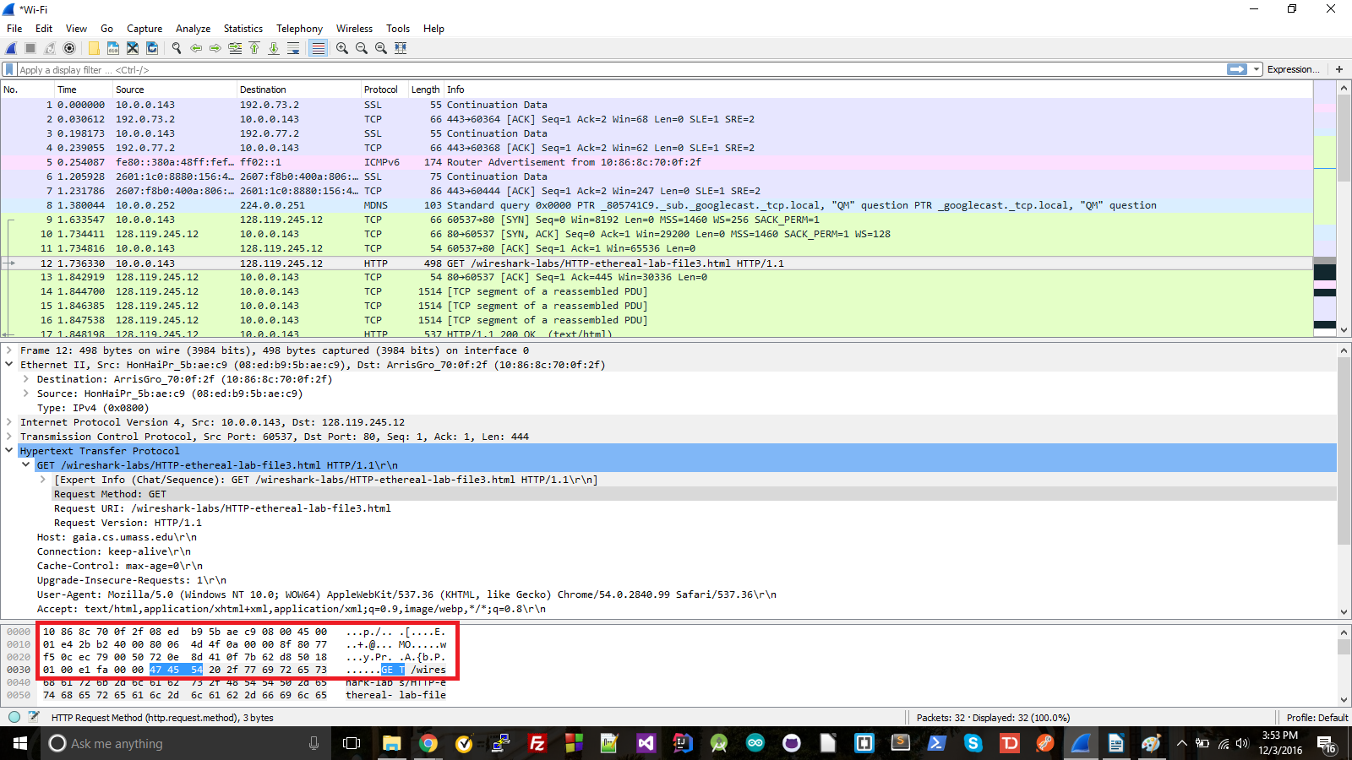

5) The source is 10:86:8c:70:0f:2f. It is not the ethernet address of gaia.umass, but of my router.
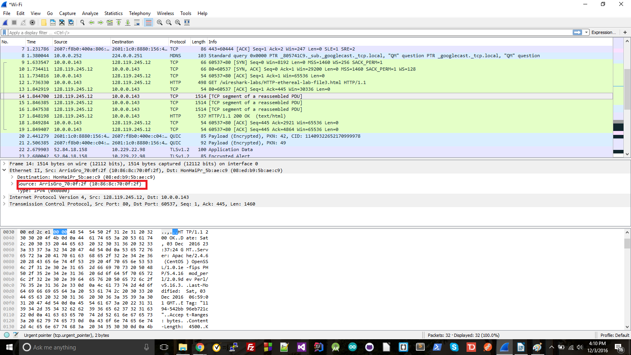

6) The destination is 08:ed:b9:5b:ae:c9. This is the address of my computer

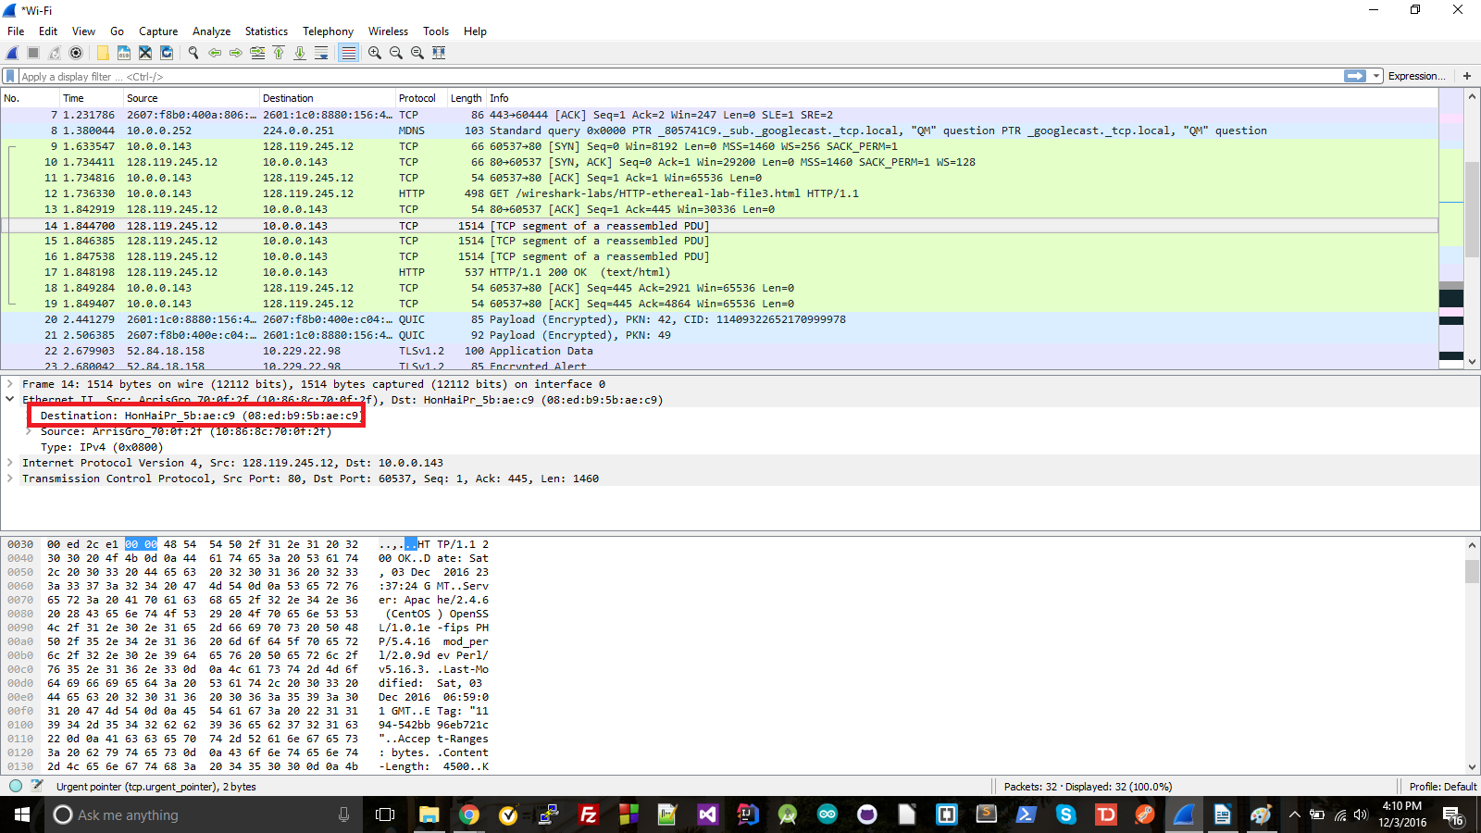

7) The type field hex value is 0x0800, which is IPv4.

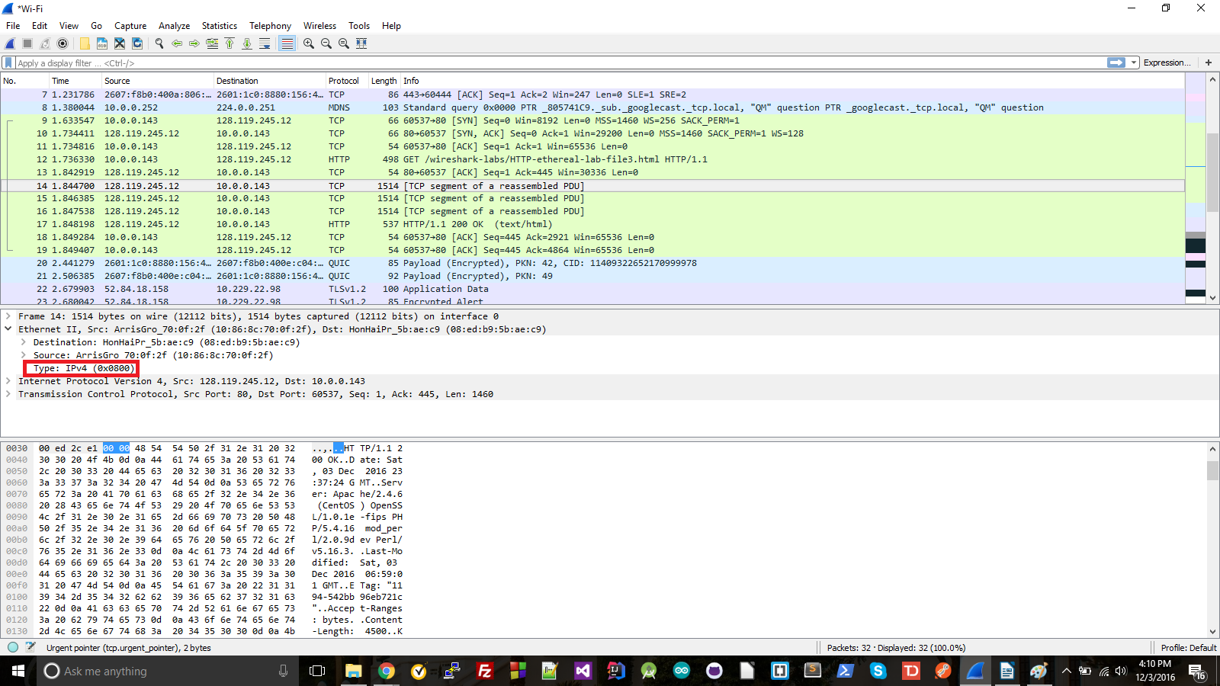

8) The 'O' in OK appears after 74 bytes.

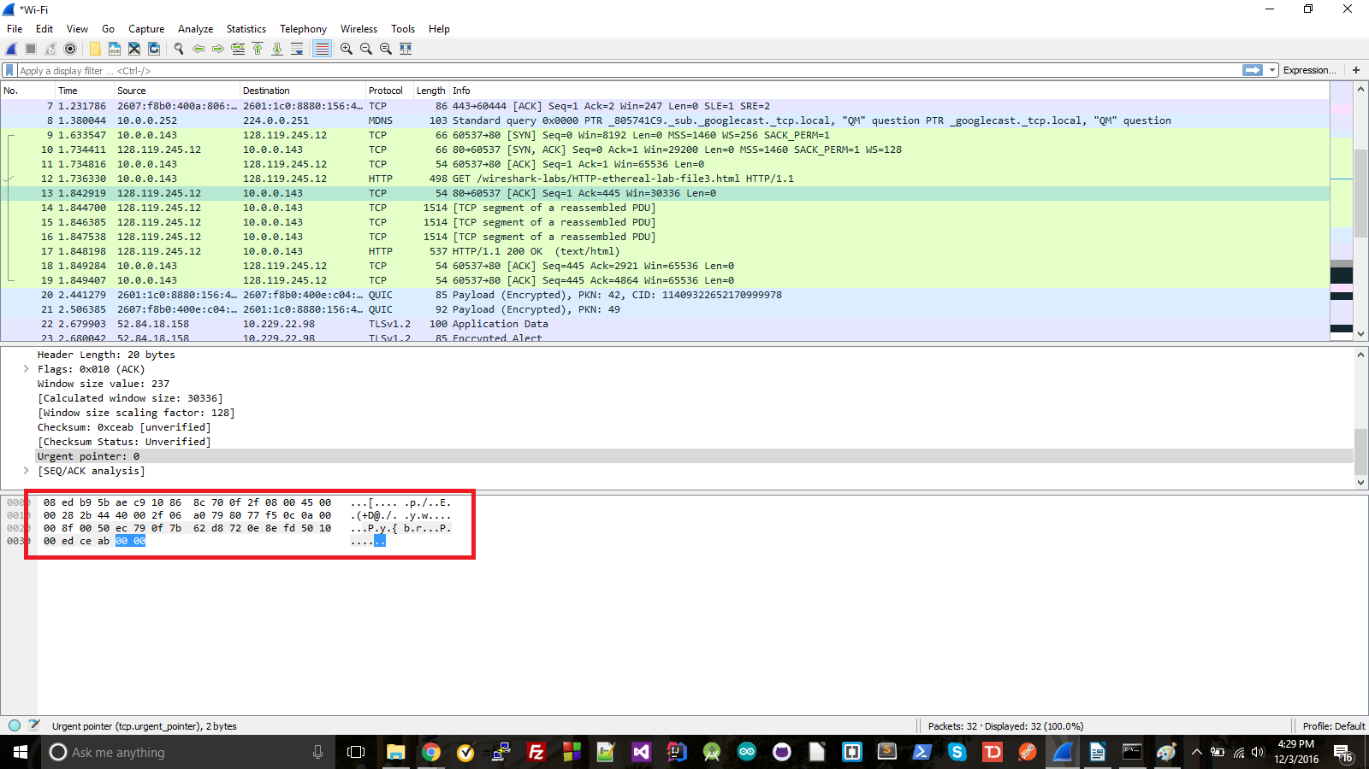

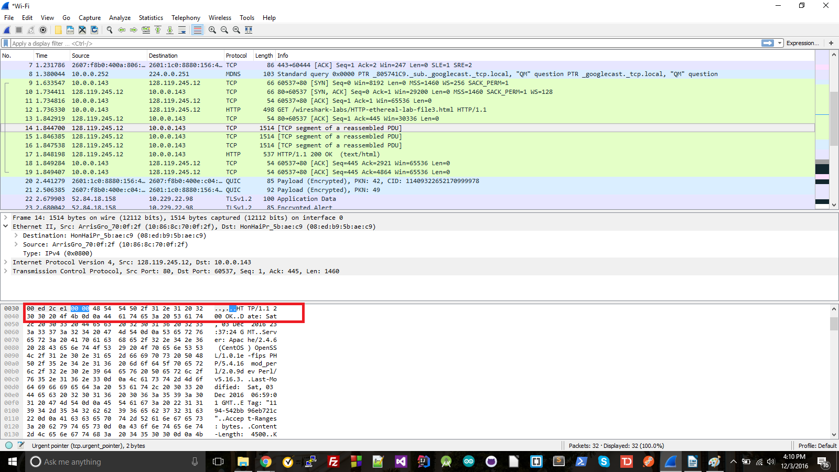

9) The Internet Address column is a list of IP addresses that have been added to the ARP table. The Physical Address column is the Physical addresses that have been logged for each IP (aka the physical address that is the actual address of that IP). The third column is type, which says if a particular IP/Physical pairing is static or dynamic, static being pairs that are manually added to the cache and are permanent, and dynamic being pairs that are added by past ARP requests/resolutions, which are temporary.
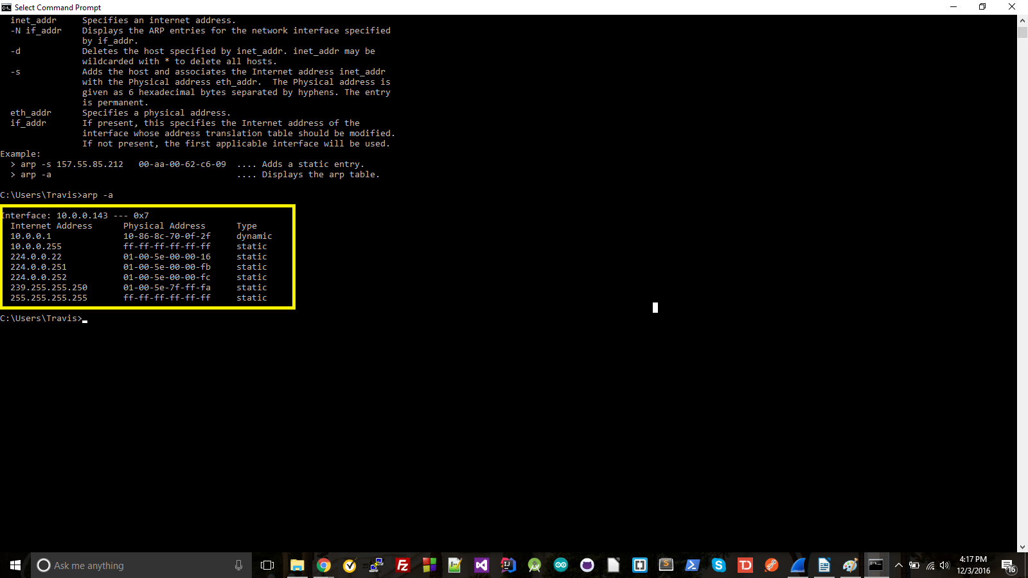
10) The source address (green) is 10:86:8c:70:0f:2f. The destination address (red) is 08:ed:b9:5b:ae:c9.
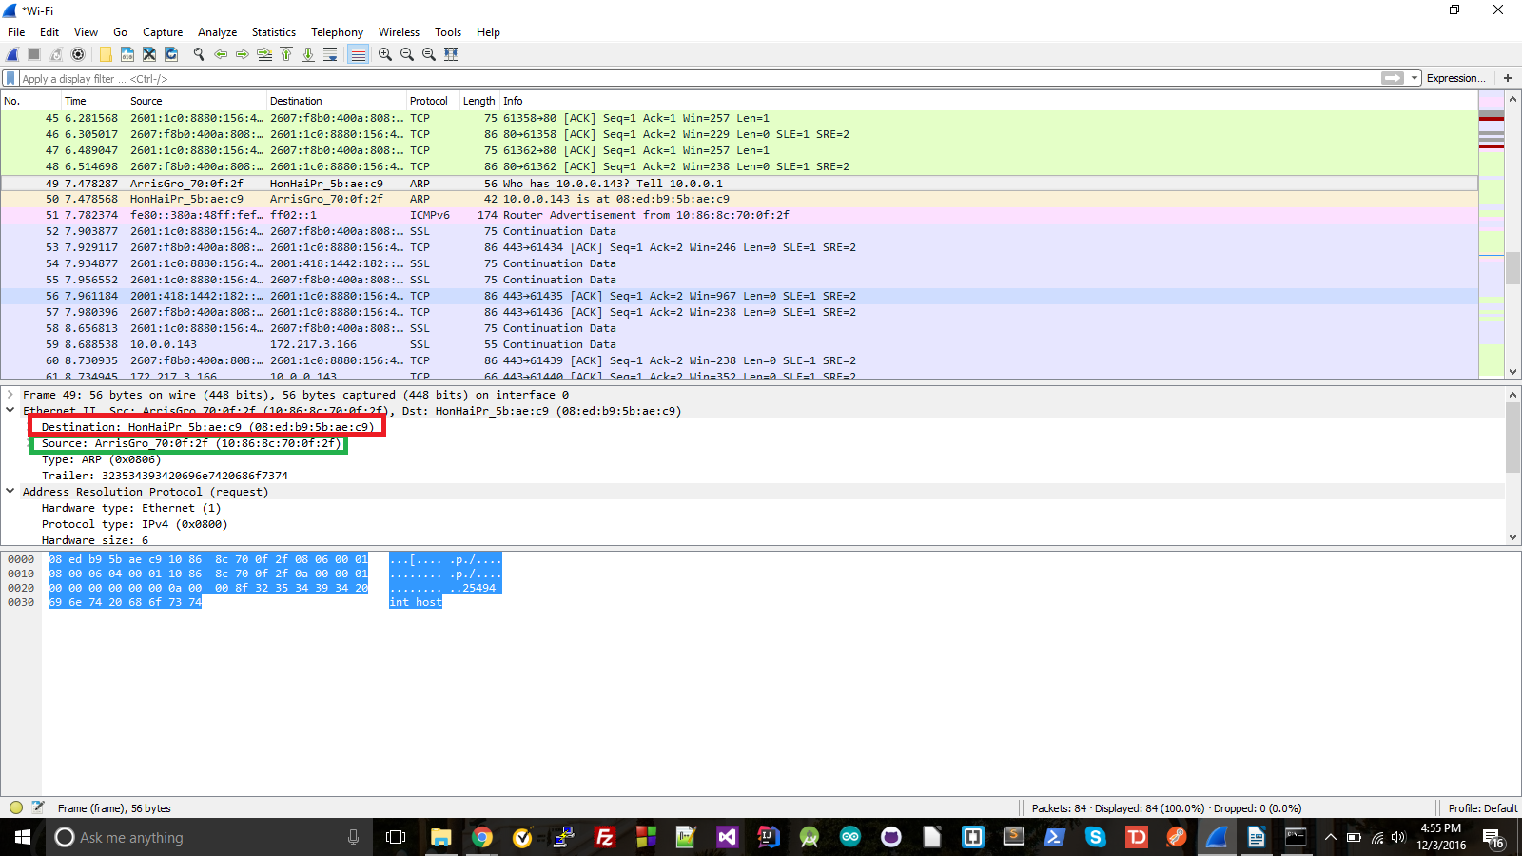

11) The value field is 0x0806. This corresponds to the ARP protocol
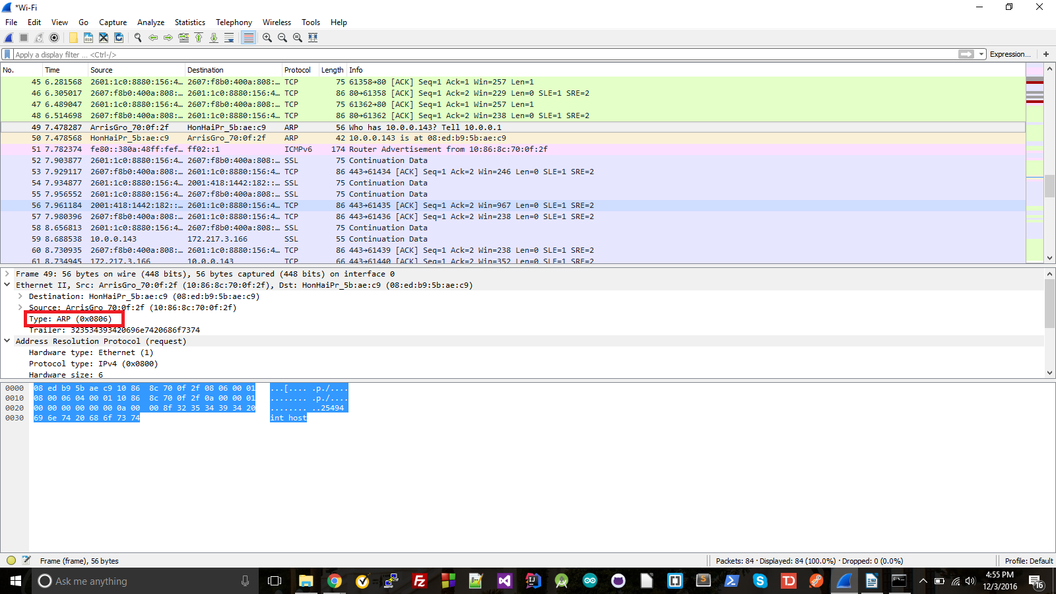
12) a: The opcode starts 160 bits from the beginning, making it 20 bytes in.
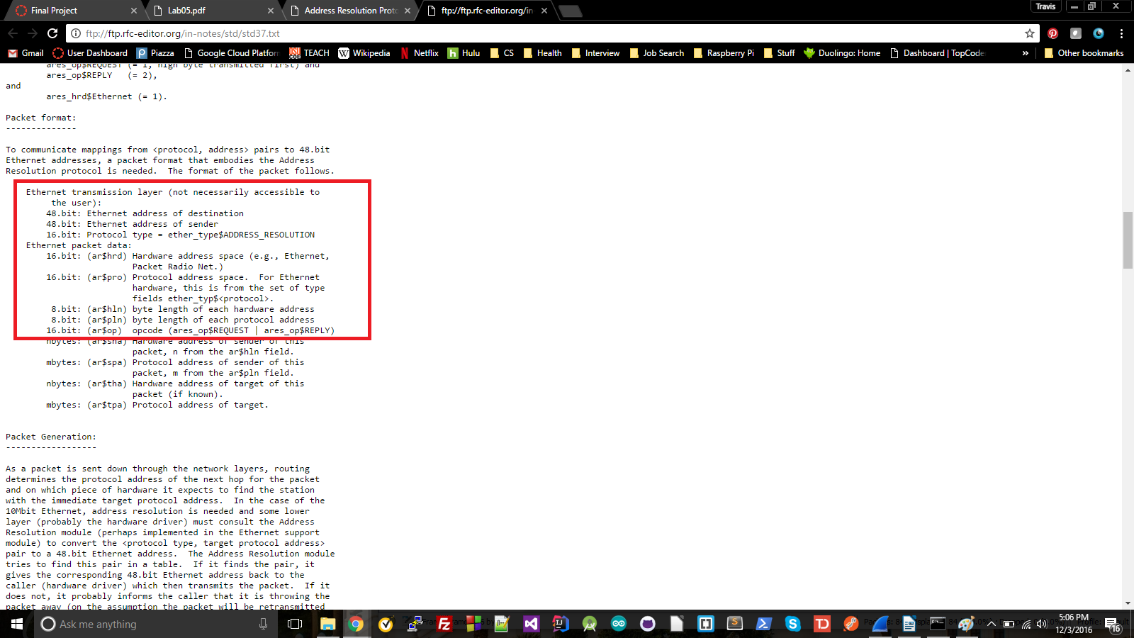

b: The opcode valus is request (1)
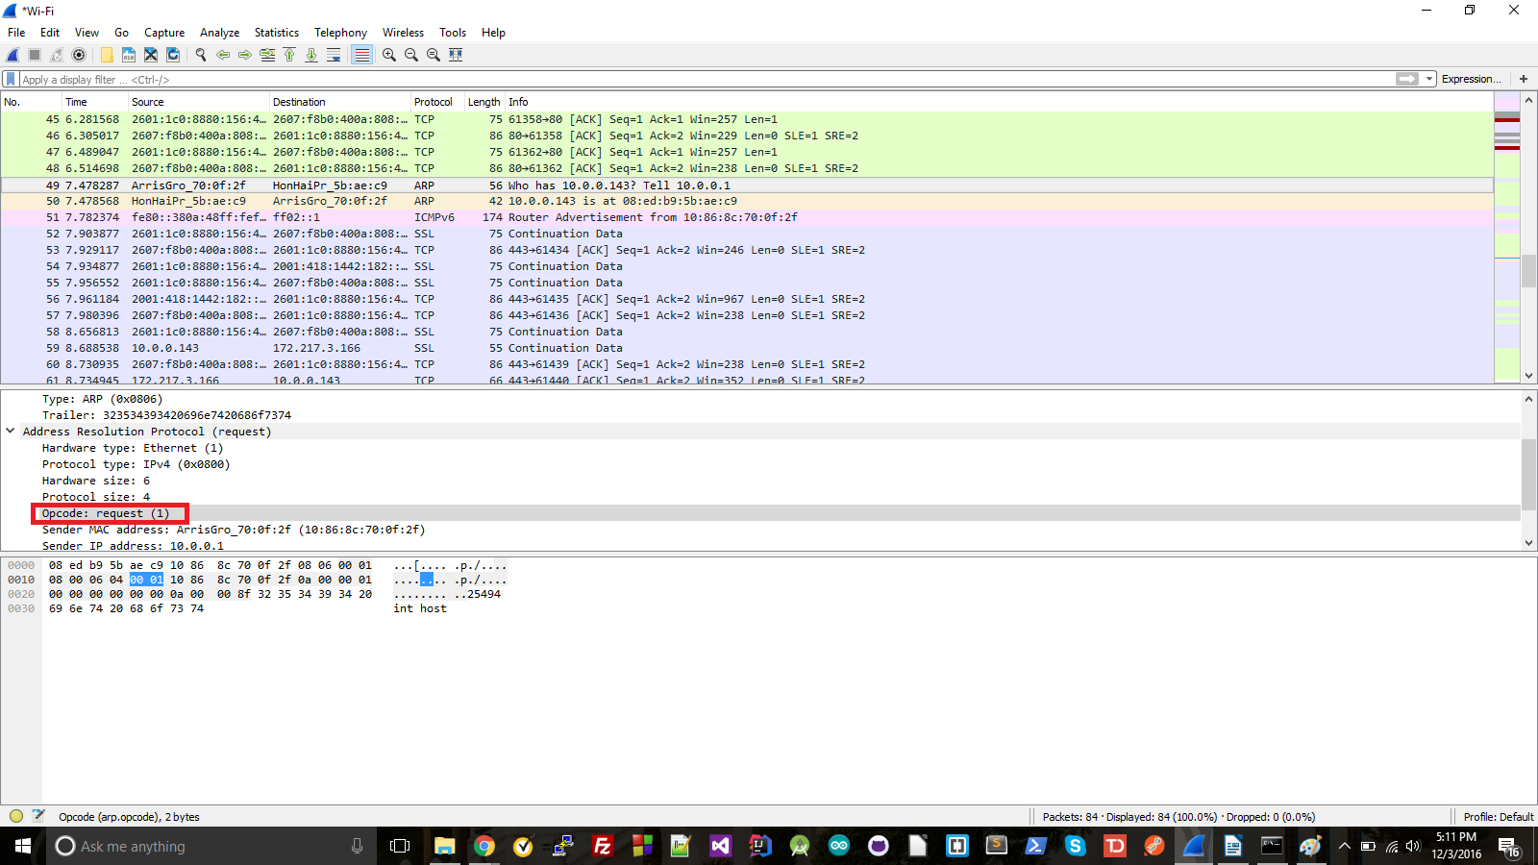
c: It does
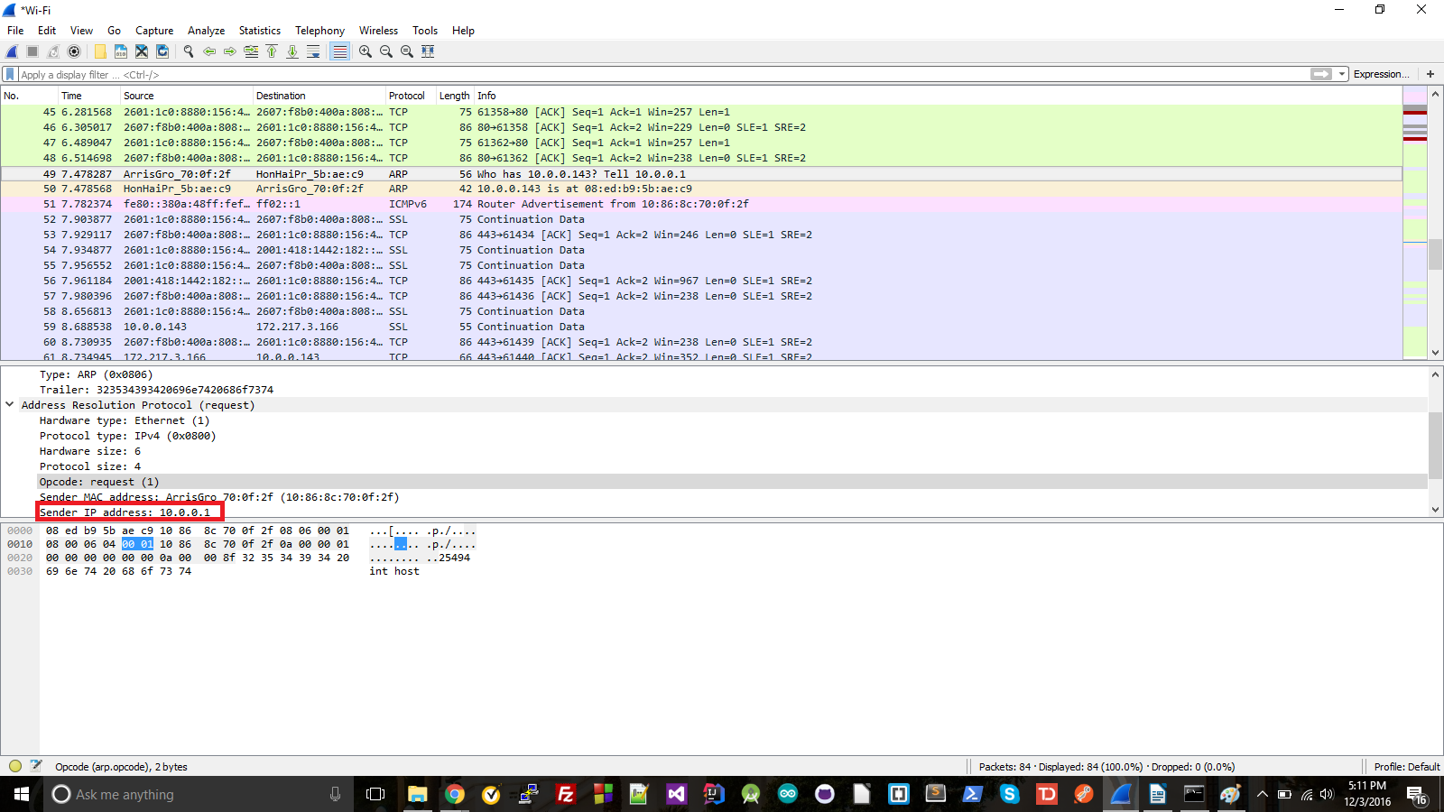

d: The question is the MAC address set to all 0's
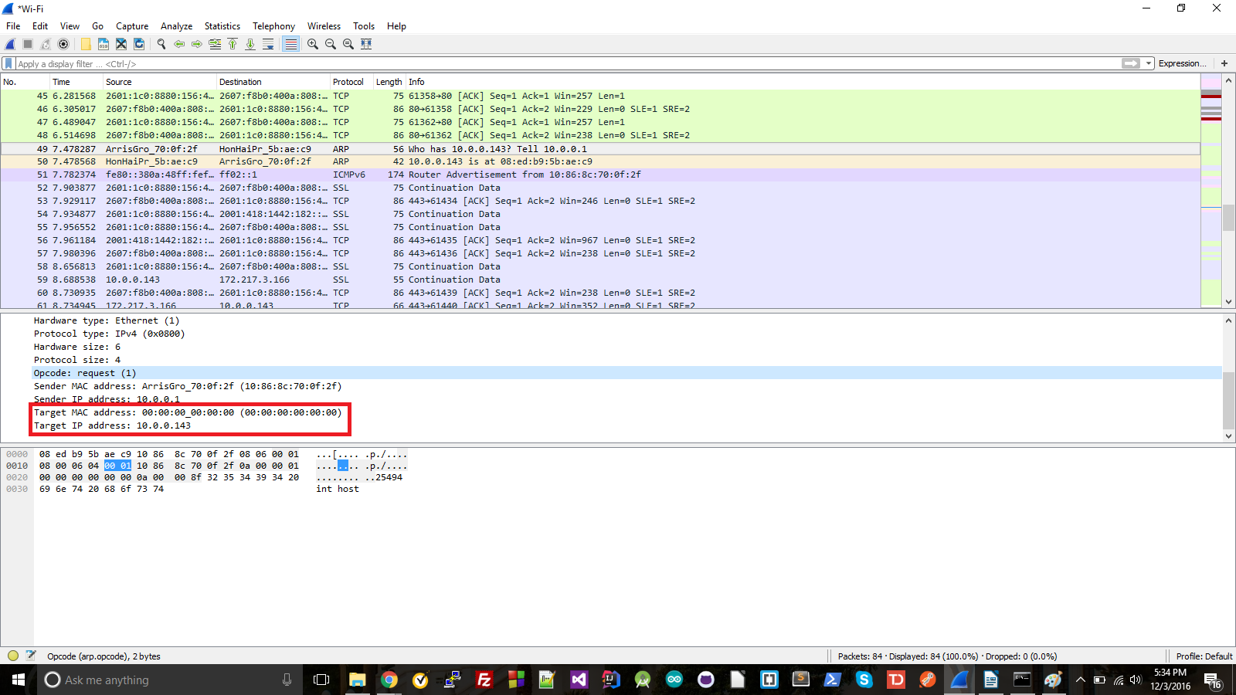

13) a: 20 bytes
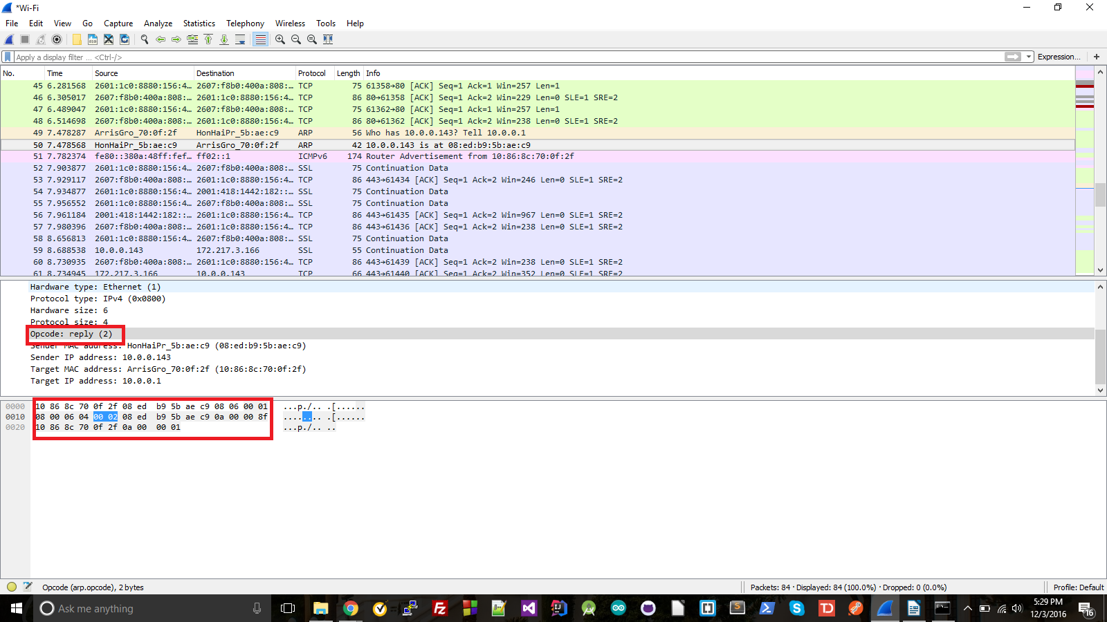

b: reply(2)
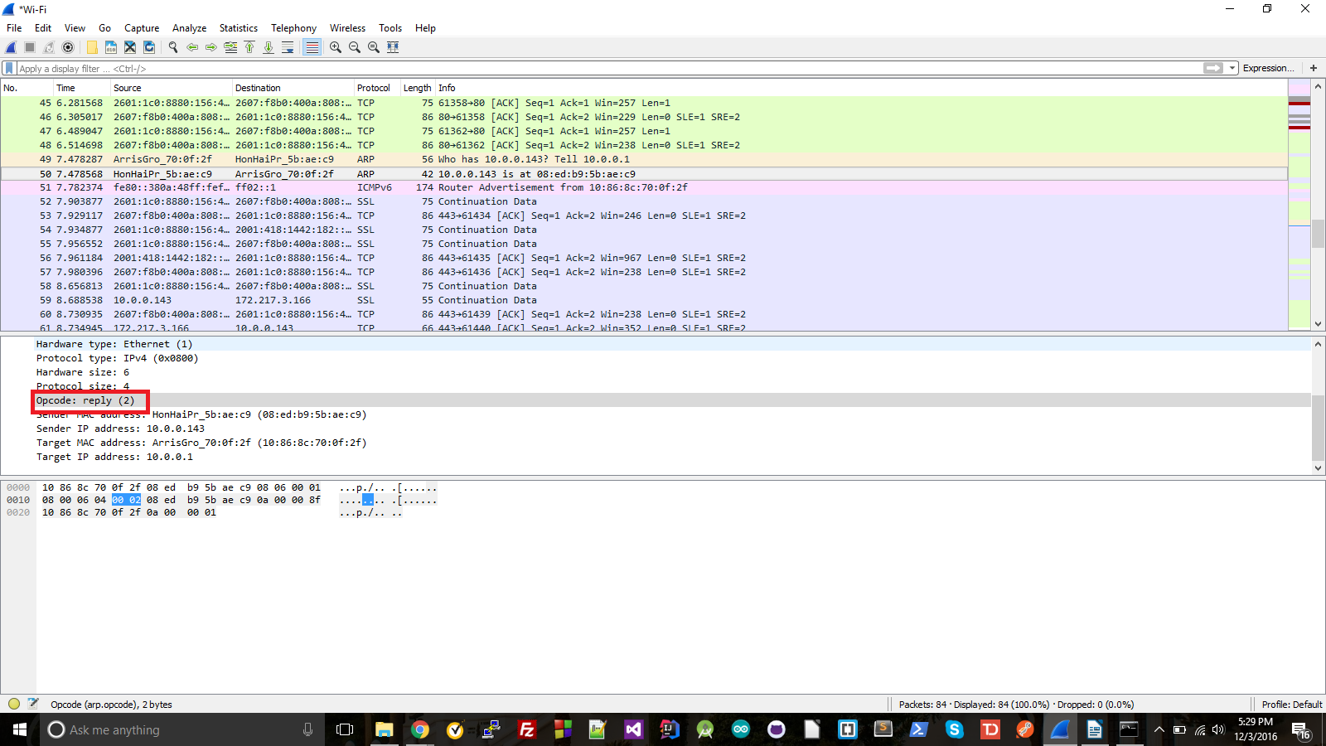
c: In the target MAC address field
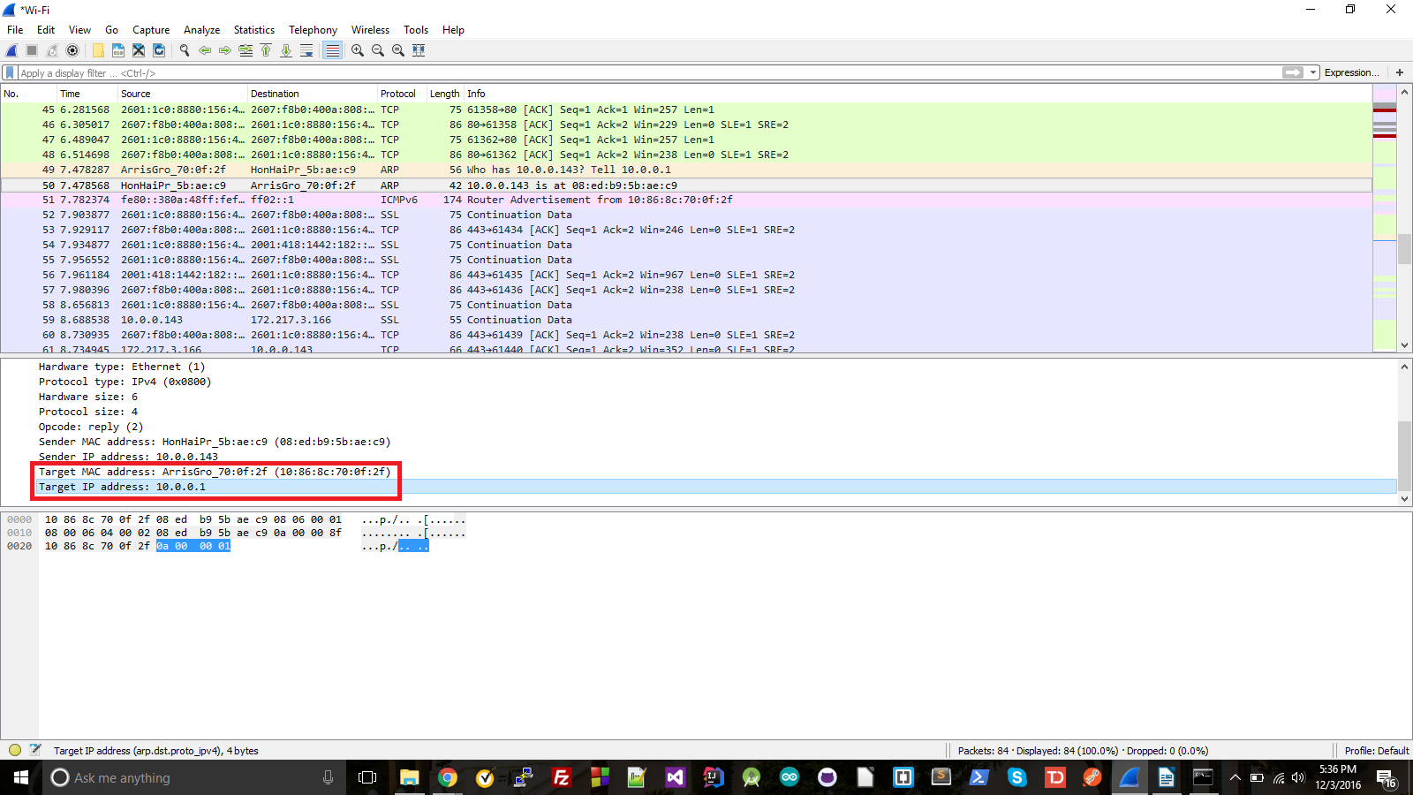

14) The source IP address: 08:ed:b9L5bLaeLc9
The destination IP address: 10:86:8c:70:0f:2f

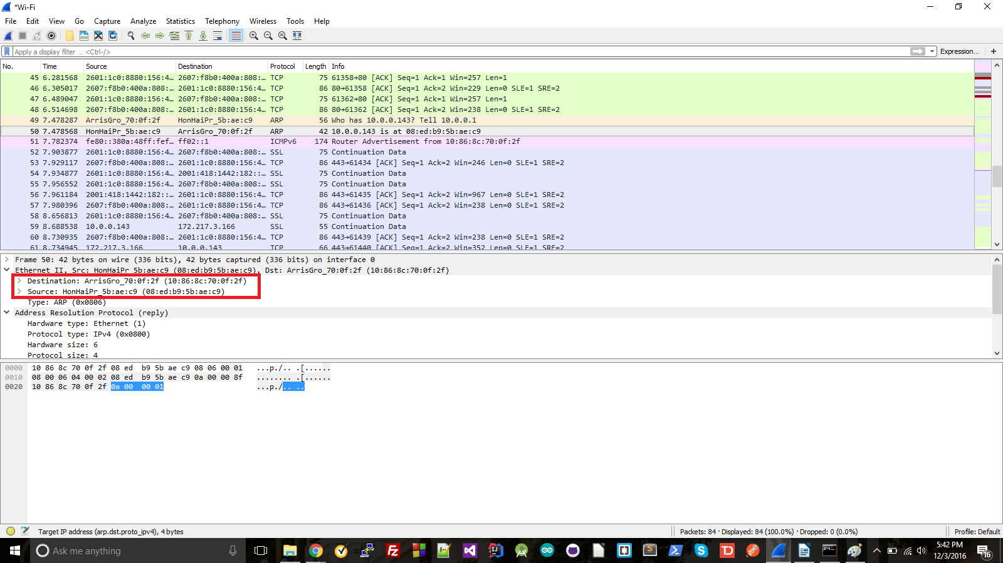
15) Because the wrong sender IP was used. The one that received the reply was 192.168.1.105 (green), while the one that did not was 192.168.1.104 (red), so the ARP reply was sent to the wrong IP for the one that did not get a reply.
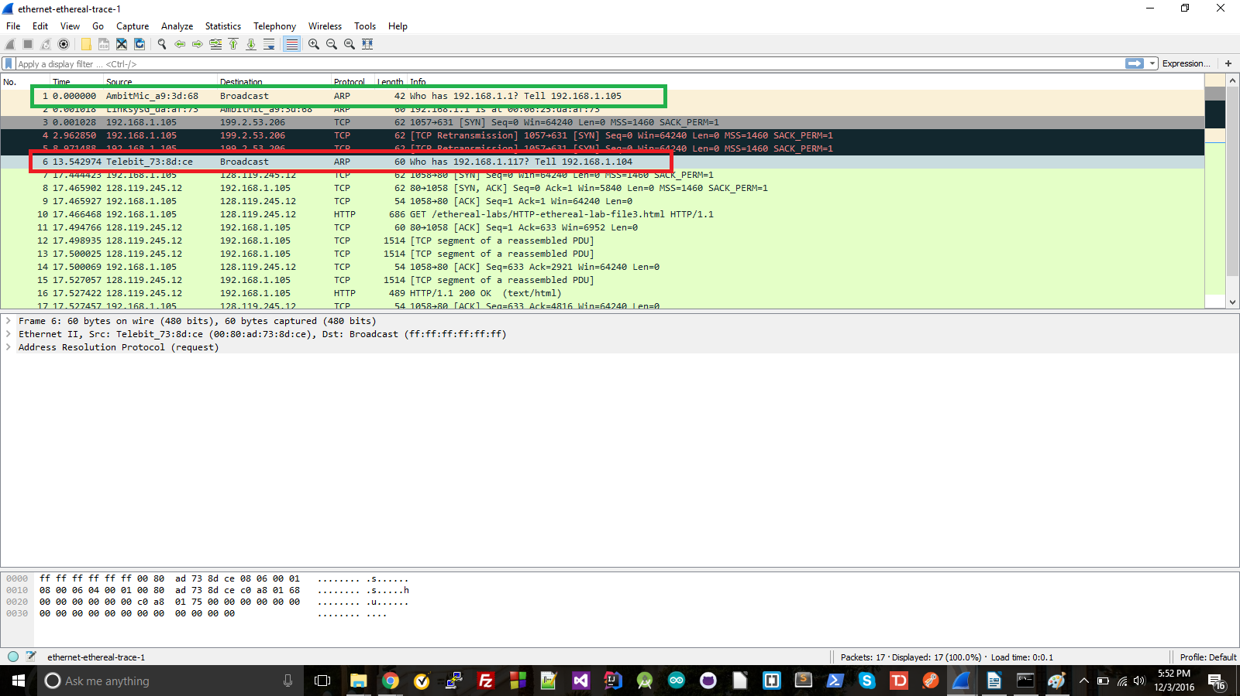
EX-1
You would send your messages to the wrong MAC address. This could cause your messages to be delayed or lost (depending on where your messages final destination were, the place you sent them could potentially still forward them towards the final destination)

EX-2
An ARP entry stays in the table for 2 minutes. If an entry is re-referenced it is given additional time in the table, up to 10 minutes.
Souce: https://technet.microsoft.com/en-us/library/cc940021.aspx

